Architecture

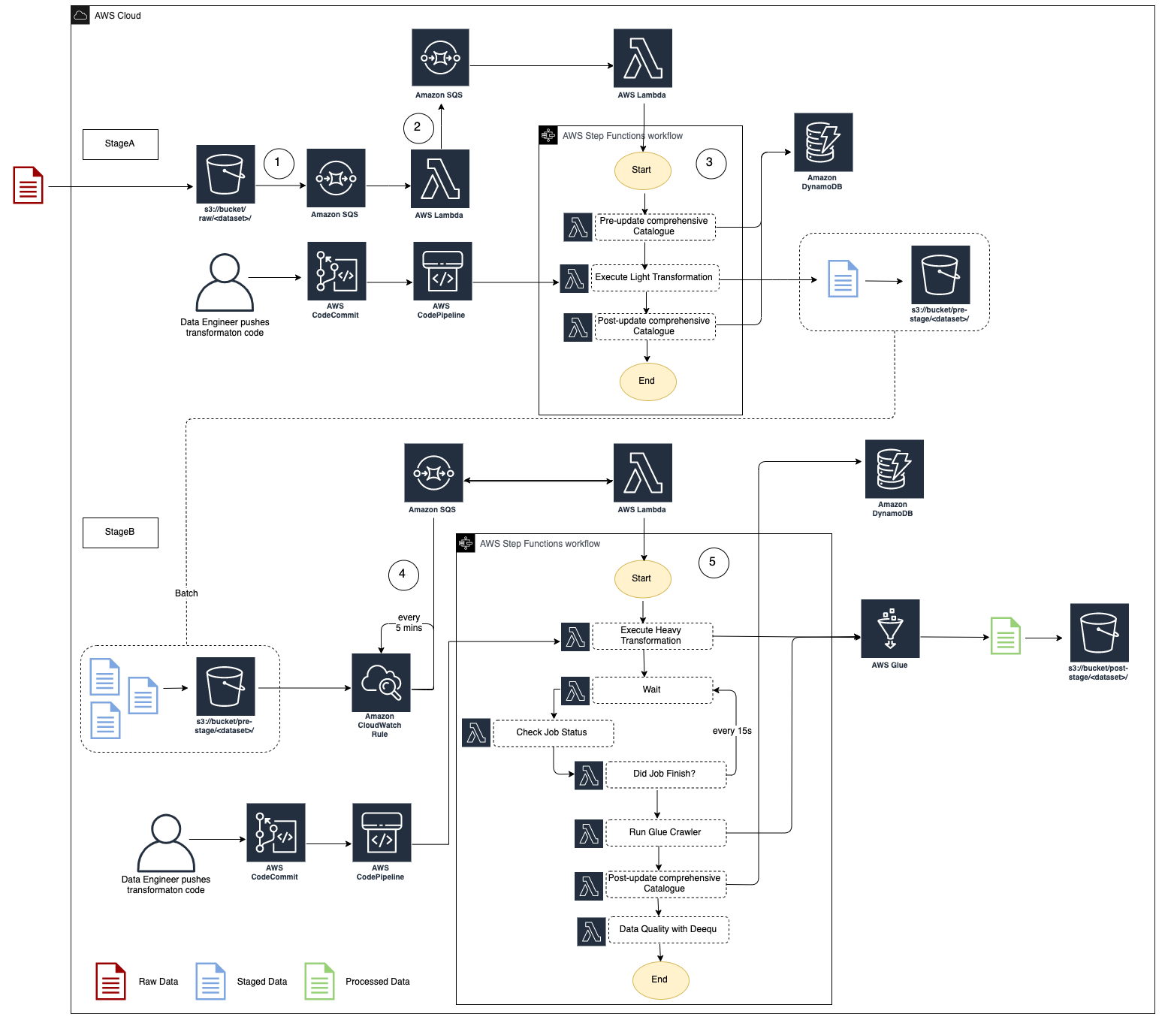
- As a file lands into the RAW bucket under the <team>/<dataset> prefix, an S3 Events Notification is created and placed in a queue
- The message is picked up by a Lambda which routes it to the appropriate SDLF team-specific pipeline
- The first stage (i.e., StageA Step Function) of the pipeline is triggered. Initial step in the processing is to update the Objects Metadata Catalog DynamoDB table (i.e., File metadata) with details about the landed object (S3 Path, timestamp…), before a light transformation is applied. The code for this light transformation would have previously been pushed into a CodeCommit repository by the data engineer and potentially gone through a code review and testing phase before entering production. The final step is to update the object metadata catalog with the output from the transformation and send the messages to the next SQS queue
- Every 5 minutes (customizable), a CloudWatch Event rule fires a Lambda which checks if there are messages in the queue sent from the previous stage. If so, it triggers the second Step Function (StageB)
- This time a heavy transformation is applied on a batch of files. This heavy transformation can be an API call to an Analytical AWS service (Glue Job, Fargate Task, EMR Step, SageMaker Notebook…) and the code is again provided by the data engineer. The state machine waits for the job to reach a SUCCEEDED state before the output is crawled to update the Glue Metadata Catalog (i.e., Tables’ metadata). A data quality step leveraging Deequ can also be run.

Tools

- AWS S3 Bucket: Buckets are containers for objects stored in Amazon S3. Here, buckets are used to store Raw, Staged and Processed Data.
- AWS SQS: Amazon Simple Queue Service (Amazon SQS) offers a secure, durable, and available hosted queue that lets you integrate and decouple distributed software systems and components. It gives the user an access to a message queue that can be used to store messages while waiting for the system to process them.
- AWS Lambda: Lambda is a compute service that lets a user to run code without provisioning or managing servers. The architecture uses Lambda Functions and Lambda Layers. While Functions are used to organize the code and are triggered when needed, Layers are used to separate function code from its dependencies. With layers, you can use libraries in your function without needing to include them in your deployment package.
- AWS Step Functions: AWS Step Functions lets the user coordinate multiple AWS services into serverless workflows, making building and updating the application easier. In the architecture, Step Functions are used to design and run workflows that stitch together services, such as AWS Lambda, AWS Glue, etc., into a feature-rich application.
- AWS CodeCommit: CodeCommit is a secure, highly scalable, managed source control service that hosts private Git repositories.
- AWS CodePipeline: AWS CodePipeline is a continuous delivery service which can be used to model, visualize, and automate the steps required to release the software. User can quickly model and configure the different stages of a software release process. CodePipeline automates the steps required to release the software changes continuously.
- AWS DynamoDB: DynamoDB stores data in tables. DynamoDB tables are schemaless—other than the primary key, user does not need to define any extra attributes or data types when a table is created.
- AWS CloudWatch: It is a monitoring and observability service which collects monitoring and operational data in the form of logs, metrics, and events.
- AWS Glue: The architecture has used Glue Crawlers which connects to a data store, progresses through a prioritized list of classifiers to determine the schema for the data, and then creates metadata tables in the data catalog.

