**WEEK 1**

SUPERSET ID-6362634

NAME- AYUSH SHARMA

DOMAIN-DOTNET

**1.** **E-commerce Platform Search Function**

**CODE:-**

using System;

using System.Collections.Generic;

class ProductSearch

{

    public static List<string> SearchProducts(List<string> products, string keyword)

    {

        List<string> results = new List<string>();

        keyword = keyword.ToLower();

        foreach (string product in products)

        {

            if (product.ToLower().Contains(keyword))

            {

                results.Add(product);

            }

        }

        return results;

    }

    static void Main(string[] args)

    {

        List<string> productList = new List<string>

        {

            "Laptop",

            "Mouse",

            "Keyboard",

            "Charger",

            "Laptop Bag",

            "Headphones",

            "Smartphone",

            "Monitor"

        };

        Console.Write("Enter search keyword: ");

        string input = Console.ReadLine();

        List<string> searchResults = SearchProducts(productList, input);

        Console.WriteLine("\nSearch Results:");

        if (searchResults.Count == 0)

        {

            Console.WriteLine("No products found.");

        }

        else

        {

            foreach (var product in searchResults)

            {

                Console.WriteLine("- " + product);

            }

        }

    }

}

**OUTPUT:-**

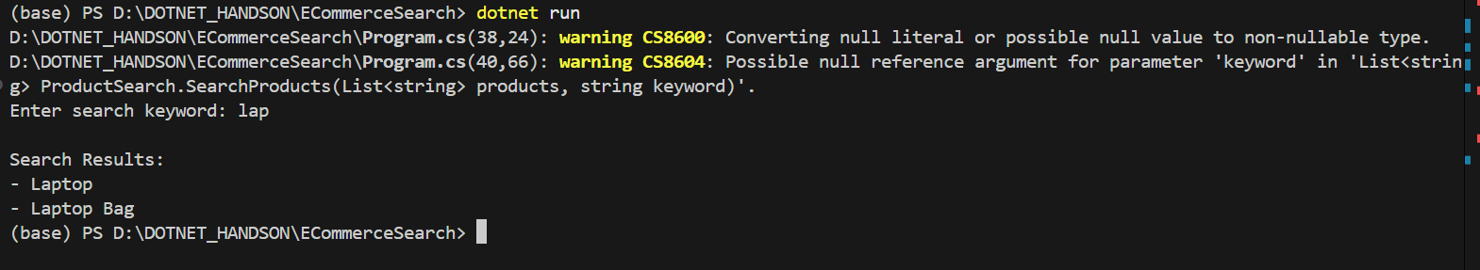

**2.** **Financial Forecasting**

**CODE:-**

using System;

using System.Collections.Generic;

class FinancialForecast

{

    // Function to calculate moving average

    public static double CalculateMovingAverage(List<double> data, int period)

    {

        if (data.Count < period)

        {

            Console.WriteLine("Not enough data for the selected period.");

            return 0;

        }

        double sum = 0;

        for (int i = data.Count - period; i < data.Count; i++)

        {

            sum += data[i];

        }

        return sum / period;

    }

    static void Main(string[] args)

    {

        // Monthly revenue data (in thousands)

        List<double> revenues = new List<double> { 10000, 12000, 11000, 15000, 13000, 14000 };

        Console.WriteLine("Past Revenues:");

        foreach (var rev in revenues)

        {

            Console.WriteLine($"- ₹{rev}");

        }

        Console.Write("\nEnter moving average period (e.g., 3): ");

        int period = int.Parse(Console.ReadLine());

        double forecast = CalculateMovingAverage(revenues, period);

        if (forecast > 0)

        {

            Console.WriteLine($"\nForecasted revenue for next month: ₹{forecast:F2}");

        }

    }

}

**OUTPUT:-**

