A Seminar

On

“Agentic AI: Autonomous Goal-Oriented Intelligent Systems for Planning, Reasoning and Task Execution”

Submitted to Savitribai Phule Pune University
for the partial fulfillment of Under Graduate Degree in
Information Technology

Presented By
Korde Ayush Sandeep | PRN: 72406771M

Guided By
Prof. V. A. Khairnar



Department of Information Technology
PVG’s College of Engineering & S. S. Dhamankar Institute of Management, Nashik
Academic Year 2026 – 27

A Seminar
On
“Agentic AI: Autonomous Goal-Oriented Intelligent Systems for Planning, Reasoning and Task Execution”

Abstract:

Agentic AI refers to AI systems that go beyond single-turn generation to autonomously pursue a user-specified goal by planning, invoking tools, observing outcomes, and adapting their next action, without step-by-step human instruction for every action [1]. Unlike conventional rule-based automation, generative AI, and standalone large language models (LLMs), which respond to a single prompt or a fixed pipeline, an agentic system decomposes a goal into subtasks, retrieves relevant knowledge, selects and invokes tools or APIs, and verifies its own results before proceeding [1][2][3]. Prior work has separately advanced planning and reasoning-action interleaving (ReAct) [4], memory and retrieval-augmented generation (RAG) [7], and multi-agent workflow coordination [5]; a parallel body of work catalogs the security, privacy, and ethical risks that arise once such agents act autonomously [6]. However, these two threads are rarely integrated into a single, demonstrable control loop: most reported architectures optimize for task capability, while risk assessment and outcome verification are treated as afterthoughts rather than first-class stages of the loop. This seminar surveys the core building blocks of Agentic AI — goal understanding, task decomposition, planning, memory/RAG, tool use, observation, and verification — and proposes a reliability-oriented agent architecture that explicitly separates planning from execution and pre-action risk screening from post-action verification, with bounded human-in-the-loop approval for high-risk actions and a retry/escalation policy bounded by a maximum retry count. The seminar evaluates this proposal qualitatively against a structural checklist of correctness rather than fabricated experimental results, and outlines a small prototype that demonstrates the loop end to end on safe, non-destructive tools.

Keywords: Agentic AI, autonomous agents, large language models, task planning, task decomposition, retrieval-augmented generation, tool use, reasoning and acting, human-in-the-loop, verification, risk assessment, multi-agent systems

- Introduction
Artificial intelligence systems relevant to this seminar have evolved through three broad stages: (a) rule-based / conventional AI, which executes fixed logic with no learning or adaptation; (b) generative AI and large language models (LLMs), which produce fluent text, code, or other content in response to a prompt but do not, by themselves, act in the world or pursue a goal across multiple steps; and (c) Agentic AI, which uses an LLM (or a similar reasoning engine) as a controller inside a loop that plans, retrieves knowledge, selects tools, executes actions, observes outcomes, and decides whether to continue, retry, or stop [1][2][3]. The distinguishing property of an agentic system is autonomous, goal-directed, multi-step behavior: given a goal, the system determines the sequence of sub-actions itself, rather than being told each step individually. This distinction matters practically — since an agentic system can attempt to actually perform actions rather than merely describe them, reliability, safety, and verification are central design concerns, not optional extras.

  - Motivation:

• LLMs are increasingly connected to real tools, APIs, files, and services, so a single incorrect or unverified action has real consequences — motivating an architecture where risk is assessed before an action executes, not only inspected after the fact [6].
• Existing literature richly covers individual capabilities — planning, ReAct-style reasoning [4], memory/RAG [7], and multi-agent coordination [5] — but rarely packages them into one teachable, reliability-first reference loop that a student or engineer can actually build and demonstrate.
• T.E. IT students entering industry will encounter agent frameworks and tool-calling copilots as part of everyday tooling; understanding the underlying control loop is a foundational, transferable skill.

  - Objective:
• Define Agentic AI precisely and distinguish it from conventional AI, generative AI, and standalone LLMs.
• Survey the core components of an agentic loop — planning, task decomposition, memory/RAG, tool use, observation, and verification — grounded in verifiable literature [1]-[7].
• Identify a concrete research gap in how existing work integrates capability with reliability governance.
• Propose a reliability-oriented Agentic AI architecture that separates planning from execution and pre-action risk screening from post-action verification, with bounded human-in-the-loop approval.
• Demonstrate the proposed control loop end-to-end through a small, safe, non-destructive prototype.

  - Problem Statement:
Existing research treats planning, memory and retrieval, tool use, multi-agent collaboration, and security/privacy risk as largely separate concerns, addressed in isolation across different surveys and systems [1][2][3][5][6]. A practical gap remains in integrating these capabilities into a minimal, teachable reference architecture that combines pre-action risk assessment, bounded human oversight, and post-action verification in one demonstrable control loop, in a way that a T.E.-level student can understand, diagram, and implement as a small working prototype. This seminar addresses that gap by proposing such an architecture and validating its feasibility through a structural evaluation framework and a demonstrable prototype, rather than isolated capability benchmarks.

- Methodology / Prototype / Idea / Algorithm
• Goal Understanding: interpret user intent and constraints from the stated goal.
• Task Decomposition & Planning: break the goal into ordered subtasks and select the next action using a ReAct-style reasoning-acting loop [4].
• Knowledge Grounding: retrieve relevant context via Memory + RAG before each action [7].
• Pre-Action Risk Gate: classify each action's risk and require human approval for high-risk actions before they execute [6].
• Post-Action Verification: observe the result, verify it against the expected outcome, and replan/retry within a bounded MAX_RETRIES before escalating to a human.
Figure 2.1 shows the resulting layered architecture: user goal at the input layer; reasoning, planning and task decomposition; knowledge grounding through Memory + RAG; a safety layer holding the risk gate and the human-approval step; and an execution/verification layer that feeds a bounded replanning loop back into the planner on verification failure.
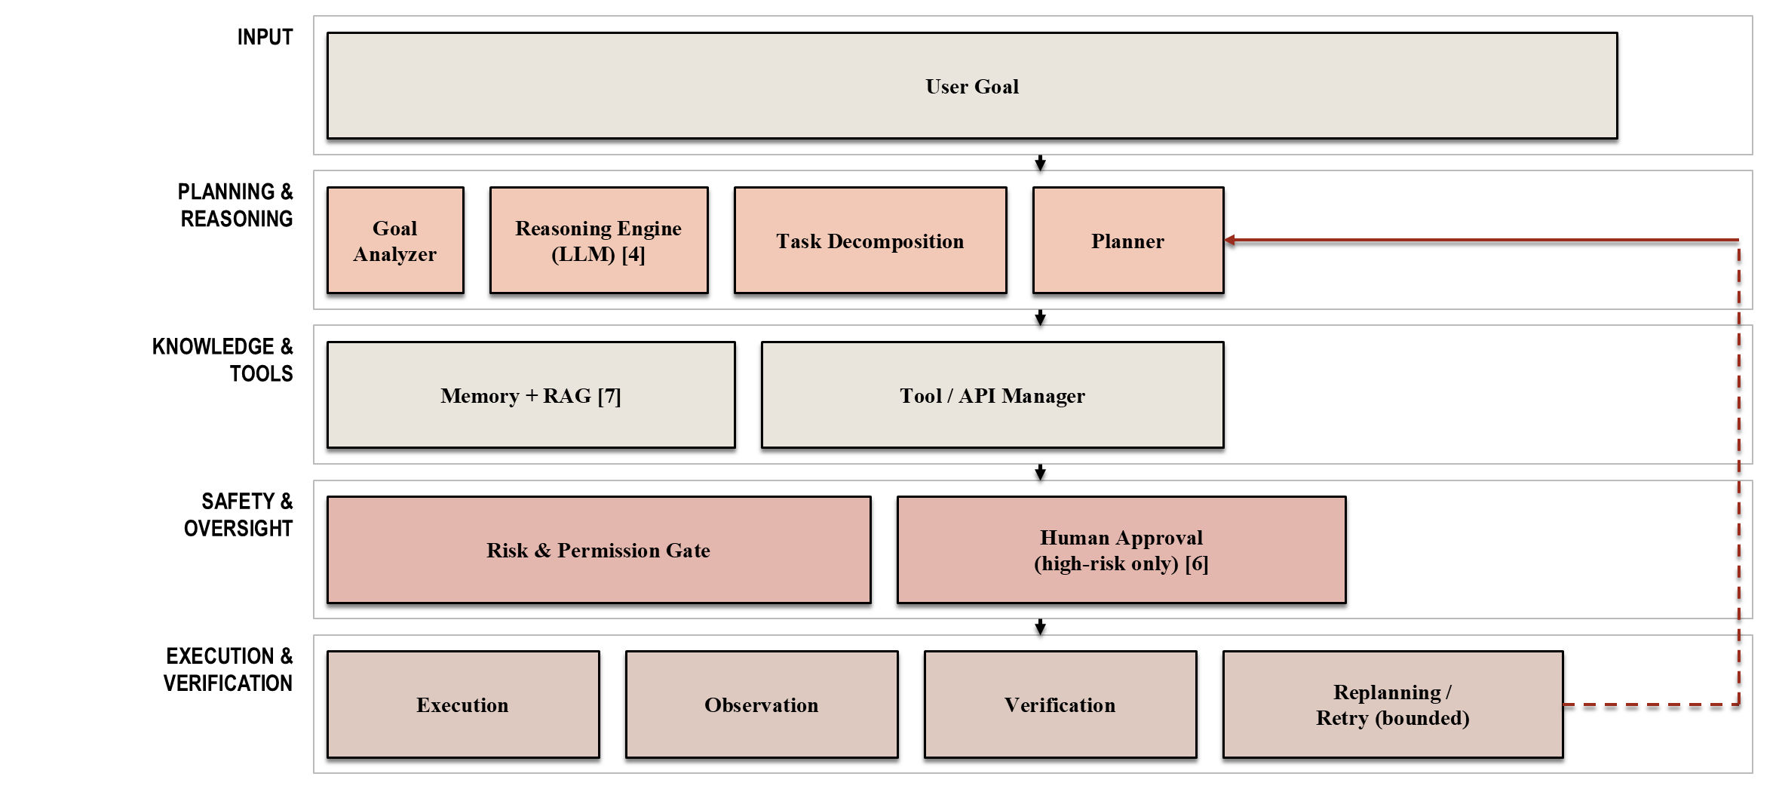
Figure 2.1: Proposed reliability-oriented Agentic AI architecture. The loop concludes with aggregated, verified outputs returned to the user after the Execution & Verification layer. Source: Author's proposed architecture, synthesized from [1], [2], [4], [7] and the risk taxonomy in [6].

Expected Outcomes:
This seminar is expected to: (i) define Agentic AI clearly relative to conventional and generative AI; (ii) synthesize a literature-grounded set of core agentic-loop components; (iii) identify and articulate a concrete research gap around reliability governance; (iv) propose a reliability-oriented architecture and bounded algorithm that separate planning from execution and pre-action risk screening from post-action verification; and (v) demonstrate the feasibility of that architecture through a small, safe conceptual prototype (Phase 3), evaluated against the structural metrics in the evaluation framework rather than fabricated performance numbers.
Applications areas, if any:
Autonomous coding assistants that plan multi-file changes, run tests, and verify results before presenting a diff; enterprise workflow copilots that read documents and draft actions with human approval for customer-facing steps; research assistants that retrieve literature via RAG and flag claims needing human verification; and personal task agents where irreversible actions (payments, sending messages) are always gated behind explicit user approval.

- Conclusion
Agentic AI extends LLMs from single-turn generation to autonomous, multi-step, goal-directed behavior by combining planning, memory/retrieval, tool use, and verification [1][2][3][4][7]. This seminar identified a gap in how existing work integrates that capability with reliability governance, and proposed an architecture that explicitly separates planning from execution and pre-action risk screening from post-action verification, with bounded human-in-the-loop approval and a retry-bounded verification loop. Future work includes completing the Phase 3 prototype, extending the architecture to multi-agent settings [5] while preserving the same reliability guarantees, and empirically evaluating the proposed metrics once a working system exists.

References
- D. B. Acharya, K. Kuppan, and B. Divya, “Agentic AI: Autonomous Intelligence for Complex Goals — A Comprehensive Survey,” IEEE Access, vol. 13, pp. 18912–18936, 2025.
- X. Dong, X. Zhang, W. Bu, D. Zhang, and F. Cao, “A Survey of LLM-based Agents: Theories, Technologies, Applications and Suggestions,” in Proc. 3rd Int. Conf. Artificial Intelligence, Internet of Things and Cloud Computing Technology (AIoTC), 2024, pp. 407–413.
- L. Wang, C. Ma, X. Feng, et al., “A survey on large language model based autonomous agents,” Frontiers of Computer Science, vol. 18, no. 6, p. 186345, 2024.
- S. Yao, J. Zhao, D. Yu, N. Du, I. Shafran, K. Narasimhan, and Y. Cao, “ReAct: Synergizing Reasoning and Acting in Language Models,” in Proc. ICLR, 2023.
- X. Li, S. Wang, S. Zeng, Y. Wu, and Y. Yang, “A survey on LLM-based multi-agent systems: workflow, infrastructure, and challenges,” Vicinagearth, vol. 1, no. 1, art. 9, 2024.
- Y. Gan, Y. Yang, Z. Ma, P. He, R. Zeng, Y. Wang, Q. Li, C. Zhou, S. Li, T. Wang, Y. Gao, Y. Wu, and S. Ji, “Navigating the Risks: A Survey of Security and Privacy Threats in LLM-Based Agents,” ACM Transactions on Software Engineering and Methodology, 2026, doi: 10.1145/3807666.
- P. Lewis et al., “Retrieval-Augmented Generation for Knowledge-Intensive NLP Tasks,” in Proc. NeurIPS, 2020.

Prof. V. A. Khairnar | Ms. S. D. Pingale | Dr. S. R. Lahane
Guide | Seminar Coordinator | Head

