KUMBH SETU / PRODUCT IMPROVEMENT

Product improvement report
  - A unified field-to-control-room experience for Nashik–Trimbakeshwar Simhastha
This report captures the implementation delivered in the latest Kumbh Setu product pass. It brings the public pilgrim journey, field response and management workspace into a more coherent product, while making simulation boundaries and operational data limits explicit.
The product remains a prototype. The strongest outcome is a clearer, safer incident lifecycle and a more dependable guided demonstration; it is not a live emergency dispatch service.
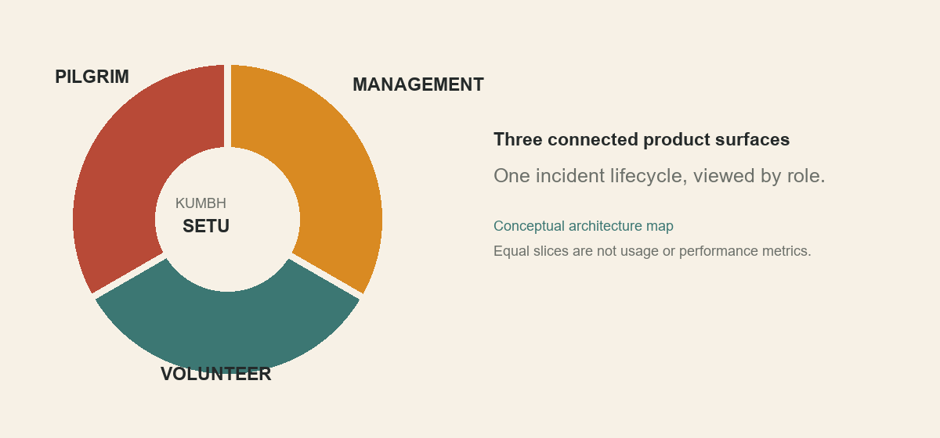
Product surfaces shown as equal conceptual parts; the graphic does not represent usage, staffing or measured outcomes.

At a glance
Area | What changed
Public entry | Editorial landing page, clearer role entry and product preview.
Pilgrim | More explicit SOS/reporting guidance, local-only disclosures and direct emergency call action.
Field response | Task-first volunteer queue, clearer incident execution and response lifecycle.
Management | More consistent navigation, incident search/filtering, responsive operational views and detail workspace.
Demo & trust | Selectable synthetic scenarios, isolated state lifecycle, clearer labels and removal of misleading operational claims.

Implementation commit: f450940f35a66cfddbff29bfbb5fae7f1d954a4b | feat: enhance Kumbh Setu product experience and workflows

Before and now
The “before” column summarizes the issues identified during the product pass. The “now” column describes the shipped implementation and its verified limits; it does not imply an operational deployment capability.
Experience | Before | Now
Visual system | Public pages felt more editorial than operational views; repeated compact panels and uneven density weakened continuity. | Warm paper, ink, saffron and river tones remain the identity; shared typography, controls and clearer role navigation improve continuity.
Landing | Strong identity but limited proof of how the product connects its users. | Clearer role entry and a populated product preview demonstrate how a report moves across roles; preview content is labelled synthetic.
Pilgrim safety | SOS/reporting copy could imply external delivery or dispatch. | SOS and reports explain their local-only prototype behavior; urgent real-world help points to 112.
Volunteer | Assistant-first entry made field work less direct. | Task queue is the default and incident actions are organized around acknowledgement, arrival, notes and resolution.
Management trust | Illustrative numbers, alerts, notices and camera-like content could read as real. | Synthetic indicators are labelled; fabricated bulletins, camera detections, forecasts and unsupported helpline details were removed or clarified.
Demo state | Scenario switches could affect ordinary shared browser state. | Demo mode snapshots normal state, isolates persistence and BroadcastChannel sync, then restores normal state on exit.
Errors & access | Error and loading feedback was uneven; keyboard focus needed refinement. | Route-level error handling, loading component and visible focus states support clearer failure and keyboard feedback.

How the product loop works
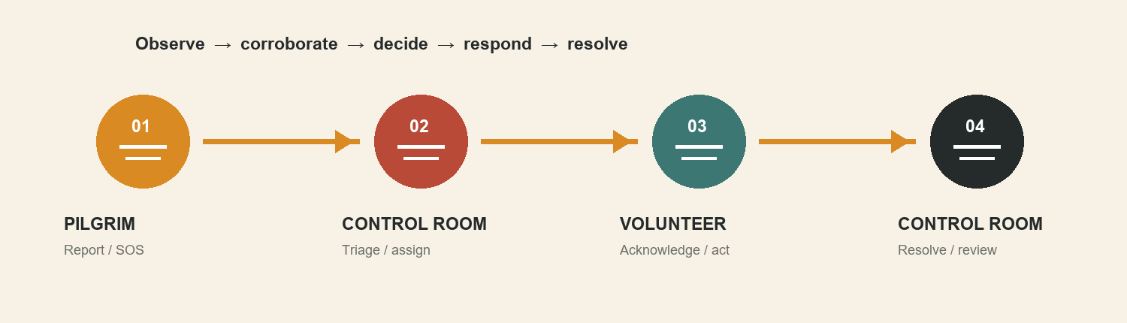
Illustrative product workflow. The activity log is application-level and is not a cryptographic or immutable audit ledger.

Improvements by experience

Pilgrim reporting
The pilgrim surface is designed for immediate, understandable choices: ask for urgent help, report a concern, or find support. The SOS flow explains what the prototype can do locally and offers a direct call path to 112. Issue and lost-person reporting include local-only and privacy context so users are not led to believe that an authority has received or dispatched a response.
- Language selection is more visible in the public-facing flow.
- Reporting forms use clearer prompts and action labels, with confirmation cues after the user submits.
- Critical urgent-help guidance is kept distinct from AI assistance and simulated product workflows.
- The experience remains a prototype; no server-backed emergency delivery is claimed.

Volunteer and field response
Field work is organized around the incident task. Volunteers can review assigned work, understand priority and location context, acknowledge the assignment, update response progress, add notes and record resolution. Task history supports continuity between the field and the management view.
- Task queue moved to the default field entry.
- Response actions use the existing incident lifecycle and shared Zustand store.
- Setu can assist with structured reporting, but proposed high-impact actions remain subject to app policy and confirmation.
- Availability of voice, translation and AI provider features depends on configured capabilities; scripted demo dialogue is not evidence of a live provider.

Management and operations
Management views received clearer navigation, search and filters for incident work, responsive layout improvements and more consistent status/context presentation. The incident detail workspace makes lifecycle history and response context easier to review. Reference directories are described as reference material rather than verified live service inventories.
- Incident queue supports a more direct triage and review workflow.
- Detail and timeline components connect action history to incident context.
- Security view no longer presents fabricated CCTV detections as evidence.
- Pulse and other seeded operational values are marked synthetic and not validated forecasts.

Demo studio and state safety
The /demo route provides three selectable deterministic synthetic scenarios: medical emergency, missing child and crowd congestion. The pre-existing missing-child flow is preserved. Medical and crowd scenarios exercise the application incident, triage, dispatch, acknowledgement, arrival, resolution, escalation, note and timeline actions where applicable.
Scenario | Demonstrated product behavior | Boundary
Medical emergency | Incident progression through management and volunteer response actions. | Synthetic scenario data; no real dispatch or emergency notification.
Missing child | Preserved multilingual missing-child workflow and cross-role progression. | Conversation/narration may be scripted; this is a demonstration, not a live case.
Crowd congestion | Scenario switch and incident workflow using synthetic congestion context. | No live crowd sensors, density feed or validated prediction.

Isolation decision
Demo state uses the existing Zustand application store with an explicit in-memory isolation flag. Starting a demo saves a return snapshot and loads a known synthetic seed atomically. During the demo, persistence skips demo state; BroadcastChannel neither sends it to ordinary tabs nor applies ordinary-tab updates into the demo view. On exit, the latest normally persisted state is restored, preserving changes received in other tabs. When browser storage is unavailable, the in-memory snapshot is used.
Restart and scenario switching reset only the isolated demo copy. This is an application-level boundary in one browser, not a separate database or security boundary. If the same tab navigates to a role app during a demo, those actions remain in the demo copy and are discarded on exit.

Why the isolation matters
The demo can be replayed without silently replacing normal persisted incidents or sharing synthetic scenario updates with other tabs. Tests cover the lifecycle, replay, switching, persistence isolation, BroadcastChannel isolation and restoration paths.

Trust, data and imagery
The product language was tightened to avoid promising emergency SMS, external dispatch, authority bulletins, camera detections, or a calibrated crowd forecast. Public numbers retained are 112, 108 and 1098 as documented official emergency references. The 2,943-record Nashik directory is reference data with known gaps; location points and facility availability are not field-verified.
No new images or data layers were added in this implementation pass. Existing local Nashik photographs remain documented with attribution and license details in docs/IMAGE_CREDITS.md. The recorded credits include Wikimedia Commons sources under CC BY-SA 4.0, CC BY 4.0 and CC BY-SA 3.0. Preserve attribution and ShareAlike requirements when reusing or adapting those assets; check the source page for exact current wording before republication.

Routes, components and validation

Routes reviewed
Route | Role in product
/ | Landing and role entry
/about | Project overview
/pilgrim | Pilgrim help, reporting and self-service
/field | Setu field companion
/volunteer | Volunteer task queue and response
/management | Control room and operations views
/demo | Guided scenario studio
/board | Common Operations Board
/login and /enroll | Access and volunteer enrollment

Notable components created or reused
Component / area | Purpose
PlatformPreview | Populated cross-role product preview on the landing experience.
IncidentDetail and IncidentTimeline | Incident context, lifecycle details and action history.
DemoScenarioPanels and DemoControls | Scenario selection, stage context, replay and guided controls.
RouteLoading, error.tsx and global-error.tsx | Loading feedback and route/global failure recovery.
OperationsView, SideNav and TopStatusBar | Management navigation, responsive operational queue and status context.
Pilgrim screens and FieldHome / TaskDetail | Public help/reporting flow and task-oriented field response.
useAppStore, persist and sync | Shared incident state with demo-specific persistence/synchronization safeguards.

Verification recorded
Check | Result
TypeScript | Passed: npx tsc --noEmit
ESLint | Passed with no warnings: npm run lint
Demo lifecycle/isolation tests | Passed: npm run test:demo
Production build | Passed using Webpack: npm run build -- --webpack
HTTP route smoke | All 10 application routes and /api/setu/status returned HTTP 200.
Browser sampling | Desktop browser checked core public, field, management and demo routes; 390px mobile sampling rechecked sampled routes with no horizontal overflow.
Demo interaction check | Medical scenario start and switch to crowd congestion observed in browser.

The verified deployment commit was pushed to main. GitHub reported a successful Vercel deployment, and the production site was checked for the updated landing headline. Production URL: https://kumbh-setu-sepia.vercel.app

Remaining limitations and next steps
The work raises product clarity and demo reliability. It does not establish operational readiness for a live Kumbh event. The prototype still needs verified data, formal response procedures, real-user field trials and production infrastructure before live use.
Area | Current boundary | Next evidence needed
Emergency operations | SOS and reporting are local prototype workflows; no emergency delivery is claimed. | Approved dispatch integrations, monitored delivery, escalation ownership and rehearsed operating procedures.
Operational data | Synthetic incidents and signals; place directory is reference-only and not verified for availability. | Authority-approved feeds, source dates, license review, site validation and a freshness owner.
Security / privacy | Prototype application-level state and audit history. | Threat model, identity and role controls, retention rules, incident response, security review and production audit design.
Accessibility | Focus states and semantic controls improved; full assistive technology audit not completed. | Screen-reader journeys, contrast review, zoom testing and moderated testing with intended users.
Responsive QA | Desktop plus selected 390px route checks. | Broader device/browser matrix and field-network testing.
AI capability | Provider features depend on configuration; fallback paths remain. | Provider credentials, latency/error monitoring, language-quality tests and field validation.

Source basis
This report reflects the implementation commit and repository records: docs/PRODUCT_DESIGN_AUDIT.md, docs/SPRINT_MEETUP_DEMO.md, docs/DATA_VALIDATION.md, docs/IMAGE_CREDITS.md, docs/REFERENCES.md, README.md and scripts/test-demo-workflows.ts. The report describes shipped prototype behavior and the checks recorded for that commit.

