IoT-Based Home Automation System
Full Build Documentation & Step-by-Step Guide
ESP8266 + 4-Channel Relay + SinricPro + Alexa + Custom AC-DC Power Supply
Built by: Ayush Patel
Hybrid manual + smart-controlled switchboard, powered by a self-built AC-DC supply

Contents
- 1. Project Overview
- 2. Components Used
- 3. Stage 1 — DC Relay Testing
- 4. Stage 2 — Cloud Control with SinricPro & Alexa
- 5. Stage 3 — Building the Custom AC-DC Power Supply
- 6. Stage 4 — Hybrid Manual + Smart Switchboard Wiring
- 7. Full Wiring Diagram
- 8. Final Firmware Code
- 9. Lessons Learned / Debugging Log
- 10. Future Work — Custom PCB

1. Project Overview
This project is a fully functional IoT home automation system built around an ESP8266 NodeMCU, a 4-channel opto-isolated relay module, and SinricPro cloud integration, with full Amazon Alexa voice control. Unlike an off-the-shelf smart switch, this system was built entirely from individual components — including a custom hand-soldered AC-to-DC power supply — and wired into a real switchboard in a hybrid configuration, so that manual wall switches and app/voice control work side-by-side without interfering with each other.
The build was carried out in four broad stages: DC-side relay and logic testing, cloud connectivity (SinricPro + Alexa), a self-built mains power supply, and finally hybrid mains wiring into an actual 3-socket switchboard.

2. Components Used
A full itemized components list (with SKUs) is provided as a separate file: Components_List.txt. In summary, the build uses:
- ESP8266 NodeMCU (CP2102) — the main controller
- 4-Channel 5V 10A opto-isolated relay module — switches the AC loads
- Hi-Link HLK-5M05 AC-DC module — converts 230V AC to 5V DC
- Fuse, varistor, filter capacitors, terminal blocks — protection circuit for the power supply
- PBS-11A self-locking push button — master power toggle for the ESP+relay system
- A modular 3-socket + 3-switch switchboard — the final installation point

3. Stage 1 — DC Relay Testing
Before any mains wiring, the relay logic was validated entirely on a safe DC bench setup.

3.1 Power Wiring
- Relay module VCC → NodeMCU VIN (5V, not 3V3)
- Relay module GND → NodeMCU GND
- A breadboard power supply module was used to provide a stable 5V rail, with NodeMCU GND, relay GND, and the breadboard GND rail all tied together (common ground) — critical for the GPIO signal to have a stable reference.

3.2 Signal Wiring
Relay Module Pin | NodeMCU Pin
IN1 | D1 (GPIO5)
IN2 | D2 (GPIO4)
IN3 | D5 (GPIO14)
IN4 (spare) | D6 (GPIO12)

⚠ Pins D3, D4, D8 and D0 were deliberately avoided as they are boot-sensitive on the ESP8266 and can prevent booting if pulled the wrong way at power-up.
A test sketch cycled each relay ON/OFF in sequence to confirm wiring and determine active-LOW behaviour (confirmed: LOW = relay ON for this opto-isolated module). Indicator LEDs were later added on the load side (COM/NO) to visually confirm each channel's switching state.

4. Stage 2 — Cloud Control with SinricPro & Alexa

4.1 Account Setup
- Created a SinricPro account and 3 Switch-type devices (free tier limit)
- Noted APP_KEY, APP_SECRET and each device's unique Device ID

4.2 Library Setup
- Installed SinricPro and ArduinoJson libraries via Arduino IDE Library Manager
- Downgraded ArduinoJson to v6.21.5 — SinricPro v4.1.0 is incompatible with ArduinoJson v7 (JsonDocument constructor became protected in v7, causing compile errors)

4.3 WiFi Provisioning
Rather than hardcoding WiFi credentials, the WiFiManager library was used — on boot, the ESP8266 opens a temporary configuration access point, letting any phone/laptop select and save the target WiFi network. This means the board can be moved between networks (home WiFi, a mobile hotspot, etc.) without re-flashing.

4.4 Alexa Integration
The SinricPro account was linked as a Smart Home skill inside the Amazon Alexa app, exposing all 3 switch devices for voice control ("Alexa, turn on switch 1", etc.) alongside the SinricPro app.

5. Stage 3 — Building the Custom AC-DC Power Supply
Instead of relying on a USB wall adapter, a permanent AC-to-DC supply was hand-built on a prototype board, so the whole ESP8266 + relay system could be powered directly from mains.

5.1 Circuit Order
Mains Live → Fuse (1A) → Toggle Switch (master power) → HLK-5M05 AC input, with a Varistor wired in parallel across the HLK's AC input pins for surge protection. The HLK's isolated 5V DC output feeds a 470µF filter capacitor and a small 1000pF ceramic capacitor (for high-frequency noise), then a terminal block for clean 5V DC output.

5.2 Safety Validation (no multimeter available)
Since a multimeter wasn't available in time, an improvised continuity tester was built using a 12V DC supply, a resistor, and an LED in series. This was used to confirm there was no unwanted electrical bridge between the AC (mains) side and the DC (output) side of the board — the single most important safety check for a self-built mains supply.
- AC-side to DC-side isolation test: LED stayed OFF — confirmed no bridge between mains and low-voltage sides
- AC-side continuity test: LED lit — confirmed fuse, varistor and HLK AC pins were correctly connected as one path
- DC-side continuity test: LED lit — confirmed HLK output, capacitor and output terminal block were correctly connected
A first power-on test was then carried out with no load connected, on a non-conductive surface, observing for smoke/heat/sparking. The board ran clean. A small LED load test on the DC output also ran with no heat or damage.

5.3 Voltage Confirmation
To confirm the exact DC output voltage without a multimeter, a spare Arduino was used to directly sample the HLK output voltage via its analog pin (well within the Arduino's safe input range for this specific module's output), confirming a healthy reading of approximately 4.7V DC — safe to connect to the NodeMCU's VIN pin.
⚠ A resistor-divider approach was initially attempted for extra ADC protection but produced inconsistent readings due to a loose ground connection in the divider; the direct-reading approach was used instead once the HLK's output was already known to be in a safe low-voltage range from the earlier LED test.

6. Stage 4 — Hybrid Manual + Smart Switchboard Wiring
The final stage wired the system into a real modular switchboard with 3 sockets and 3 switches, so that manual switches and app/Alexa control work independently, in parallel, on the same load.

6.1 Wiring Logic (per channel)
- Manual switch input and Relay COM both connect to a common Live bus
- Manual switch output and the same channel's Relay NO both land together at that socket's Live-in terminal (joined via a proper connector block)
- Neutral and Earth are wired directly and commonly to all sockets — never switched or relayed
- A separate Live branch (through its own fuse) feeds the AC-DC power supply module directly from the main Live bus, independent of the 3 switches
- A master toggle switch (PBS-11A) sits in series on that AC-DC module's Live branch, acting as a full power cut-off for the ESP8266 + relay system only — sockets are unaffected by this switch
⚠ With this parallel design, either the manual switch OR the relay can turn a load ON. For the app to have full authority to turn a load OFF, the physical switch must be in the OFF position. This is an accepted trade-off for a simple, low-risk hybrid design given the project timeline.

7. Full Wiring Diagram
The complete system wiring — low-voltage control side, the custom AC-DC power module, and the mains-side hybrid switchboard wiring — is shown below.
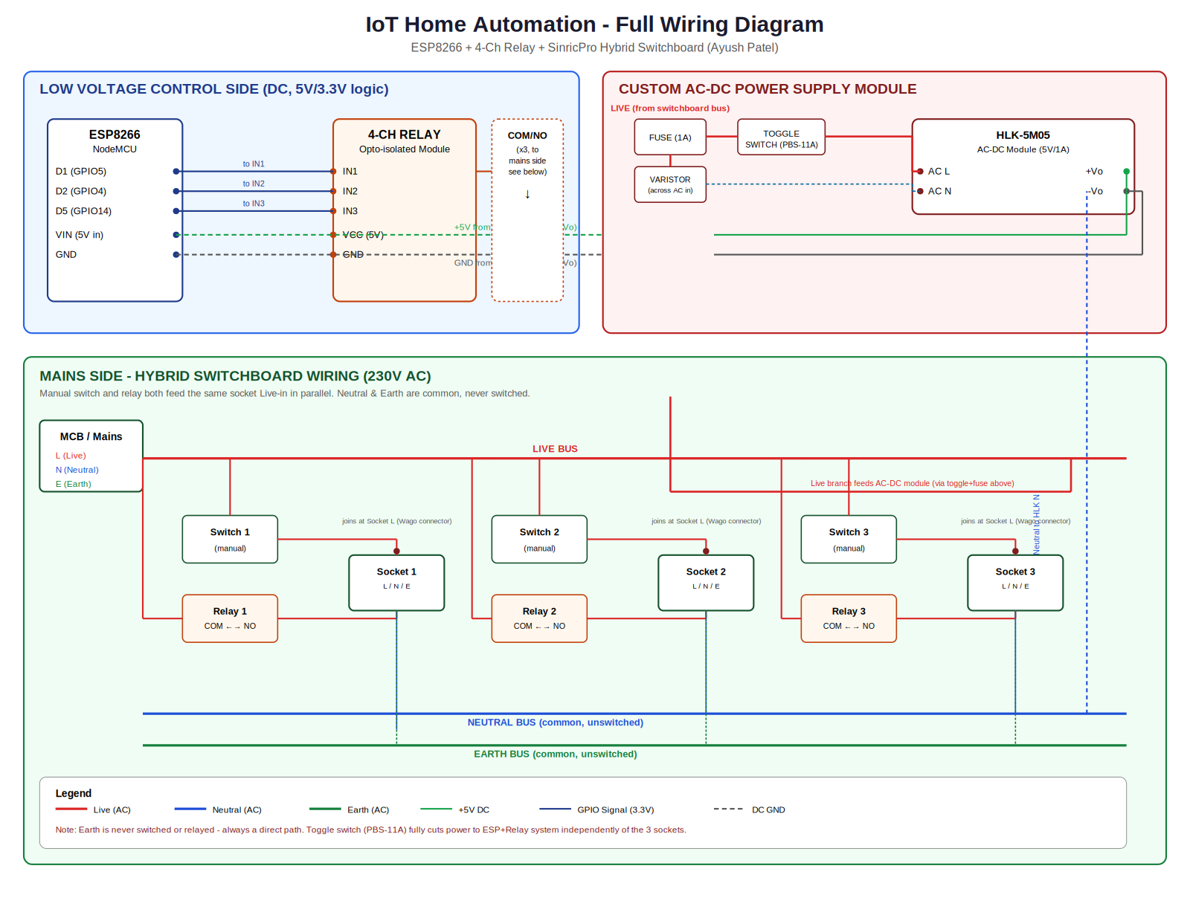

8. Final Firmware Code
The final, working firmware (ESP8266, Arduino IDE) — WiFiManager for flexible provisioning, SinricPro for cloud/Alexa control, active-LOW relay logic:
#define ENABLE_DEBUG
#ifdef ENABLE_DEBUG
#define DEBUG_ESP_PORT Serial
#define NODEBUG_WEBSOCKETS
#define NDEBUG
#endif
#include <Arduino.h>
#include <ESP8266WiFi.h>
#include <WiFiManager.h>
#include <SinricPro.h>
#include <SinricProSwitch.h>
void setupWiFi() {
WiFiManager wm;
wm.setConfigPortalTimeout(180);
bool res = wm.autoConnect("ALEXA", "12345678");
if (!res) {
Serial.println("Failed to connect. Deep sleeping...");
ESP.deepSleep(0);
} else {
Serial.println("Connected!");
Serial.printf("IP: %s\n", WiFi.localIP().toString().c_str());
}
}
#define APP_KEY "YOUR_APP_KEY"
#define APP_SECRET "YOUR_APP_SECRET"
#define SWITCH_ID_1 "YOUR_DEVICE_ID_1"
#define SWITCH_ID_2 "YOUR_DEVICE_ID_2"
#define SWITCH_ID_3 "YOUR_DEVICE_ID_3"
#define BAUD_RATE 115200
#define RELAY1 D1
#define RELAY2 D2
#define RELAY3 D5
bool onPowerState(const String &deviceId, bool &state) {
int relayPin;
if (deviceId == SWITCH_ID_1) relayPin = RELAY1;
else if (deviceId == SWITCH_ID_2) relayPin = RELAY2;
else if (deviceId == SWITCH_ID_3) relayPin = RELAY3;
else return false;
digitalWrite(relayPin, state ? LOW : HIGH); // active-LOW
Serial.printf("Device %s turned %s\n", deviceId.c_str(), state ? "ON" : "OFF");
return true;
}
void setupSinricPro() {
SinricPro[SWITCH_ID_1].onPowerState(onPowerState);
SinricPro[SWITCH_ID_2].onPowerState(onPowerState);
SinricPro[SWITCH_ID_3].onPowerState(onPowerState);
SinricPro.onConnected([](){ Serial.println("Connected to SinricPro"); });
SinricPro.onDisconnected([](){ Serial.println("Disconnected from SinricPro"); });
configTime(5.5 * 3600, 0, "pool.ntp.org", "time.google.com");
SinricPro.begin(APP_KEY, APP_SECRET);
}
void setup() {
Serial.begin(BAUD_RATE);
pinMode(RELAY1, OUTPUT);
pinMode(RELAY2, OUTPUT);
pinMode(RELAY3, OUTPUT);
digitalWrite(RELAY1, HIGH);
digitalWrite(RELAY2, HIGH);
digitalWrite(RELAY3, HIGH);
setupWiFi();
setupSinricPro();
}
void loop() {
SinricPro.handle();
}
⚠ Replace APP_KEY, APP_SECRET and the three SWITCH_ID values with your own SinricPro credentials before flashing. Never commit real credentials to a public repository — regenerate them from the SinricPro dashboard if ever exposed.

9. Lessons Learned / Debugging Log
- ArduinoJson v7 breaks SinricPro v4.1.0 — fix by pinning ArduinoJson to v6.21.5
- Mobile hotspots can silently block/throttle NTP (UDP port 123), preventing the TLS handshake SinricPro needs — switching to well-known NTP pools (Google, Cloudflare) and being patient with retries helped
- An overly strict manual NTP wait loop actually made the SinricPro connection less reliable than trusting the library's own internal retry logic — simpler code won here
- Physically power-cycling via a master toggle switch is often more reliable for a WiFi reset than software-only reconnect logic, and it's simpler to build
- Improvised safety testing (LED-based continuity tester, Arduino-based voltage check) is a genuinely usable fallback for validating a self-built power supply when a multimeter isn't available — but a real multimeter remains the recommended tool for future projects

10. Future Work — Custom PCB
The next phase of this project is designing a compact custom PCB that integrates the ESP8266 circuitry, relay driver stage, and AC-DC power supply onto a single small board — sized to fit inside a standard Indian modular switchboard cavity. The goal is an affordable, retrofit-friendly alternative to expensive proprietary WiFi switch modules, letting any existing switchboard be upgraded without replacing wiring or fittings.

