Implementing Java Control Statements and Loops

Assigment – 1 | SEM – 2

|  |
| --- |
| NAME: Ayush Vinod Upadhyay  ROLL NO: I025  SAP ID: 60003220131  BRANCH: Information Technology  BATCH: 1 |

1. Given an integer, n, perform the following conditional actions:

· If n is odd, print Weird

· If n is even and in the inclusive range of 2 to 5, print Not Weird

· If n is even and in the inclusive range of 6 to 20, print Weird

· If n is even and greater than 20, print Not Weird

CODE

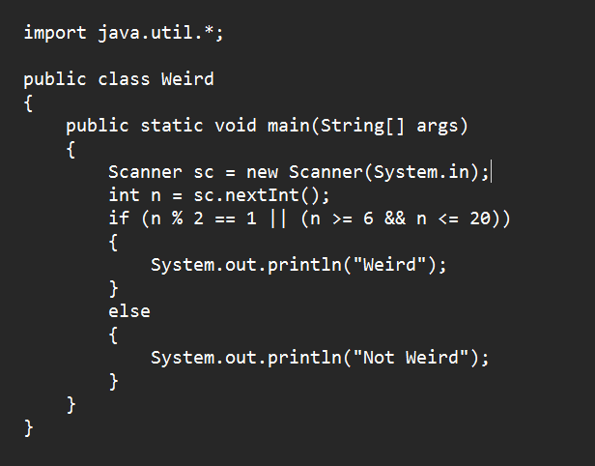

OUTPUT

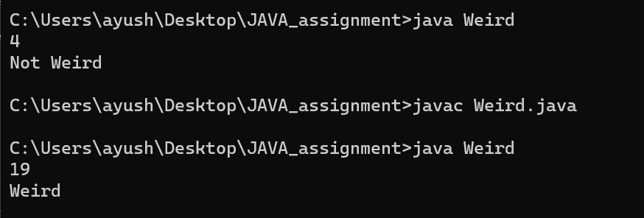

2. WAP to find largest of 3 numbers using nested if else and nested ternary operator.

CODE – Nested if-else

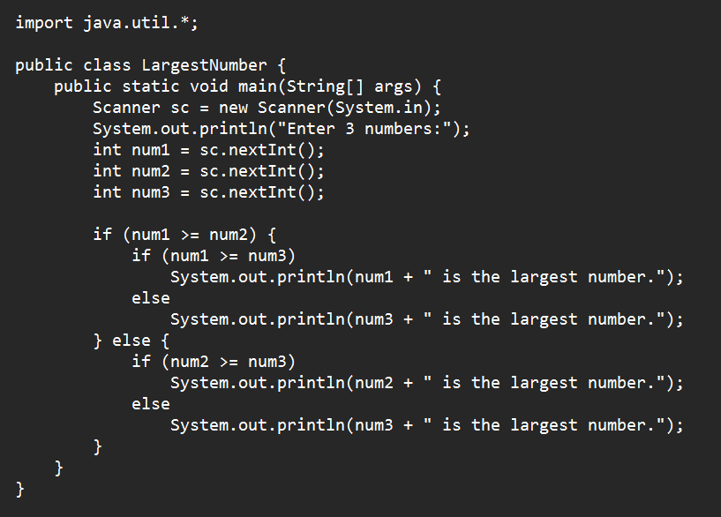

OUTPUT

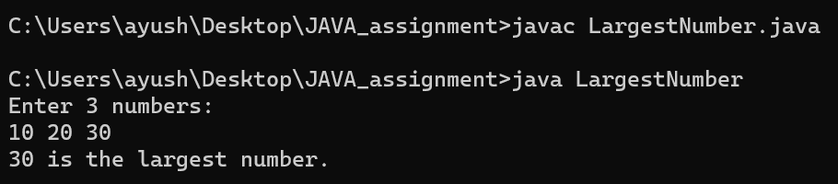

CODE – using Ternary Operator

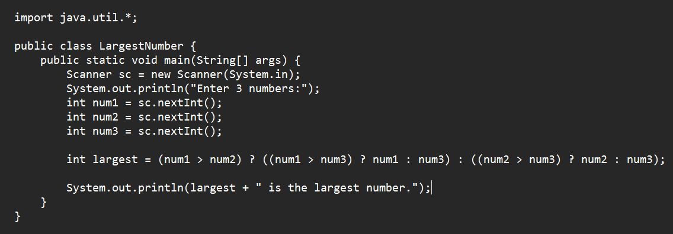

OUTPUT



3. Write a Java program that reads a positive integer from command line and count the number of digits the number (less than ten billion) has.

CODE

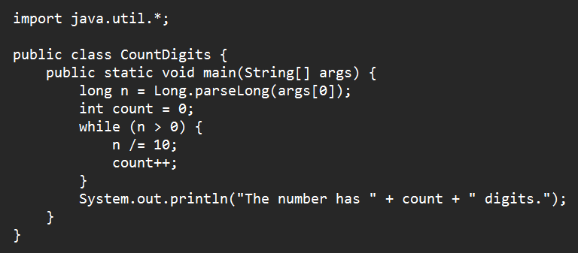

OUTPUT

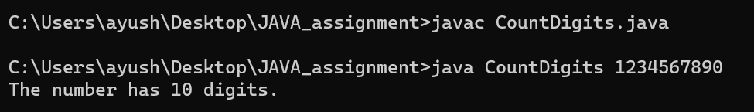

4. Write a menu driven program using switch case to perform mathematical operations.

CODE

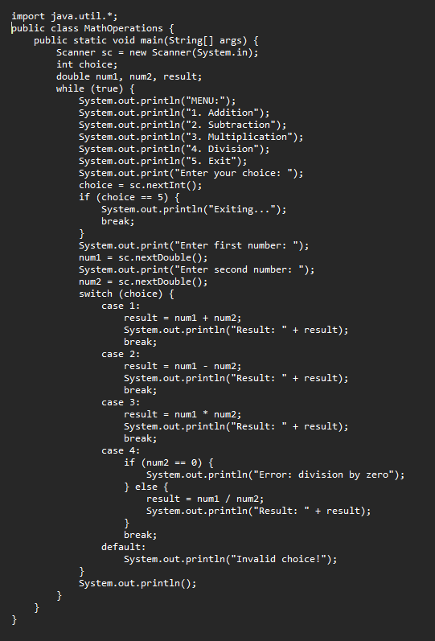

OUTPUT

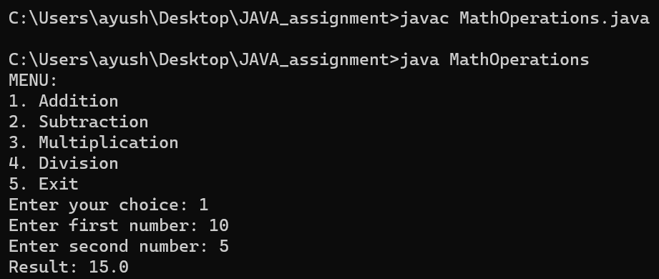

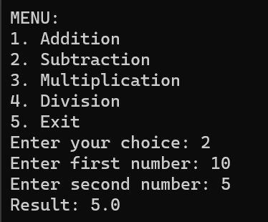 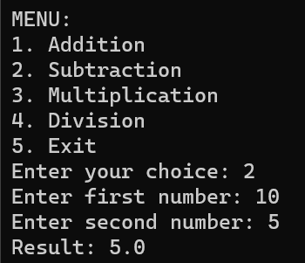

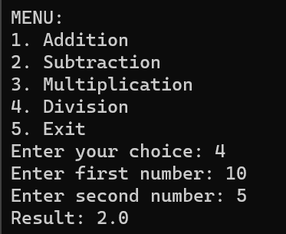 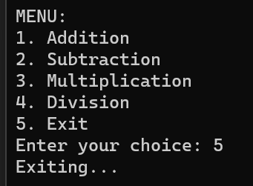

5. WAP to find grade of student from input marks using if else ladder and switch case.

CODE

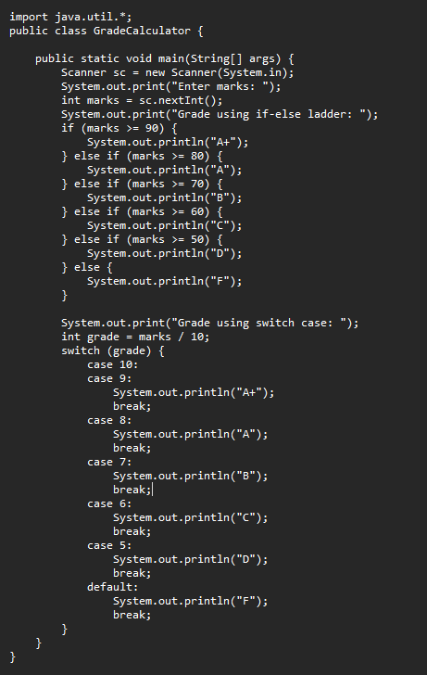

OUTPUT

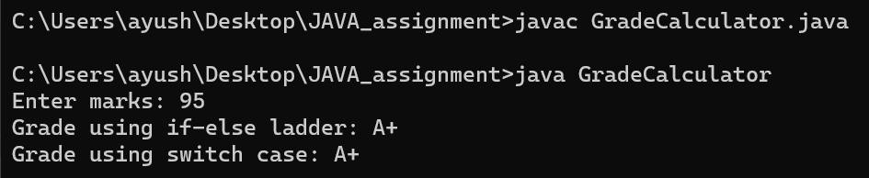

6. WAP to print the sum of following series 1+1/2^2+1/3^2+1/4^2……+1/n^2

CODE

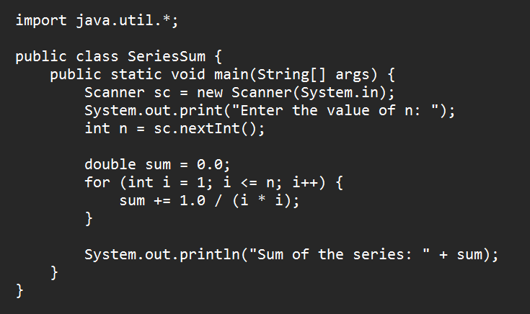

OUTPUT

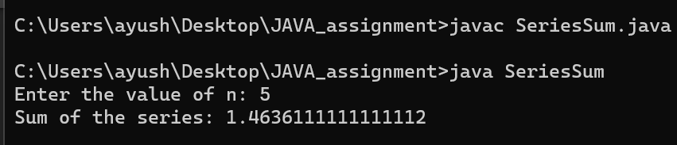

7. WAP to display the following patterns:

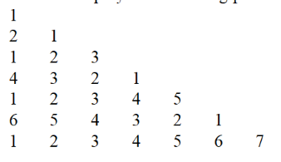

CODE

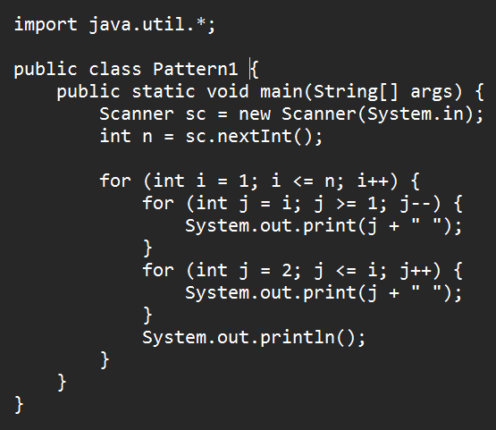

OUTPUT

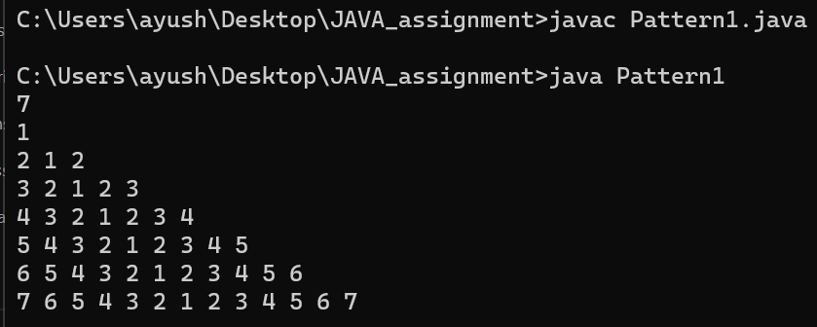

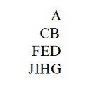

CODE

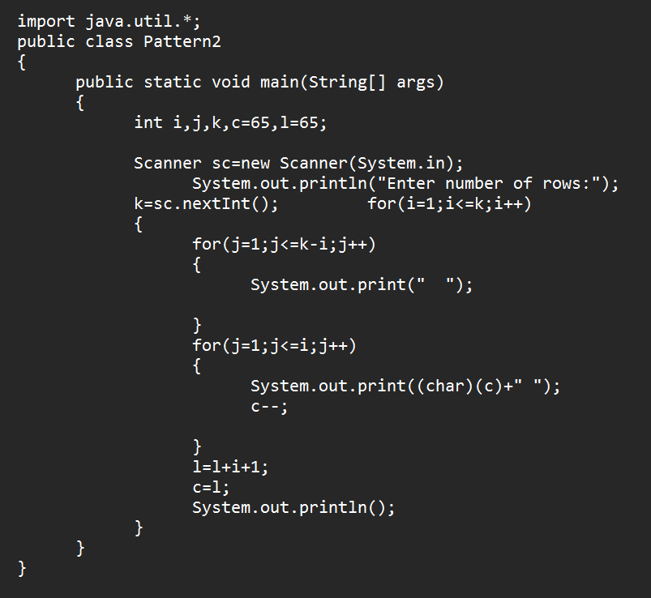

OUTPUT

