|  |
| --- |
| NAME: Ayush Vinod Upadhyay  ROLL NO: I025  SAP ID: 60003220131  BRANCH: Information Technology  BATCH: 1 |

1. You have been given an array of positive integers A1, A2,...,An with length N and you have to print an array of same length (N) where the values in the new array are the sum of every number in the array, except the number at that index.

CODE

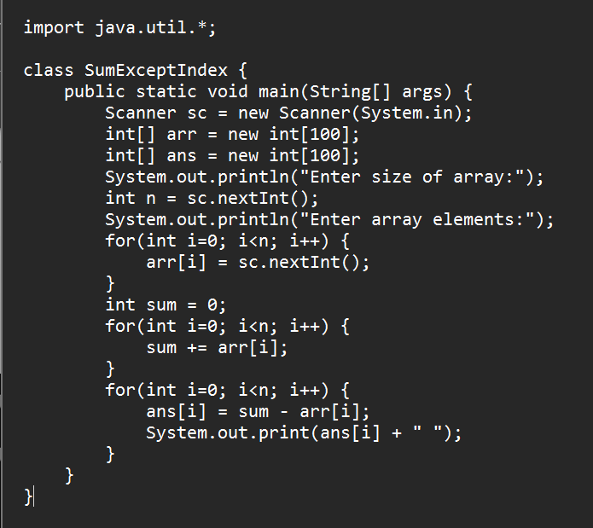

OUTPUT

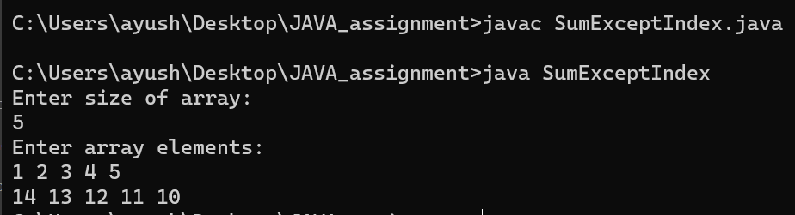

2. The annual examination results of 5 students are tabulated as follows: WAP to read the data and determine the following: Total marks obtained by each student. The student who obtained the highest total marks

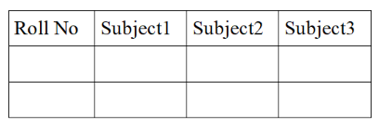

CODE

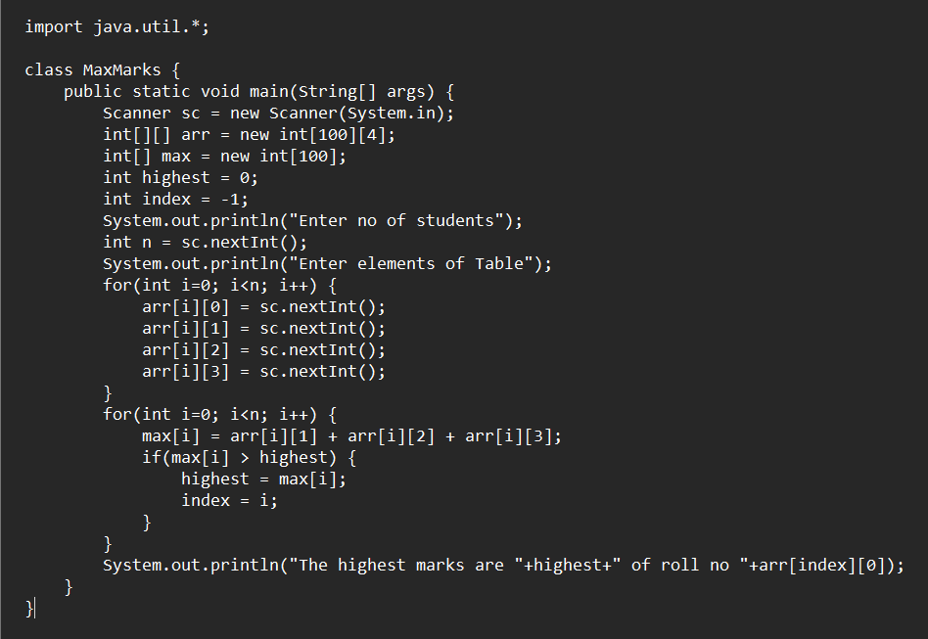

OUTPUT

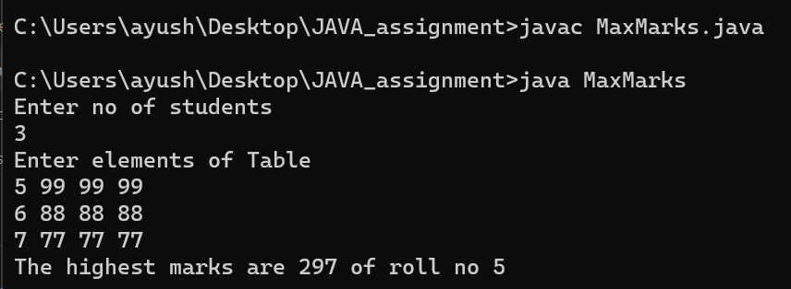

3. WAP to display following pattern using irregular arrays (jagged arrays).

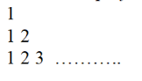

CODE

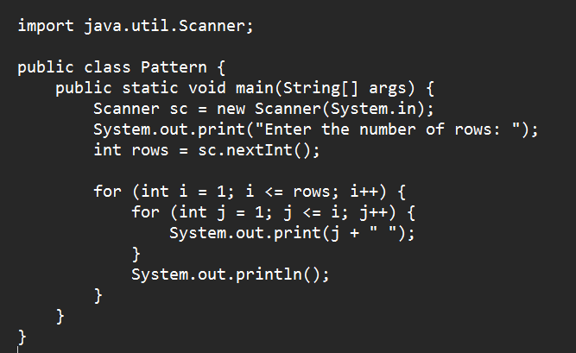

OUTPUT

