IMPLEMENTATION OF VECTORS

Assignment – 4 | SEM – 2

|  |
| --- |
| NAME: Ayush Vinod Upadhyay  ROLL NO: I025  SAP ID: 60003220131  BRANCH: Information Technology  BATCH: 1 |

1. WAP to accept students name from command line and store them in vector.

CODE  
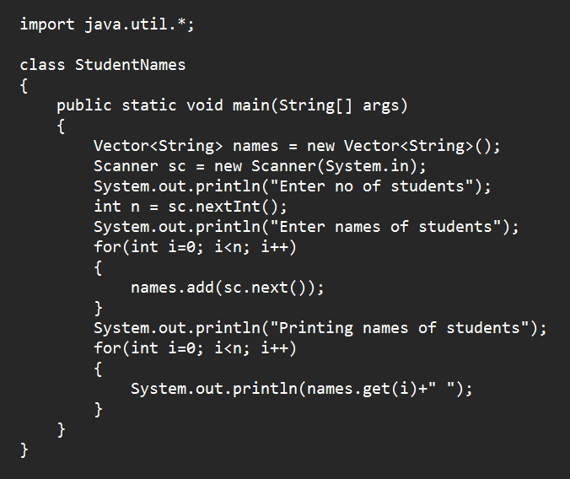

OUTPUT

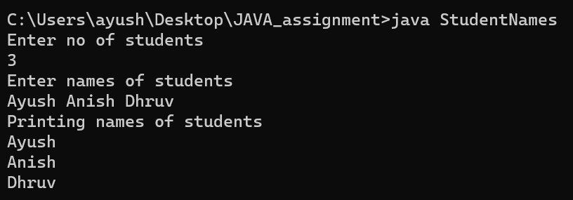

2. WAP to add n strings in a vector array. Input new string and check if it is present in the vector. If present delete it else add to the vector

CODE

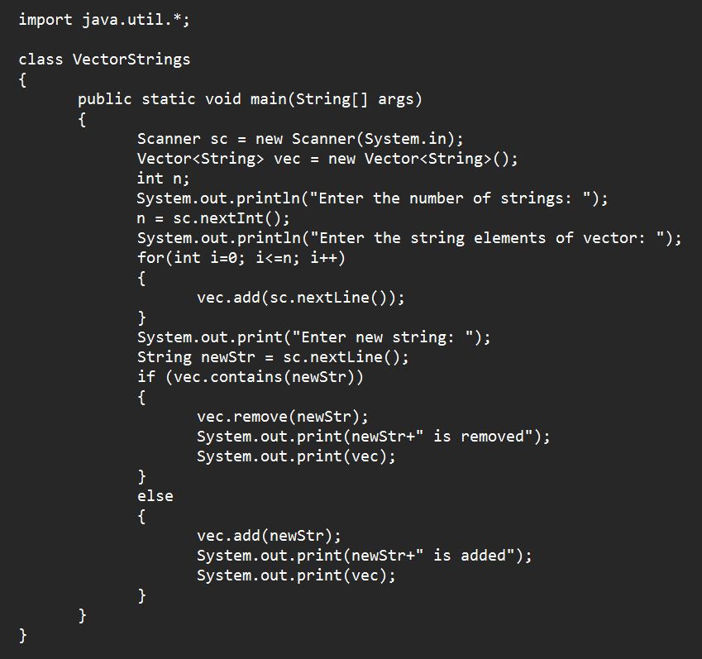

OUTPUT

