MySQL Schema creation
Part 1:
Preparing for ER Diagram:
There exists a table with following attributes:
SHOWS(show_name, type, genre, popularity, original_language, production_name, creator_name, network_name)
The above table exists as the main table. For ER diagram, the table is split into multiple entities.
- SHOWS(show_name(PR), type, genre, popularity, original_language)
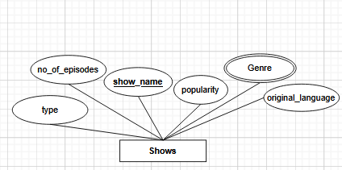
- CREATOR(creator_name(PR), gender, nationality, birth_date)
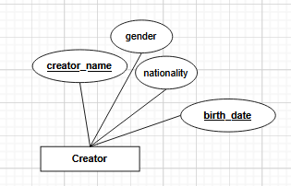
- PRODUCTION(production_name(PR), establish_date, production_headquarter, website)
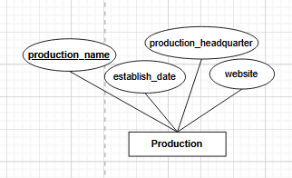
- NETWORK(network_name(PR), network_type, launch_date, network_headquarter)
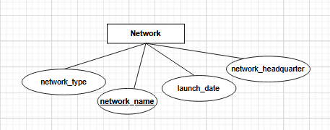
To fulfill the condition of requiring 4 attributes for each entity:
In the relation CREATOR, the attributes gender, nationality, and birth_date are added. Derived attribute age can be added if required.
In the relation PRODUCTION, the attributes establish_date, production_headquarter and website are added.
In the relation NETWORK, the attributes network_type, launch_date, and network_headquarter are added.
The added attributes’ values are extracted from the internet.
Relationships and cardinality between entities:
- Produced_By (Production, Shows):
- Cardinality: Many-to-Many
- Description: Multiple productions can be involved in the creation of a show, and a production can create multiple shows.
- Mandatory: Yes (Assuming at least one production is involved)

- Created_By (Creator, Shows):
- Cardinality: Many-to-Many
- Description: Multiple creators can work on multiple shows, and each show can have multiple creators.
- Mandatory: Yes (Assuming every show has at least one identifiable creator)

- Broadcasted_By (Network, Shows):
- Cardinality: Many-to-Many
- Description: Multiple networks can broadcast a show, and a network can broadcast multiple shows.
- Mandatory: Yes (Assuming at least one network broadcasts the show)

ER Diagram:
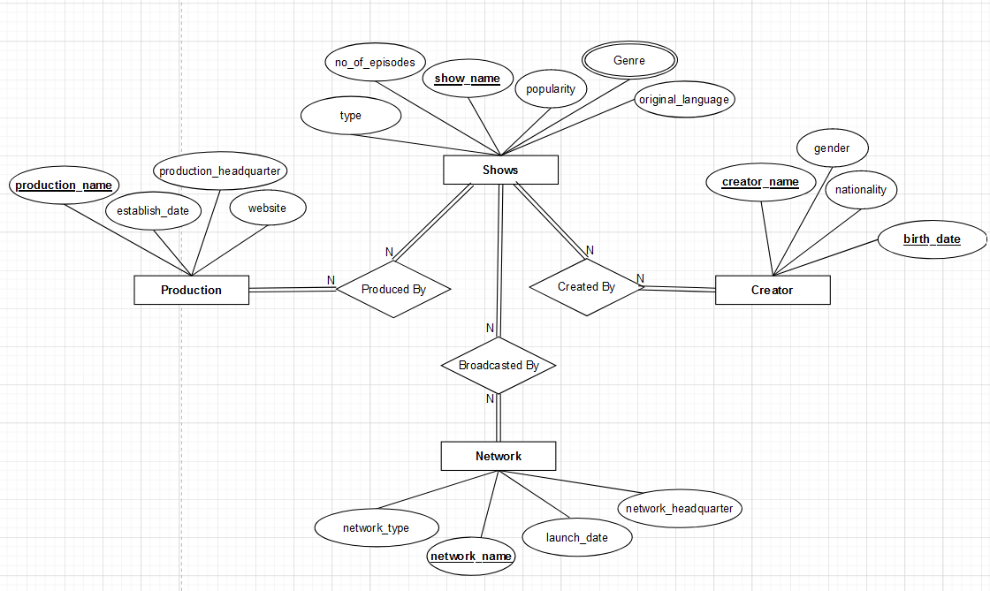
Junction Tables:
There is a need for junction tables for each relation:
Junction Table for Produced_By Relation (Many-to-Many between Production and Shows):
- Table Name: Show_Production
- Attributes:
  - show_name (Foreign Key)
  - production_name (Foreign Key)
- Both show_name and production_name together form the composite primary key.
Junction Table for Created_By Relation (Many-to-Many between Creator and Shows):
- Table Name: Show_Creator
- Attributes:
  - show_name (Foreign Key)
  - creator_name (Foreign Key)
- Both show_name and creator_name together form the composite primary key.
Junction Table for Broadcasted_By Relation (Many-to-Many between Network and Shows):
- Table Name: Show_Network
- Attributes:
  - show_name (Foreign Key)
  - network_name (Foreign Key)
- Both show_name and network_name together form the composite primary key.
Understanding the normalization for the relations:
- SHOWS(show_name(PR), type, genre, popularity, original_language)
- CREATOR(creator_name(PR), gender, nationality, birth_date)
- PRODUCTION(production_name(PR), establish_date, production_headquarter, website)
- NETWORK(network_name(PR), network_type, launch_date, network_headquarter)
- Show_Production(show_name(PR), production_name(PR))
- Show_Creator(show_name(PR), creator_name(PR))
- Show_Network(show_name(PR), network_name(PR))
1 NF:
The above relations don’t qualify for 1 NF because the values of all attributes are not atomic.
The attribute genre is a multivariate attribute. So, creating another relation genre as weak entity of show is a good idea.
- One SHOWS entity can be associated with multiple GENRE entities. Also, each SHOWS entity should have at least one genre.
- One GENRE entity can be associated with multiple SHOWS entities. Also, each GENRE should have at least one SHOWS.
So, the cardinality between SHOWS and GENRE is Many-to-Many and it is mandatory for both to have at least one association.
2 NF:
- SHOWS(show_name(PR), type, popularity, original_language)
- CREATOR(creator_name(PR), gender, nationality, birth_date)
- PRODUCTION(production_name(PR), establish_date, production_headquarter, website)
- NETWORK(network_name(PR), network_type, launch_date, network_headquarter)
- Show_Production(show_name(PR), production_name(PR))
- Show_Creator(show_name(PR), creator_name(PR))
- Show_Network(show_name(PR), network_name(PR))
- Genre(show_name(FK;PK), genre(PK))
Here, there are no partial dependencies amongst the relations.
3 NF:
- SHOWS(show_name(PR), type, popularity, original_language)
- CREATOR(creator_name(PR), gender, nationality, birth_date)
- PRODUCTION(production_name(PR), establish_date, production_headquarter, website)
- NETWORK(network_name(PR), network_type, launch_date, network_headquarter)
- Show_Production(show_name(PR), production_name(PR))
- Show_Creator(show_name(PR), creator_name(PR))
- Show_Network(show_name(PR), network_name(PR))
- Genre(show_name(FK;PK), genre(PK))
There are no transitive dependencies amongst the relations.

Updated ER diagram:
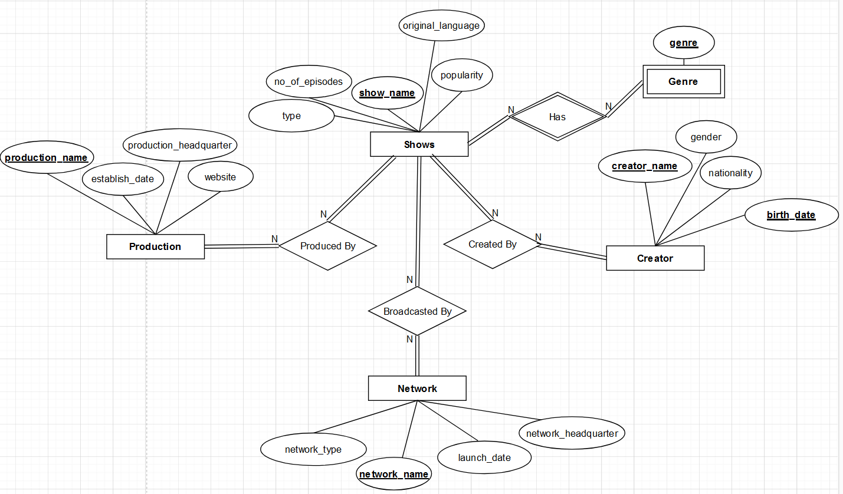

Part 2:
Define:
- Creators Table: It stores information about TV show creators, like their name, gender, nationality, and birthdate.
- Network Table: This table holds data about TV networks, including their name, type, launch date, and headquarters.
- Production Table: It contains details about production companies, such as their name, establishment date, headquarters, and website.
- Shows Table: This table stores info about TV shows, like their name, number of episodes, original language, popularity, and type.
- Show_Creator Relationship: A table that connects TV shows with their creators, establishing who created which show.
- Show_Genre Relationship: It connects TV shows with their genres, indicating the genre(s) of each show.
- Show_Network Relationship: This table links TV shows with the networks they are aired on, specifying which show is broadcasted on which network.
- Show_Production Relationship: It connects TV shows with the production companies responsible for producing them.
The script ensures data consistency and integrity by using foreign key constraints and indexes. It's designed to optimize query performance and maintain relational integrity.

Required schema and table creation:
CREATE DATABASE IF NOT EXISTS `tv_shows`;
USE `tv_shows`;
DROP TABLE IF EXISTS `creator`;
CREATE TABLE `creator` (
`creator_name` varchar(255) NOT NULL,
`gender` enum('Male','Female','Other') NOT NULL,
`nationality` varchar(255) DEFAULT NULL,
`birthdate` date DEFAULT NULL,
PRIMARY KEY (`creator_name`)
) ENGINE=InnoDB DEFAULT CHARSET=utf8mb4 COLLATE=utf8mb4_0900_ai_ci;
DROP TABLE IF EXISTS `network`;
CREATE TABLE `network` (
`network_name` varchar(255) NOT NULL,
`network_type` varchar(255) NOT NULL,
`launch_date` date DEFAULT NULL,
`network_headquarter` varchar(255) DEFAULT NULL,
PRIMARY KEY (`network_name`)
) ENGINE=InnoDB DEFAULT CHARSET=utf8mb4 COLLATE=utf8mb4_0900_ai_ci;
DROP TABLE IF EXISTS `production`;
CREATE TABLE `production` (
`production_companies` varchar(255) NOT NULL,
`establish_date` date DEFAULT NULL,
`production_headquarter` varchar(255) DEFAULT NULL,
`website` varchar(255) DEFAULT NULL,
PRIMARY KEY (`production_companies`)
) ENGINE=InnoDB DEFAULT CHARSET=utf8mb4 COLLATE=utf8mb4_0900_ai_ci COMMENT='table production with attributes production_companies, establish_date, production_headquarter, and website.';
DROP TABLE IF EXISTS `shows`;
CREATE TABLE `shows` (
`name` varchar(255) NOT NULL,
`number_of_episodes` int NOT NULL,
`original_language` varchar(45) NOT NULL,
`popularity` float(10,3) DEFAULT NULL,
`type` varchar(45) NOT NULL,
PRIMARY KEY (`name`)
) ENGINE=InnoDB DEFAULT CHARSET=utf8mb4 COLLATE=utf8mb4_0900_ai_ci COMMENT='shows table with attributes number of episodes, original language, popularity and type ';
DROP TABLE IF EXISTS `show_creator`;
CREATE TABLE `show_creator` (
`show_name` varchar(255) NOT NULL,
`creator_name` varchar(255) NOT NULL,
PRIMARY KEY (`show_name`,`creator_name`),
KEY `creator_nameFK_idx` (`creator_name`),
CONSTRAINT `creator_nameFK` FOREIGN KEY (`creator_name`) REFERENCES `creator` (`creator_name`) ON DELETE CASCADE ON UPDATE CASCADE,
CONSTRAINT `show_creatorFK` FOREIGN KEY (`show_name`) REFERENCES `shows` (`name`) ON DELETE CASCADE ON UPDATE CASCADE
) ENGINE=InnoDB DEFAULT CHARSET=utf8mb4 COLLATE=utf8mb4_0900_ai_ci COMMENT='show and creator entity junction table.';
DROP TABLE IF EXISTS `show_genre`;
CREATE TABLE `show_genre` (
`show_name` varchar(255) NOT NULL,
`genre` varchar(255) NOT NULL,
PRIMARY KEY (`show_name`,`genre`),
CONSTRAINT `show2genreFK` FOREIGN KEY (`show_name`) REFERENCES `shows` (`name`) ON DELETE CASCADE ON UPDATE CASCADE
) ENGINE=InnoDB DEFAULT CHARSET=utf8mb4 COLLATE=utf8mb4_0900_ai_ci;
DROP TABLE IF EXISTS `show_network`;
CREATE TABLE `show_network` (
`show_name` varchar(255) NOT NULL,
`network_name` varchar(255) NOT NULL,
PRIMARY KEY (`show_name`,`network_name`),
KEY `network_nameFK_idx` (`network_name`),
CONSTRAINT `network_nameFK` FOREIGN KEY (`network_name`) REFERENCES `network` (`network_name`) ON DELETE CASCADE ON UPDATE CASCADE,
CONSTRAINT `show_networkFK` FOREIGN KEY (`show_name`) REFERENCES `shows` (`name`) ON DELETE CASCADE ON UPDATE CASCADE
) ENGINE=InnoDB DEFAULT CHARSET=utf8mb4 COLLATE=utf8mb4_0900_ai_ci COMMENT='show_network junction table';
DROP TABLE IF EXISTS `show_production`;
CREATE TABLE `show_production` (
`show_name` varchar(255) NOT NULL,
`production_name` varchar(255) NOT NULL,
PRIMARY KEY (`show_name`,`production_name`),
KEY `productionFK_idx` (`production_name`),
CONSTRAINT `productionFK` FOREIGN KEY (`production_name`) REFERENCES `production` (`production_companies`) ON DELETE CASCADE ON UPDATE CASCADE,
CONSTRAINT `show_nameFK` FOREIGN KEY (`show_name`) REFERENCES `shows` (`name`) ON DELETE CASCADE ON UPDATE CASCADE
) ENGINE=InnoDB DEFAULT CHARSET=utf8mb4 COLLATE=utf8mb4_0900_ai_ci COMMENT='A junction table for show and production';

Entity insertion:
INSERT INTO tv_shows.shows (name, number_of_episodes, original_language, popularity, type) VALUES
('The Late Show with Stephen Colbert', 1419, 'en', 3707.008, 'Talk Show'),
('The Tonight Show Starring Jimmy Fallon', 1233, 'en', 2419.997, 'Talk Show'),
('Land of Desire', 150, 'pt', 1937.067, 'Scripted'),
('Grey\'s Anatomy', 419, 'en', 1647.218, 'Scripted'),
('Game of Thrones', 73, 'en', 1083.917, 'Scripted'),
('Family Guy', 411, 'en', 1073.325, 'Scripted'),
('Sex Education', 32, 'en', 1008.977, 'Scripted'),
('Last Week Tonight with John Oliver', 281, 'en', 974.817, 'News'),
('Ahsoka', 8, 'en', 954.747, 'Miniseries'),
('Law & Order: Special Victims Unit', 538, 'en', 953.554, 'Scripted'),
('We Bare Bears', 138, 'en', 918.303, 'Scripted'),
('The Walking Dead: Daryl Dixon', 6, 'en', 896.871, 'Scripted'),
('The Continental: From the World of John Wick', 3, 'en', 894.69, 'Miniseries'),
('Bob\'s Burgers', 269, 'en', 894.596, 'Scripted'),
('Hawaii Five-0', 240, 'en', 853.839, 'Scripted'),
('CSI: Crime Scene Investigation', 335, 'en', 851.572, 'Scripted'),
('Star Trek: The Next Generation', 176, 'en', 803.474, 'Scripted'),
('Star Trek: Voyager', 171, 'en', 801.532, 'Scripted'),
('This Is Us', 105, 'en', 783.85, 'Scripted'),
('Saturday Night Live', 951, 'en', 758.387, 'Scripted'),
('Chicago P.D.', 208, 'en', 755.394, 'Scripted'),
('NCIS', 457, 'en', 754.614, 'Scripted'),
('Suits', 134, 'en', 745.23, 'Scripted'),
('Dexter\'s Laboratory', 221, 'en', 729.288, 'Scripted');
INSERT INTO tv_shows.production (production_companies, establish_date, production_headquarter, website) VALUES
('Spartina Productions', '2009-06-15', 'Los Angeles, CA, USA', 'https://www.spartinaproductions.com'),
('Broadway Video', '1979-10-11', 'New York City, NY, USA', 'https://www.broadwayvideo.com'),
('Estúdios Globo', '1965-04-26', 'Rio de Janeiro, Brazil', 'https://www.redeglobo.globo.com/estudios'),
('The Mark Gordon Company', '2000-05-23', 'Los Angeles, CA, USA', 'https://www.markgordoncompany.com'),
('Revolution Sun Studios', '2012-08-17', 'Atlanta, GA, USA', 'https://www.revolutionsunstudios.com'),
('20th Century Fox Television', '1949-06-20', 'Los Angeles, CA, USA', 'https://www.disney.com/'),
('Eleven', '2006-11-07', 'Sydney, Australia', 'https://www.eleven.com.au'),
('Sixteen String Jack Productions', '2015-03-10', 'London, UK', NULL),
('Lucasfilm Ltd.', '1971-12-17', 'San Francisco, CA, USA', 'https://www.lucasfilm.com'),
('Wolf Entertainment', '1996-10-05', 'Los Angeles, CA, USA', 'https://www.wolfentertainment.com'),
('Cartoon Network Studios', '1994-10-01', 'Atlanta, GA, USA', 'https://www.cartoonnetworkstudios.com'),
('AMC Studios', '2010-03-01', 'New York City, NY, USA', 'https://www.amc.com'),
('Thunder Road', '2003-09-12', 'Santa Monica, CA, USA', 'https://www.thunderroadfilms.com'),
('K/O Paper Products', '2009-07-24', 'Los Angeles, CA, USA', NULL),
('Alliance Atlantis', '1998-01-05', 'Toronto, Canada', NULL),
('Paramount Television Studios', '1967-02-15', 'Los Angeles, CA, USA', 'https://www.paramountstudios.com'),
('Universal Television', '1951-02-09', 'Universal City, CA, USA', 'https://www.universaltv.com'),
('thinkfilm', '2001-06-12', 'New York City, NY, USA', NULL),
('Dutch Oven', '2018-09-03', 'Amsterdam, Netherlands', 'https://www.dutchovenproductions.nl'),
('Hanna-Barbera Productions', '1957-07-07', 'Los Angeles, CA, USA', NULL),
('CBS Studios', '1939-01-05', 'Studio City, CA, USA', 'https://www.cbsstudios.com'),
('ShondaLand', '2005-05-17', 'Los Angeles, CA, USA', 'https://www.shondaland.com'),
('Television 360', '2003-11-19', 'Beverly Hills, CA, USA', 'https://www.television360.com'),
('Fuzzy Door Productions', '1998-09-09', 'Burbank, CA, USA', 'https://www.fuzzydoorproductions.com'),
('Avalon Television', '1989-03-01', 'London, UK', 'https://www.avalonuk.com'),
('Idiotbox', '2011-04-30', 'Sydney, Australia', NULL),
('Lionsgate Television', '1997-07-10', 'Santa Monica, CA, USA', 'https://www.lionsgate.com'),
('Bento Box Entertainment', '2001-08-27', 'Burbank, CA, USA', 'https://www.bentoboxent.com'),
('101st Street Entertainment', '2007-12-18', 'New York City, NY, USA', NULL),
('CBS Productions', '1949-01-01', 'Los Angeles, CA, USA', 'https://https://www.cbs.com/'),
('Rhode Island Ave. Productions', '2002-06-30', 'Washington, D.C., USA', NULL),
('NBC Studios', '1927-09-16', 'New York City, NY, USA', 'https://www.nbcstudios.com'),
('Hypnotic', '1996-07-01', 'Los Angeles, CA, USA', NULL),
('Electric Hot Dog Productions', '2014-11-28', 'Chicago, IL, USA', 'https://www.electrichotdogproductions.com'),
('ABC Studios', '2001-05-01', 'Burbank, CA, USA', 'https://www.abcstudios.go.com'),
('Generator Entertainment', '1996-03-12', 'Vancouver, Canada', NULL),
('20th Television Animation', '1989-12-17', 'Los Angeles, CA, USA', NULL),
('Partially Important Productions', '2019-08-05', 'Los Angeles, CA, USA', NULL),
('Studios USA', '2002-10-01', 'New York City, NY, USA', NULL),
('Skybound Entertainment', '2010-03-08', 'Los Angeles, CA, USA', 'https://www.skybound.com'),
('Wilo Productions', '2016-04-22', 'Toronto, Canada', 'https://www.wiloproductions.ca'),
('Zaftig Films', '2007-06-14', 'London, UK', NULL),
('Belisarius Productions', '1984-01-01', 'Los Angeles, CA, USA', NULL),
('UCP', '2004-10-04', 'Universal City, CA, USA', 'https://www.ucp.com'),
('Touchstone Television', '1985-06-10', 'Burbank, CA, USA', NULL),
('Bighead Littlehead', '2003-09-12', 'New York City, NY, USA', NULL),
('20th Television', '1989-10-01', 'Los Angeles, CA, USA', NULL),
('Universal Media Studios', '2007-05-28', 'Universal City, CA, USA', NULL),
('Valhalla Entertainment', '2002-07-12', 'Los Angeles, CA, USA', 'https://www.valhallaentertainment.com'),
('Buck & Millie Productions', '2013-11-19', 'London, UK', NULL),
('Circle of Confusion', '2006-08-04', 'Los Angeles, CA, USA', 'https://www.circleofconfusion.com');
INSERT INTO tv_shows.creator (creator_name, gender, nationality, birthdate) VALUES
('Jon Stewart', 'Male', 'American', '1962-11-28'),
('Jimmy Fallon', 'Male', 'American', '1974-09-19'),
('Walcyr Carrasco', 'Male', 'Brazilian', NULL),
('Shonda Rhimes', 'Female', 'American', '1970-01-13'),
('David Benioff', 'Male', 'American', '1970-09-25'),
('Seth MacFarlane', 'Male', 'American', '1973-10-26'),
('Laurie Nunn', 'Female', 'British', '1980-06-01'),
('John Oliver', 'Male', 'British', '1977-04-23'),
('Dave Filoni', 'Male', 'American', '1974-06-07'),
('Dick Wolf', 'Male', 'American', '1946-12-20'),
('Daniel Chong', 'Male', 'American', '1978-11-06'),
('David Zabel', 'Male', 'American', '1968-06-12'),
('Greg Coolidge', 'Male', 'American', '1972-12-28'),
('Jim Dauterive', 'Male', 'American', '1954-06-17'),
('Alex Kurtzman', 'Male', 'American', '1973-09-07'),
('Anthony Zuiker', 'Male', 'American', '1968-01-17'),
('Gene Roddenberry', 'Male', 'American', '1921-08-19'),
('Dan Fogelman', 'Male', 'American', '1976-02-19'),
('Lorne Michaels', 'Male', 'Canadian', '1944-11-17'),
('Donald P. Bellisario', 'Male', 'American', '1935-08-08'),
('Aaron Korsh', 'Male', 'American', '1966-11-16'),
('Genndy Tartakovsky', 'Male', 'Russian-American', '1970-01-17'),
('Stephen Colbert', 'Male', 'American', '1964-05-13'),
('Tom Purcell', 'Male', 'American', '1964-07-27'),
('Chris Licht', 'Male', 'American', '1971-03-02'),
('D.B. Weiss', 'Male', 'American', '1971-04-23'),
('Kirk Ward', 'Male', 'American', '1963-03-01'),
('Shawn Simmons', 'Male', 'American', '1974-11-19'),
('Loren Bouchard', 'Male', 'American', '1969-10-12'),
('Ann Donahue', 'Female', 'American', '1955-05-05'),
('Roberto Orci', 'Male', 'American', '1973-07-20'),
('Peter M. Lenkov', 'Male', 'American', '1964-05-09'),
('Michael Piller', 'Male', 'American', '1948-05-30'),
('Rick Berman', 'Male', 'American', '1945-12-25'),
('Jeri Taylor', 'Female', 'American', '1938-06-30'),
('Dick Ebersol', 'Male', 'American', '1947-07-28'),
('Matt Olmstead', 'Male', 'American', '1964-01-25'),
('Don McGill', 'Male', 'American', '1969-12-28');
INSERT INTO tv_shows.network (network_name, network_type, launch_date, network_headquarter)
VALUES
('CBS', 'Broadcast', '1927-09-18', 'New York City, NY, USA'),
('NBC', 'Broadcast', '1926-11-15', 'New York City, NY, USA'),
('TV Globo', 'Broadcast', '1965-04-26', 'Rio de Janeiro, Brazil'),
('ABC', 'Broadcast', '1943-10-12', 'Burbank, CA, USA'),
('HBO', 'Cable', '1972-11-08', 'New York City, NY, USA'),
('FOX', 'Broadcast', '1986-10-09', 'Los Angeles, CA, USA'),
('Netflix', 'Streaming', '1997-08-29', 'Los Gatos, CA, USA'),
('Disney+', 'Streaming', '2019-11-12', 'Burbank, CA, USA'),
('Cartoon Network', 'Cable', '1992-10-01', 'Atlanta, GA, USA'),
('AMC', 'Cable', '1980-10-01', 'New York City, NY, USA'),
('Peacock', 'Streaming', '2020-07-15', 'New York City, NY, USA'),
('UPN', 'Broadcast', '1995-01-16', 'Los Angeles, CA, USA'),
('USA Network', 'Cable', '1977-09-22', 'New York City, NY, USA'),
('Amazon Prime', 'Streaming', '2005-09-07', 'Seattle, WA, USA'),
('Syndication', 'Broadcast', NULL, NULL);
# Test case
INSERT INTO tv_shows.shows (name, number_of_episodes, original_language, popularity, type) VALUES
('Test life of test',203, 'en', 450.664, 'Talk Show');
INSERT INTO tv_shows.production (production_companies, establish_date, production_headquarter, website) VALUES
('Test Productions', '2024-02-15', 'Los Angeles, CA, USA', 'https://www.test.com');
INSERT INTO tv_shows.network (network_name, network_type, launch_date, network_headquarter)
VALUES
('ABCDE', 'Broadcast', '1999-09-18', 'New York City, NY, USA');
INSERT INTO tv_shows.show_genre (show_name, genre) VALUES
('Test life of test', 'Comedy');
INSERT INTO tv_shows.show_production(show_name, production_name) VALUES
('Test life of test', 'Test Productions');
INSERT INTO tv_shows.show_network (show_name, network_name) VALUES
('Test life of test', 'ABCDE');

Junction insertion:
INSERT INTO tv_shows.show_genre (show_name, genre) VALUES
('The Late Show with Stephen Colbert', 'Comedy'),
('The Tonight Show Starring Jimmy Fallon', 'Comedy'),
('Land of Desire', 'Drama'),
("Grey's Anatomy", 'Drama'),
('Game of Thrones', 'Sci-Fi & Fantasy'),
('Family Guy', 'Animation'),
('Sex Education', 'Comedy'),
('Last Week Tonight with John Oliver', 'Talk'),
('Ahsoka', 'Sci-Fi & Fantasy'),
('Law & Order: Special Victims Unit', 'Crime'),
('We Bare Bears', 'Family'),
('The Walking Dead: Daryl Dixon', 'Sci-Fi & Fantasy'),
('The Continental: From the World of John Wick', 'Crime'),
("Bob's Burgers", 'Comedy'),
('Hawaii Five-0', 'Crime'),
('CSI: Crime Scene Investigation', 'Crime'),
('Star Trek: The Next Generation', 'Sci-Fi & Fantasy'),
('Star Trek: Voyager', 'Sci-Fi & Fantasy'),
('This Is Us', 'Comedy'),
('Saturday Night Live', 'Comedy'),
('Chicago P.D.', 'Crime'),
('NCIS', 'Crime'),
('Suits', 'Drama'),
("Dexter's Laboratory", 'Animation'),
('The Late Show with Stephen Colbert', 'Talk'),
('The Tonight Show Starring Jimmy Fallon', 'Talk'),
('Land of Desire', 'Crime'),
('Game of Thrones', 'Drama'),
('Family Guy', 'Comedy'),
('Sex Education', 'Drama'),
('Last Week Tonight with John Oliver', 'Comedy'),
('Ahsoka', 'Action & Adventure'),
('Law & Order: Special Victims Unit', 'Drama'),
('We Bare Bears', 'Comedy'),
('The Walking Dead: Daryl Dixon', 'Action & Adventure'),
('The Continental: From the World of John Wick', 'Action & Adventure'),
("Bob's Burgers", 'Animation'),
('Hawaii Five-0', 'Drama'),
('CSI: Crime Scene Investigation', 'Drama'),
('Star Trek: The Next Generation', 'Action & Adventure'),
('Star Trek: Voyager', 'Drama'),
('This Is Us', 'Drama'),
('Saturday Night Live', 'News'),
('Chicago P.D.', 'Drama'),
('NCIS', 'Drama'),
("Dexter's Laboratory", 'Comedy'),
('Land of Desire', 'Soap'),
('Game of Thrones', 'Action & Adventure'),
('Last Week Tonight with John Oliver', 'News'),
('Law & Order: Special Victims Unit', 'Mystery'),
('We Bare Bears', 'Animation'),
('Hawaii Five-0', 'Action & Adventure'),
('CSI: Crime Scene Investigation', 'Mystery'),
('Star Trek: The Next Generation', 'Drama'),
('Star Trek: Voyager', 'Action & Adventure'),
('NCIS', 'Action & Adventure'),
("Dexter's Laboratory", 'Sci-Fi & Fantasy'),
('We Bare Bears', 'Kids'),
('Star Trek: The Next Generation', 'Mystery');
INSERT INTO tv_shows.show_creator (show_name, creator_name) VALUES
('The Late Show with Stephen Colbert', 'Jon Stewart'),
('The Tonight Show Starring Jimmy Fallon', 'Jimmy Fallon'),
('Land of Desire', 'Walcyr Carrasco'),
('Grey''s Anatomy', 'Shonda Rhimes'),
('Game of Thrones', 'David Benioff'),
('Family Guy', 'Seth MacFarlane'),
('Sex Education', 'Laurie Nunn'),
('Last Week Tonight with John Oliver', 'John Oliver'),
('Ahsoka', 'Dave Filoni'),
('Law & Order: Special Victims Unit', 'Dick Wolf'),
('We Bare Bears', 'Daniel Chong'),
('The Walking Dead: Daryl Dixon', 'David Zabel'),
('The Continental: From the World of John Wick', 'Greg Coolidge'),
('Bob''s Burgers', 'Jim Dauterive'),
('Hawaii Five-0', 'Alex Kurtzman'),
('CSI: Crime Scene Investigation', 'Anthony Zuiker'),
('Star Trek: The Next Generation', 'Gene Roddenberry'),
('Star Trek: Voyager', 'Gene Roddenberry'),
('This Is Us', 'Dan Fogelman'),
('Saturday Night Live', 'Lorne Michaels'),
('Chicago P.D.', 'Dick Wolf'),
('NCIS', 'Donald P. Bellisario'),
('Suits', 'Aaron Korsh'),
('Dexter''s Laboratory', 'Genndy Tartakovsky'),
('The Late Show with Stephen Colbert', 'Stephen Colbert'),
('The Late Show with Stephen Colbert', 'Tom Purcell'),
('The Late Show with Stephen Colbert', 'Chris Licht'),
('Game of Thrones', 'D.B. Weiss'),
('The Continental: From the World of John Wick', 'Kirk Ward'),
('The Continental: From the World of John Wick', 'Shawn Simmons'),
('Bob''s Burgers', 'Loren Bouchard'),
('CSI: Crime Scene Investigation', 'Ann Donahue'),
('Hawaii Five-0', 'Roberto Orci'),
('Hawaii Five-0', 'Peter M. Lenkov'),
('Star Trek: Voyager', 'Michael Piller'),
('Star Trek: Voyager', 'Rick Berman'),
('Star Trek: Voyager', 'Jeri Taylor'),
('Saturday Night Live', 'Dick Ebersol'),
('Chicago P.D.', 'Matt Olmstead'),
('NCIS', 'Don McGill');
INSERT INTO tv_shows.show_production(show_name, production) VALUES
('The Late Show with Stephen Colbert', 'Spartina Productions'),
('The Tonight Show Starring Jimmy Fallon', 'Broadway Video'),
('Land of Desire', 'Estúdios Globo'),
('Grey''s Anatomy', 'The Mark Gordon Company'),
('Game of Thrones', 'Revolution Sun Studios'),
('Family Guy', '20th Century Fox Television'),
('Sex Education', 'Eleven'),
('Last Week Tonight with John Oliver', 'Sixteen String Jack Productions'),
('Ahsoka', 'Lucasfilm Ltd.'),
('Law & Order: Special Victims Unit', 'Wolf Entertainment'),
('We Bare Bears', 'Cartoon Network Studios'),
('The Walking Dead: Daryl Dixon', 'AMC Studios'),
('The Continental: From the World of John Wick', 'Thunder Road'),
('Bob''s Burgers', '20th Century Fox Television'),
('Hawaii Five-0', 'K/O Paper Products'),
('CSI: Crime Scene Investigation', 'Alliance Atlantis'),
('Star Trek: The Next Generation', 'Paramount Television Studios'),
('Star Trek: Voyager', 'Paramount Television Studios'),
('This Is Us', '20th Century Fox Television'),
('Saturday Night Live', 'Broadway Video'),
('Chicago P.D.', 'Universal Television'),
('NCIS', 'thinkfilm'),
('Suits', 'Dutch Oven'),
('Dexter''s Laboratory', 'Hanna-Barbera Productions'),
('The Late Show with Stephen Colbert', 'CBS Studios'),
('The Tonight Show Starring Jimmy Fallon', 'Universal Television'),
('Grey''s Anatomy', 'ShondaLand'),
('Game of Thrones', 'Television 360'),
('Family Guy', 'Fuzzy Door Productions'),
('Last Week Tonight with John Oliver', 'Avalon Television'),
('Law & Order: Special Victims Unit', 'Universal Television'),
('The Walking Dead: Daryl Dixon', 'Idiotbox'),
('The Continental: From the World of John Wick', 'Lionsgate Television'),
('Bob''s Burgers', 'Bento Box Entertainment'),
('Hawaii Five-0', '101st Street Entertainment'),
('CSI: Crime Scene Investigation', 'CBS Productions'),
('This Is Us', 'Rhode Island Ave. Productions'),
('Saturday Night Live', 'NBC Studios'),
('Chicago P.D.', 'Wolf Entertainment'),
('NCIS', 'Paramount Television Studios'),
('Suits', 'Hypnotic'),
('Dexter''s Laboratory', 'Cartoon Network Studios'),
('The Tonight Show Starring Jimmy Fallon', 'Electric Hot Dog Productions'),
('Grey''s Anatomy', 'ABC Studios'),
('Game of Thrones', 'Generator Entertainment'),
('Family Guy', '20th Television Animation'),
('Last Week Tonight with John Oliver', 'Partially Important Productions'),
('Law & Order: Special Victims Unit', 'Studios USA'),
('The Walking Dead: Daryl Dixon', 'Skybound Entertainment'),
('Bob''s Burgers', 'Wilo Productions'),
('Hawaii Five-0', 'CBS Studios'),
('CSI: Crime Scene Investigation', 'CBS Studios'),
('This Is Us', 'Zaftig Films'),
('Saturday Night Live', 'Universal Television'),
('NCIS', 'Belisarius Productions'),
('Suits', 'UCP'),
('Grey''s Anatomy', 'Touchstone Television'),
('Game of Thrones', 'Bighead Littlehead'),
('Family Guy', '20th Television'),
('Law & Order: Special Victims Unit', 'Universal Media Studios'),
('The Walking Dead: Daryl Dixon', 'Valhalla Entertainment'),
('Bob''s Burgers', 'Buck & Millie Productions'),
('This Is Us', '20th Television'),
('NCIS', 'CBS Studios'),
('The Walking Dead: Daryl Dixon', 'Circle of Confusion'),
('Bob''s Burgers', '20th Television Animation');
INSERT INTO tv_shows.show_network (show_name, network_name) VALUES
('The Late Show with Stephen Colbert', 'CBS'),
('The Tonight Show Starring Jimmy Fallon', 'NBC'),
('Land of Desire', 'TV Globo'),
('Grey''s Anatomy', 'ABC'),
('Game of Thrones', 'HBO'),
('Family Guy', 'FOX'),
('Sex Education', 'Netflix'),
('Last Week Tonight with John Oliver', 'HBO'),
('Ahsoka', 'Disney+'),
('Law & Order: Special Victims Unit', 'NBC'),
('We Bare Bears', 'Cartoon Network'),
('The Walking Dead: Daryl Dixon', 'AMC'),
('The Continental: From the World of John Wick', 'Peacock'),
('Bob''s Burgers', 'FOX'),
('Hawaii Five-0', 'CBS'),
('CSI: Crime Scene Investigation', 'CBS'),
('Star Trek: The Next Generation', 'Syndication'),
('Star Trek: Voyager', 'UPN'),
('This Is Us', 'NBC'),
('Saturday Night Live', 'NBC'),
('Chicago P.D.', 'NBC'),
('NCIS', 'CBS'),
('Suits', 'USA Network'),
('Dexter''s Laboratory', 'Cartoon Network'),
('The Continental: From the World of John Wick', 'Amazon Prime');

Required Queries:
USE tv_shows;
-- Simple One --
# Get shows table (SELECT)
SELECT * FROM tv_shows.shows;
# Get types of shows available (ORDER BY)
SELECT * FROM tv_shows.shows
ORDER BY popularity DESC;
# Get distinct values of types of tv shows (DISTINCT)
SELECT DISTINCT type AS "show_type" FROM tv_shows.shows;
# Get comedy genre tv shows with more than 250 episodes (AND)
SELECT * FROM tv_shows.shows AS S
WHERE number_of_episodes > 250 AND
S.name IN (SELECT show_name FROM tv_shows.show_genre WHERE genre="comedy");
# Get show that are either Miniseries or News (IN)
SELECT name FROM tv_shows.shows
WHERE type IN ('Miniseries','News');
# Get all tv_shows with creators named David (LIKE)
SELECT S.* FROM tv_shows.shows AS S
JOIN tv_shows.show_creator AS C ON S.name = C.show_name
WHERE C.creator_name LIKE 'David%';
-- Aggregate function --
# Count total number of episodes of tv show
SELECT SUM(number_of_episodes) AS "Total number of episodes"
FROM tv_shows.shows;
# Find tv show with minimum popularity
SELECT * FROM tv_shows.shows
WHERE popularity = (SELECT MIN(popularity) FROM tv_shows.shows);
# Get number of networks for each network_types
SELECT network_type, COUNT(*) AS number_of_networks
FROM tv_shows.network
GROUP BY network_type;
-- Joins --
# Get networks that have the same headquarter location (Self join)
SELECT A.network_name AS network1, B.network_name AS network2
FROM tv_shows.network A
JOIN tv_shows.network B
ON A.network_headquarter = B.network_headquarter
AND A.network_name != B.network_name;
# Get creators with number of tv shows they worked (INNER JOIN)
SELECT C.creator_name, COUNT(SC.show_name) AS num_tv_shows
FROM tv_shows.creator AS C
INNER JOIN tv_shows.show_creator AS SC
ON C.creator_name = SC.creator_name
GROUP BY C.creator_name
ORDER BY num_tv_shows DESC;
# Get show name with creator; there is 'test life of test' to check for outer join (OUTER JOIN)
SELECT S.name AS show_name, C.creator_name AS creator_name
FROM tv_shows.shows S
LEFT OUTER JOIN tv_shows.show_creator SC ON S.name = SC.show_name
LEFT OUTER JOIN tv_shows.creator C ON SC.creator_name = C.creator_name;
-- Having --
# Get networks with 2 or more shows and average popularity of greater than 1000.
SELECT network_name, COUNT(*) AS num_shows, AVG(popularity) AS avg_popularity
FROM tv_shows.show_network SN
JOIN tv_shows.shows S ON SN.show_name = S.name
GROUP BY network_name
HAVING num_shows >= 2 AND avg_popularity > 1000;
-- Views --
# View 1: Most popular tv show in each genre
DROP VIEW IF EXISTS Most_Popular_Show_By_Genre;
CREATE VIEW Most_Popular_Show_By_Genre AS
SELECT genre, name, popularity
FROM (
SELECT sg.genre, s.name, s.popularity,
ROW_NUMBER() OVER (PARTITION BY sg.genre ORDER BY s.popularity DESC) AS rn
FROM tv_shows.shows s
INNER JOIN tv_shows.show_genre sg ON s.name = sg.show_name
) AS ranked_shows
WHERE rn = 1;
SELECT * FROM Most_Popular_Show_By_Genre;
# View 2: production companies and number of shows they made
DROP VIEW IF EXISTS Production_Company_Shows_Count;
CREATE VIEW Production_Company_Shows_Count AS
SELECT p.production_companies, COUNT(sp.show_name) AS total_shows
FROM tv_shows.production p
LEFT JOIN tv_shows.show_production sp ON p.production_companies = sp.production_name
GROUP BY p.production_companies;
SElECT * FROM Production_Company_Shows_Count;
# View 3: Average popularity based on genre
DROP VIEW IF EXISTS Average_Popularity_By_Genre;
CREATE VIEW Average_Popularity_By_Genre AS
SELECT genre, AVG(popularity) AS average_popularity
FROM tv_shows.shows s
INNER JOIN tv_shows.show_genre sg ON s.name = sg.show_name
GROUP BY genre;
SElECT * FROM Average_Popularity_By_Genre
ORDER BY average_popularity DESC;
UPDATE tv_shows.shows
SET popularity = 60000
WHERE name = 'Test life of test';
DELETE FROM tv_shows.shows
WHERE name = 'Test life of test';
INSERT INTO tv_shows.shows (name, number_of_episodes, original_language, popularity, type) VALUES
('Test life of test',203, 'en', 450.664, 'Talk Show');
-- Triggers --
#DROP TRIGGER validate_birthdate;
#DROP TRIGGER validate_birthdate_update;
#DROP TRIGGER prevent_update_creator_birthdate_null;
# Trigger 1
DELIMITER $$
CREATE TRIGGER validate_birthdate
BEFORE INSERT ON tv_shows.creator
FOR EACH ROW
BEGIN
IF NEW.birthdate > CURDATE() THEN
SIGNAL SQLSTATE '45000'
SET MESSAGE_TEXT = 'Birthdate cannot be in the future';
END IF;
END$$
DELIMITER ;
# Trigger 2
DELIMITER $$
CREATE TRIGGER validate_birthdate_update
BEFORE UPDATE ON tv_shows.creator
FOR EACH ROW
BEGIN
IF NEW.birthdate > CURDATE() THEN
SIGNAL SQLSTATE '45000'
SET MESSAGE_TEXT = 'Birthdate cannot be in the future';
END IF;
END$$
DELIMITER ;
# Trigger check
SELECT * FROM creator;
-- Trigger 1 Check: Updating creator's birthdate with future birthdate --
-- (GIVES ERROR DUE TO TRIGGER) --
UPDATE tv_shows.creator
SET birthdate = '1966-11-16'
WHERE creator_name = 'Aaron Korsh';
-- Trigger 2 Check: Adding new creator with future birthdate --
-- (GIVES ERROR DUE TO TRIGGER) --
INSERT INTO tv_shows.creator (creator_name, gender, nationality, birthdate) VALUES
('Ayush Bhusal', 'Male', 'Nepali', '2033-12-12');
# Trigger 3:
DELIMITER $$
CREATE TRIGGER prevent_update_creator_birthdate_null
BEFORE UPDATE ON tv_shows.creator
FOR EACH ROW
BEGIN
IF NEW.birthdate IS NULL THEN
SIGNAL SQLSTATE '45000'
SET MESSAGE_TEXT = 'Cannot update creator''s birthdate to null';
END IF;
END$$
DELIMITER ;
-- Trigger 3 Check: Updating creator's birthdate with null.
-- You can have null date for creator's birthdate. But once added, it cannot be null. (GIVES ERROR DUE TO TRIGGER)
UPDATE tv_shows.creator
SET birthdate = null
WHERE creator_name = 'Aaron Korsh';
# Trigger check
SELECT * FROM creator;

Note 1: Dump file is added together with the word file to ease schema creation.
Note 2: Due to copyright infringement issue, names can be represented as primary keys in this scenario.
Note 3: If triggers work correctly, it should be errors to certain test cases in the script.
Note 4: All Personal Information data is fake in this project.

