GitHub License Utilization and Dormancy Architecture
  - Cloud Run GitHub App BigQuery and Grafana design
Document item | Value
Status | DEV implementation and stakeholder review
Environment | db-dev-l4to-mp-github
Dataset | github_governance
Audience | GitHub Platform, Governance, Security, Cloud Engineering, and License Operations
Last updated | 25 September 2026

Executive summary
The proposed solution creates a separate GitHub License Utilization and Dormancy capability on top of the existing audit-log platform. A daily Cloud Run Job retrieves the current enterprise license population through a GitHub App, stores immutable evidence in Cloud Storage, and appends a validated snapshot to Terraform-managed BigQuery tables. Existing streamed audit events provide the activity history. The two datasets are joined only in derived license-intelligence views and are presented through a dedicated Grafana dashboard.
The current design treats a dormant user as a review candidate, not as proof that access should be removed. A 90-day candidate must be currently licensed, pass staff and SCIM eligibility checks, satisfy the applicable activity or authentication policy, and have sufficient supporting data. The first release will not revoke licenses automatically.

Decisions
- Keep license intelligence separate from the Governance Intelligence dashboards while reusing github_audit_events_normalized.
- Use a Cloud Run Job and GitHub App rather than BigQuery Data Transfer or per-user GitHub API calls.
- Create permanent BigQuery objects only through Terraform. Runtime code may append data and update run metadata but may not create, replace, or delete tables.
- Expose only snapshots whose run status is COMPLETE through github_license_users_current.
- Require a controlled review, notification, and grace period before any group or license removal.

Scope
In scope | Outside the first release
Daily consumed-license inventory | Automatic license or SCIM-group removal
30, 45, 60, and 90-day inactivity views | Replacement of the existing identity-management process
Activity and authentication evidence from BigQuery | A general employee activity-monitoring product
Staff, UBR, and SCIM eligibility integration | Advanced Security seat reporting in the license collector
Grafana analysis and controlled CSV export | Direct Grafana scans of the normalized audit table

Architecture
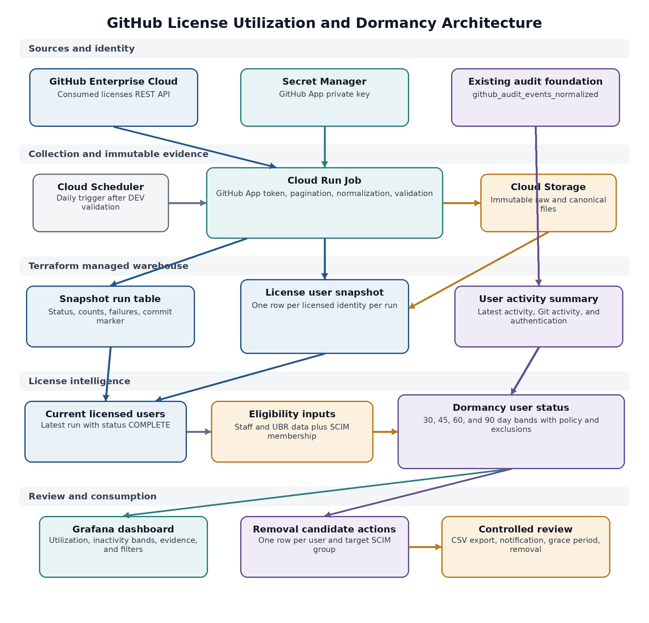
Figure 1 End to end license utilization and dormancy data flow

Component responsibilities
Component | Responsibility | Control
GitHub App | Authenticates the collector to the enterprise licensing API | Enterprise installation with Enterprise billing read-only
Cloud Scheduler | Starts the batch on the approved cadence | Paused until manual validation and first full load pass
Cloud Run Job | Authenticates, paginates, normalizes, archives, loads, and validates | One task, one parallel execution unit, immutable execution ID
Cloud Storage | Retains raw API pages, canonical NDJSON, and manifests | Create-only objects, restricted PII access, approved encryption and retention
BigQuery | Stores snapshot history, activity aggregates, and derived status | Terraform-managed objects and append-only snapshot loads
Grafana | Presents utilization, evidence, trends, and review queues | Queries derived tables and views rather than raw audit events

Current and target state
Capability | State | Notes
Audit event foundation | Available | github_audit_events_normalized contains audit and Git events and already supports governance reporting
License snapshot run table | Created | Tracks collection state, API totals, load counts, failures, and validation results
License user snapshot | Created | Partitioned historical inventory with one normalized row per license identity per run
Current licensed-user view | Created | Selects only the latest COMPLETE run
Cloud Run collector | Prepared for deployment | Validate mode should run before the first write-enabled execution
Activity summary | Next phase | Aggregates latest non-SSO activity, Git activity, authentication, and counts by actor
Eligibility and SCIM snapshots | Next phase | Persists staff, UBR, flow type, target groups, and LDAP or SCIM results
Dormancy and removal views | Next phase | Separates one row per user from one row per user and target group
Grafana dashboard | After data reconciliation | Build after the BigQuery calculation matches the legacy script

License collection flow
1. Cloud Scheduler starts a single Cloud Run Job execution. During rollout, the schedule remains paused and executions are started manually.
2. The job reads the GitHub App private key from Secret Manager, creates an app JWT in memory, and exchanges it for a short-lived enterprise installation token.
3. The collector calls GET /enterprises/{enterprise}/consumed-licenses with 100 records per page and follows every pagination link on the configured GitHub API origin.
4. Each source record is normalized to the snapshot schema. The identity key prefers GitHub login, then SAML identity, then Enterprise Server user IDs. An unresolved source hash is the final fallback.
5. Raw pages, canonical NDJSON, and an extraction manifest are written to execution-specific Cloud Storage paths. Objects are created with a generation precondition so retries cannot overwrite evidence.
6. A BigQuery load job appends the canonical file to the existing table using CREATE_NEVER, WRITE_APPEND, the destination schema, zero tolerated bad rows, and a deterministic job ID.
7. The job validates loaded rows, distinct identity keys, unresolved identities, API totals, pagination, and the change from the previous complete snapshot.
8. Only a COMPLETE run is eligible for the current licensed-user view. REVIEW_REQUIRED, REJECTED, and FAILED runs remain available for evidence but do not replace the current inventory.

Storage paths and partitioning
gs://<bucket>/github-license-snapshots/
snapshot_date=YYYY-MM-DD/
run_id=<cloud-run-execution>/
raw/page-00001.json.gz
canonical/users.ndjson.gz
manifest/extracted.json.gz
manifest/validated.json.gz
The snapshot tables are partitioned by snapshot_date. The user snapshot is clustered by github_login_normalized, license_type, and identity_key_type. Runtime SQL always includes the partition date so it remains compatible with required partition filters.

BigQuery data model
Object | Grain | Purpose | Lifecycle
github_license_snapshot_runs | One row per collector execution | Commit marker, source totals, load counts, validation, and failure evidence | Created and changed through Terraform; rows updated by the job
github_license_user_snapshot | One row per identity and run | Immutable historical licensed-user inventory | Append-only loads
github_license_users_current | One row per identity in latest complete run | Stable current inventory for downstream joins | Terraform-managed view
github_user_activity_summary | One row per audit actor | Latest activity, Git activity, authentication, and event counts | Scheduled aggregation
github_license_user_eligibility_snapshot | One row per licensed user and date | Staff match, UBR hierarchy, flow type, account type, and policy eligibility | Daily snapshot
github_scim_membership_snapshot | One row per user, target group, and date | Persisted LDAP or SCIM membership result and any lookup error | Daily snapshot
github_license_dormancy_user_status | One row per current licensed user | Applicable signal, inactivity bands, exclusion reason, and candidate state | Derived view or scheduled table
github_license_removal_candidate_actions | One row per candidate and target group | Operational removal actions without duplicating dashboard user counts | Derived view

Snapshot user schema groups
Field group | Representative fields
Run lineage | snapshot_date, snapshot_run_id, captured_at, enterprise_slug, loaded_at
Identity | license_identity_key, identity_key_type, github_login, github_login_normalized, saml_name_id
Profile and contact | github_name, github_profile_url, email_address, verified_domain_emails
License and roles | license_type, member_roles, enterprise_roles, pending_org_invites
Account types | is_github_com_user, is_enterprise_server_user, is_visual_studio_subscription_user
Security and linked accounts | two_factor_auth_enabled, enterprise_server_user_ids, enterprise_server_emails, total_user_accounts
Source lineage | source_system, source_api_version, collector_version, source_record_hash

advanced_security_enabled remains null in this collector because the consumed-licenses response does not provide a per-user Advanced Security flag. Advanced Security active-committer reporting requires a separate API flow and should not be inferred here.

Run status model
Status | Meaning | Visible as current | Action
STARTED | Run row registered | No | Wait or investigate a stale run
EXTRACTED | GitHub data archived and extraction counts recorded | No | Continue load or retry safely
LOADED | BigQuery append completed | No | Validation should follow
COMPLETE | All validation checks passed | Yes | No action
REVIEW_REQUIRED | Load succeeded but a safety threshold fired | No | Review evidence before controlled approval or rerun
REJECTED | The snapshot is empty, incomplete, or count-invalid | No | Correct the source or configuration and start a new execution
FAILED | A technical stage failed | No | Fix the failure and retry or start a new execution

Validation and retry controls
- An empty API response is rejected and never promoted.
- A loaded-row count different from the paginated API record count is rejected.
- Duplicate identity keys, unresolved identities, an API total mismatch, or a user-count change above the configured threshold hold the run in REVIEW_REQUIRED.
- The default count-change review threshold is 20 percent and should be calibrated after several valid snapshots.
- The Cloud Run execution name becomes snapshot_run_id. GCS objects are immutable and the BigQuery load uses a deterministic job ID, so retrying the same execution cannot append a duplicate snapshot.
- The current view uses the run table as a commit marker and therefore does not expose partially loaded data.

Activity and dormancy calculation
Audit-log streaming replaces the legacy script's per-user audit API and GraphQL contribution calls. The normalized table retains audit and Git events beyond the ordinary API's short Git-event window. At enterprise volume, Grafana must not aggregate hundreds of millions of normalized rows for each refresh, so activity is summarized before it is joined to the license inventory.
Signal | Definition | Use
latest_activity | Maximum event_time for the actor where action is not business.sso_response | Default activity-based policy and TDI parity
latest_git_activity | Maximum event_time where action starts with git. | Visible diagnostic evidence for clone, fetch, and push activity
latest_authentication | Maximum event_time where action equals business.sso_response | Authentication-based policy for the applicable non-TDI flow
activity counts | Event and Git-event counts in the reporting window | Usage intensity, anomaly checks, and review context

Dormancy policy
TDI flow effective_signal = latest_activity
Non-TDI flow effective_signal = latest_authentication
candidate = currently_licensed
AND account_type = HUMAN
AND staff_matched = TRUE
AND scim_eligible_for_action = TRUE
AND effective_signal is older than the policy window
AND no data or directory lookup error exists
Band | Interpretation | Default treatment
Active within 30 days | Recent applicable signal | No action
Inactive 30 to 44 days | Early inactivity | Dashboard visibility
Inactive 45 to 59 days | Sustained inactivity | Dashboard and manager analysis
Inactive 60 to 89 days | Approaching reclaim threshold | Pre-review and notification planning
Dormant 90 days or more | Policy threshold met | Candidate only after all eligibility and evidence checks
No activity observed | No event matched for the licensed identity | Separate evidence state, not automatic dormancy
Insufficient coverage | The required history is incomplete | Exclude from confirmed candidate counts

Identity and eligibility controls
- Classify accounts as HUMAN, SERVICE_ACCOUNT, BOT_OR_APP, or UNKNOWN. A svc- prefix is useful but is not sufficient as the only classifier.
- Start every calculation from the current licensed-user inventory and left join activity. This keeps licensed users with zero observed events in the report.
- Persist LDAP or SCIM lookup results with checked_at, is_member, check_status, and check_error. A directory error must never be interpreted as non-membership or dormancy.
- Count users in the dashboard from the user-level view. Generate group-removal rows from the action view so membership in two target groups does not count as two dormant users.
- Show organization-owner membership and other privileged roles as a review warning before removal.

DEV data observations
Observation | Design implication
Approximately 484 million events were present in the inspected history | Create incremental activity aggregates and avoid direct dashboard scans
Approximately 34,378 actors appeared in the audit data | Audit actors are not the license population; join from the consumed-license inventory
One technical identity generated approximately 212 million events | Separate human and technical identities before utilization reporting
The 91-day span contained events on 81 dates | The DEV gap is accepted for the prototype because streaming was stopped and restarted
Authentication evidence is common for people but often absent for technical accounts | Keep activity and authentication as separate signals

Production use of a confirmed 90-day status requires continuous audit coverage for the complete window. Missing evidence must lower confidence; it must not make a user appear more dormant. The DEV gap does not block pipeline and dashboard development, but the dashboard should continue to show data coverage and freshness.

Grafana dashboard
The dashboard should be named GitHub License Utilization and Dormancy and should query only derived license-intelligence objects. The normalized audit table remains the source of evidence but is not a dashboard data source for per-refresh aggregation.
Section | Panels
Data health | Latest complete license snapshot, collection status, audit freshness, and 90-day coverage confidence
License summary | Consumed and purchased seats, current licensed humans, active within 30 days, 30+, 45+, 60+, and confirmed 90-day candidates
Analysis | Inactivity bands, TDI versus non-TDI, UBR and manager breakdown, organization distribution, and latest activity type
Candidate review | Login, staff account, policy signal, last activity, last Git activity, last authentication, inactivity days, eligibility, exclusion reason, and review status
Technical identities | Service-account utilization and high-volume technical identities in a separate row
Operations | Users with no staff match, failed directory checks, unresolved identities, and snapshots held for review

Recommended filters
- Dormancy threshold with 30, 45, 60, and 90-day values
- Flow type with TDI and non-TDI values
- Account type
- UBR level and manager
- Organization and target SCIM group
- Candidate status and exclusion reason
- License type and Advanced Security status when a separate source is available

Security and access model
Control area | Required control
GitHub App | Enterprise installation with Enterprise billing read-only. Enterprise organizations and Enterprise people remain No access for this collector.
GitHub private key | Secret Manager secret value supplied outside Terraform state. Pin a numeric secret version after DEV validation.
Runtime identity | Dedicated Cloud Run service account with BigQuery job creation, dataset-scoped table read and update-data permissions, archive object create and read, and access to one secret.
Scheduler identity | Separate service account with only permission to invoke the specific Cloud Run Job.
BigQuery changes | Tables and views are created and changed only through Terraform. The application uses CREATE_NEVER and cannot create or delete tables.
Network | Outbound HTTPS to the GitHub API and Google APIs through the approved VPC, proxy, or Cloud NAT path. Use an approved static egress IP when the enterprise IP allow list requires it.
Data protection | Treat raw license pages and canonical snapshots as identity data. Apply approved location, CMEK, retention, access review, logging, and DLP controls.
Logging | Log execution identifiers, stages, counts, and error classes only. Do not log tokens, private keys, user names, email addresses, or API bodies.

GitHub released Enterprise billing permissions for GitHub Apps in August 2026. The current UI provides read-only and read-and-write levels. This collector requires read-only. If the API returns 403, inspect the X-Accepted-GitHub-Permissions response header and resolve any tenant or preview issue without adding unrelated write permissions.

Deployment plan
Phase | Configuration | Exit criteria
GitHub App | Install at enterprise level, grant Enterprise billing read-only, and store the PEM in Secret Manager | Installation token can be created and the app permission is visible on the installation
Validate mode | RUN_MODE equals validate and scheduler remains paused | Authentication and every API page succeed; no GCS or BigQuery writes occur
First full load | RUN_MODE equals full and scheduler remains paused | One manual execution ends COMPLETE and source, archive, BigQuery, and current-view counts reconcile
Legacy comparison | Run the legacy script and BigQuery calculation for the same 90-day policy | Every case where the legacy script says active and BigQuery says dormant is explained
Scheduled collection | Enable the daily Terraform-managed schedule | Several consecutive complete snapshots and no unexplained count drift
Dashboard release | Point Grafana to derived views | Stakeholders validate counts, exclusions, evidence, and export fields

Operational monitoring
Condition | Severity | Response
No COMPLETE license snapshot within the expected daily window | High | Check Cloud Scheduler, Cloud Run execution, GitHub authentication, and run status
Collector status FAILED or REJECTED | High | Use failure_stage and error_message, correct the issue, and launch a new execution
Collector status REVIEW_REQUIRED | Medium | Review duplicates, unresolved identities, API total mismatch, and count delta before promotion or rerun
GitHub API returns 403 | High | Check enterprise installation, Enterprise billing read-only, installation approval, API host, and accepted-permissions header
GitHub API returns 429 or repeated 5xx | Medium | Review rate-limit headers, proxy behavior, retries, and collection duration
Audit coverage or freshness is insufficient | High for 90-day decisions | Keep users out of confirmed-candidate totals until evidence is sufficient
Directory membership checks fail | Medium | Set LDAP_CHECK_FAILED and do not produce a removal action

Implementation sequence
1. Deploy the collector in validate mode with Enterprise billing read-only and confirm complete pagination.
2. Execute one full snapshot, reconcile source and BigQuery counts, and confirm github_license_users_current changes only after COMPLETE.
3. Create the incremental github_user_activity_summary process from github_audit_events_normalized.
4. Load the staff and UBR snapshot and persist SCIM or LDAP membership results rather than checking them only in memory.
5. Create github_license_dormancy_user_status and github_license_removal_candidate_actions through Terraform.
6. Compare the 30, 45, 60, and 90-day outputs with the legacy script and review every active-to-dormant mismatch.
7. Build and validate the Grafana dashboard, then add the controlled CSV export and operational alerts.

Acceptance criteria
- Every current consumed license appears once in the latest complete snapshot or has a documented identity-resolution exception.
- A failed or suspicious run does not change the current licensed-user view.
- A Cloud Run retry cannot overwrite archive evidence or append duplicate rows for the same execution.
- The dashboard does not query github_audit_events_normalized directly for user-level aggregation.
- Every candidate shows its applicable policy, source timestamps, inactivity days, eligibility result, and exclusion reason.
- Service accounts, directory failures, missing staff matches, privileged roles, and insufficient coverage are excluded or clearly separated.
- No automated removal occurs until the legacy comparison, stakeholder approval, notification, and grace-period process are complete.

References
- GitHub REST API enterprise licensing
- GitHub Apps enterprise billing permission release
- GitHub App installation access tokens
- Cloud Run Jobs
- Schedule Cloud Run Jobs
- Cloud Run Job secrets
- Load newline-delimited JSON from Cloud Storage
- BigQuery clustered tables

