GitHub Governance Intelligence Platform
Proposal for Discussion
Objective | Convert stored GitHub Enterprise audit logs into actionable governance visibility for platform, product, and compliance stakeholders.
Core Idea | Build a read-only intelligence layer that normalizes audit events, tracks pipeline health, classifies governance events, enables dashboards/reports, and later supports controlled AI-assisted investigation.
Boundary | Do not duplicate Chronicle/SOC security detections such as broker bypass. Chronicle remains the owner of security alerts and incident response.
MVP Outcome | A 4–6 week MVP with audit pipeline health, governance overview, repo drilldown, and automated evidence/reporting views.

1. Why This Matters
- GitHub audit logs are already stored securely, but raw logs are difficult for product/platform teams to use directly.
- Chronicle can own security detections and incident workflows; the GitHub platform team can own governance visibility, data quality, and self-service investigation context.
- Managers and product owners need faster answers to questions like: who changed access, which repos had risky governance changes, and whether audit-log ingestion is healthy.
- This turns recent audit-log migration work from a compliance plumbing task into a visible platform capability.

2. Proposed Product Scope
Phase | What We Build | Primary Value
Phase 1: Audit Log Pipeline | Ingest, deduplicate, normalize, enrich, and monitor audit-log data quality. | Trusted data foundation; visibility into freshness, duplicates, parse failures, and missing windows.
Phase 2: Governance Classification | Classify events such as admin access changes, external collaborators, repo visibility changes, branch protection changes, and audit stream health events. | Governance intelligence without duplicating security alerting.
Phase 3: Dashboards + Reports | Grafana dashboards for pipeline health, governance overview, repo drilldown, and evidence/report exports. | Self-service visibility for PO, manager, compliance, and platform stakeholders.
Phase 4: AI Assistant | Controlled assistant over approved APIs to summarize risky changes, explain alerts, and generate timelines with event citations. | Faster investigations and reporting, without free-form access to raw logs.

3. 4–6 Week MVP
- Read-only MVP; no GitHub write actions and no security incident creation.
- Five starter governance categories: admin/owner access changes, external collaborator additions, repository visibility changes, branch protection changes, and audit stream health/configuration changes.
- Two initial dashboards: Audit Pipeline Health and Governance Overview.
- One drilldown flow: select organization/repository and view recent governance events, risk reasons, and event timeline.
- One report: weekly privileged access and repository governance evidence report.

4. Dashboard Concept
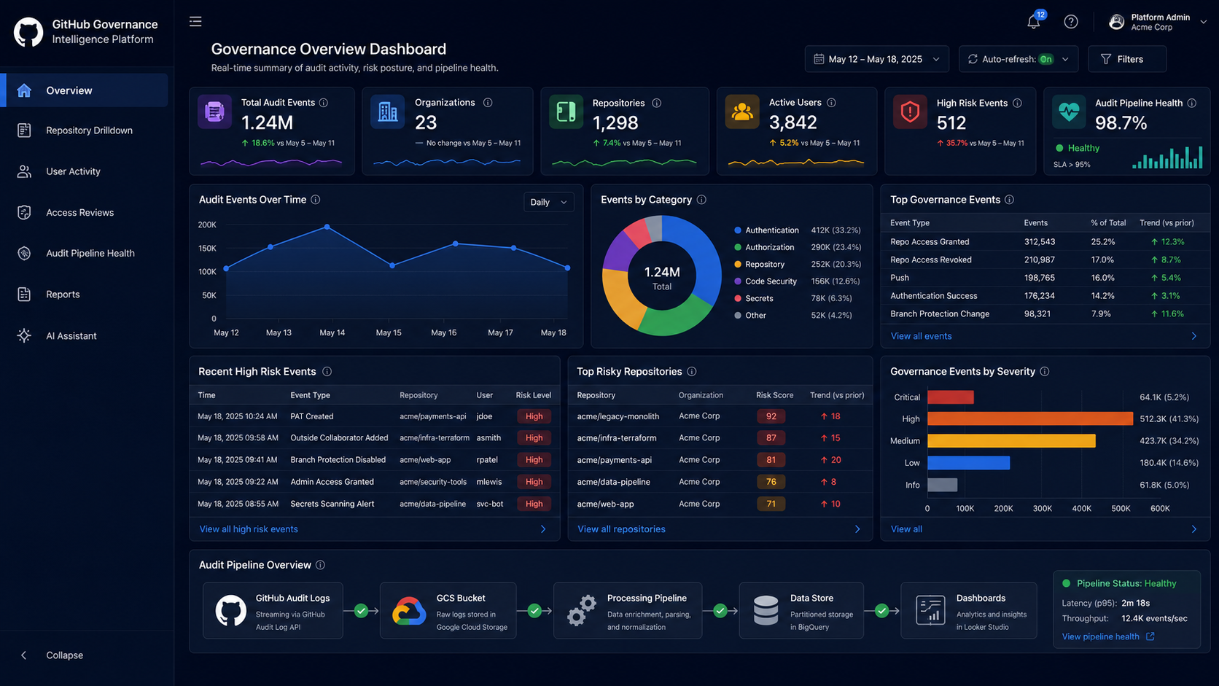
Concept mockup: Governance Overview Dashboard for product/platform stakeholders.

5. Data Needed
Data | Why Needed
GitHub audit log events | Base event stream: action, actor, timestamp, org, repo, target user/team, metadata.
Pipeline metadata | Source file, ingest time, parse status, duplicate hash, event lag, missing windows.
Repository metadata | Owner team, application, business unit, criticality, production/sensitive flag.
User/team mapping | Internal identity, active/inactive status, team membership, privileged role context.
Chronicle/security boundary inputs | Know which detections already exist and where security escalation should remain with Chronicle/SOC.

6. Stakeholder Value
Stakeholder | Value
Product Owner | Visible product capability: governance dashboards, adoption metrics, evidence reports, and roadmap for AI-assisted investigation.
Manager | Turns audit-log migration into a cross-functional platform maturity initiative with measurable impact.
Compliance/Audit | Faster evidence generation for privileged access, repo visibility, branch protection, and audit stream continuity.
GitHub Platform Team | Self-service investigation views reduce repeated manual queries and improve operational transparency.
Chronicle/Security | Clear separation: security alerts remain in Chronicle; platform layer adds context, data quality, and governance reporting.

7. Success Metrics
- Reduce time to answer common audit questions from hours to minutes.
- Automate weekly/monthly governance evidence reports.
- Track audit ingestion freshness, duplicate rate, parse failure rate, and missing data windows.
- Enable self-service drilldowns by org/repo/user for approved stakeholders.
- Measure adoption through dashboard views, report downloads, and reduction in ad-hoc audit-log queries.

8. Questions for Manager Discussion
- Which audit-log questions do product/platform/compliance stakeholders repeatedly ask today?
- What exactly does Chronicle already own for broker bypass and other GitHub security detections?
- Can we define this as governance intelligence rather than security alerting to avoid overlap?
- Do we have access to raw or parsed audit events and the required repo/user ownership metadata?
- Would a 4–6 week read-only MVP with two dashboards and one evidence report be worth validating with stakeholders?

