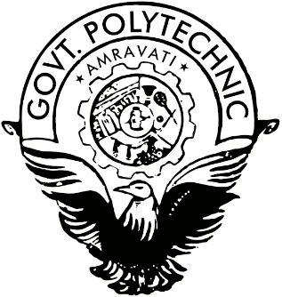

**Vision**

**Provide skilled professionals in Computer Engineering to contribute towards the advancement of technology useful for society and industrial environment.**

# Mission

**M1**. Impart need based and value based education by providing exposure of latest tools and technologies in the area of computer engineering to satisfy the stakeholders.

**M2**. Upgrade and maintain facilities for quality technical education with continuous effort for excellence in Computer Engineering.

**M3.** Train students with Computer Engineering knowledge to apply it in the general disciplines of design, deployment of software and integration of existing technologies for E-governance and for benefit of society.

**M4**. Provide a learning ambience to enhance innovations, problem solving skills, leadership qualities, team spirit and ethical responsibilities.

**M5.** Provide an academic environment and consultancy services to the industry and society in the area of Computer Engineering.

**MICRO-PROJECT REPORT**

ON

**Natural Language Preprocessing**

**In Partial fulfilment of Diploma in Computer Engineering**

**In the subject of**

**Python Programming (CM5461)**

**By**

**Ms. Bhagyashree Tekade (19CM003)**

**Mr. Ayush Bulbule (19CM007)**

**Mr. Pratham Gaur (19CM020)**

**Mr. Malhar Joshi (19CM033)**

**Ms. Wruddhi Raut (19CM053)**

**Ms. Akansha Shewatkar (19CM057)**

**Submitted To**

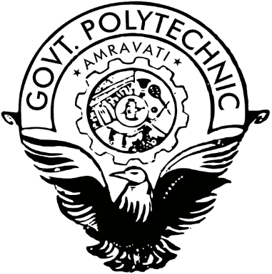

**Government Polytechnic, Amravati**

(An Autonomous Institute of Govt. of Maharashtra)

Under the guidance of

**Prof. M. R. Torney**

**Lecturer in Python Programming**

Department of Computer Science & Engg.

Government Polytechnic, Amravati

**(2020-2021)**

|  |  |
| --- | --- |
|  | **Government Polytechnic, Amravati.**  **(An Autonomous Institute of Govt. of Maharashtra)**  **Department of Computer Science & Engg.** |
| *Certificate*  This is to certify that **Ms. Bhagyashree Tekade (19CM003), Mr. Ayush Bulbule (19CM007), Mr. Pratham Gaur (19CM020), Mr. Malhar Joshi (19CM033), Ms. Wruddhi Raut (19CM053), Ms. Akansha Shewatkar (19CM057)** of Third Semester Diploma in Computer Engineering has satisfactorily completed the micro project entitled “**Natural Language Preprocessing”** in **(CM5461) Python Programming**  the academic year 2020-21 as prescribed in curriculum. | |

|  |  |
| --- | --- |
| Date: 06 /05 /2021  Place: Amravati | **Prof. M. R. Torney**  Lecturer in Python Programming |

**Annexure-I**