Dr Arvinder Singh Soin.

Social midia :- <https://www.instagram.com/arvindersoin/?hl=en>

Twitter :- <https://www.instagram.com/arvindersoin/?hl=en>

Fb :- <https://www.facebook.com/arvindersinghsoin/>

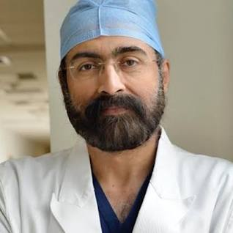

Dr Puneet Girdhar



Fb :- <https://www.facebook.com/DrPuneetGirdhar/>

Twitter account :- <https://twitter.com/drpuneetspine?lang=en>

Insatgram:- <https://www.instagram.com/dr.puneet.girdhar/?hl=en>

Dr Rita Bakshi

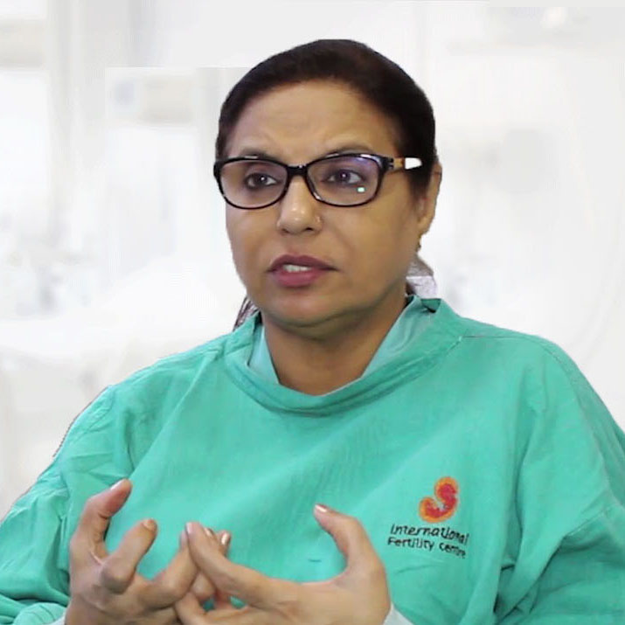

**Twitter :-** [**https://twitter.com/dr_ritabakshi?lang=en**](https://twitter.com/dr_ritabakshi?lang=en)

**Fb :-** [**https://www.facebook.com/drritabakshi.in/**](https://www.facebook.com/drritabakshi.in/)

**Insta:-** [**https://www.instagram.com/drrita_bakshi/?hl=en**](https://www.instagram.com/drrita_bakshi/?hl=en)

Dr Amit Agarwal

Instagram:- <https://www.instagram.com/labnol/?hl=en>

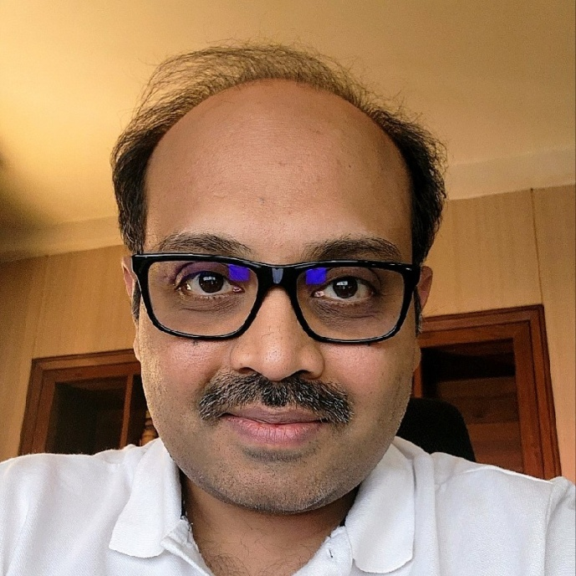

**Twitter:-** [**https://twitter.com/labnol?lang=en**](https://twitter.com/labnol?lang=en)

[Dr Vaishali Sharma](https://www.drvaishalisharma.com/dr-vaishali-sharma/)

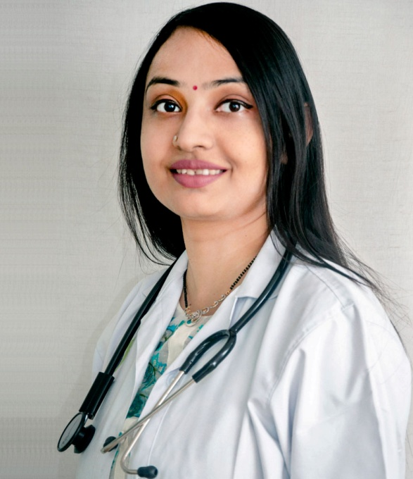

**Inagram :-** [**https://www.instagram.com/drvaishalisharma/?hl=en**](https://www.instagram.com/drvaishalisharma/?hl=en)

**Fb :-**  https://www.facebook.com/drvaishalisharmamdgynaeaiims/

Linkedin :- https://www.linkedin.com/in/vaishali-sharma-032578160/?originalSubdomain=in