Employee Attrition and Performance Analysis Report
Acknowledgements
This project was completed with guidance from faculty and support from peers.
Objective and Scope
To analyze employee attrition patterns and identify key influencing factors using data analytics.
Problem Statement
Organizations face high employee turnover which impacts productivity and costs.
Existing Approaches
Traditional HR analysis relies on basic statistics without deep insights.
Approach / Methodology - Tools and Technologies used
Python, Pandas, NumPy, Matplotlib, Seaborn, Scikit-learn, Power BI.
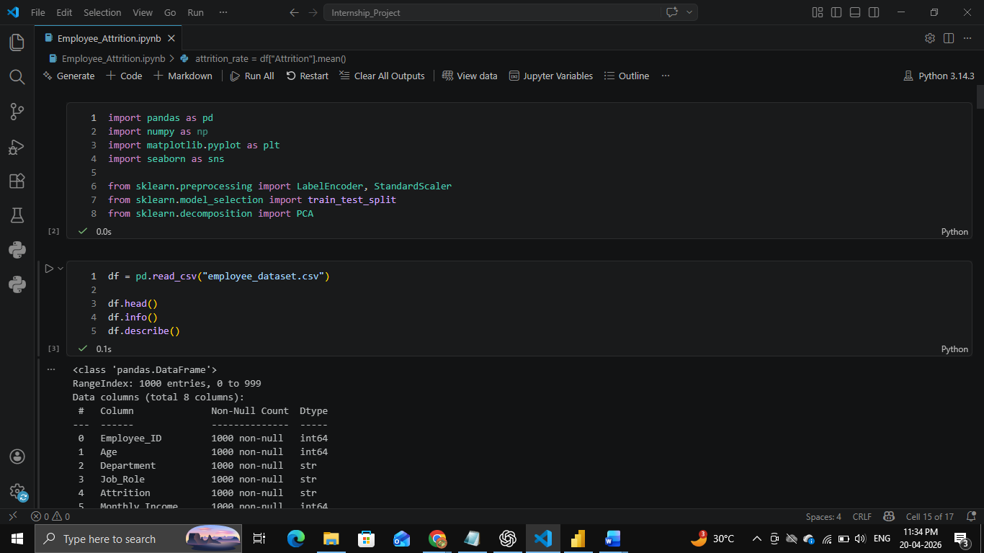
Workflow
Data Collection → Preprocessing → Feature Engineering → PCA → Visualization → Dashboard.
Data Description and Information:
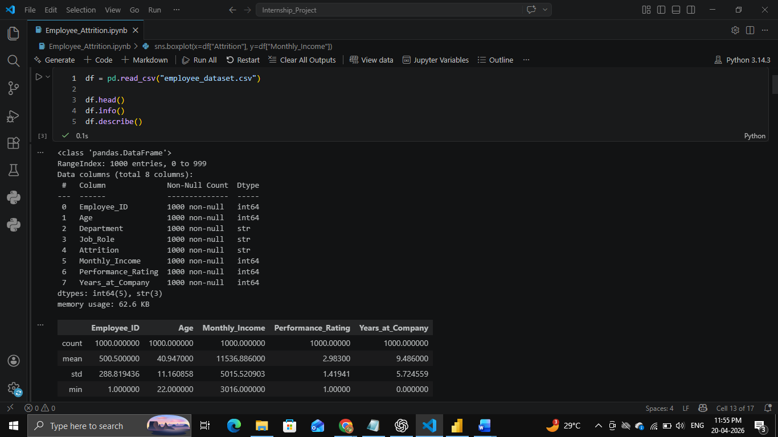

Processing:
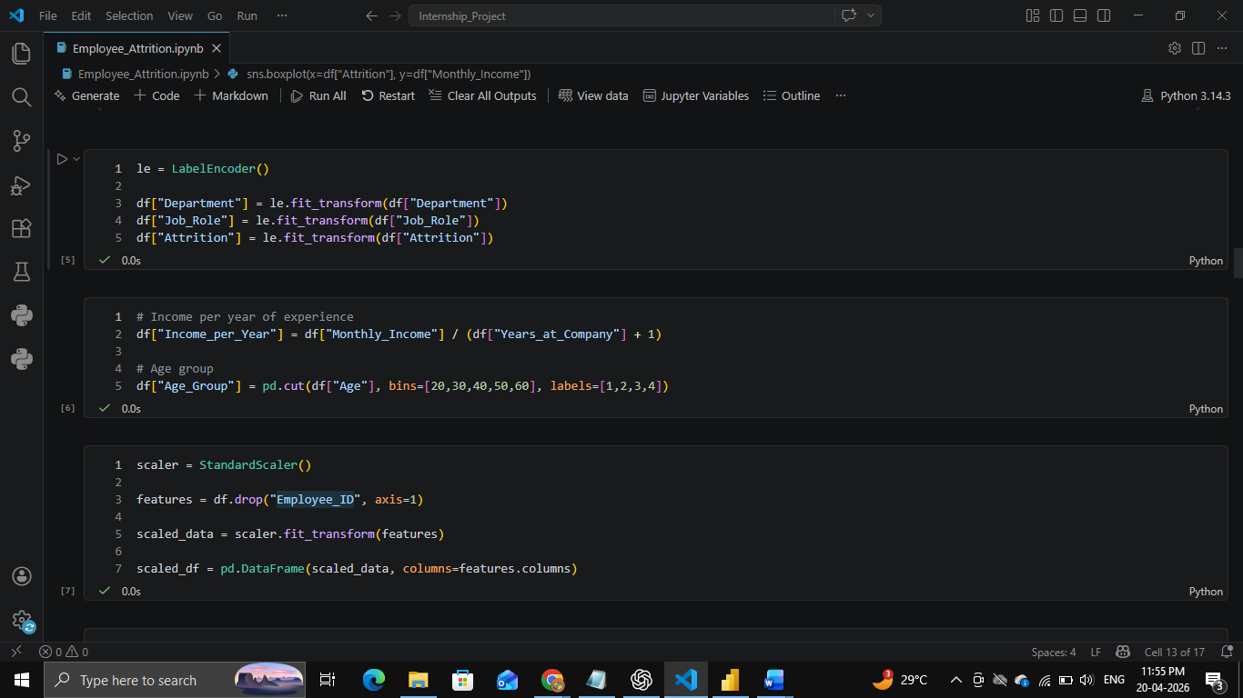
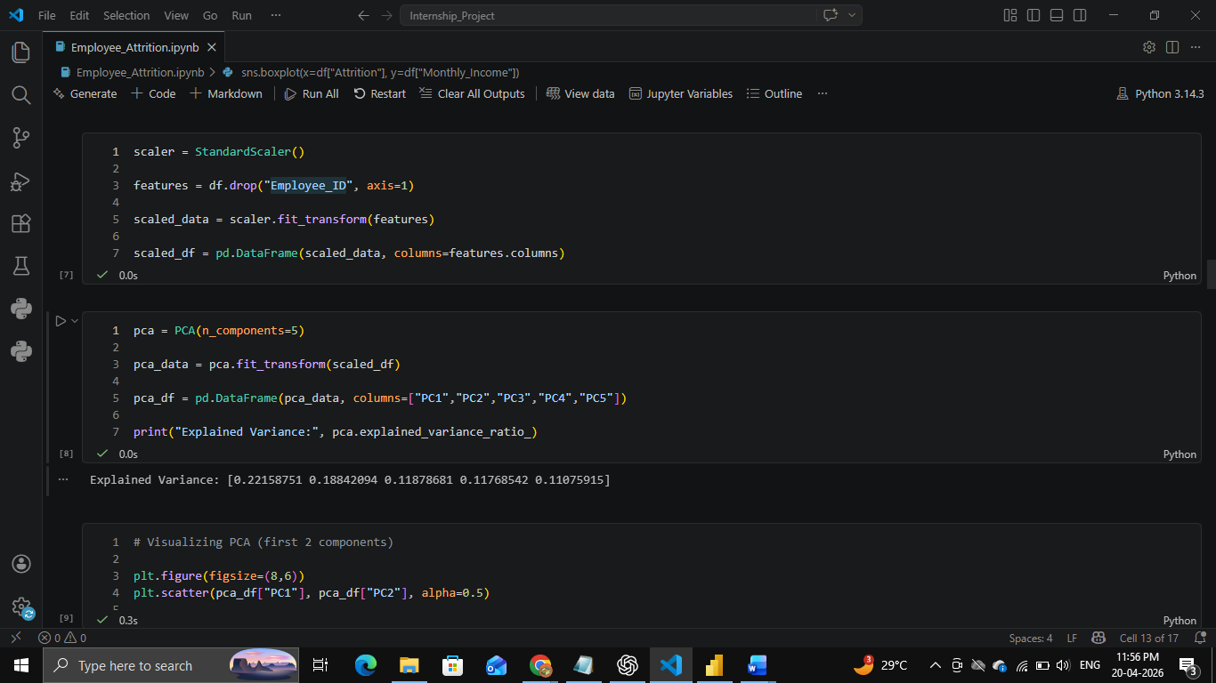
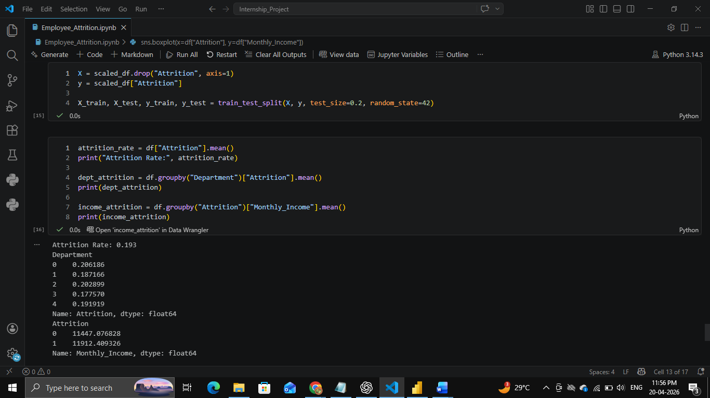
Assumptions
Dataset is collected from Kaggle and represents realistic employee behavior.
Implementation - Data collection, Processing Steps, Diagrams - Charts, Table
Data was chosen from Kaggle Platform and processed using Python. Visualizations include charts and heatmaps.
Dataset:
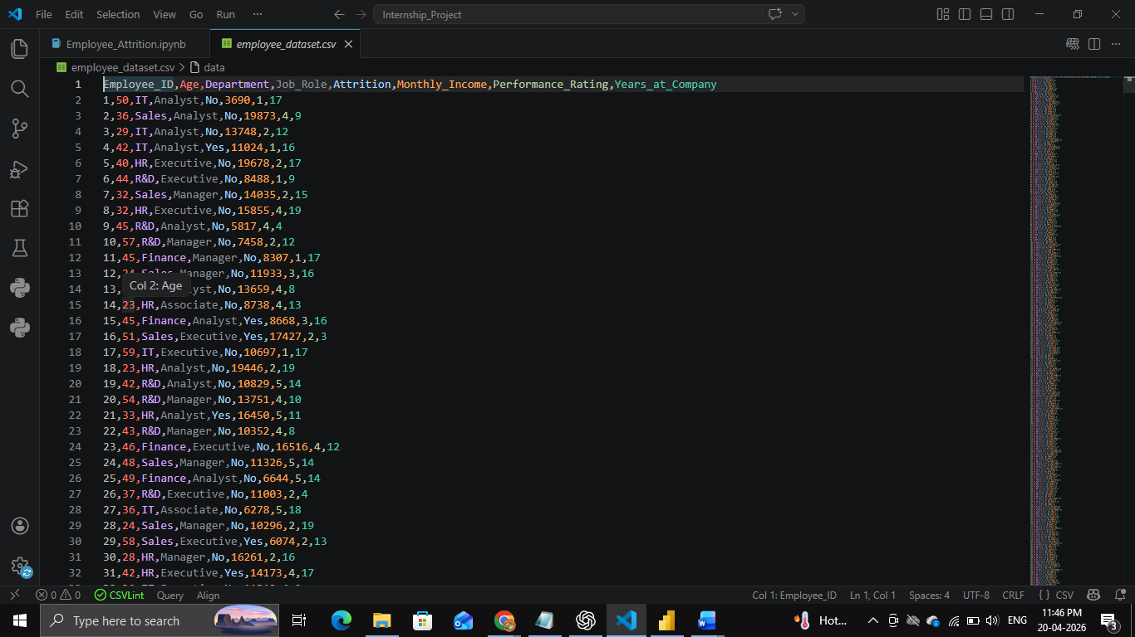
Charts:
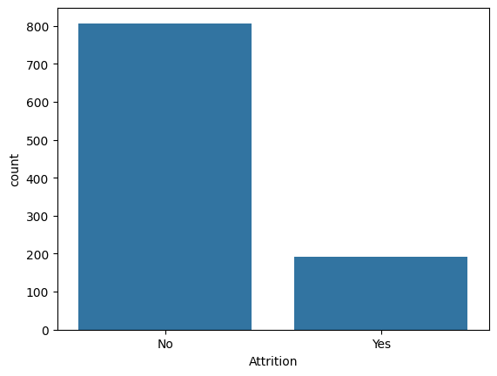

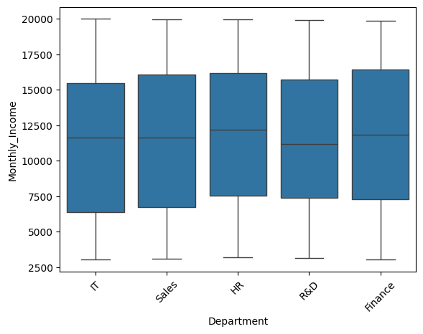

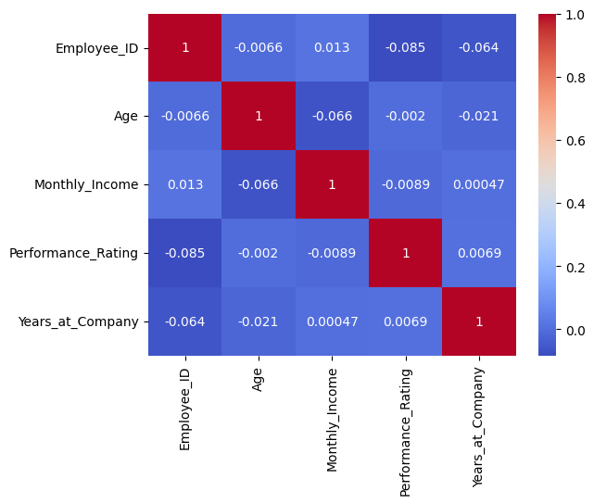

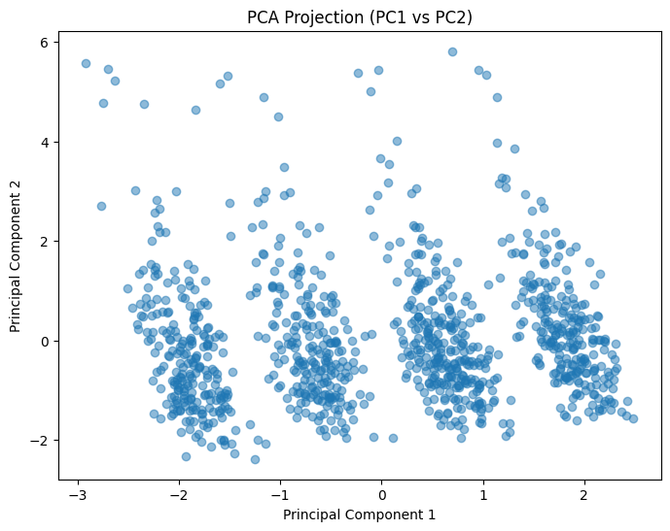

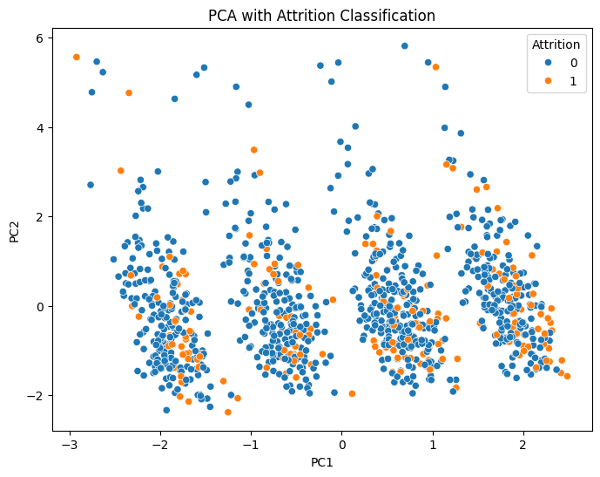

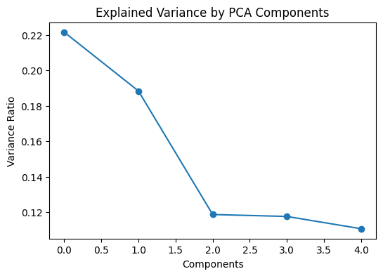

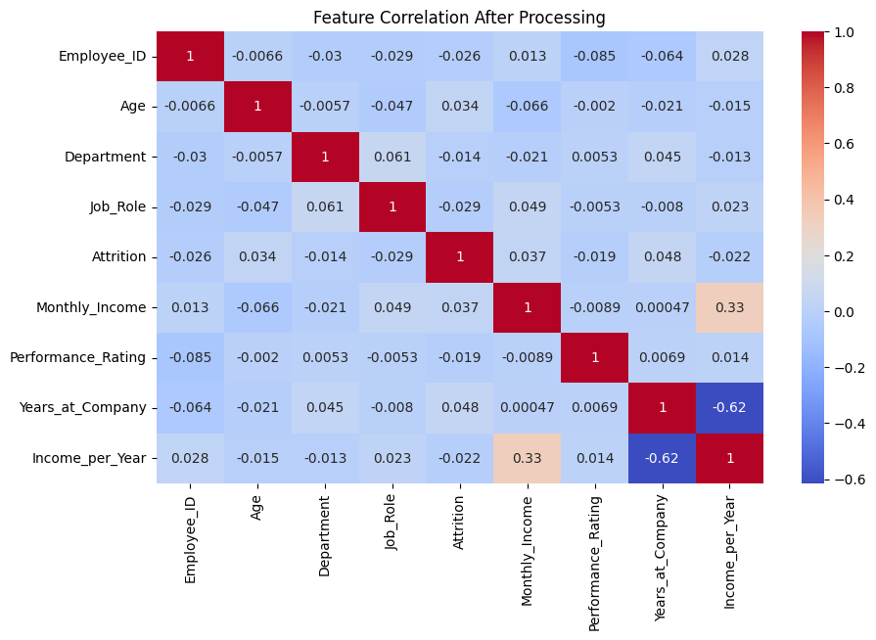

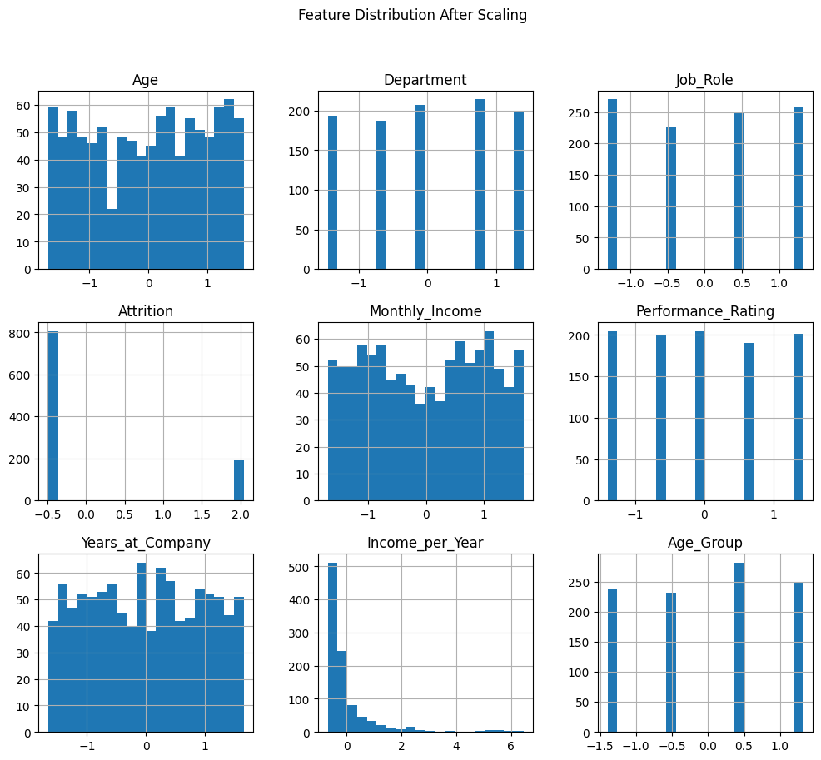

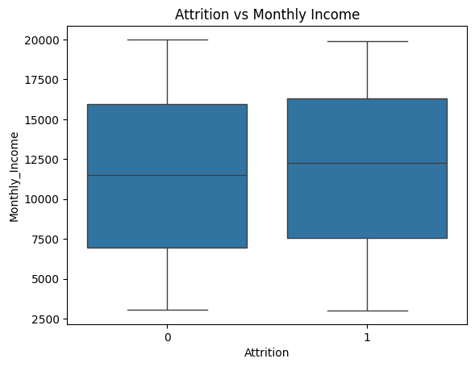

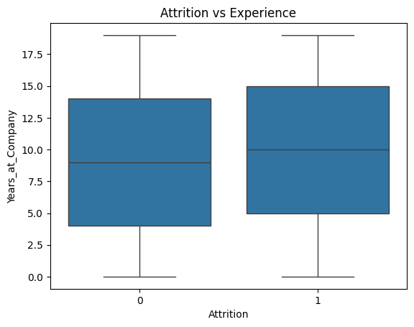

Solution Design
A structured pipeline was created including preprocessing, modeling, and dashboarding.
Challenges & Opportunities
Handling dataset and ensuring meaningful insights.
Reflections on the project
Project improved understanding of data pipelines and visualization.
Recommendations
Improve salary structure and employee engagement programs.
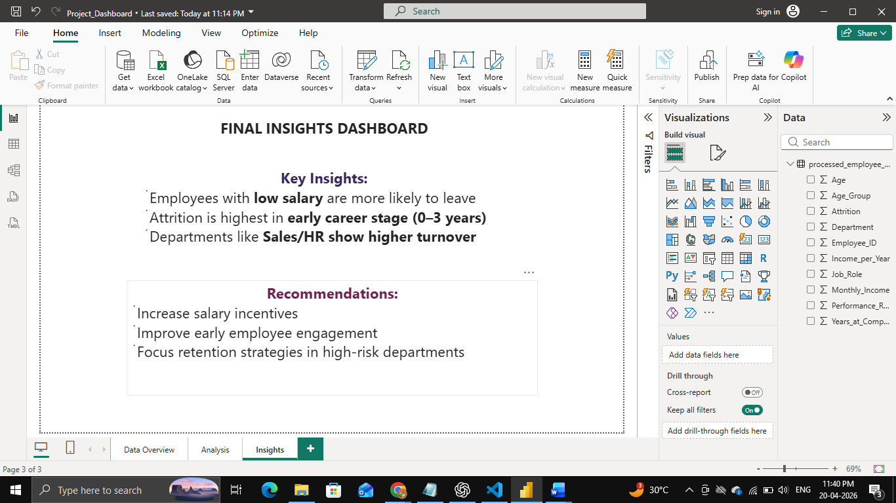

Outcome / Conclusion
Attrition is influenced by salary, experience, and department.
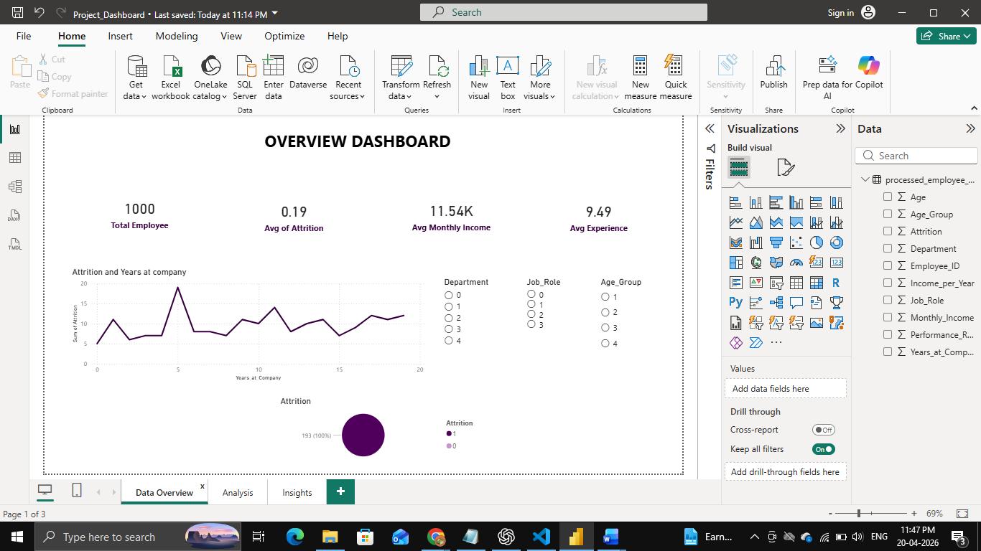
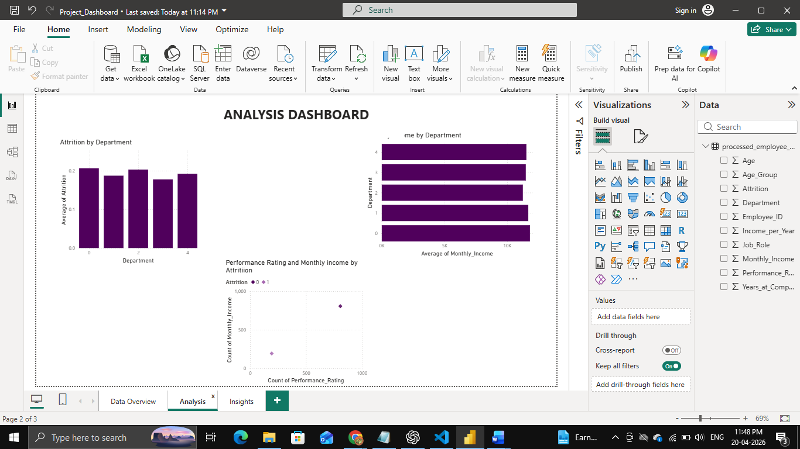

Enhancement Scope
Future scope includes real dataset integration and ML model deployment.
Link to code and executable file
GitHub Link:
Research questions and responses
What factors influence attrition? → Salary, experience, department.

