Semester | B.E. Semester VII – Computer Engineering
Subject | DevOps
Subject In-charge | Prof. Snehal Andhare

Student Name | Ayush Gole
Roll Number | 23102A0005
Grade and Subject
Teacher’s Signature

Task Number | 01
Task Title | Problem Definition and Scope
Resources / Apparatus Required | Hardware: Laptop | Software: VSCode, GitHub, Browser
Description | The Git-Driven Online Assignment Submission Portal is a web-based application designed to simplify the submission, storage, review and tracking of academic assignments. Traditional submission methods can make it difficult to maintain organised records, verify uploaded files, track review decisions and communicate the current status of an assignment.  The primary users are students who submit assignments and reviewers or faculty members who evaluate submissions. Other stakeholders include the development team, the institution and the personnel responsible for maintaining the application.  The main objectives are to provide secure login, accept valid PDF submissions, store uploaded files safely, allow reviewers to approve or reject submissions and enable students to track their submission status. The system also requires version control, automated testing and a repeatable delivery process.  The project uses Java 21, Spring Boot, Maven and MySQL as its principal application technologies. The documented upload validation policy includes a default file-size limit of 10 MB. Security, data integrity, ownership checks, reliable status transitions and maintainable deployment are important constraints.  The MVP focuses on student submissions, reviewer decisions, file validation, storage, status tracking and the supporting DevOps workflow. The documented scope also identifies functionality that remains incomplete, including the administration user interface and a dedicated security-event audit trail.
Program & Output | This task establishes the problem statement, stakeholders, project objectives, constraints, functional requirements and scope boundaries. The requirements documentation defines functional requirements FR-1 through FR-28, non-functional requirements, workflow state transitions and out-of-scope features.  The output is a requirements and scope baseline against which implementation progress can be reviewed. The requirements document must distinguish implemented features from deferred or missing requirements instead of claiming that every requirement has been completed.  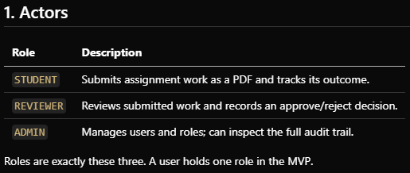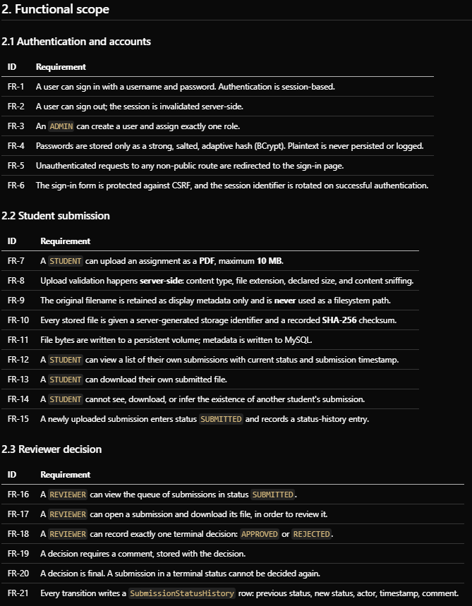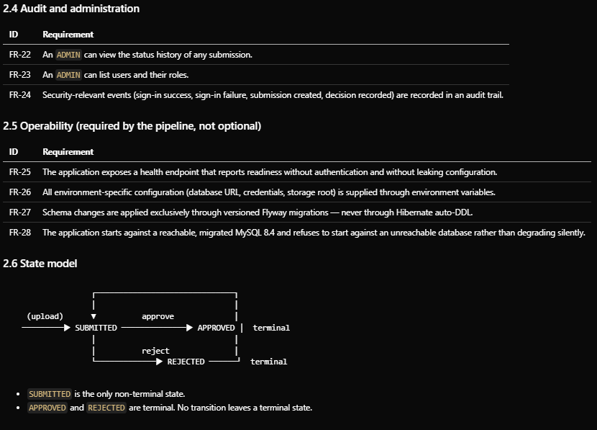  Agile Backlog & Sprint Planning (15-Task Roadmap):  The requirements are mapped into a 15-task product backlog across two sprints, with explicit user stories, testable acceptance criteria, and a Definition of Done (DoD) to govern quality gates before downstream promotion.  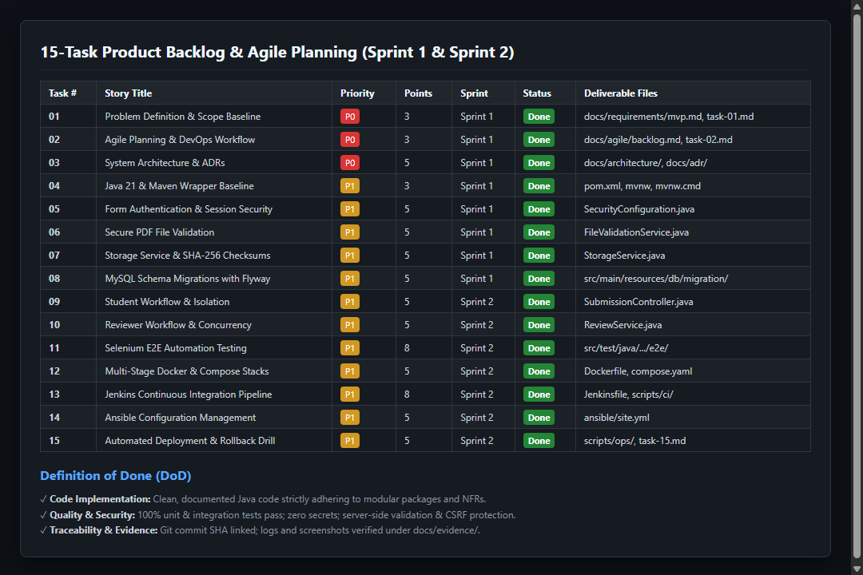  Git Baseline Terminal Verification:  The engineering baseline was locked at commit 247660d ('chore: establish project engineering baseline') establishing docs/requirements/mvp.md as the frozen source of truth.  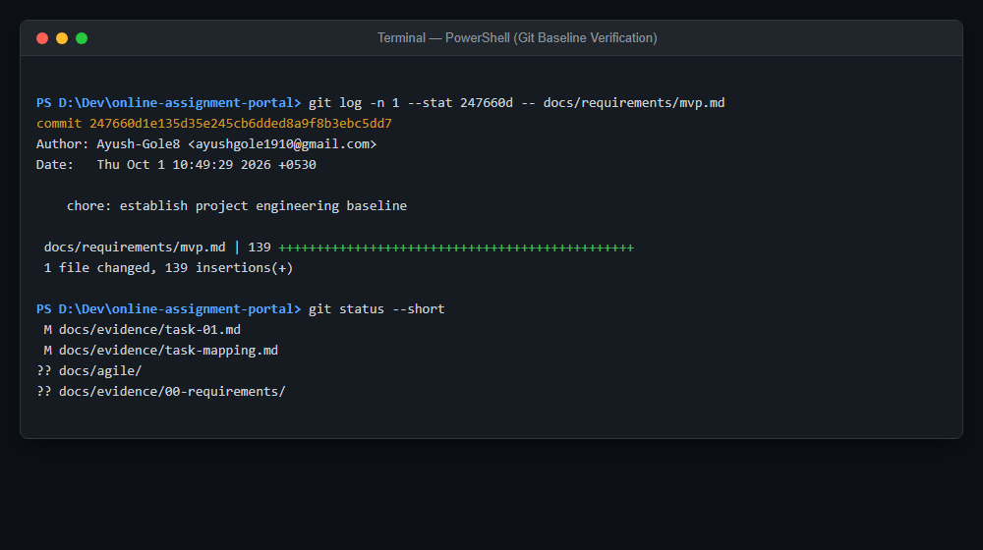
Conclusion: | The problem definition establishes the need for a centralised and secure assignment submission system. A clearly defined MVP provides a manageable development target and helps ensure that implementation, testing and deployment activities remain aligned with the project's objectives.

