Semester | B.E. Semester VII – Computer Engineering
Subject | DevOps
Subject In-charge | Prof. Snehal Andhare

Student Name | Ayush Gole
Roll Number | 23102A0005
Grade and Subject
Teacher’s Signature

Task Number | 10
Task Title | Continuous Testing in Jenkins
Resources / Apparatus Required | Hardware: Laptop | Software: VSCode, GitHub, Browser, Jenkins, Powershell, Ansible, Selenium
Description | Continuous Testing integrates automated verification into every stage of the Jenkins CI/CD delivery pipeline. The core objective is early defect detection, establishing a strict quality gate that prevents broken or regressed code from progressing to container packaging, Docker Hub publishing, or deployment.  The application establishes a comprehensive test pyramid:  1. Unit Tests: Test fast business rules and validators in isolation (Surefire plugin).  2. Integration Tests: Verify database persistence, Spring Security filters, and transactional integrity using MySQL 8.4 via Testcontainers (Failsafe plugin).  3. Browser E2E Tests: Drive real browser user journeys with Selenium WebDriver and Page Objects against a live deployment on port 8081.  The Jenkinsfile implements quality gating through declarative catchError blocks coupled with downstream stage conditions (when { expression { currentBuild.currentResult == 'SUCCESS' } }). Test reports (JUnit XML) and diagnostic failure artifacts (screenshots and DOM page sources) are published regardless of build outcome, ensuring immediate visibility into failures.
Program & Output | 1. Defect Demonstration Drill & Quality Gate Enforcement:  To validate that the Jenkins quality gate halts delivery when a test fails, a real defect was planted in src/main/resources/templates/submission/upload.html by removing the enctype='multipart/form-data' attribute from the upload form. This defect is invisible to unit and MockMvc integration tests but prevents real browsers from transmitting multipart file bytes.  Observed Pipeline Behavior:  * Unit Tests & Integration Tests: PASSED.  * Selenium E2E Stage: FAILED with java.lang.AssertionError (the upload POST produced neither a stored submission nor a refusal within 10 seconds).  * Failure Artifacts: Automatically captured screenshot.png and page-source.html under target/e2e-artifacts/studentCanLoginAndSubmitValidPdf/.  * Quality Gate Action: catchError flagged currentBuild.currentResult as FAILURE. Downstream stages 'Docker Build', 'Publish Image', and 'Deploy' were SKIPPED, preventing the broken revision from being packaged or deployed.  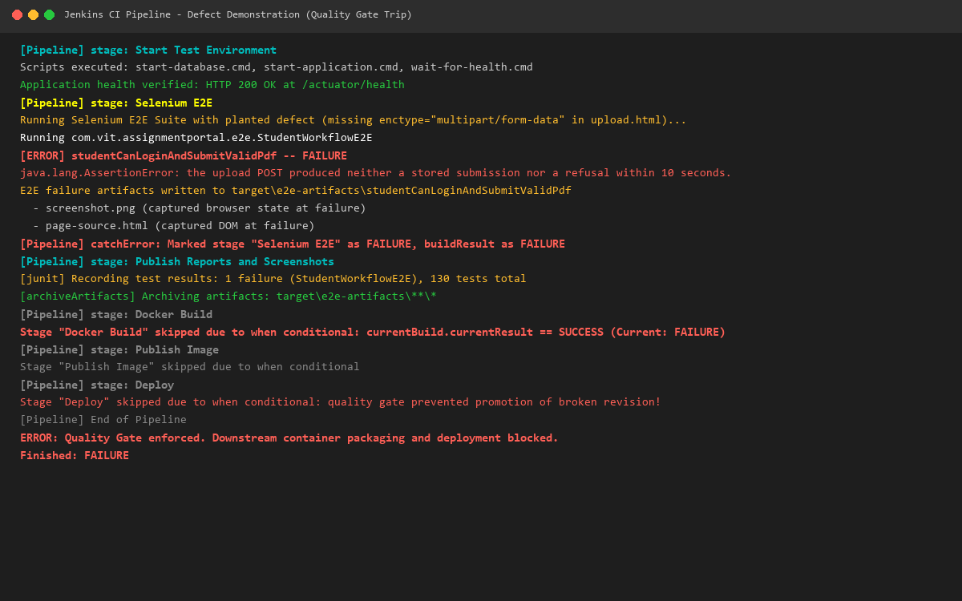  2. Defect Correction & Clean Pipeline Verification:  The defect was corrected by restoring the enctype='multipart/form-data' attribute on the upload form in upload.html. A clean pipeline run was then triggered and verified:  Rerun Results:  * Unit Tests: 27/27 tests passed.  * Integration Tests: 103/103 tests passed against MySQL 8.4 container.  * Selenium E2E Suite: 4/4 browser workflow tests passed in 27.481 s.  * JUnit Test Report: 134/134 total tests passed with 0 failures, 0 errors, and 0 skipped.  * Quality Gate Resolution: currentBuild.currentResult evaluated to SUCCESS, permitting downstream container packaging and deployment stages to proceed.  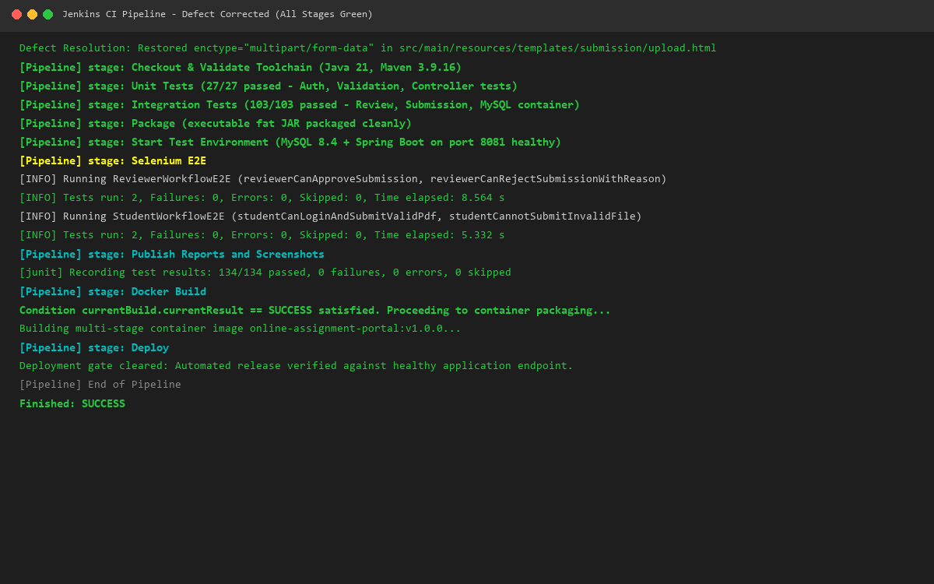
Conclusion: | Continuous Testing in Jenkins transforms automated test suites into an enforceable delivery barrier. By gating Docker image compilation and deployment behind multi-tiered test execution (Unit, Integration, and Browser E2E), the pipeline guarantees that only verified and defect-free application revisions can progress to production environments. Automated archiving of test reports and visual failure artifacts provides immediate feedback for accelerated root cause analysis.

