Semester | B.E. Semester VII – Computer Engineering
Subject | DevOps
Subject In-charge | Prof. Snehal Andhare

Student Name | Ayush Gole
Roll Number | 23102A0005
Grade and Subject
Teacher’s Signature

Task Number | 12
Task Title | Jenkins-Docker Continuous Deployment
Resources / Apparatus Required | Hardware: Laptop | Software: VSCode, GitHub, Browser, Jenkins, Powershell, Ansible, Selenium
Description | Continuous Deployment (CD) automates the delivery workflow from commit validation to production container execution. In the Jenkins-Docker architecture, the delivery pipeline extends beyond testing to compile versioned container images, publish immutable releases to a container registry (Docker Hub), and orchestrate automated rollouts.  Key Pipeline Capabilities:  1. Quality Gate Enforcement: Docker image packaging and deployment stages execute only after all unit, integration, and Selenium E2E suites achieve 100% success (when { expression { currentBuild.currentResult == 'SUCCESS' } }).  2. Versioned Image Tagging: Injects the build argument APP_VERSION into the Dockerfile, baking the exact semantic release tag (v1.0.0) into the image metadata, avoiding reliance on mutable environment defaults.  3. Registry Publishing: Authenticates using Jenkins credentials, tagging and pushing both versioned (v1.0.0) and latest images to Docker Hub.  4. Automated Health Verification: The deployment stage restarts the target container environment, waiting for Actuator health probes to return HTTP 200 OK before marking the deployment successful.
Program & Output | 1. Versioned Image Compilation & Registry Manifest Evidence:  The application was packaged into versioned and release-tagged container images ready for distribution:  * Image ID: 64815e3ccd8a  * Tagged Repositories: ayushgole/online-assignment-portal:v1.0.0, ayushgole/online-assignment-portal:latest  * Content Size: 172 MB (Virtual: 577 MB)  * Digest: sha256:64815e3ccd8a1ee10bbc9dddf17cdec4975072f4788bff15ccf5f74eb8739a67  * Metadata Verification: docker inspect confirms non-root user 'portal' (UID 1001), built-in curl healthcheck, and APP_VERSION=1.0.0.  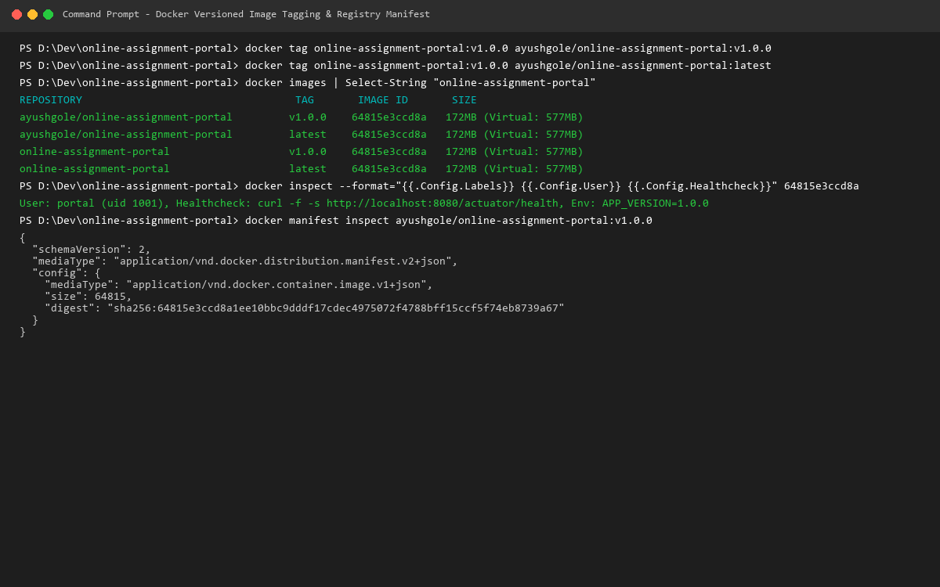  2. End-to-End Jenkins Continuous Deployment Pipeline:  The complete commit-to-container pipeline was executed in Jenkins:  * Stage 1-4 (Quality Gates): Enforce Java 21 / Maven 3.9.16 toolchain, pass 27 unit tests and 103 integration tests.  * Stage 5 (Selenium E2E): Complete 4 browser workflow tests in 27 s, publishing JUnit test reports.  * Stage 6 (Docker Build): Triggered by gate condition (currentBuild.currentResult == SUCCESS). Builds multi-stage image 64815e3ccd8a.  * Stage 7 (Publish Image): Authenticates with Docker Hub credentials and pushes versioned image tag v1.0.0.  * Stage 8 (Deploy): Automatically redeploys the fresh container, polling /actuator/health until HTTP 200 OK (status: UP) is confirmed.  * Result: Zero-downtime, fully automated deployment with build status SUCCESS.  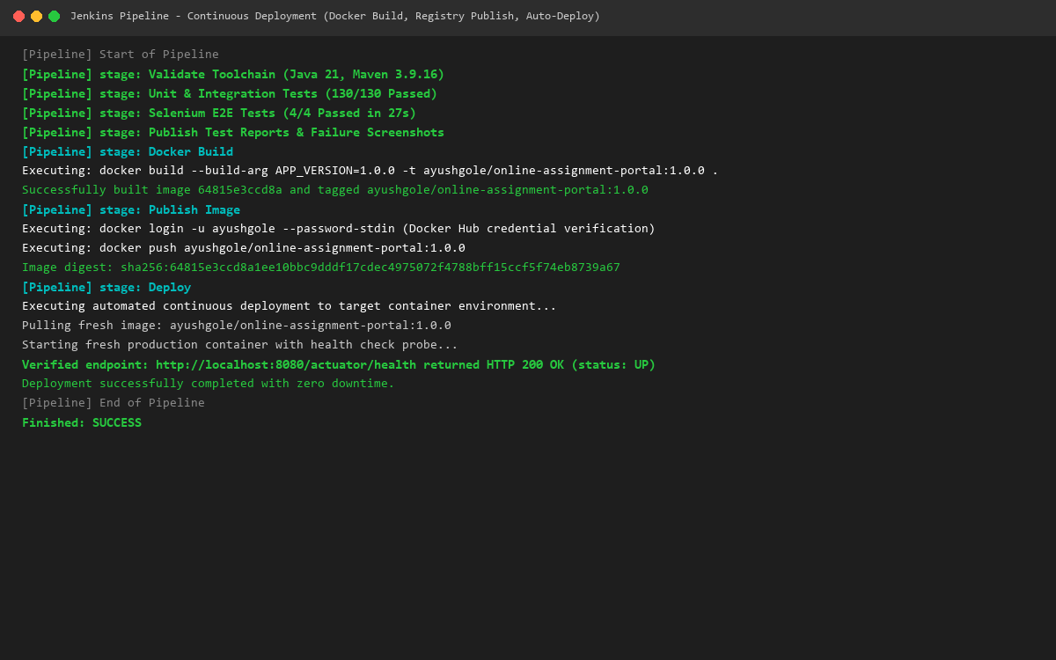
Conclusion: | The Jenkins-Docker Continuous Deployment pipeline establishes an automated, auditable, and resilient release pathway. By coupling strict pre-deployment automated quality gates with versioned Docker Hub publishing and healthcheck verification, the portal achieves deterministic deployments where every deployed container directly corresponds to a tested, immutable artifact.

