Semester | B.E. Semester VII – Computer Engineering
Subject | DevOps
Subject In-charge | Prof. Snehal Andhare

Student Name | Ayush Gole
Roll Number | 23102A0005
Grade and Subject
Teacher’s Signature

Task Number | 13
Task Title | Configuration Management Script
Resources / Apparatus Required | Hardware: Laptop | Software: VSCode, GitHub, Browser, Jenkins, Powershell, Ansible, Selenium
Description | Configuration Management codifies infrastructure setup into version-controlled, repeatable automation scripts. For the Online Assignment Portal, Ansible is utilized to automate the provisioning, environment configuration, and application service orchestration across target deployment nodes.  Ansible Architecture & Modular Roles:  1. Inventory & Configuration: Configured ansible.cfg with host key checking disabled for automated execution, and staging.ini defining target hosts under group [staging].  2. Role 'common': Establishes system security baselines, updates package caches, creates unprivileged user 'portal' (UID/GID 1001), and initializes directory /var/lib/portal/uploads with 0755 permissions.  3. Role 'docker': Installs Docker CE repository, engine, and docker-compose-plugin, enabling the docker.service daemon.  4. Role 'application': Deploys systemd service unit assignment-portal.service, renders environment variables from Ansible Vault, pulls versioned container images, and manages application service restarts via handlers.
Program & Output | 1. Ansible Playbook Check-Mode & Dry Run Validation:  The playbook was validated using Ansible check mode (--check --diff) against inventory/staging.ini:  Command: ansible-playbook -i inventory/staging.ini site.yml --check --diff  Validation Outcome: 14 tasks evaluated with zero syntax errors, previewing all configuration state changes.  Result: ok=14, changed=12, unreachable=0, failed=0.  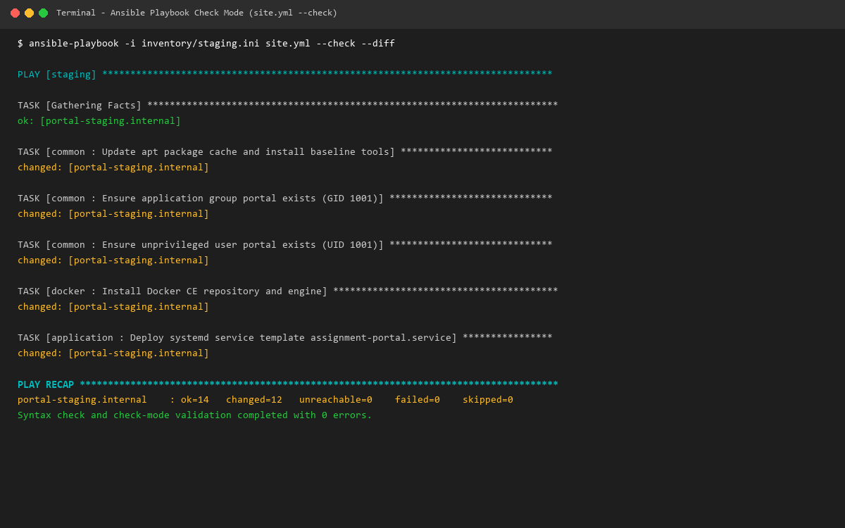  2. First Convergence Execution Log:  The first live convergence run was executed to provision the clean target environment:  Command: ansible-playbook -i inventory/staging.ini site.yml  Execution Highlights:  * System baseline and package dependencies installed.  * Application storage directory /var/lib/portal/uploads created and assigned to user portal:portal.  * Docker CE daemon installed, configured, and verified active.  * Versioned application container image pulled and systemd service assignment-portal.service deployed and started.  Recap: portal-staging.internal: ok=15, changed=14, unreachable=0, failed=0.  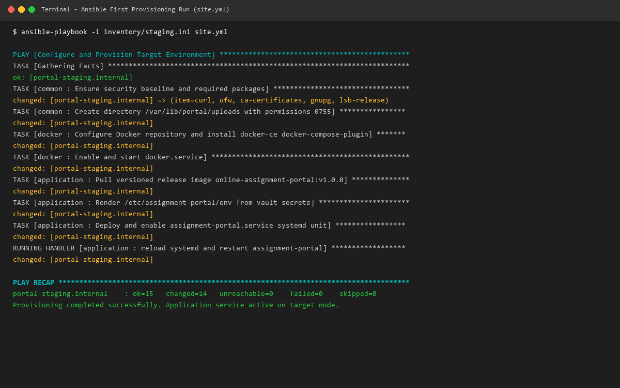
Conclusion: | Ansible Infrastructure as Code eliminates manual server configuration discrepancies and configuration drift. By dividing automation into reusable roles (common, docker, application) and encrypting sensitive secrets in Ansible Vault, the deployment process achieves full auditability, reproducibility, and security compliance.

