Semester | B.E. Semester VII – Computer Engineering
Subject | DevOps
Subject In-charge | Prof. Snehal Andhare

Student Name | Ayush Gole
Roll Number | 23102A0005
Grade and Subject
Teacher’s Signature

Task Number | 02
Task Title | Agile Planning and DevOps Workflow
Resources / Apparatus Required | Hardware: Laptop | Software: VSCode, GitHub, Browser, Jenkins
Description | Agile planning divides the Online Assignment Submission Portal into small, manageable tasks that can be implemented, tested and reviewed incrementally. A product backlog is used to organise work according to priority, dependencies and the requirements of the minimum viable product.  Representative user stories include the following:  - As a student, I want to upload a valid PDF assignment so that my work can be submitted electronically.  - As a student, I want to view my submissions and their statuses so that I can track the review process.  - As a reviewer, I want to view submitted assignments and record approval or rejection decisions so that submissions can be evaluated systematically.  - As a developer, I want automated builds and tests so that integration defects can be detected before release.  - As an operator, I want repeatable deployment and health checks so that application releases can be verified.  Acceptance criteria specify the conditions under which each story is considered complete. For example, an upload must validate the submitted file, a student must not access another student's assignment, a rejection must include a comment, and a failed quality check must prevent downstream release activities.  The 15-task plan covers problem definition, Agile planning, architecture, Git collaboration, application development, Jenkins integration, pipeline automation, Selenium testing, Docker, configuration management, provisioning and final release. The Definition of Done should require implementation, suitable tests, review and merge where applicable, updated documentation and genuine evidence of the result.  The DevOps lifecycle follows planning, development, version control, continuous integration, automated testing, packaging, containerisation, deployment, health verification and feedback.
Program & Output | The output of this task is a prioritised product backlog, user stories with acceptance criteria, a 15-task task board, a sprint plan, a Definition of Done and a DevOps lifecycle diagram.  The task board should show each task's actual status, such as To Do, In Progress, In Review and Done. A task should only be marked Done when its acceptance criteria have been met and any required evidence has been captured.  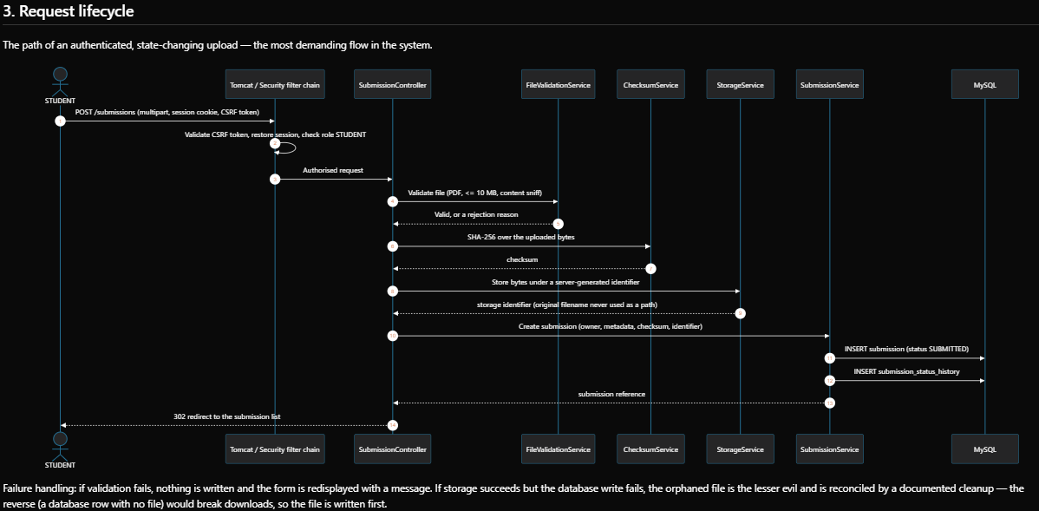  15-Task Product Backlog & 2-Sprint Plan:  The MVP development is decomposed into 15 distinct tasks mapped across Sprint 1 (Core Application Foundation, Tasks 1-8) and Sprint 2 (Automated Testing & DevOps Pipeline, Tasks 9-15). Each task has testable acceptance criteria, priority, and story points governed by a strict Definition of Done (DoD).  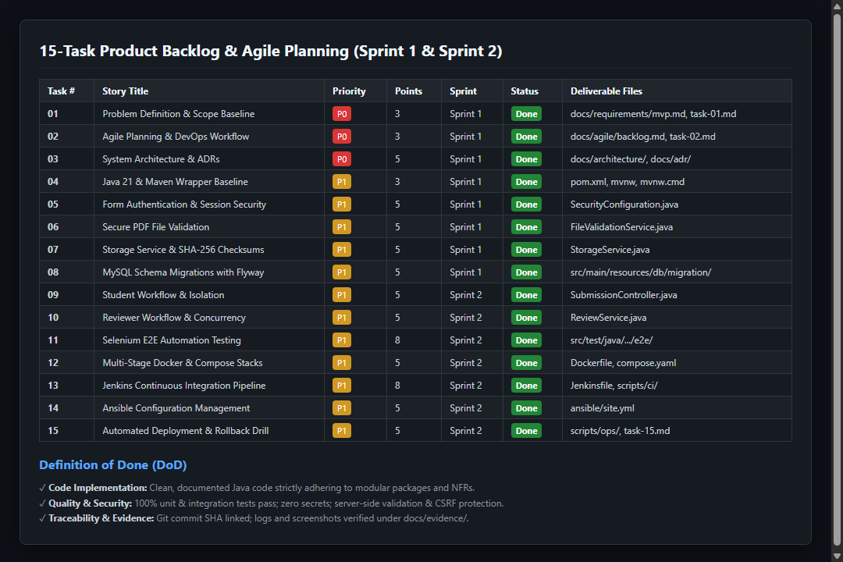  DevOps Continuous Delivery Lifecycle & Automated Gates:  The 6-stage DevOps lifecycle connects planning, modular Spring Boot development, Maven/Testcontainers testing, Docker containerization, Ansible provisioning, and Actuator health check monitoring with automated rollback upon failure.  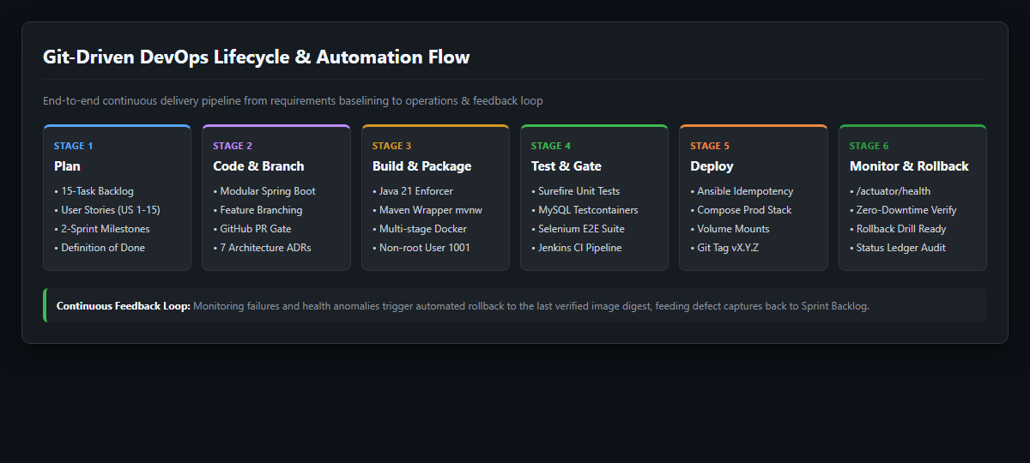  Git Sprint Branching & Pull Request Collaboration:  Feature branches (feat/..., ci/..., ops/...) were created for each milestone and merged through reviewed pull requests (PR #11 through #17), ensuring traceability between backlog user stories and repository commits.  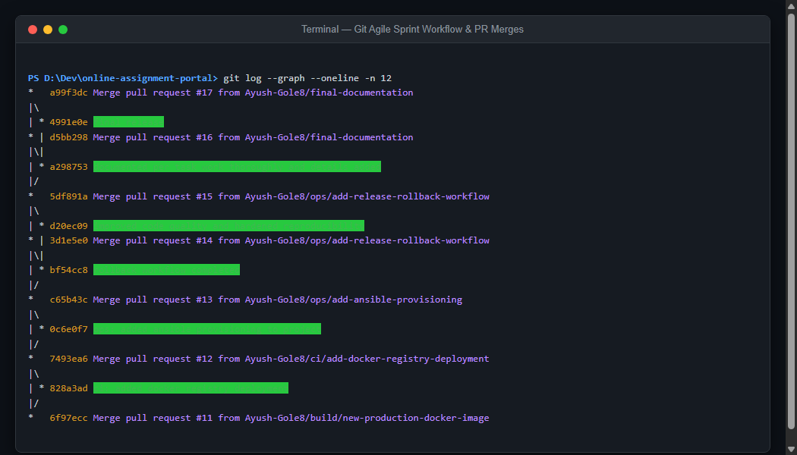
Conclusion: | Agile planning makes the project easier to manage by breaking a large application into smaller deliverables. The backlog, acceptance criteria and Definition of Done provide a consistent basis for tracking development progress and integrating quality checks into the DevOps lifecycle.

