Semester | B.E. Semester VII – Computer Engineering
Subject | DevOps
Subject In-charge | Prof. Snehal Andhare

Student Name | Ayush Gole
Roll Number | 23102A0005
Grade and Subject
Teacher’s Signature

Task Number | 04
Task Title | Git and GitHub Repository Initialization
Resources / Apparatus Required | Hardware: Laptop | Software: VSCode, GitHub, PowerShell
Description | Git is used to maintain the source history of the Online Assignment Submission Portal, while GitHub provides a central location for storing the repository and collaborating on changes.  Repository initialization establishes a structured project baseline. The repository should include project documentation, the application source code, test code, Maven build configuration, deployment resources, automation scripts and supporting diagrams. The README should explain the purpose of the portal, its technology stack, development setup and the major project workflows.  A .gitignore file prevents generated files, build output, local configuration and sensitive information from being committed. Meaningful commit messages make individual changes easier to identify. Branch naming rules distinguish feature development, bug fixes and maintenance work. Issue templates and contribution rules improve consistency when multiple contributors work on the project.  The repository also serves as the source of truth for the Jenkins pipeline, automated testing, Docker packaging and configuration-management resources. Changes should be reviewed before they are merged into the relevant shared branch.
Program & Output | The output is a GitHub repository containing the Online Assignment Submission Portal project structure and its initial source baseline.  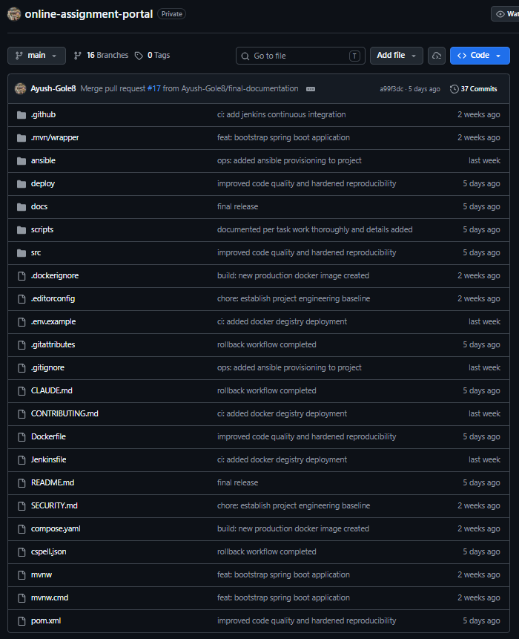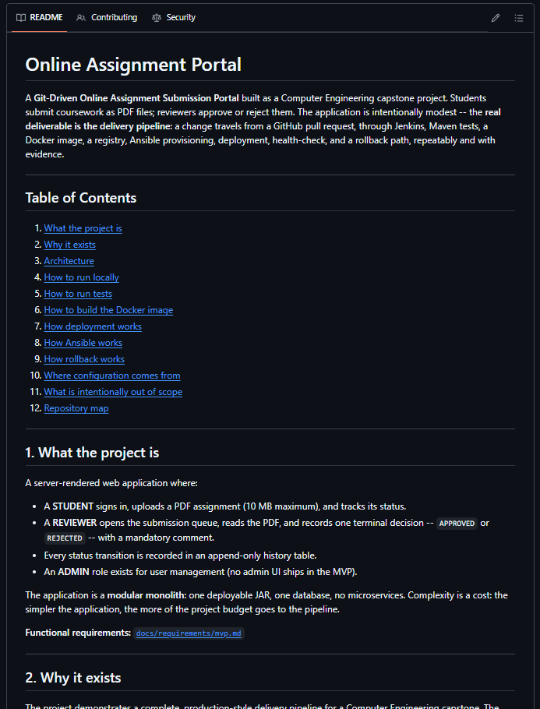
Conclusion: | Git and GitHub provide version control, collaboration and traceability throughout the project. A well-organised repository forms the foundation for feature development, code review, automated builds and release management.

