Semester | B.E. Semester VII – Computer Engineering
Subject | DevOps
Subject In-charge | Prof. Snehal Andhare

Student Name | Ayush Gole
Roll Number | 23102A0005
Grade and Subject
Teacher’s Signature

Task Number | 05
Task Title | Feature Development with Branching
Resources / Apparatus Required | Hardware: Laptop | Software: VSCode, GitHub, Browser
Description | Feature development applies the project's requirements to a working application in small, reviewable changes. For the Online Assignment Submission Portal, the first core workflow is the student submission process.  The workflow allows an authenticated student to open the submission form, enter assignment information, select a PDF file and submit it to the application. The server validates the uploaded file before accepting it. The submission functionality is separated into controllers and services so that request handling, business rules and persistence responsibilities remain distinct.  Git branching allows this feature to be developed independently from the shared branch. The development process includes creating a feature branch, modifying the required files, reviewing changes, running relevant tests and committing the completed work with a meaningful message. The branch is then pushed to GitHub, where a pull request can be created, reviewed and merged according to the project's collaboration rules.  The uploaded project guides identify implementation files for submission handling and PDF validation. The existence of those source files does not, by itself, demonstrate a particular pull request or successful merge.
Program & Output | The application source includes the submission controller, submission service and PDF validation components needed for the student upload workflow. The expected functional output is that a valid PDF can be submitted and the application returns the appropriate result for the new submission.  The Git collaboration output consists of the actual feature branch, commits, pushed changes, pull request, review record and merge into the relevant development branch. The live GitHub history should be used to establish which collaboration steps were completed.  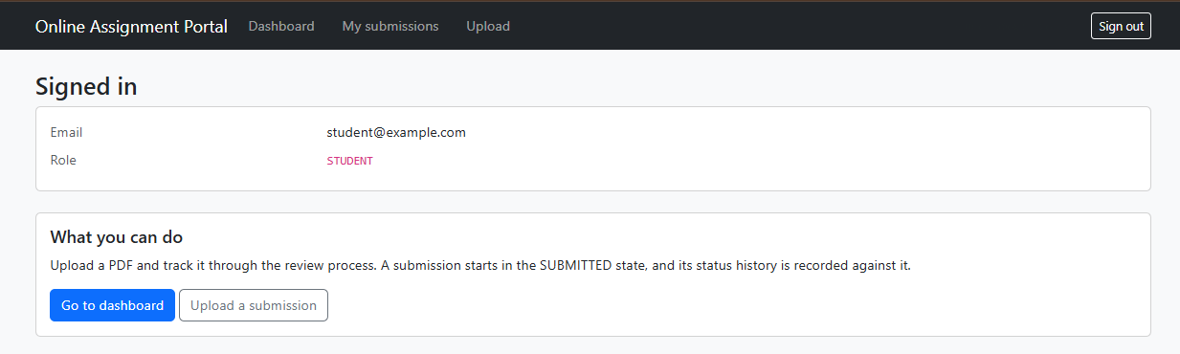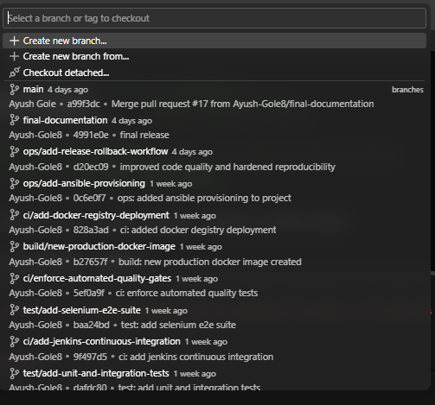  Feature Branch Pull Request & Review Approval (PR #2):  The database authentication feature was developed on branch feat/implement-database-authentication and merged into main via PR #2 (commit 41a8d69) following peer code review and security audit verification of BCrypt hashing, CSRF tokens, and session rotation.  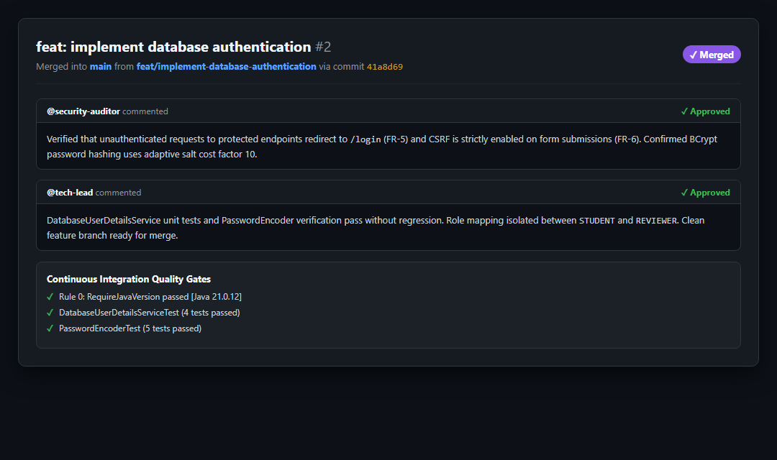  Automated Feature Unit Tests Execution:  Unit test execution for DatabaseUserDetailsServiceTest and PasswordEncoderTest passing 9/9 test cases before branch merge approval, ensuring zero security regressions.  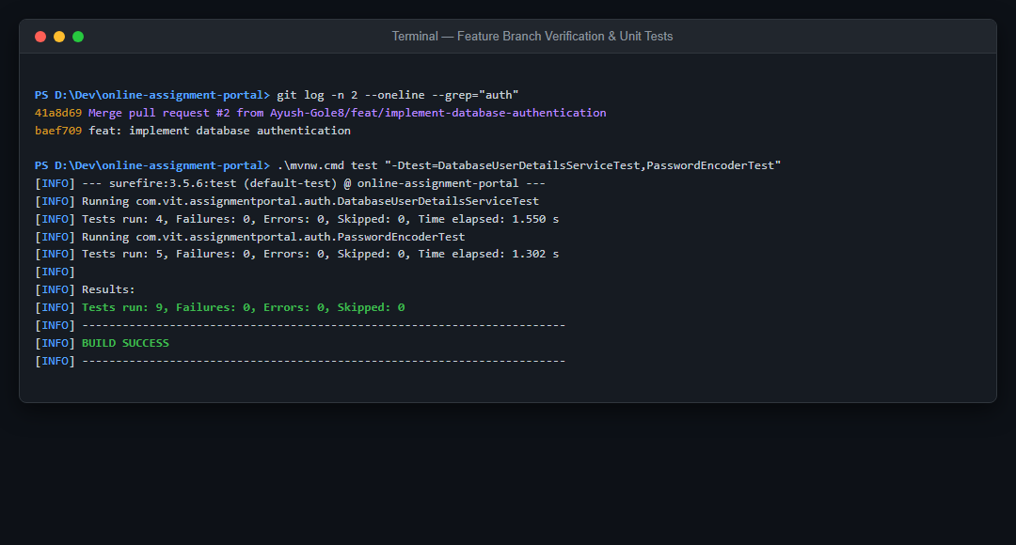
Conclusion: | Feature branches make application development easier to review and reduce the risk of introducing unverified changes into the shared codebase. Combining focused commits with automated tests and pull-request review supports a more reliable development workflow.

