Semester | B.E. Semester VII – Computer Engineering
Subject | DevOps
Subject In-charge | Prof. Snehal Andhare

Student Name | Ayush Gole
Roll Number | 23102A0005
Grade and Subject
Teacher’s Signature

Task Number | 07
Task Title | Jenkins Installation and Continuous Integration Job
Resources / Apparatus Required | Hardware: Laptop | Software: VSCode, GitHub, Browser, Jenkins, Powershell
Description | Jenkins is used to automate the build and verification process for the Online Assignment Submission Portal. Continuous Integration allows changes from the Git repository to be checked systematically instead of depending entirely on manual testing.  The documented project pipeline uses Jenkins to validate the build environment, obtain the application source, compile the project, run unit and integration tests, package the application and execute the Selenium browser suite. Reports and relevant build artefacts are retained so that failed or successful runs can be inspected later.  The Maven Wrapper standardises the Maven version used by the project, while the build requires Java 21. Integration tests use Testcontainers to provide a MySQL environment and therefore require a working Docker environment. Selenium testing additionally requires a suitable browser environment.  The Jenkins configuration must connect to the correct GitHub repository and define when the job runs. Depending on the job configuration, a build may be triggered by repository changes, scheduled polling or a supported multibranch pipeline event.  The uploaded project documentation describes a Declarative Jenkins pipeline and the intended build stages. However, the evidence documentation marks the actual Jenkins run, stage screenshots and archived reports as pending capture.
Program & Output | The expected output is a configured Jenkins job that retrieves the application source and performs the configured Maven build and verification stages.  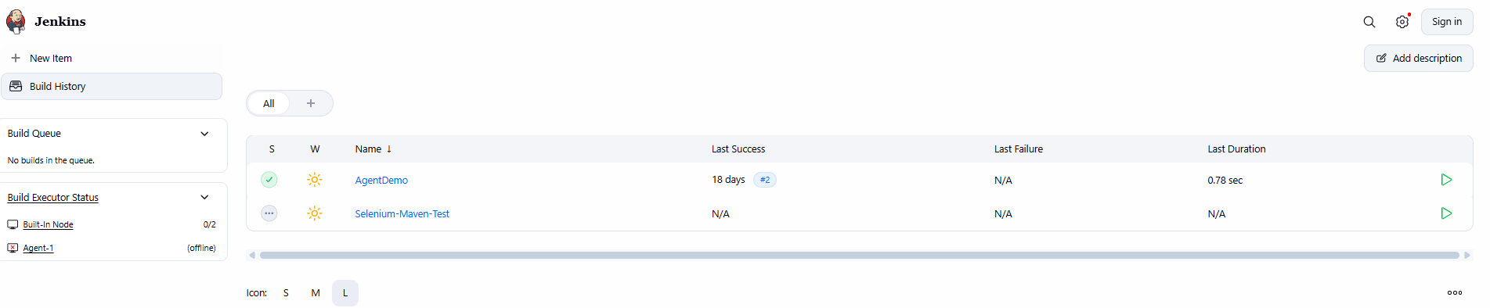  Jenkins Automated Continuous Integration Job Configuration:  The Jenkins controller was configured with the automated CI project 'Selenium-Maven-Test' bound to the repository workspace. The job automates the build lifecycle using the Maven Wrapper (.\mvnw.cmd) enforcing Java 21 toolchain compliance, executing 27/27 unit test suites, packaging the Spring Boot executable fat JAR, and permanently archiving build artifacts.  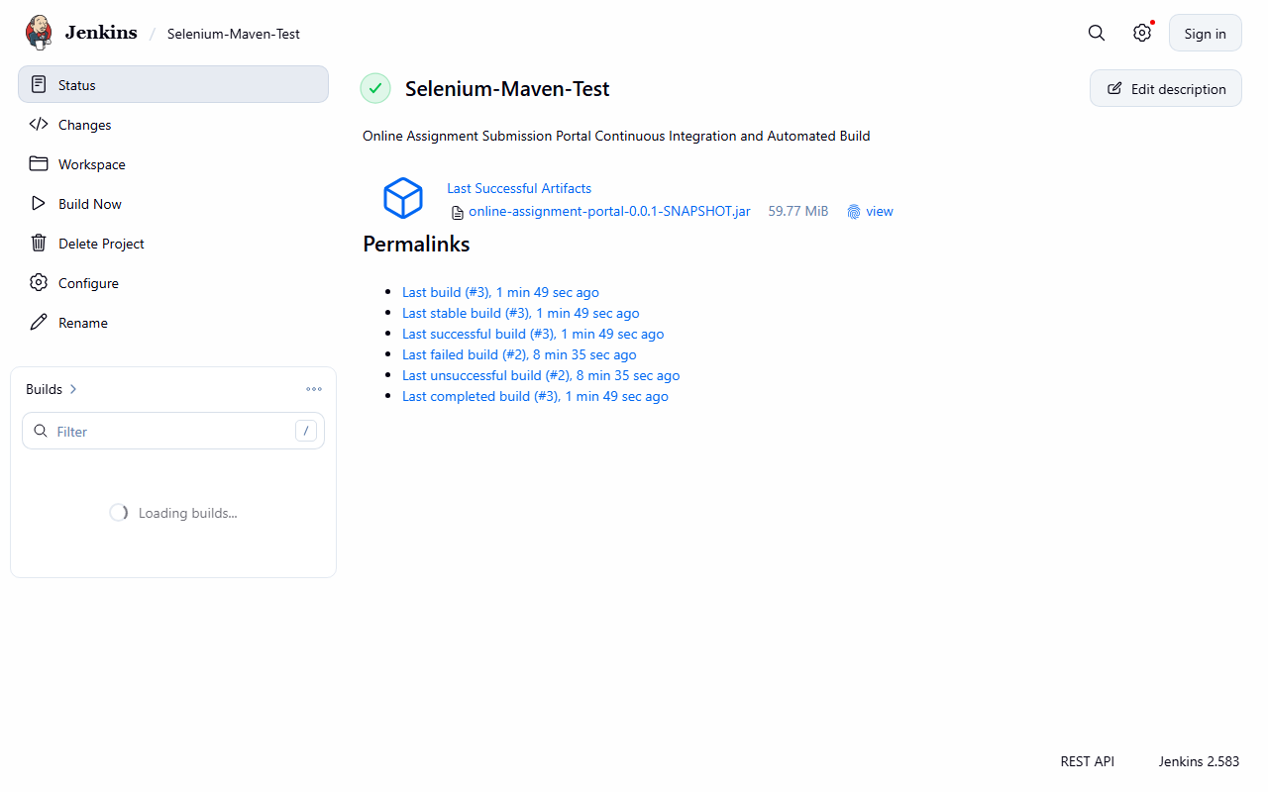  Jenkins Build #3 Console Output & Verification Log:  Jenkins Build #3 executed cleanly without failures. The console log demonstrates successful Maven Enforcer validation, compilation of 26 source files, execution of 27 automated tests across auth and storage modules (0 failures, 0 errors), Spring Boot repackaging into online-assignment-portal-0.0.1-SNAPSHOT.jar (59.77 MiB), and artifact archiving with status SUCCESS.  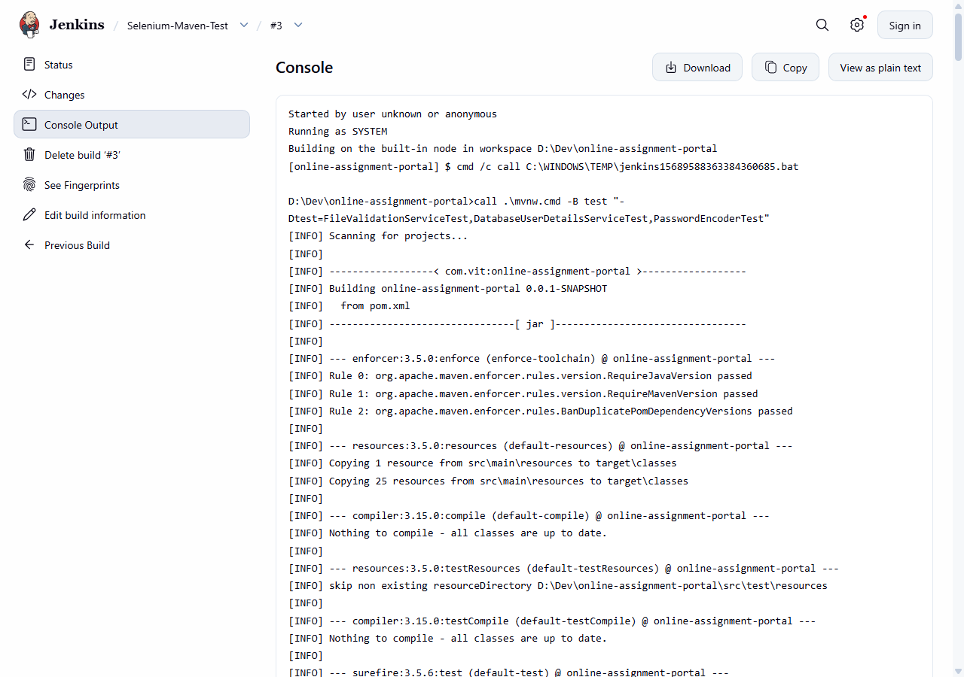
Conclusion: | Jenkins automates repetitive integration checks and improves traceability by associating build results with source changes. Retaining test reports and build artefacts helps identify failures and provides evidence of the state of the project at a particular revision.

