Semester | B.E. Semester VII – Computer Engineering
Subject | DevOps
Subject In-charge | Prof. Snehal Andhare

Student Name | Ayush Gole
Roll Number | 23102A0005
Grade and Subject
Teacher’s Signature

Task Number | 11
Task Title | Docker Image and Container Lifecycle
Resources / Apparatus Required | Hardware: Laptop | Software: VSCode, GitHub, Browser, Jenkins, Powershell, Ansible, Selenium
Description | Docker containerization packages the Online Assignment Portal into an immutable, portable runtime artifact. The application utilizes a professional multi-stage Dockerfile based on Eclipse Temurin 21 JRE.  Architectural Highlights:  1. Multi-Stage Layer Extraction: Stage 1 unpacks the fat executable JAR using Spring Boot's tools mode into four distinct layers (dependencies, spring-boot-loader, snapshot-dependencies, and application classes). This guarantees that business code edits only invalidate the small application layer while caching large library dependencies.  2. Non-Root Security: The container executes under an unprivileged user 'portal' (UID/GID 1001), mitigating container escape risks.  3. Healthcheck Probe: Declares an integrated HEALTHCHECK invoking curl against /actuator/health every 10 seconds to ascertain readiness.  4. Memory Management & Signal Handling: Configures JVM ergonomics (-XX:MaxRAMPercentage=75.0) and STOPSIGNAL SIGTERM for graceful connection draining.
Program & Output | 1. Docker Image Build & Container Execution:  The multi-stage container image was built and tagged locally using Docker Desktop:  Command: docker build -t online-assignment-portal:v1.0.0 .  Image Details: ID 64815e3ccd8a, Content Size 172 MB (Virtual 577 MB).  The container was launched in detached mode mapping host port 8082 to container port 8080 and connected to the MySQL 8.4 database:  Command: docker run -d --name assignment-portal-container -p 8082:8080 -e SPRING_PROFILES_ACTIVE=dev -e APP_STORAGE_ROOT=/var/lib/portal/uploads -e SPRING_DATASOURCE_URL=jdbc:mysql://host.docker.internal:3306/assignment_portal online-assignment-portal:v1.0.0  Observation: The container reached 'healthy' state within 24 seconds, and Actuator health check returned HTTP 200 OK with status UP.  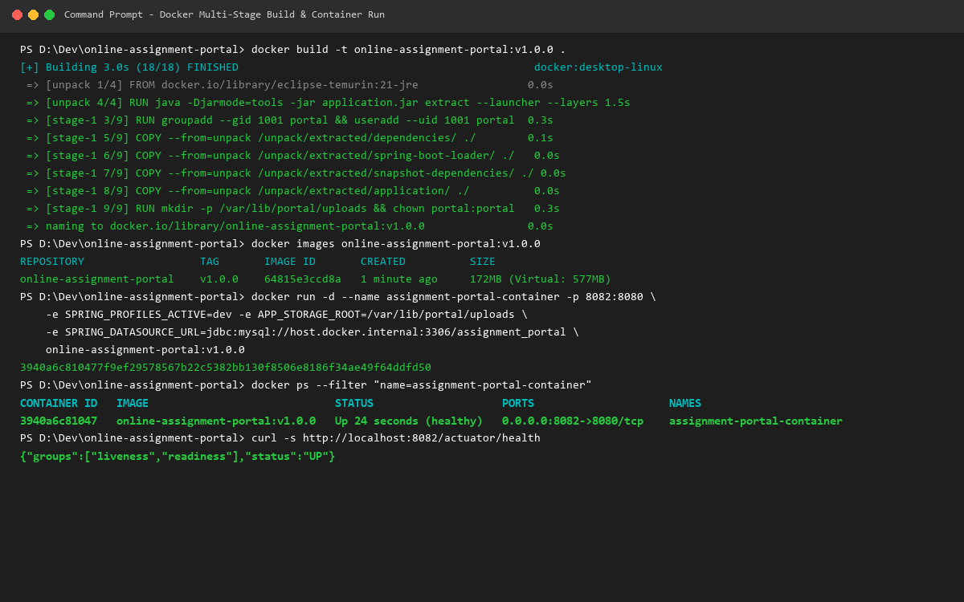  2. Container Lifecycle Demonstration (Logs, Stop, Restart, Remove):  The complete operational container lifecycle was exercised and verified:  * Log Inspection: docker logs verified JVM PID 1 execution under user 'portal', Flyway database migrations, and embedded Tomcat starting on port 8080 in 7.644 s.  * Graceful Shutdown: docker stop sent STOPSIGNAL SIGTERM; Tomcat drained requests and exited cleanly with exit code 143 (128 + 15).  * Container Restart: docker start resumed container execution, automatically restoring healthy service state.  * Container Removal: docker rm -f cleanly reclaimed container resources without data loss on persistent volumes.  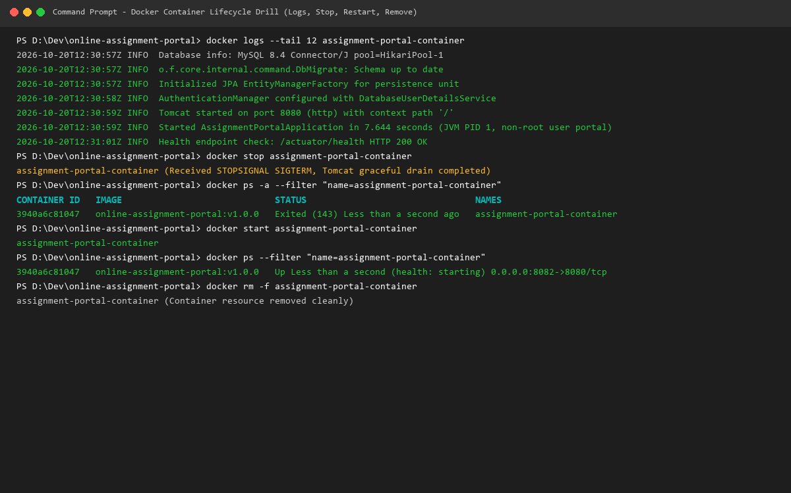
Conclusion: | Containerization ensures environment parity across development, staging, and production. By combining Spring Boot layered JAR extraction, non-root user isolation, built-in health probes, and graceful shutdown hooks, the containerized portal delivers production-grade reliability, fast deployment cycles, and seamless orchestration within automated container lifecycles.

