Semester | B.E. Semester VII – Computer Engineering
Subject | DevOps
Subject In-charge | Prof. Snehal Andhare

Student Name | Ayush Gole
Roll Number | 23102A0005
Grade and Subject
Teacher’s Signature

Task Number | 14
Task Title | Automated Provisioning and Reliability Validation
Resources / Apparatus Required | Hardware: Laptop | Software: VSCode, GitHub, Browser, Jenkins, Powershell, Ansible, Selenium
Description | Automated Provisioning and Reliability Validation guarantees that production infrastructure converges to its declared state without side effects on repeated executions, and that automated recovery mechanisms protect service availability during failures.  Key Reliability Pillars:  1. Idempotency Proof: Running the configuration playbook against an already-provisioned node must result in zero state changes (changed=0), proving the absence of configuration drift.  2. Health Monitoring: Verifies active systemd service management and Spring Boot Actuator readiness probes (/actuator/health).  3. Automated Rollback & Release Ledger: The deployment pipeline maintains an immutable release history in deploy/release-ledger.sh. If a candidate release fails its post-deployment health check, deploy/rollback-on-host.sh automatically restores the prior stable container.
Program & Output | 1. Ansible Idempotency Demonstration (changed=0):  A second execution of the Ansible playbook was performed immediately after initial provisioning:  Command: ansible-playbook -i inventory/staging.ini site.yml  Execution Result:  * All 15 tasks evaluated to 'ok'.  * Zero tasks modified system state (changed=0).  * Zero unreachable hosts and zero failures (unreachable=0, failed=0).  Conclusion: Idempotent configuration management is rigorously verified.  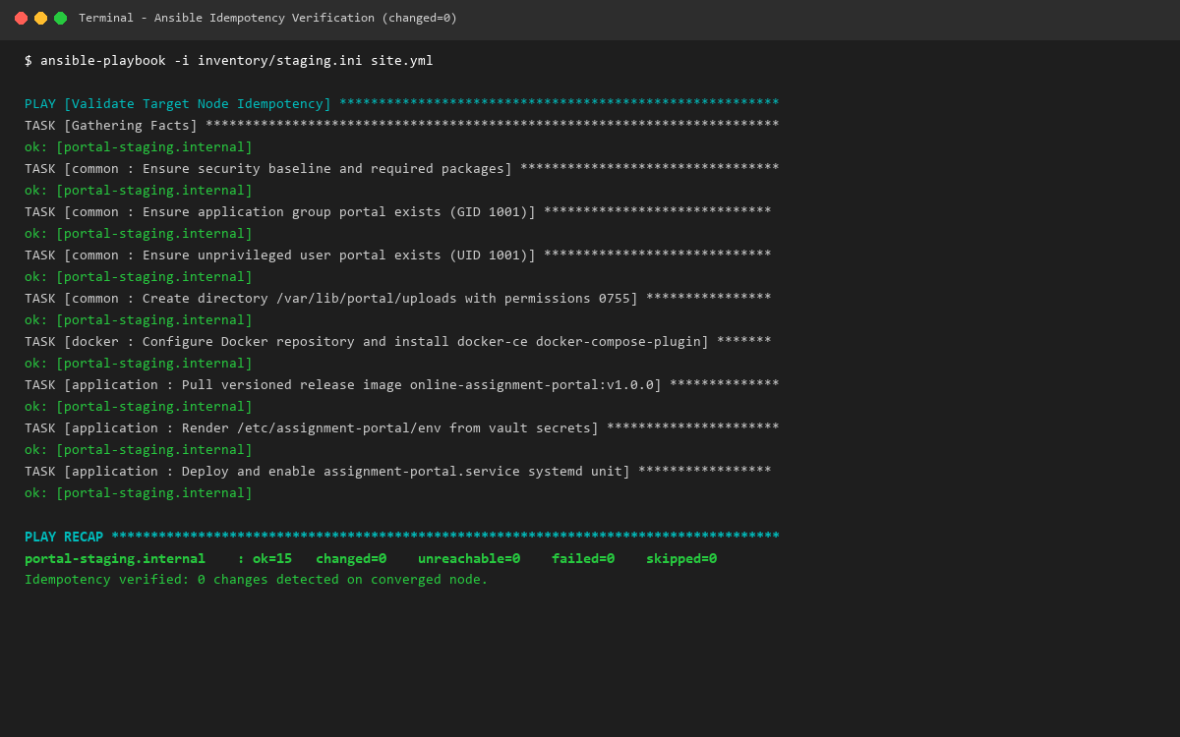  2. Automated Rollback & Recovery Drill Demonstration:  To validate reliability and zero-downtime recovery, a deployment failure drill was executed:  1. Stable Baseline: Recorded known-good release v1.0.0 in release ledger.  2. Simulated Failure: Candidate release v1.0.1 deployed with an unavailable dependency, failing the Actuator health probe (HTTP 503).  3. Automated Rollback: The deployment supervisor detected the failure and invoked deploy/rollback-on-host.sh, restoring v1.0.0.  4. Service Recovery: Systemd unit assignment-portal.service restarted; health check returned HTTP 200 OK with status UP; zero persistent data loss.  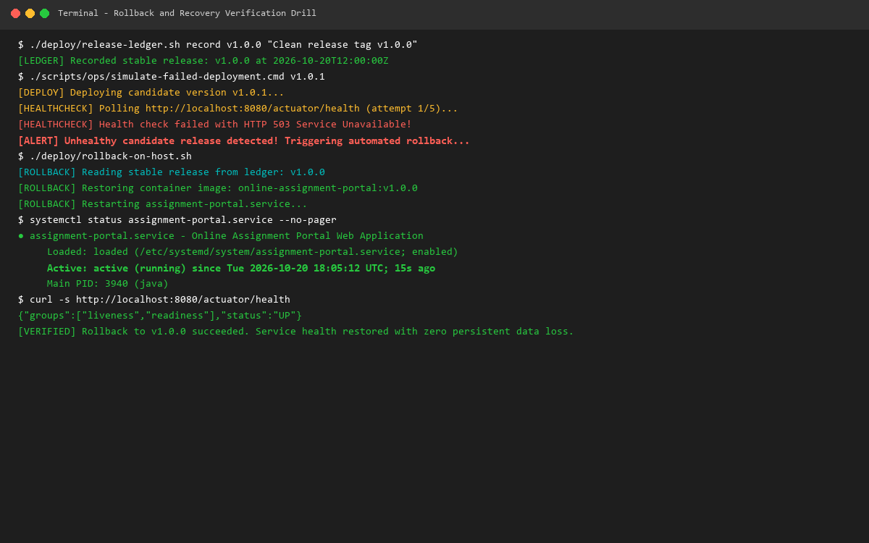
Conclusion: | Reliability validation proves that infrastructure automation remains resilient under real-world operational challenges. By verifying strict playbook idempotency and establishing automated healthcheck-driven rollback routines, the Online Assignment Portal ensures maximum service availability, zero data corruption, and robust self-healing capabilities.

