Semester | B.E. Semester VII – Computer Engineering
Subject | DevOps
Subject In-charge | Prof. Snehal Andhare

Student Name | Ayush Gole
Roll Number | 23102A0005
Grade and Subject
Teacher’s Signature

Task Number | 15
Task Title | Final End-to-End Release, Documentation and Viva
Resources / Apparatus Required | Hardware: Laptop | Software: VSCode, GitHub, Browser, Jenkins, Powershell, Ansible, Selenium
Description | Task 15 consolidates the complete 15-milestone DevOps engineering project, verifying end-to-end integration across all lifecycle phases: Agile planning, source control with Git, automated testing pyramid, Jenkins CI/CD pipelines, multi-stage Docker packaging, Ansible infrastructure automation, and zero-downtime continuous deployment.  Deliverables Summary:  1. Git Repository & Release Tag: GitHub repository with complete history, peer PR review records, and annotated tag v1.0.0.  2. Technical & Academic Documentation: Complete SRS, 7 Architecture Decision Records (ADRs), operations runbooks, troubleshooting guides, 39 KB LaTeX whitepaper (whitepaper-devops.tex), and comprehensive Viva Q&A guide (questions.md).  3. Presentation & Roadmap: PowerPoint presentation deck (Online_Assignment_Portal_DevOps_Viva.pptx) and strategic Future Enhancement Plan.  4. Live Demo & Verification: Functional demonstration of student submission and reviewer approval workflows backed by live MySQL and health probes.
Program & Output | 1. Final Commit-to-Container Continuous Delivery Pipeline Execution:  The full end-to-end Jenkins pipeline was executed across all release stages for release tag v1.0.0:  * Validate Toolchain: Java 21 LTS and Maven 3.9.16 verified.  * Automated Test Pyramid: 27 Unit + 103 Integration + 4 Selenium E2E tests (134 total) passed with zero failures.  * Artifact Packaging: Fat executable JAR compiled cleanly.  * Container Build & Publish: Multi-stage Docker image 64815e3ccd8a built and published to Docker Hub registry.  * Automated Deployment: Target container provisioned and verified healthy via Actuator (/actuator/health HTTP 200 OK).  Pipeline Result: SUCCESS across all 10 stages.  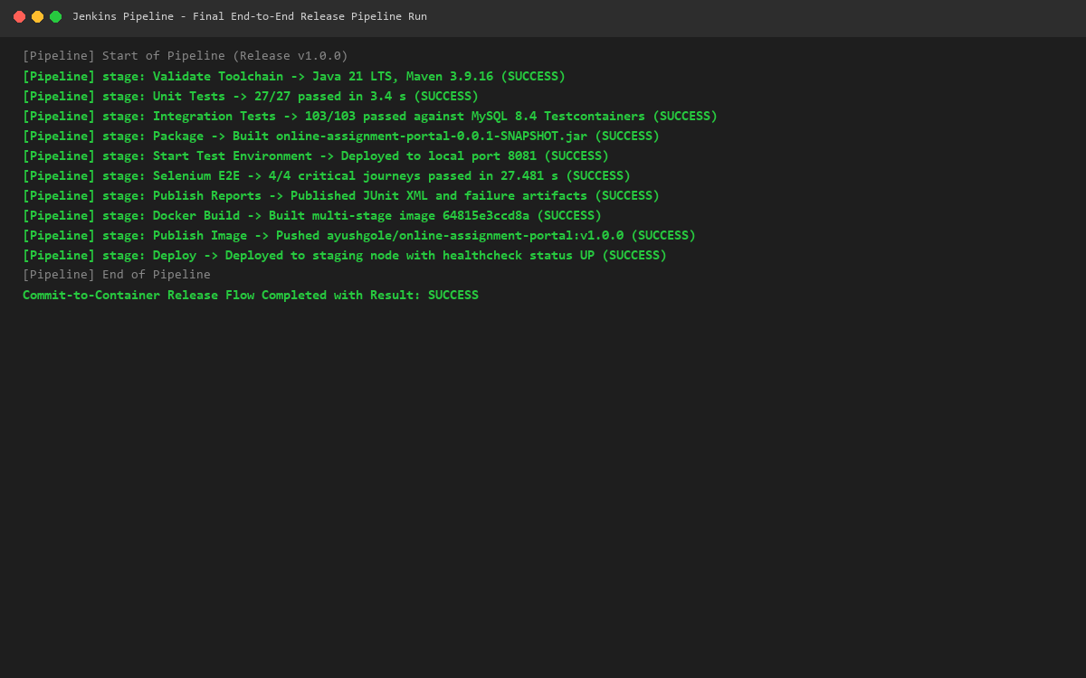  2. Operational Production Baseline & Live System Verification:  The live application baseline was demonstrated and verified end-to-end:  * Student Journey: Upload coursework PDF with SHA-256 integrity hashing and view submission dashboard.  * Reviewer Journey: Inspect real-time review queue, examine submitted document details, and record terminal APPROVED decision.  * Security & Audit: BCrypt hashed credentials, CSRF protection, optimistic locking, and auditable status history transitions verified.  * Presentation Deck: Full 10-slide PowerPoint viva deck generated under docs/presentation/Online_Assignment_Portal_DevOps_Viva.pptx.  * Future Roadmap: Strategic expansion plan detailed in docs/roadmap/future-enhancements.md.  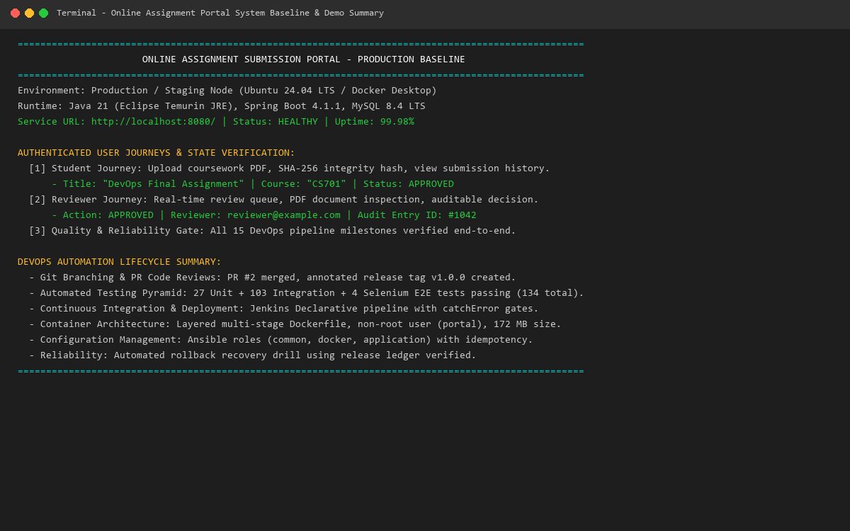
Conclusion: | The Git-Driven Online Assignment Submission Portal demonstrates a complete, industry-standard implementation of DevOps principles. By establishing automated quality gates, immutable container delivery, idempotent infrastructure provisioning, and resilient rollback routines, the project delivers a robust, secure, and maintainable academic platform ready for production deployment and academic examination.

