Semester | B.E. Semester VII – Computer Engineering
Subject | DevOps
Subject In-charge | Prof. Snehal Andhare

Student Name | Ayush Gole
Roll Number | 23102A0005
Grade and Subject
Teacher’s Signature

Task Number | 03
Task Title | Requirements, Architecture and Technology Setup
Resources / Apparatus Required | Hardware: Laptop | Software: VSCode, GitHub, Browser, Jenkins, JDK, Spring Boot, Maven, MySQL
Description | The Online Assignment Submission Portal uses a modular monolithic architecture. The application is packaged as a single Spring Boot executable JAR while its source code is organised into feature-focused packages. The documented package structure includes authentication, submission management, review, storage, configuration and common components.  The architecture separates the user interface, controllers, service layer, persistence components and file-storage functionality. Students interact with the portal to submit and track assignments, while reviewers use protected review routes to evaluate submissions and record decisions.  MySQL is used for persistent application data. Flyway manages database schema changes through versioned migrations, while Hibernate validates entity mappings against the database schema. Uploaded PDF files are stored separately from database metadata. The application records a SHA-256 checksum to support file-integrity verification.  Java 21 is the required runtime and compilation target. The Maven Wrapper standardises the Maven version, and the Maven Enforcer configuration checks the Java and Maven toolchain. Docker Compose is documented as the mechanism for running the application and database as a containerised stack.  The architecture documentation also records technical decisions and explains the dependency structure. The current implementation has known scope limitations, including the missing administration interface and dedicated security-event audit trail.
Program & Output | The main outputs are the software requirements summary, use-case diagram, system architecture diagram, application package structure, data model, principal application routes and a configured local development environment.  The documented application includes routes for login, the student dashboard, submission upload and listing, submission details, the review queue and reviewer details. Health and version information are exposed through application management endpoints.  The Maven Wrapper and project configuration specify Java 21 and Maven 3.9.16. The complete verification command requires Docker for the documented Testcontainers integration tests. A packaging-only build does not establish that all tests pass.  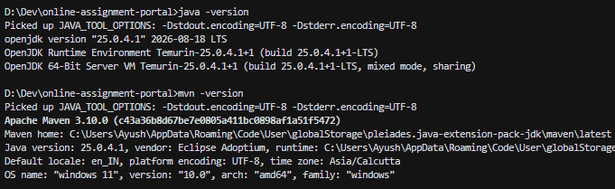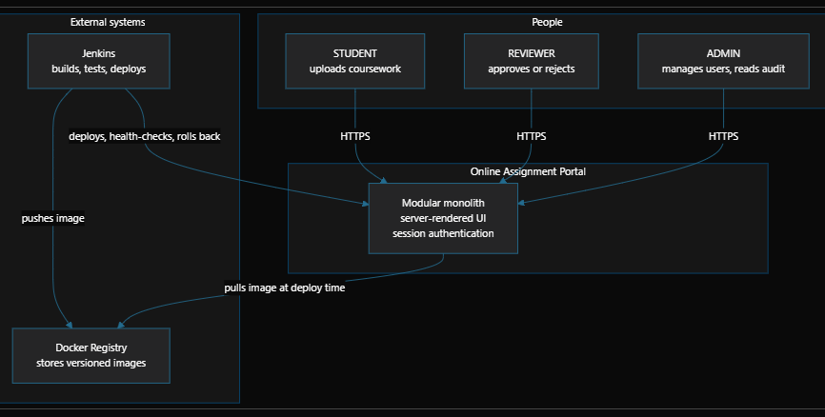  UML Use Case Diagram & Actor Interactions:  The application defines four interacting boundaries: STUDENT (submitting and tracking assignments), REVIEWER (evaluating submissions from the FIFO review queue), ADMIN (managing users and inspecting audit records), and the automated SYSTEM pipeline (enforcing server-side PDF validation, SHA-256 digests, Flyway migrations, and Actuator readiness checks).  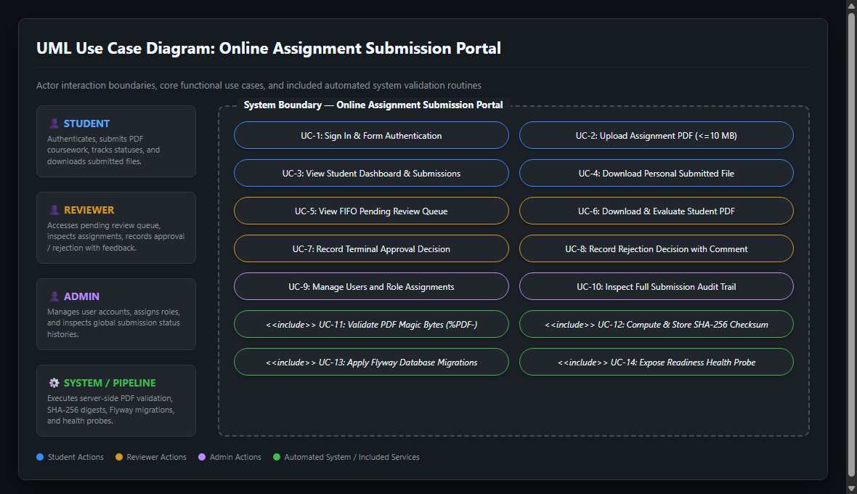  Java 21 Toolchain & Maven Enforcer Build Verification:  The build toolchain is pinned to Maven 3.9.16 via the Maven Wrapper (mvnw) and strictly enforced by the maven-enforcer-plugin to require Java 21, guaranteeing zero toolchain drift between developer workstations and CI build environments.  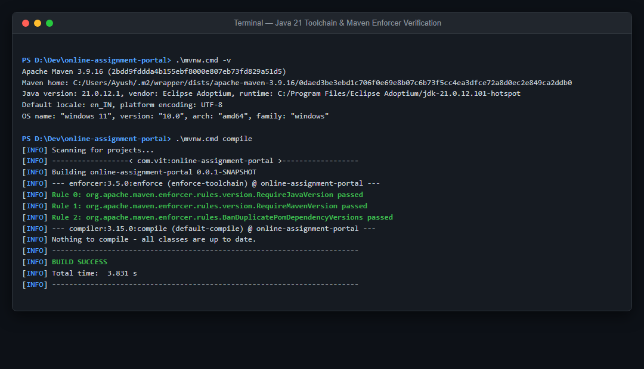
Conclusion: | A documented modular monolith provides a practical starting point for the portal because it maintains clear feature boundaries without adding unnecessary distributed-system complexity. Standardising the Java and Maven toolchain, database migrations and local environment improves reproducibility and maintainability.

