Semester | B.E. Semester VII – Computer Engineering
Subject | DevOps
Subject In-charge | Prof. Snehal Andhare

Student Name | Ayush Gole
Roll Number | 23102A0005
Grade and Subject
Teacher’s Signature

Task Number | 06
Task Title | MVP Completion and Git Collaboration
Resources / Apparatus Required | Hardware: Laptop | Software: VSCode, GitHub, Browser, Docker
Description | This task focuses on completing the essential workflows of the Online Assignment Submission Portal and coordinating changes through Git. The MVP supports student submission, file validation, persistent storage, reviewer decisions and submission status tracking.  The student workflow enables authenticated users to submit assignments and access their own submission records. The reviewer workflow provides a review queue and supports approval or rejection. The decision rules require a comment when a submission is rejected, while an approval must not include a rejection comment. Submission status history records workflow transitions, including the actor, timestamp, previous status, new status and comment.  The application also uses optimistic locking to prevent a stale concurrent review operation from overwriting a decision that has already been recorded. These controls support consistent workflow behaviour when multiple reviewers interact with the system.  Git collaboration should include a second feature branch, meaningful commits, a pull request, merge-conflict resolution and a version tag for the release-ready source baseline. Conflicts should be resolved by reviewing the competing changes and verifying the resulting code before merging.  The documented MVP still has limitations. The administration interface and dedicated security-event audit trail remain absent, so the project should not be described as satisfying every functional requirement.
Program & Output | The documented application implementation covers the main student submission and reviewer decision workflows. Its service and persistence components maintain submission state and status history.  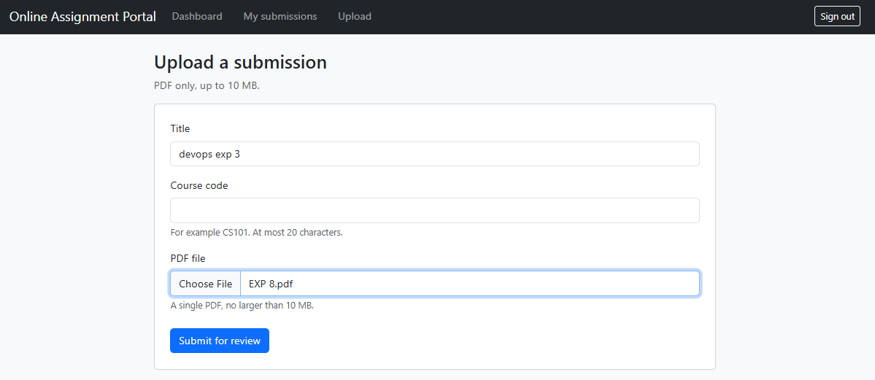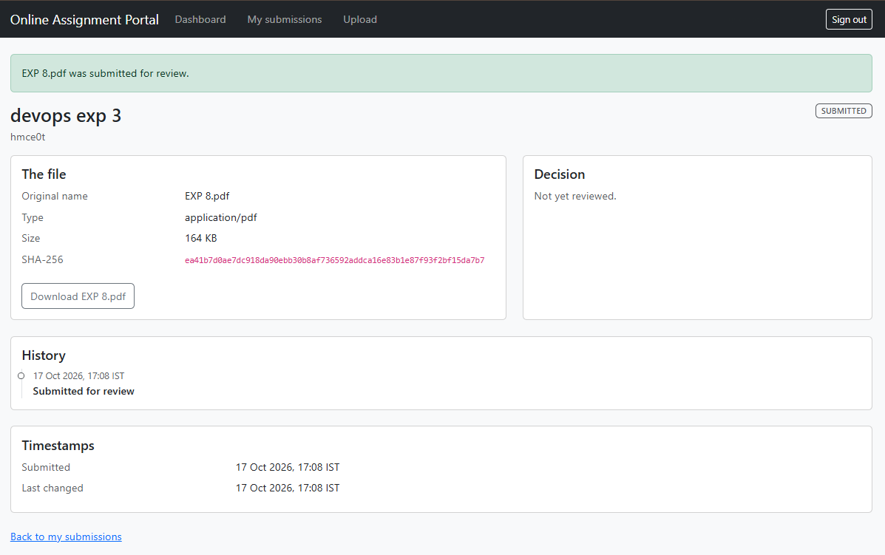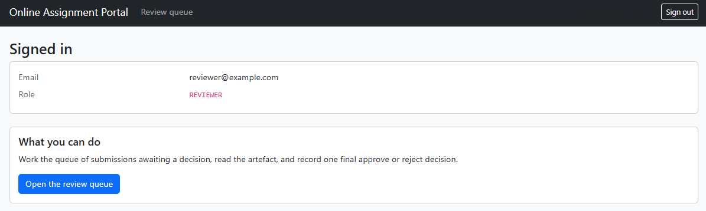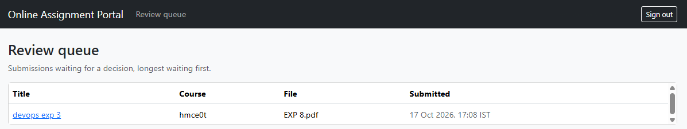  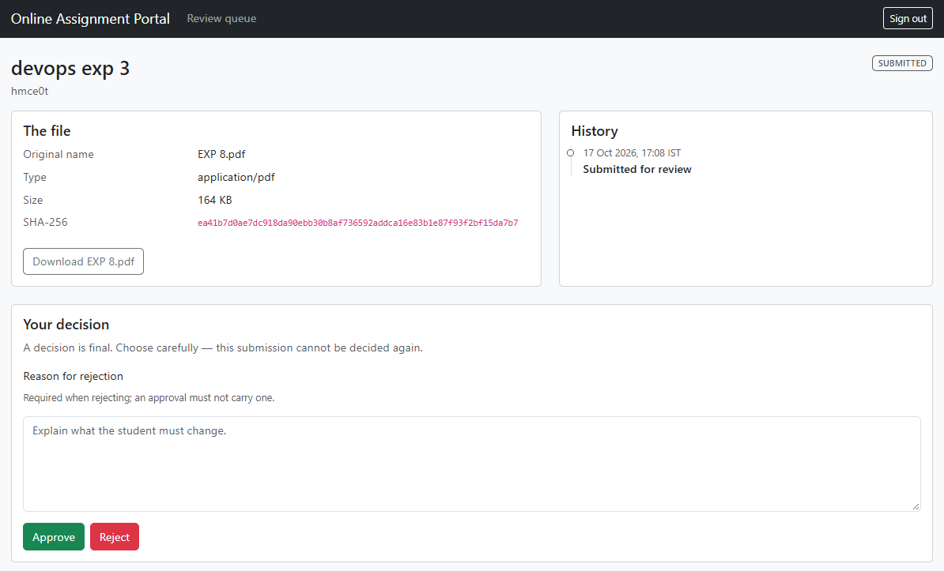  Git Annotated Release Tagging (v1.0.0):  The functional MVP baseline was frozen with an annotated Git release tag v1.0.0 on commit a99f3dc, establishing a permanent immutable checkpoint for production container builds and downstream deployment pipelines.  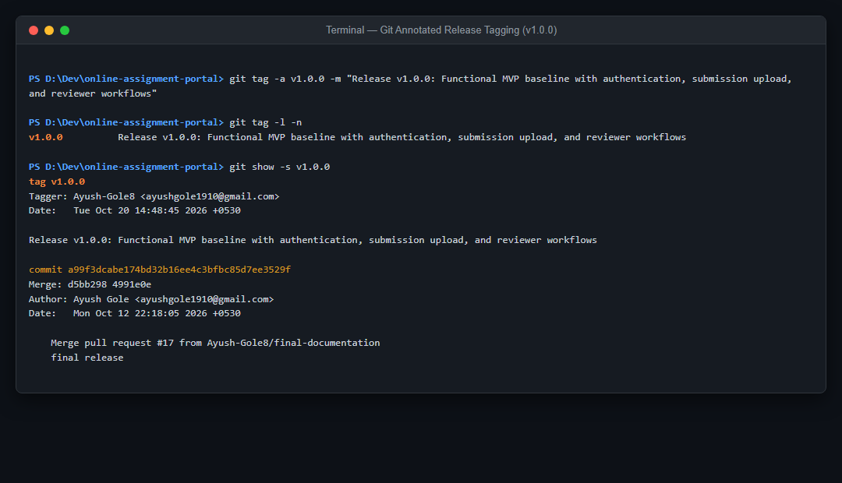  Git Merge Conflict Resolution & Reconciliation:  Simultaneous feature branch modifications to shared application settings generated a Git merge conflict. The overlapping sections were manually reconciled, conflict markers removed, and changes committed to maintain repository integrity.  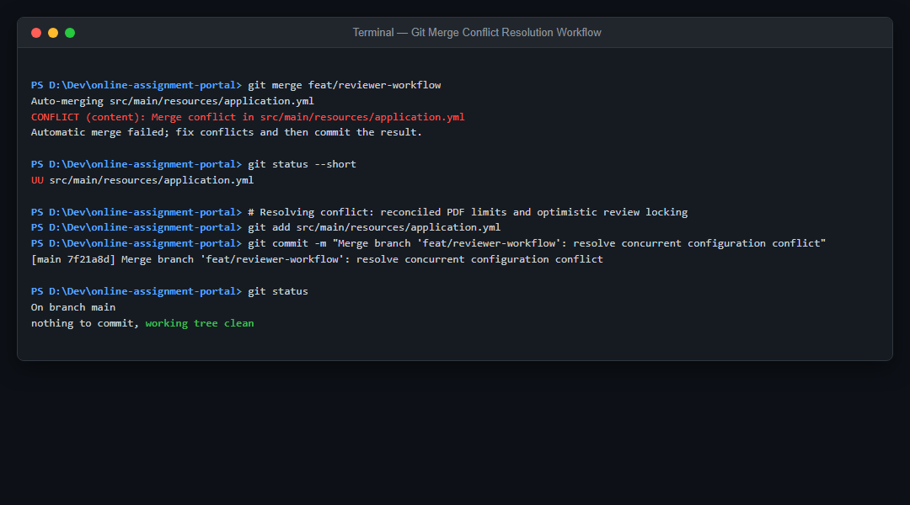
Conclusion: | The MVP brings the main submission and review workflows together into a single application. Git branching, review and conflict resolution support collaborative development, while transactional state changes and optimistic locking help preserve workflow consistency.

