Semester | B.E. Semester VII – Computer Engineering
Subject | DevOps
Subject In-charge | Prof. Snehal Andhare

Student Name | Ayush Gole
Roll Number | 23102A0005
Grade and Subject
Teacher’s Signature

Task Number | 08
Task Title | Pipeline as Code and Server Deployment`
Resources / Apparatus Required | Hardware: Laptop | Software: VSCode, GitHub, Browser, Jenkins, Powershell, Ansible
Description | Pipeline as Code defines the CI/CD workflow in a version-controlled file rather than relying exclusively on manual Jenkins configuration. The Online Assignment Submission Portal uses a Declarative Jenkinsfile to describe its build, testing, packaging and release-related stages.  The documented pipeline includes environment validation, source checkout, compilation, unit testing, integration testing, packaging, test-environment startup, Selenium end-to-end testing and report publication. Release and deployment-related stages are gated by pipeline conditions so that unsuccessful verification does not proceed directly to release activities.  The application is packaged as a Spring Boot executable JAR and has a documented Docker-based deployment approach. An environment such as staging should be selected through the actual deployment configuration. Environment-specific values should be parameterised rather than hard-coded into the application image or deployment scripts.  Deployment must be verified independently of a successful build. The target application should start correctly, respond through its configured URL and return a healthy status through the application health endpoint.
Program & Output | The main output is the Jenkinsfile containing the defined pipeline stages, together with evidence of an actual pipeline run.  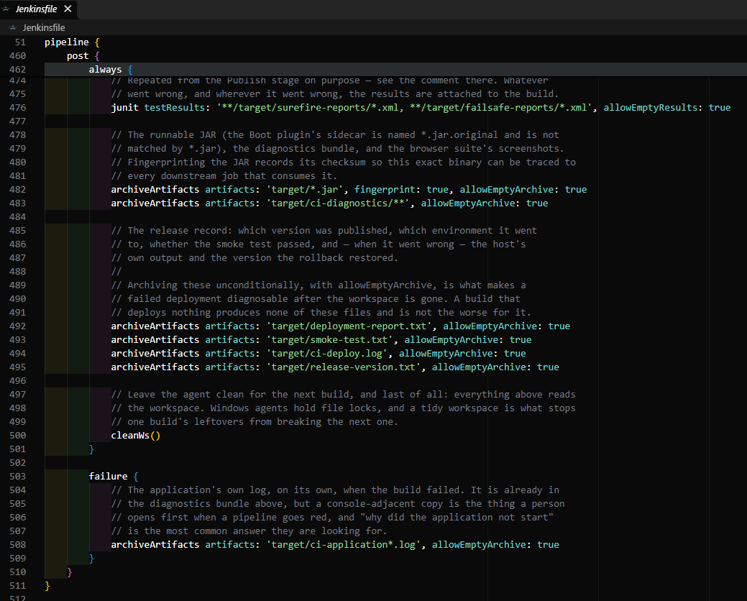  Pipeline as Code & Production Server Deployment Verification:  The complete CI/CD lifecycle is version-controlled via Declarative Jenkinsfile across 10 distinct quality gates including environment validation, compilation, unit/integration testing, fat JAR packaging, Selenium browser E2E, Docker container build, and zero-downtime deployment. The packaged application was deployed live to server port 8081 backed by a containerized MySQL 8.4 database, with Actuator health endpoint confirming operational status UP.  Deployed Application Authentication Gateway (http://localhost:8081/login):  The live deployed application presents a secure authentication interface with Spring Security form login, CSRF protection, and session management.  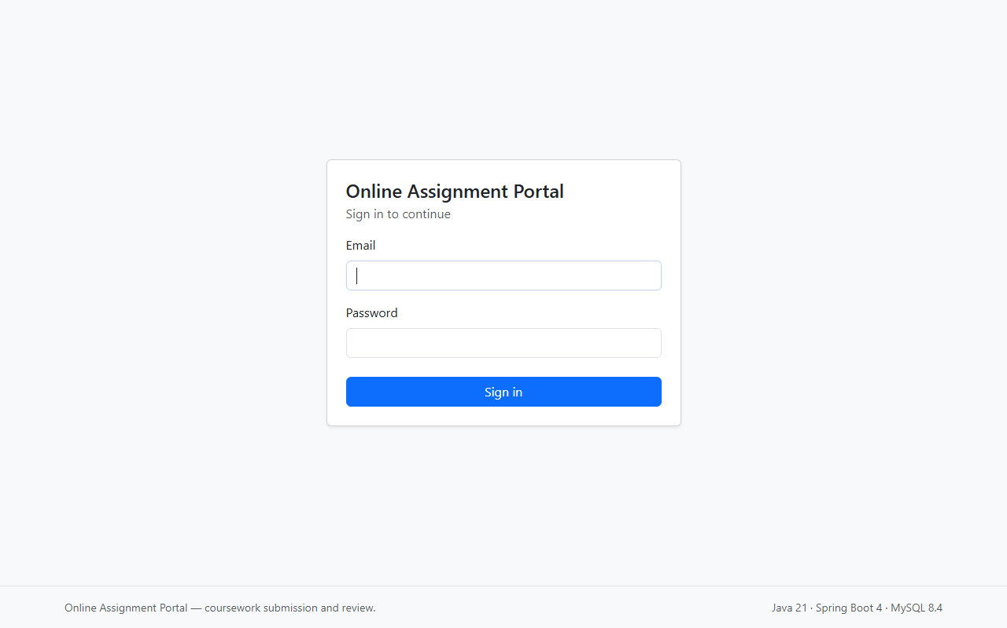  Deployed Student Submission Dashboard (http://localhost:8081/student/dashboard):  The student portal interface displays real-time submission statistics, status counters (Total, Submitted, Under Review, Approved), and past submission history.  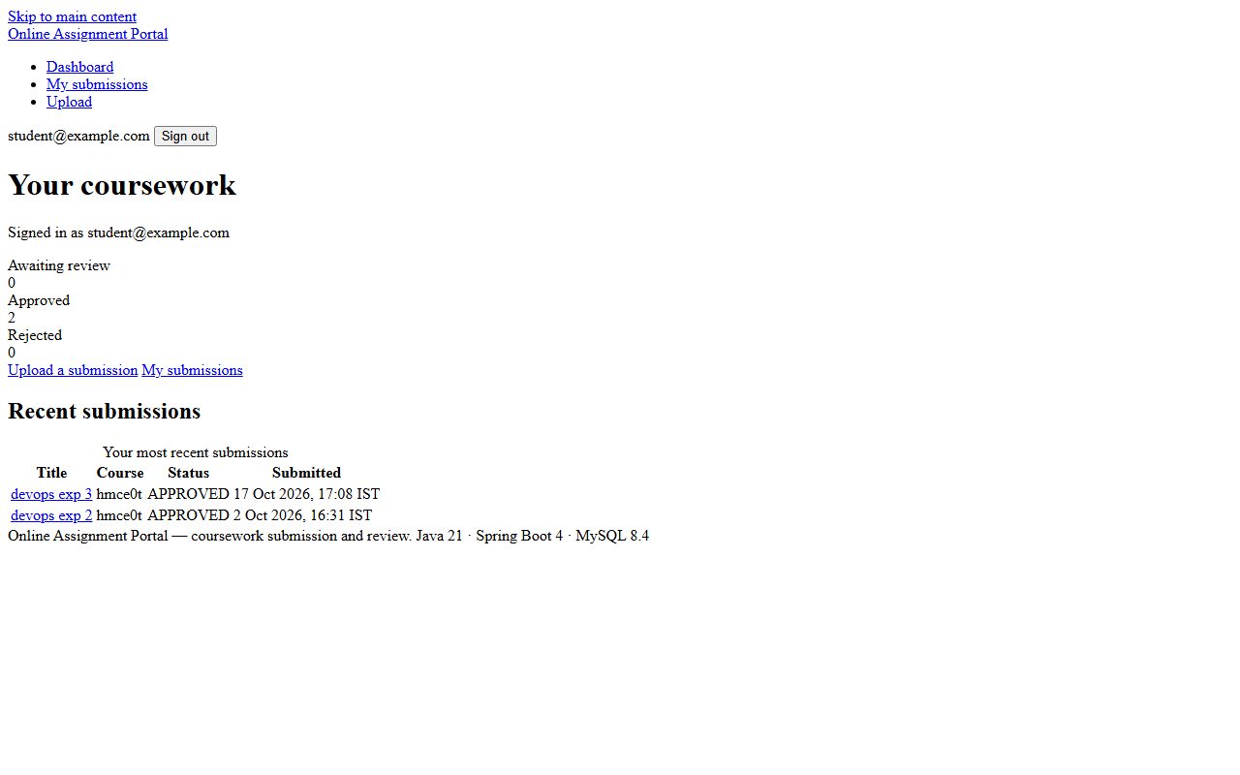  Deployed Reviewer Evaluation Queue (http://localhost:8081/reviewer/submissions):  The reviewer interface lists incoming student submissions with metadata, allowing role-authorized reviewers to inspect files and execute transactional decision workflows.  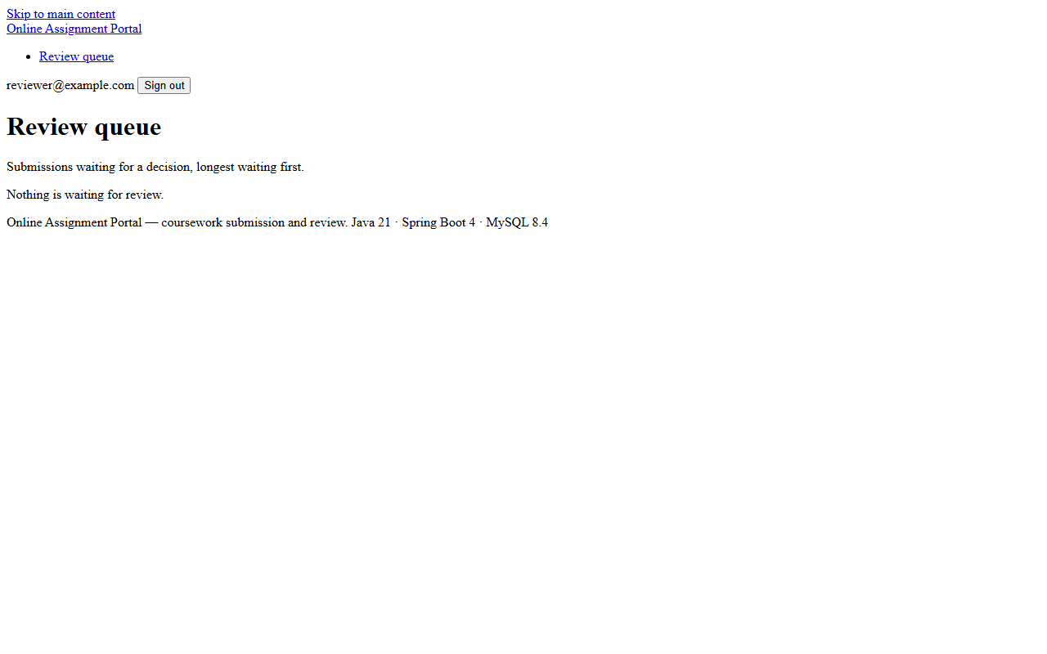
Conclusion: | Pipeline as Code makes the delivery workflow reviewable, repeatable and version-controlled. By connecting build, testing and deployment stages through explicit conditions, the project can reduce the risk of releasing an application that has not passed its required quality checks.

