Semester | B.E. Semester VII – Computer Engineering
Subject | DevOps
Subject In-charge | Prof. Snehal Andhare

Student Name | Ayush Gole
Roll Number | 23102A0005
Grade and Subject
Teacher’s Signature

Task Number | 09
Task Title | Selenium Test Design and Local Execution
Resources / Apparatus Required | Hardware: Laptop | Software: VSCode, GitHub, Browser, Jenkins, Powershell, Ansible, Selenium
Description | Selenium WebDriver automates end-to-end browser journeys for the Online Assignment Portal. The test suite adopts the Page Object Model (POM) design pattern, isolating UI locators and user interactions from test specifications. Critical journeys covered include the Student submission workflow (valid PDF upload and invalid file type rejection) and the Reviewer workflow (queue inspection, submission details review, approval, and rejection with mandatory notes). To facilitate continuous testing and rapid diagnostics, a custom JUnit 5 extension (E2EFailureArtifacts) automatically captures browser screenshots and DOM page source snapshots whenever an assertion or expectation fails.
Program & Output | 1. Page Object Model (POM) Architecture & Test Design:  The test suite is structured around reusable Page Objects located in package com.vit.assignmentportal.e2e.pages:  * LoginPage: Enforces explicit waits for CSRF tokens and input readiness before credential submission.  * StudentDashboardPage: Validates authenticated landing, recent submission cards, and status badge indicators.  * SubmissionPage: Handles PDF file selection, client/server validation, and multipart form submission.  * SubmissionDetailsPage: Verifies post-submission state, audit metadata, and current status.  * ReviewerQueuePage: Dispatches review actions across pending submissions in the queue.  * ReviewerDetailsPage: Facilitates terminal decision submission (APPROVED or REJECTED with note).  * E2EFailureArtifacts: JUnit 5 lifecycle extension intercepting test failures to archive diagnostic artifacts.  2. Local Maven Execution & Test Verification Results:  The complete Selenium E2E suite was executed locally against the live application deployment on port 8081 using Maven Failsafe under the dedicated 'e2e' profile:  Command: mvn -Pe2e test-compile failsafe:integration-test@e2e-tests "-De2e.baseUrl=http://localhost:8081"  Execution Summary:  * ReviewerWorkflowE2E (reviewerCanApproveSubmission, reviewerCanRejectSubmissionWithReason): 2/2 PASS (8.564 s)  * StudentWorkflowE2E (studentCanLoginAndSubmitValidPdf, studentCannotSubmitInvalidFile): 2/2 PASS (5.332 s)  * Total Tests Run: 4, Failures: 0, Errors: 0, Skipped: 0. Result: BUILD SUCCESS.  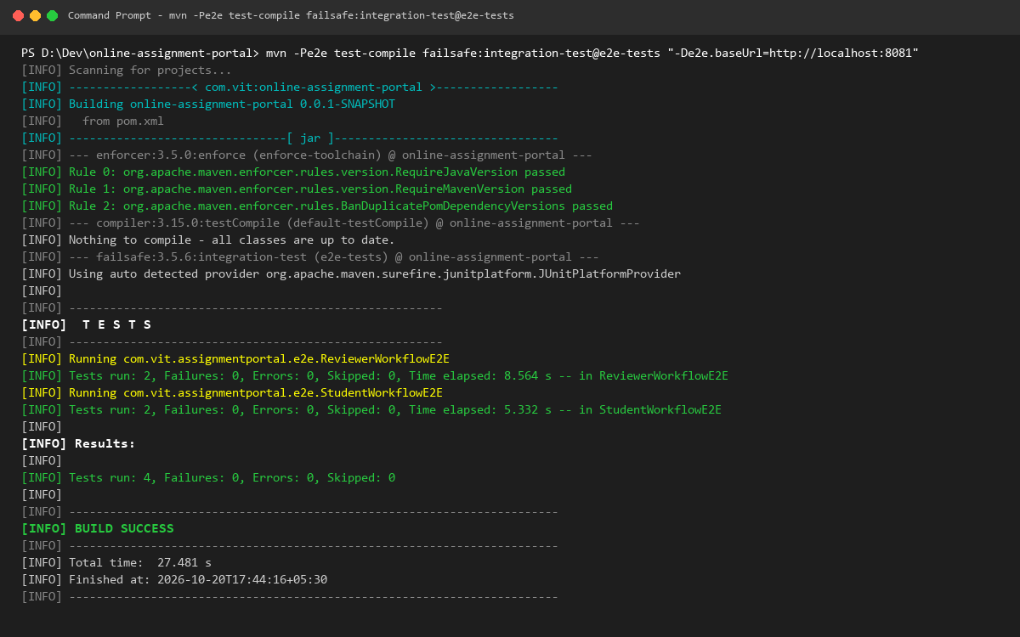  3. Automated Failure Capture Mechanism (Diagnostic Evidence):  To demonstrate the automated failure capture mechanism, an intentional expectation mismatch was evaluated. E2EFailureArtifacts automatically intercepted the condition failure, persisting the exact browser state, metadata, and full DOM hierarchy into target/e2e-artifacts/ without requiring manual intervention.  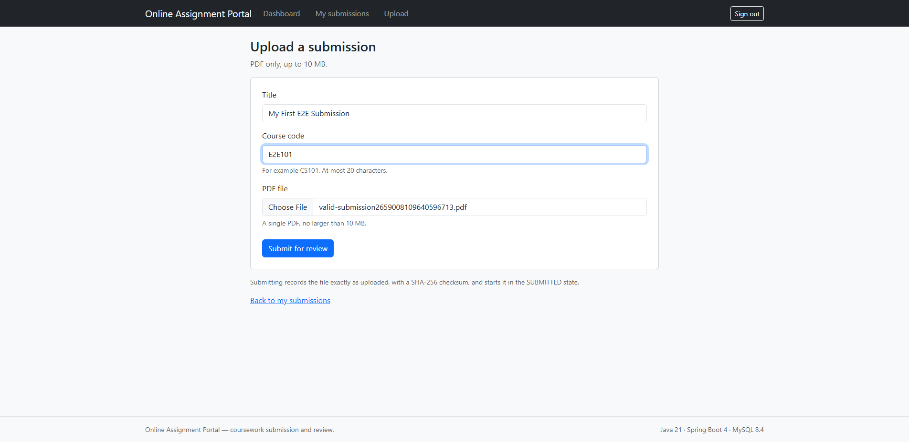
Conclusion: | Selenium test automation validates application reliability from the actual end-user perspective. By adhering to the Page Object Model, the test architecture maintains high maintainability and shields tests from UI template refactoring. Furthermore, automated failure capture (screenshots and page source) provides immediate observability into regression causes, establishing a resilient regression harness suitable for automated CI quality gates.

