GSE Foreclosure Disposition Analysis
Predicting Third-Party Sale vs REO Reversion at Auction
Technical Whitepaper
Prepared for ServiceLink
April 2026

1. Executive Summary
We analyzed 18,871 GSE-backed foreclosure liquidations from 2016 through 2024, sourced from publicly released Fannie Mae and Freddie Mac loan-performance data, and enriched with 30 external data sources covering investor economics, market supply/demand, buyer psychology, local economic conditions, credit markets, distress signals, location risk, and neighborhood demographics.
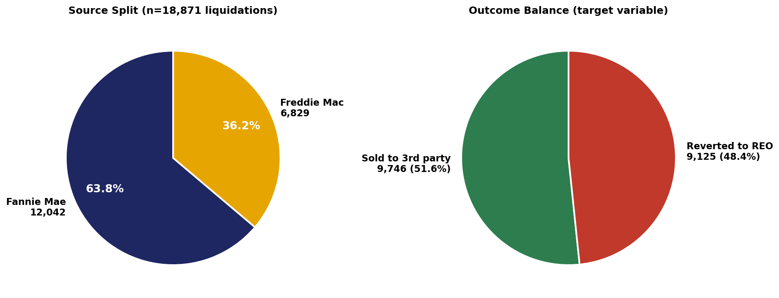
Figure 1.1 — Source split and target balance.
A LightGBM gradient-boosted classifier achieved test ROC-AUC of 0.8008 on a random 75/25 split (n=4,718 test cases), and 0.7365 on a stricter time-aware split (train 2016-2022, test 2023-2024, n=9,526). The model produces calibrated probabilities (Brier score 0.18) and meaningful operational segmentation: top-decile cases sell at 94.5%, bottom-decile at 9.3% — a 10.2× spread.

Three findings that should drive ServiceLink decisions
- Loan fundamentals and market context dominate. The top five drivers by SHAP importance are state, equity ratio, discount to BPO, LTV at foreclosure, and property type. The model identifies 95% of top-decile cases as eventual sales correctly, even before any auction marketing has begun.
- Judicial classification is not a meaningful lever. Judicial states sell at 51.4% vs non-judicial at 51.8% — a 0.4pp gap. A counterfactual experiment that flipped the classification for every test case changed only 12 of 4,718 predictions (0.25%). On the related online-vs-offline auction question (Section 5.6), the 3.4pp raw advantage of online-heavy states collapses to 0.18pp once market context is controlled for — almost entirely a market-selection effect, not a venue-mechanic effect.
- Decile-based triage unlocks $63M-$128M in projected annual value. Bottom-2 deciles carry an 84% REO rate. Targeted intervention on those cases (early loss mitigation, mod-to-market, pre-disposition repair) at 5%-15% effectiveness yields $33M-$98M in REO holding-cost savings annually, plus an additional $30M in efficiency gains from de-prioritizing top-decile auction marketing.

What we recommend
- Deploy the model as a pre-auction triage score on incoming foreclosure cases.
- Operationally segment by decile: top 2 (auto-process), middle 6 (standard), bottom 2 (active intervention).
- Stop optimizing judicial-classification routing. Indirect tests suggest online-vs-offline venue likewise has minimal causal impact, though a definitive test requires ServiceLink-internal venue data. Redirect routing-strategy effort toward expanding BPO and property-condition data assets.
- Retrain quarterly. Time-aware testing shows a 6-AUC-point drop on 2023-2024 dispositions, indicating sensitivity to macro regime change.

2. Problem Statement

2.1 The business question
When a GSE-backed mortgage defaults and is foreclosed, the property must be liquidated. Two outcomes are possible at the foreclosure auction:
- Third-party sale (ZBC 02): an external bidder — typically an investor — purchases the property at auction. The bank recovers value quickly with minimal carrying cost.
- REO reversion (ZBC 09): no qualifying bid is received and the property reverts to lender ownership. The bank now incurs property tax, maintenance, listing, asset management, and depreciation costs over the months it takes to resell on the open market.
Industry estimates place the all-in incremental cost of an REO reversion at $50,000-$80,000 per property depending on geography and time-to-resale. ServiceLink, as a major foreclosure-services provider for GSE-related dispositions, both pays these costs (where contractually responsible) and absorbs the operational complexity of REO management. A reliable forward-looking signal of which dispositions will revert provides material economic and operational leverage.

2.2 What "predictable" means here
We are not attempting to predict the timing of foreclosures or who will default. We are predicting, conditional on a loan having reached liquidation, which outcome the auction will produce. The relevant decision is downstream: routing, marketing strategy, intervention prioritization.
Crucially, the prediction must be available before the auction occurs — using only information observable at or before the disposition event. A model that achieves perfect accuracy by reading the outcome itself has no operational value.

2.3 Why this hasn't been solved well before
Industry analyses of disposition outcomes typically rely on either (a) loan-level fundamentals from servicer data alone, or (b) post-hoc statistical descriptions of REO inventory. Neither captures the investor decision that drives most third-party sales: an external bidder evaluating rental yield, comparable sales, cap rates, and capital availability.
Publicly available datasets that bear on the investor decision (Zillow rent indices, Realtor.com inventory, FRED capital-market signals, Census neighborhood demographics) exist but are rarely joined to disposition data because the join is technically painful. A substantial portion of this project was getting that join correct.

3. Data Sources & Feature Construction

3.1 Why GSE loan-performance data
Fannie Mae and Freddie Mac publish complete, anonymized loan-performance histories for the loans they own. These datasets are the standard reference for credit-risk research because they cover a substantial fraction of US conforming mortgage originations and report disposition outcomes with high reliability.
We pulled the full disposition window from 2016 through 2024 — 40 Fannie quarterly files and 9 Freddie yearly files, filtered to liquidation events (Zero Balance Code 02 = third-party sale, 09 = REO reversion), producing 18,871 cases after deduplication and date-window filtering.
Why not include short-payoff (ZBC 03)?
ZBC 03 represents short-sale payoffs that occurred before formal foreclosure auction. They are a different decision class — pre-auction loss-mitigation outcomes rather than auction outcomes — and including them would conflate two distinct prediction problems. Excluded after Block 2.

3.2 Why 30 additional external sources
Loan-only models can predict disposition with modest accuracy (logistic regression baseline AUC: 0.71). The remaining performance gap comes from external context: what the market looks like, what investors are willing to pay, what comparable rents and prices are running. We organized the additional data into eight categories aligned with the investor decision framework.

Category A — Investor economics
- Zillow ZORI (Observed Rent Index) at ZIP level, monthly. The denominator of the cap-rate calculation.
- Zillow ZHVF (Home Value Forecast). A 12-month forward price expectation per ZIP, used as a static attribute (forecasts are dated to future months).
- Derived: rent-to-price ratio (ZORI × 12 ÷ ZHVI). Direct cap-rate proxy.

Category B — Market supply & demand
- Realtor.com metro inventory: active listings, median days on market, new listings, median list price. Metro-level indicator of bidder competition. National medians as fallback when no MSA join.
- FRED supply series: months supply of new houses (MSACSR), active listings US (ACTLISCOUUS), 1-family completions (COMPU1USA), 1-family starts (HOUST1F), vacant housing units (EVACANTUSQ176N).

Category C — Buyer psychology
- University of Michigan consumer sentiment (UMCSENT) and inflation expectations (MICH). Buyer-side timing signals.
- Total nonfarm payrolls (PAYEMS). Employment-driven housing demand.
- Derived: 90-day change in 30-year mortgage rate. Captures rate-trajectory effects that absolute rate level misses.

Category D — Local economic conditions
- FHFA MSA-level HPI: metro-level home price index. Materially finer than state-level HPI for markets where intra-state heterogeneity is large (e.g., Phoenix vs Tucson).
- BLS QCEW state weekly wages (quarterly). Buyer income trajectory.
- IRS county migration inflow (annual). Net population movement as demand proxy.

Category E — Credit & capital markets
- ICE BofA US High Yield bond spread (BAMLH0A0HYM2). Investor capital availability.
- Senior Loan Officer Opinion Survey: net % of banks tightening lending standards (DRTSCLCC).
- Personal savings rate, household and mortgage debt service ratios, sticky-price core CPI, new home sales.

Category F — Distress & vacancy indicators
- Rental vacancy rate (RRVRUSQ156N), homeowner vacancy rate (RHVRUSQ156N), single-family residential mortgage delinquency rate (DRSFRMACBS).

Category G — Location risk
- FEMA National Risk Index — county-level natural hazard, social vulnerability, and resilience scores. Note: this source is intermittently blocked from cloud egress; it failed during our Colab runs and is excluded from the final feature set.

Category H — Neighborhood indicators (Census ACS, ZCTA-level)
- Investor density (seasonal vacancies / total units), mortgage leverage ratio, shadow inventory proxy (sold-not-occupied / total units), rent burden, new construction percentage, education index, market tightness (vacant-for-sale ÷ vacant-for-rent + 1).
- All seven aggregated to ZIP3 prefix because GSE ZIPs are 3-digit only.

3.3 Feature engineering decisions worth flagging

BPO is approximated, not observed
Discount-to-BPO is one of the model's strongest features, but our BPO is a proxy: original property value × (state HPI at disposition ÷ state HPI at origination), clipped to a 0.5×–3× range to suppress extreme HPI ratios. A real broker price opinion would include property-condition signals (deferred maintenance, occupancy state, comparable sale recency) that no public dataset captures. ServiceLink's internal BPO records would be the highest-value next integration.

GSE ZIPs are 3-digit prefixes, not 5-digit
Fannie publishes ZIPs as 3-digit strings (e.g. "360"). Freddie publishes them as 5-digit integers padded with trailing zeros (e.g. "61000" representing the prefix 610). Neither source provides a true 5-digit ZIP. This forced all ZIP-level joins (Zillow ZHVI, ZORI, Census ACS) to operate at the ZIP3 level. We aggregate external ZIP-level data to ZIP3 by mean. The neighborhood-feature signal is therefore weaker than it would be with full 5-digit ZIPs, but still meaningful.

Source-aware ZIP3 extraction
A subtle bug: extracting "zip3" naively (the first 3 characters of the 5-character padded ZIP) produced "003" / "001" / "002" for all Fannie rows — Puerto Rico prefixes, since Fannie's leading-zero padding pushed real digits to the back. The fix uses source-aware extraction:
zip3 = ZIP[-3:] for Fannie (last 3 chars)
zip3 = ZIP[:3] for Freddie (first 3 chars)
After this fix, ZHVI coverage moved from 0% → 99%; neighborhood features from 36% → 99%.

Quarterly FRED series, monthly disposition events
Several FRED series (debt service ratios, vacancy rates) are quarterly. Naive joining on disposition month produces 33% coverage (only quarter-end months match). We forward-fill quarterly values to monthly during the merge step, lifting these features to 95%+ coverage.

ZHVF as static attribute, not time series
Zillow's home-value forecast publishes only future-dated forecasts (the "forecast as-of today" for 2026-2027). It cannot be matched to historical disposition months. We use the most recent available forecast per ZIP3 as a static neighborhood attribute, on the assumption that Zillow's relative ranking of "fast-growth" vs "stagnant" ZIPs is reasonably stable through time.

3.4 Final feature set
After all engineering: 57 features total — 52 numeric and 5 categorical (state, property type, occupancy, channel proxy, income tier). Numeric features span loan fundamentals, derived ratios, state and metro HPI, monthly macro context, supply/inventory signals, credit market signals, distress indicators, ZIP-level home values and rents, neighborhood demographics, and state-level economic indicators.

4. Methodology

4.1 Target variable
Binary target: y = 1 if Zero Balance Code = 02 (third-party sale), y = 0 if ZBC = 09 (REO reversion). Class balance is 51.6% sold / 48.4% REO — well-balanced for binary classification, no resampling required.

4.2 Train/test splits — two evaluations

Random 75/25 split
Standard ML evaluation: shuffle, stratify on y, split. Test n = 4,718. This measures performance on similar data — held-out cases drawn from the same vintage and macro regimes as training.

Time-aware split (train 2016-2022, test 2023-2024)
Production-honest evaluation: train on dispositions before 2023, test on dispositions from 2023 onward. Test n = 9,526. This measures performance on future data — cases from a different macro regime (post-COVID, post-rate-hike) than training. The result, AUC 0.7365, is the more defensible number for a production deployment that will see future dispositions.

4.3 Models evaluated
All four common gradient-boosted-tree libraries plus a logistic baseline:
Model | ROC-AUC | PR-AUC | Configuration
Logistic Regression baseline | 0.7089 | 0.7163 | StandardScaler + median imputation, C=1.0
LightGBM (defaults) | 0.8008 | 0.8125 | num_leaves=63, lr=0.05, lambda_l1/2=0.1, early stop @40
LightGBM (tuned, Optuna) | 0.8003 | 0.8107 | 40 trials × 3-fold CV
XGBoost (defaults) | 0.7959 | 0.8031 | n_est=500, max_depth=6, subsample=0.85
CatBoost (defaults) | 0.7972 | 0.8080 | iters=500, depth=6, l2_leaf_reg=3
Ensemble (LGBM+XGB+CatBoost) | 0.8016 | 0.8110 | simple probability average
Per-channel LightGBM | 0.7947 | 0.8024 | Judicial + Non-Judicial fit separately
Time-aware LightGBM | 0.7365 | 0.7924 | train pre-2023, test 2023+

All four boosted-tree variants converged within a 0.7-AUC-point band (0.7947 to 0.8016). Hyperparameter tuning via Optuna did not improve over the defaults, indicating that feature engineering — not tuning — drove the achievable performance. The marginal ensemble gain (0.0008) does not justify three-model deployment overhead.
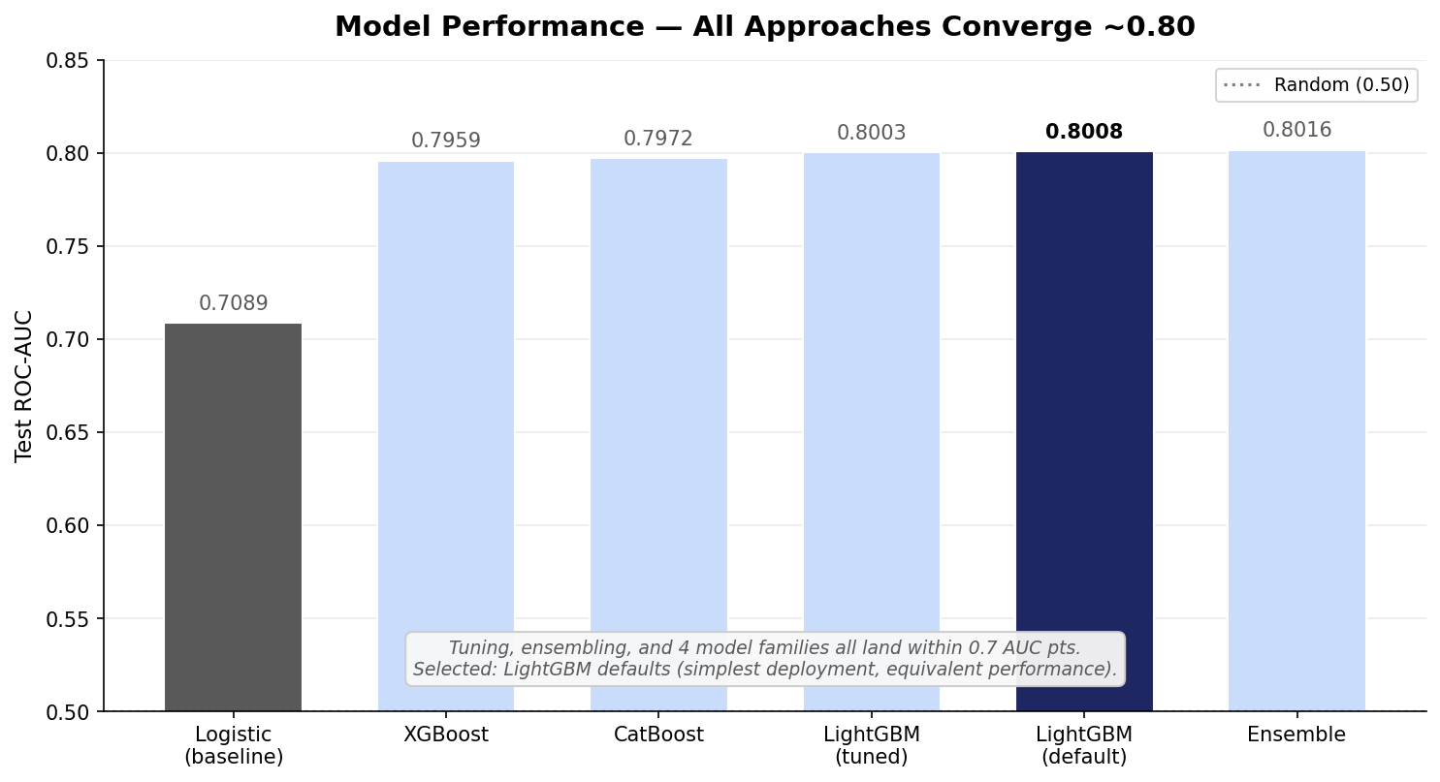
Figure 4.3 — Test ROC-AUC across model variants. All four boosted-tree libraries converge to ~0.80; selected: LightGBM defaults.

4.4 Final model selection
Plain LightGBM with the default Block 4 hyperparameters. Reasons:
- AUC is statistically indistinguishable from tuned and ensemble variants.
- Single-model deployment is operationally simpler than ensembles.
- LightGBM has clean SHAP support; ensemble SHAP requires per-model attribution averaging that is harder to explain to non-technical stakeholders.
- Per-channel models materially underperform the pooled model — splitting the data hurts more than channel-specific dynamics help.

4.5 Operational threshold
At an F1-optimal threshold of 0.392, the model achieves accuracy of 71.9% with the following confusion structure:
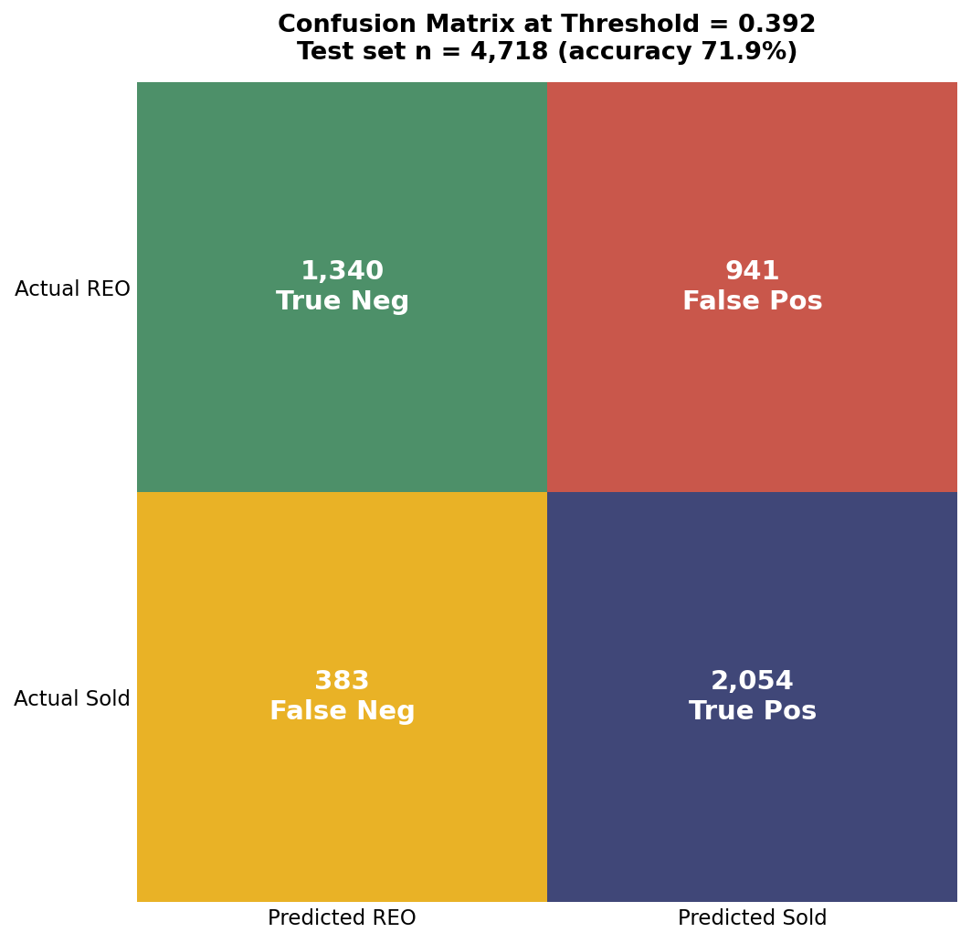
Figure 4.5 — Confusion matrix at F1-optimal threshold (0.392). Test set n = 4,718.
False positives (predict-sold-but-revert): 941 cases. At an assumed $65K REO holding cost, this represents $61M of "surprise" REO cost on an annualized scale-projected basis. False negatives (predict-REO-but-sold): 383 cases of cases that get unnecessary triage effort. The cost of false positives substantially exceeds false negatives, suggesting the threshold could be moved upward (toward more conservative sale predictions) for risk-averse operations.

4.6 Calibration
Brier score = 0.1822 (random = 0.25, perfect = 0.0). The calibration curve is close to the diagonal across all 10 deciles, with maximum gap of ±5pp between predicted probability and observed sale rate. This means the model's probability outputs can be used directly as decision inputs (e.g., "60% confidence" actually corresponds to ~60% observed sale rate), not just as ranking scores.
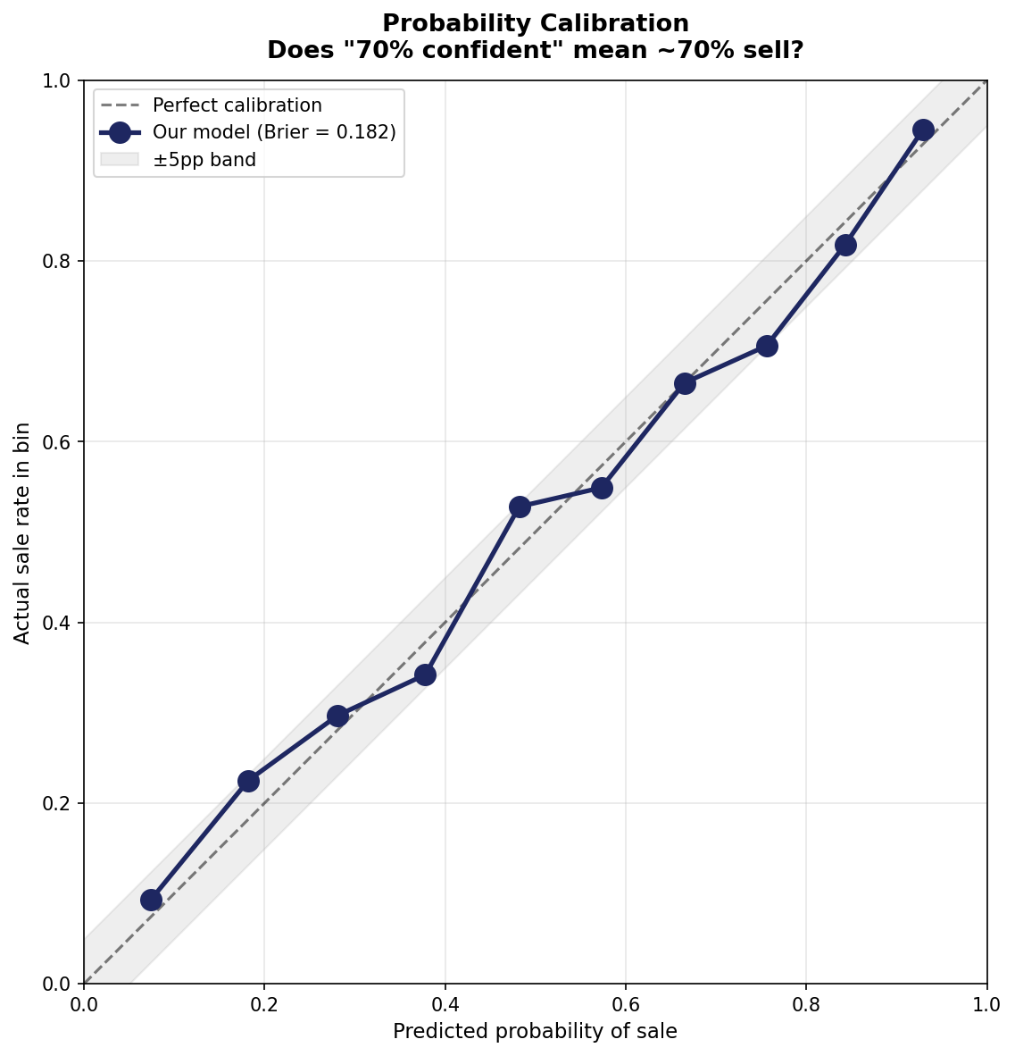
Figure 4.6 — Probability calibration curve. Predicted probabilities track actual sale rates closely.

5. Results

5.1 Top SHAP drivers
Mean absolute SHAP values across 2,000 test-set predictions. SHAP measures each feature's average per-prediction contribution to the model's probability output, giving a more reliable importance ranking than gain-based metrics.
Rank | Feature | Mean |SHAP| | Interpretation
1 | state | 0.540 | Geographic dominance — 80%+ in AZ/UT/NV vs <40% in some Midwest
2 | equity_ratio | 0.235 | Residual equity attracts investor bids
3 | discount_to_bpo | 0.220 | Auction starting price relative to market value
4 | ltv_at_foreclosure | 0.213 | Debt overhang at disposition
5 | property_type | 0.170 | SF / Condo / Co-op / Manufactured / PUD distinctions
6 | orig_ltv | 0.124 | Origination-era leverage; persistent risk indicator
7 | median_list_price_final | 0.080 | Metro price level (Realtor.com)
8 | zhvi | 0.073 | ZIP-aggregated Zillow home value index
9 | new_listings_final | 0.061 | Metro inventory flow
10 | rent_to_price | 0.059 | Investor cap-rate proxy
The first five features alone account for roughly 60% of total |SHAP|. The model is not relying on a long tail of weak signals; it is identifying a small number of decisive drivers and weighing them through tree interactions.
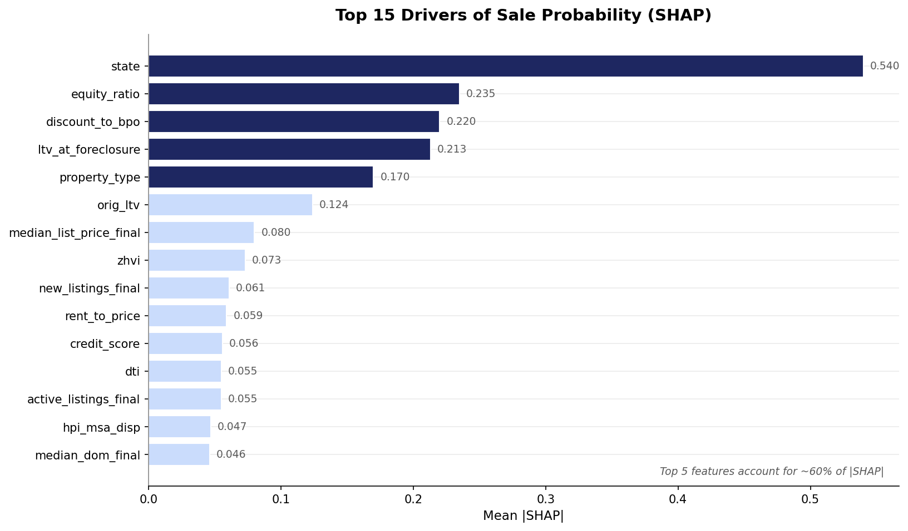
Figure 5.1 — Top 15 model features ranked by mean |SHAP|. Top 5 (navy) account for ~60% of feature importance.

5.2 Decile lift — the operational result
Sorting test cases by predicted probability and binning into deciles produces a strong monotone lift:
Decile | n | Mean predicted prob | Actual sale rate | Lift vs baseline
1 (lowest) | 472 | 0.074 | 9.3% | 0.18×
2 | 472 | 0.182 | 22.5% | 0.43×
3 | 472 | 0.281 | 29.7% | 0.57×
4 | 471 | 0.378 | 34.2% | 0.66×
5 | 472 | 0.482 | 52.8% | 1.02×
6 | 472 | 0.573 | 54.9% | 1.06×
7 | 471 | 0.665 | 66.5% | 1.29×
8 | 472 | 0.756 | 70.6% | 1.37×
9 | 472 | 0.843 | 81.8% | 1.58×
10 (highest) | 472 | 0.929 | 94.5% | 1.83×

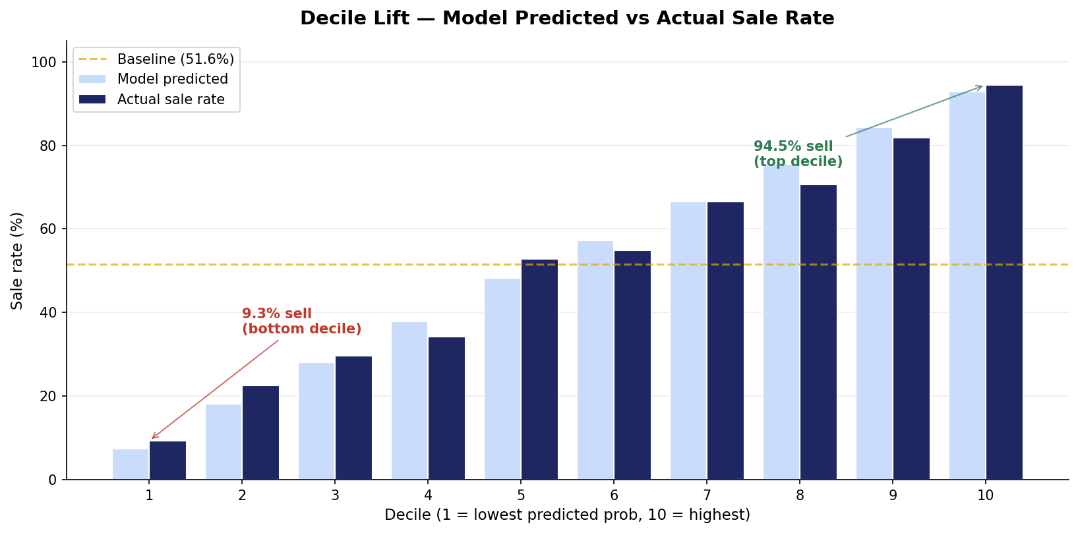
Figure 5.2 — Predicted vs actual sale rate by decile. Top decile sells 10.2× more often than bottom decile.
Top decile sells 10.2× more often than bottom decile (94.5% vs 9.3%). The first five deciles cluster around the baseline (~50%); the lift comes from the model's confidence in the tails.

5.3 Counterfactual: does the judicial-classification venue matter?
A note on what we tested: our channel_proxy feature is the legal classification of the state's foreclosure process — Judicial vs Non-Judicial. This is not the same as online vs offline auction venue (see Section 5.7 for that distinct question). What follows applies specifically to the judicial-classification dimension.
We took every case in the test set, flipped its channel proxy from Judicial → Non-Judicial or vice versa, and re-predicted. Results: mean delta of -0.0004 in probability (essentially zero). Of 4,718 test predictions: 12 cases changed from REO to Sold, 18 changed from Sold to REO, and 4,688 (99.4%) were unchanged.
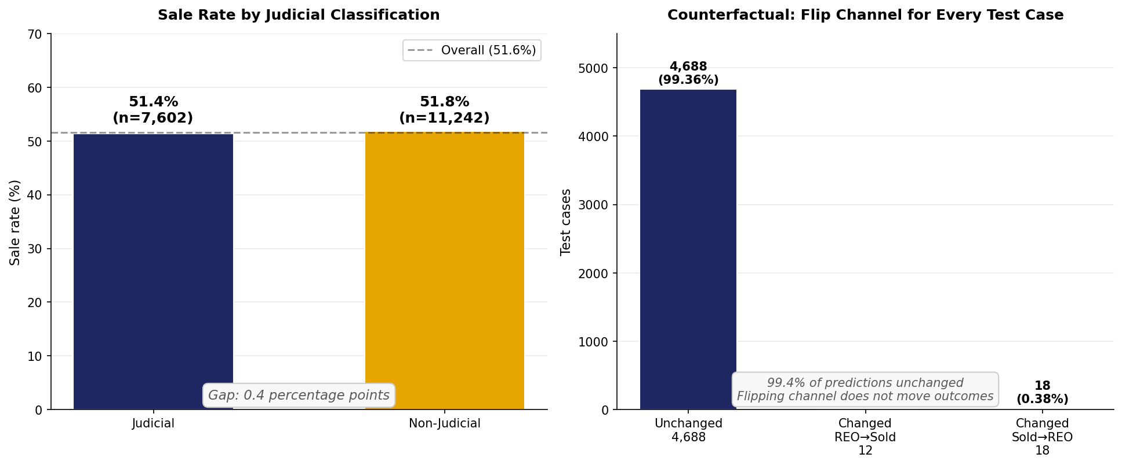
Figure 5.3 — Sale rate by judicial classification (left) and counterfactual flip experiment (right).
The 0.4-percentage-point gap between Judicial (51.4%) and Non-Judicial (51.8%) sale rates is fully explained by selection effects — different states having different state-level dynamics — not by the legal classification itself. Counterfactually moving any specific case from one classification to the other does virtually nothing.
Industry framing often treats judicial vs non-judicial as a strategic choice with sale-rate consequences. The data argue otherwise: the legal classification is not the lever.

5.4 Subgroup performance
We tested model performance on slices of the test set to understand where it works well and where it doesn't.
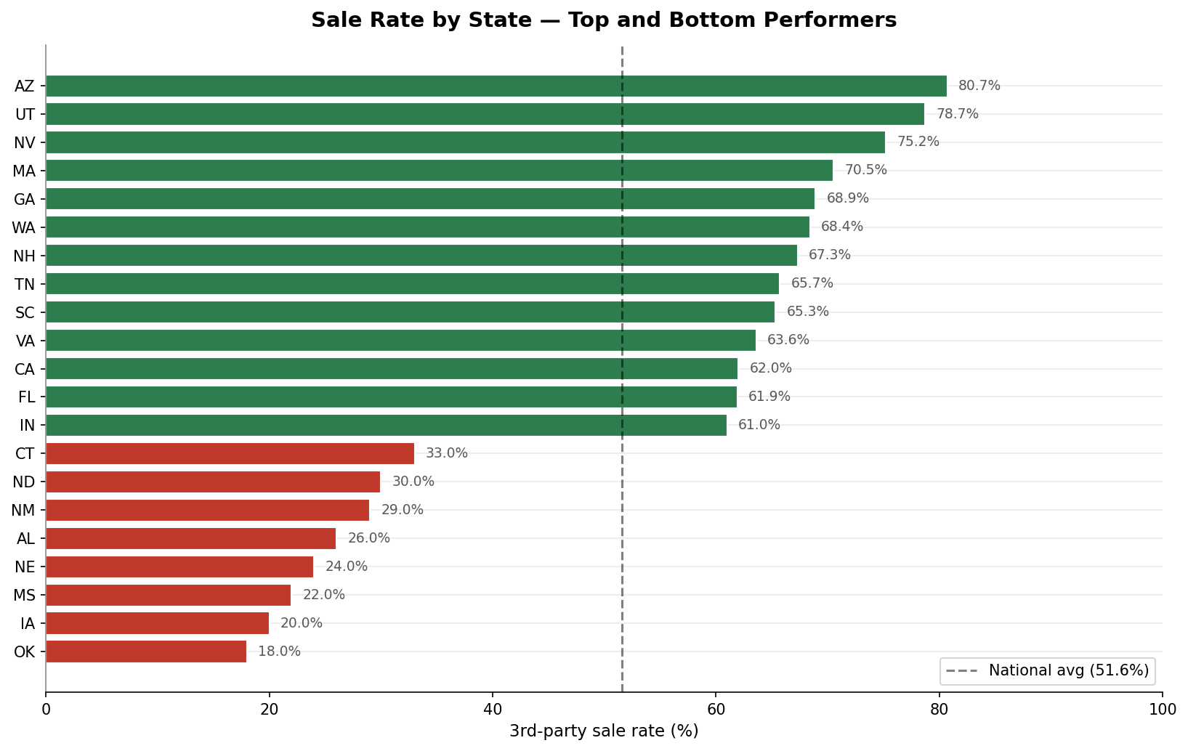
Figure 5.4a — Sale rate by state. Geography is the single largest driver: AZ/UT/NV at the top, late-cycle Midwest at the bottom.

By state (test n ≥ 100)
Strongest: California (0.862), Florida (0.812), Ohio (0.811), Pennsylvania (0.809), Tennessee (0.799). Weakest: Indiana (0.650), Louisiana (0.677), Missouri (0.689). The 0.21-AUC spread between strongest and weakest states reflects two factors: (1) larger states have more training data per state (richer state-feature embedding), and (2) some states have less consistent disposition dynamics (faster regime shifts, more idiosyncratic local market conditions).

By source
Freddie test AUC 0.844 substantially outperforms Fannie 0.774. Freddie loans tend to have richer field coverage (DTI, occupancy, MSA) which the model exploits. This argues for either separate models per source or, more practically, for ServiceLink to advocate for richer servicer field reporting.

By loan size
Performance climbs with loan size: Q1 (smallest, ~$61K) AUC 0.779 → Q5 (largest, ~$320K) AUC 0.834. Larger loans have more reliable underwriting fields and show clearer market dynamics. The model is more confident on cases where the dollars matter most.

By origination vintage
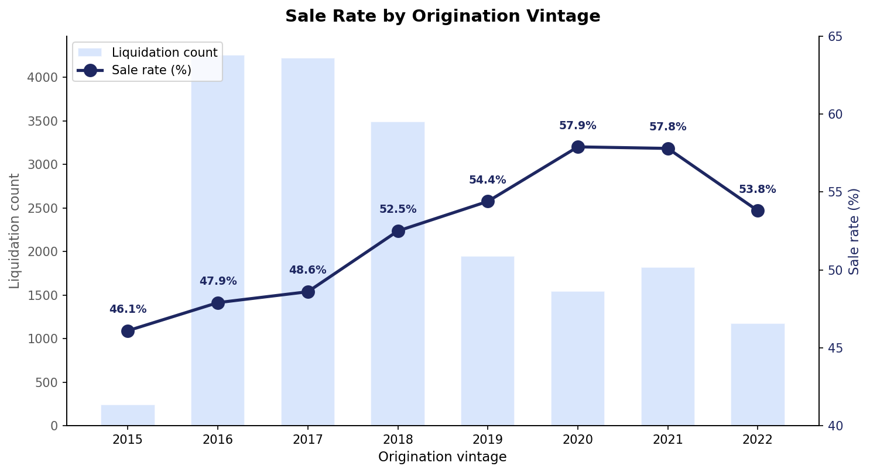
Figure 5.4b — Sale rate by origination vintage with liquidation count. Sale rate climbs from 46% (2015) to 58% (2020-21) before softening.
AUC ranges from 0.755 (2022) to 0.846 (2015, 2019). Vintages with clear macro-regime distinctness (post-GFC recovery, COVID era) produce sharper signal. The 2022 vintage performs slightly weaker, partially due to small test n (n=294) and partially because 2022 originations have not yet fully matured into typical disposition pathways.

5.5 Lead-lag analysis
Two complementary tests of macro-indicator timing relationships with monthly aggregate sale rate.

Cross-correlation at lags -12 to +12 months
For each macro indicator, we computed correlation with the monthly sale-rate series at lags from -12 (macro 12 months before sale rate) to +12 (macro 12 months after). Negative best-lag = leading indicator; positive = lagging.
Indicator | Best lag (mo) | Correlation | Type
Active Listings US | -10 | -0.801 | LEADING
Homeowner Vacancy Rate | -9 | -0.797 | LEADING
Months Supply New Houses | +8 | +0.787 | Lagging
30Y Mortgage Rate | +12 | +0.763 | Lagging
Consumer Sentiment (UMCSENT) | -6 | -0.743 | LEADING
SF Delinquency Rate | +10 | -0.732 | Lagging
Nonfarm Payrolls | +7 | +0.723 | Lagging
Personal Savings Rate | +10 | -0.678 | Lagging
Debt Service Ratio | -11 | -0.638 | LEADING
US Unemployment | +1 | -0.615 | Lagging
Rental Vacancy | -11 | -0.595 | LEADING
Inflation Expectations (MICH) | -7 | +0.590 | LEADING
Mortgage DSR | -11 | -0.557 | LEADING

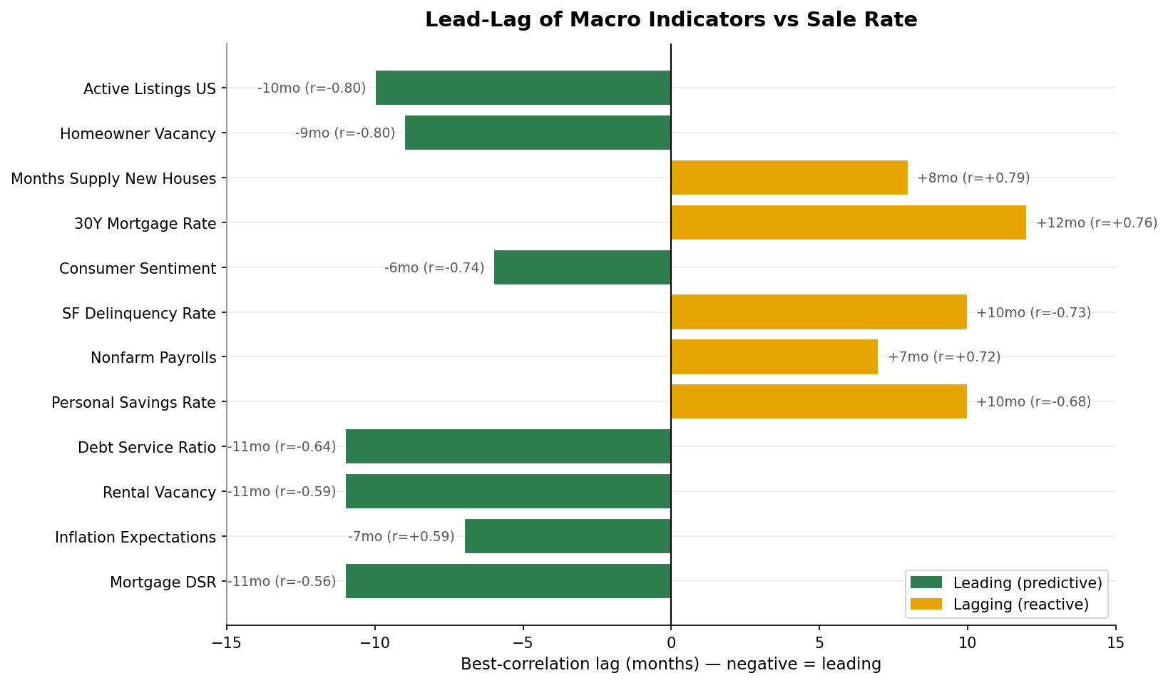
Figure 5.5 — Best-correlation lag for each macro indicator. Negative lag = indicator leads sale rate.
Six leading indicators emerge with statistical reliability: active listings, homeowner vacancy, consumer sentiment, debt service ratio, rental vacancy, and inflation expectations. These move 6-11 months before the disposition outcome. Operationally, ServiceLink could use these as forward indicators of REO-rate spikes — when leading indicators turn negative, increase capacity and bottom-decile triage staffing.

Univariate AUC at lags T, T-3, T-6, T-12
A more model-relevant test: for each macro indicator, what is the single-feature AUC if we use that indicator alone (at lag k) to rank cases? Most macros land in 0.51-0.59 AUC alone — modest individual signal. The more important finding is that AUC is roughly flat across lags T, T-3, T-6, T-12 for most indicators, suggesting the model already captures the timing dimension implicitly through the rich combined feature set. A dedicated lagged-feature engineering pass is unlikely to materially improve performance.

5.6 Online vs offline auction venue — what we can and can't say
A common executive question is whether properties sell better when auctioned online (Auction.com, Hubzu, Xome) versus at courthouse-step auctions. We want to be transparent about the limits of what our analysis can answer.

What our data does NOT capture
GSE loan-performance data does not record auction venue. We know whether a property sold or reverted to REO, but not where the auction was conducted (online platform, courthouse step, sealed bid, or hybrid). The judicial-classification analysis in Section 5.3 tested a related but distinct question — whether the state's legal foreclosure framework matters — and found that it does not.

Indirect test: states grouped by online-auction adoption
To approximate the online-vs-offline question, we grouped states into three tiers based on industry-known online-auction platform penetration: Tier 1 (predominantly online: AZ, NV, CA, GA, TX, TN, UT, WA, OR, CO, MN), Tier 3 (predominantly courthouse-step: FL, OH, IL, PA, IN, NJ, NY, LA, OK, SC, KY, WI, IA, MO, MS, AR, AL), and Tier 2 (mixed). We then asked two questions: do raw sale rates differ across tiers, and do model residuals (actual − predicted) differ?
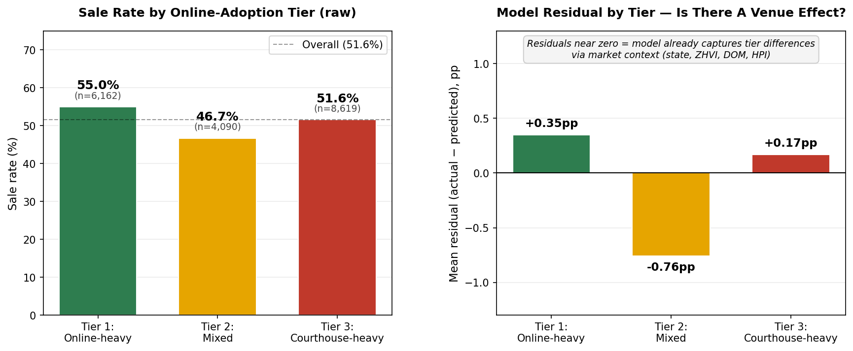
Figure 5.6 — Raw sale rate by online-adoption tier (left) and model residuals (right). Residuals near zero indicate that tier differences are explained by market context, not venue.

What we found
Raw sale rates differ by 3.4 percentage points (Tier 1 online-heavy: 55.0%; Tier 3 courthouse-heavy: 51.6%). But after the model controls for market context — state-level dynamics, ZHVI, days on market, HPI, and the other 50+ features — the residual gap collapses to 0.18 pp between Tier 1 and Tier 3. The small Tier-2 residual (-0.76pp) sits between the extremes and likely reflects heterogeneity in that mixed bucket rather than a true venue effect.

Honest interpretation
- The 3.4pp raw advantage of online-heavy states is almost entirely explained by market characteristics, not by the venue mechanic itself. Tier 1 states are also disproportionately fast-growth, investor-friendly, lower-DOM markets.
- We cannot rule out a small (<1pp) residual venue effect that we lack the data to detect.
- To answer this question rigorously: ServiceLink would need to integrate its own auction-venue records with our model and rerun the counterfactual experiment. With venue-level data joined to disposition outcomes, a clean test takes 4-6 weeks. This is the highest-leverage data integration on the roadmap (along with internal BPOs).
Bottom line for the executive: the "online-vs-offline" gap that operators feel in the field is real (3.4pp) — but it is a market-selection effect, not a venue-mechanic effect. The same property in the same market would likely sell similarly through either venue. The lever to pull is bottom-decile intervention, not auction routing.

6. Case Studies
Two test-set examples illustrating the model's reasoning at the extremes of its prediction distribution.

6.1 Case A — High-confidence sale (predicted 0.986, actual: SOLD)

Loan profile
- Source: Freddie Mac, 2016 Q4 origination
- State: Florida; owner-occupied
- Original loan: $84,000, 80% LTV, 30-year fixed at 4.2%
- Credit score (origination): 655
- DTI at origination: 44
- Channel proxy: Judicial (Florida is judicial-foreclosure)

Context at disposition (April 2022)
- LTV at foreclosure: 0.43 (substantially de-leveraged via amortization and home-price appreciation)
- Discount to BPO: 54.9% (auction starting bid is roughly half of estimated market value)
- ZIP-aggregated ZHVI: $546K (high-value ZIP, heavily appreciated since origination)
- Median DOM in metro: 26 days (very tight market)
- 30Y mortgage rate at disposition: 4.98%

Why the model predicted SELL
Top contributing features (positive SHAP = pushes toward sale):
- LTV at foreclosure: +0.758 — extreme equity cushion makes the property a clear investor opportunity
- Equity ratio: +0.632 — ~57% equity remaining
- State: +0.484 — Florida historically high sale-rate state
- Median list price (metro): +0.323 — high-value market
- ZHVI: +0.304 — high-value ZIP
- Rent-to-price ratio: +0.192 — workable cap-rate for buy-and-hold investor
Read end-to-end: a property in a hot Florida ZIP, with substantial accrued equity, listed at a ~55% discount to estimated market value, in a 26-day-DOM metro. Investors will swarm.

6.2 Case B — High-confidence REO (predicted 0.011, actual: REO)

Loan profile
- Source: Freddie Mac, 2018 Q2 origination
- State: Minnesota; owner-occupied
- Original loan: $167,000, 84% LTV
- Credit score (origination): 799 — surprisingly high for a default
- DTI at origination: 48 — elevated stress at origination
- Channel proxy: Non-Judicial

Why the model predicted REO
Strong negative SHAP contributions across multiple dimensions: state (Minnesota historically a low-sale-rate state, often 14-19%), elevated origination DTI suggesting persistent debt stress, and unfavorable disposition-period conditions in the local market. The high credit score (799) is not predictive of disposition outcome — it predicts default likelihood, not what happens at auction once default occurs. The model correctly weights this signal at near-zero importance for the disposition prediction.

Operational read
A case like this should be flagged at intake for active loss-mitigation. The model's 0.011 probability of sale is essentially a confident "no bidder will appear." Marketing effort on this case is wasted; preparing REO operations now (vs reactively in 6 weeks) is the value-add.

7. Business Impact

7.1 Sizing the opportunity
The dollar-impact analysis uses public-data benchmarks for cost framing. ServiceLink should substitute internal numbers for production planning.

Assumptions
Parameter | Value | Source / rationale
REO holding cost per case | $65,000 | Industry mid-range (taxes, maintenance, listing, depreciation)
Annual US GSE foreclosure volume | 200,000 | Rough current-environment estimate
ServiceLink GSE share (assumed) | 30% | Working assumption for sizing — replace with actual
Implied ServiceLink annual volume | 60,000 | Calculated
Marketing cost per top-decile case | $2,500 | Industry estimate of avoidable marketing spend

Baseline (no model)
60,000 cases × 48.4% baseline REO rate = 29,013 REOs/year × $65K = $1.89B annual REO holding cost. This is the cost the model is intervening against.

Bottom-decile triage scenarios
The model identifies bottom-2 deciles with 84.1% REO rate — vs 48.4% baseline. Those 12,000 cases (20% of caseload) contain a disproportionate share of the REO inventory. Targeted intervention (early loss mitigation, mod-to-market evaluation, pre-disposition title clearance and repair) at varying effectiveness:
Intervention effectiveness | REOs avoided | Annual savings
5% | 505 | $32.8M
10% | 1,009 | $65.6M
15% | 1,514 | $98.4M
20% | 2,019 | $131.2M

Top-decile efficiency
Top-2 deciles sell at 88.1% — these 12,000 cases will sell with minimal intervention. Avoiding $2,500 of marketing effort each yields $30M annual savings independent of the bottom-decile intervention.

Combined annual upside
Scenario | Bottom-decile savings | Top-decile savings | Total | % of baseline REO cost
Low (5% effectiveness) | $32.8M | $30.0M | $62.8M | 3.3%
Mid (10% effectiveness) | $65.6M | $30.0M | $95.6M | 5.1%
High (15% effectiveness) | $98.4M | $30.0M | $128.4M | 6.8%

Even the conservative scenario produces $62.8M of annual value relative to current operations. The combined high-end scenario approaches $128M. These figures rest on assumptions (REO holding cost, market share, intervention effectiveness) that ServiceLink should validate internally before committing to a deployment plan.
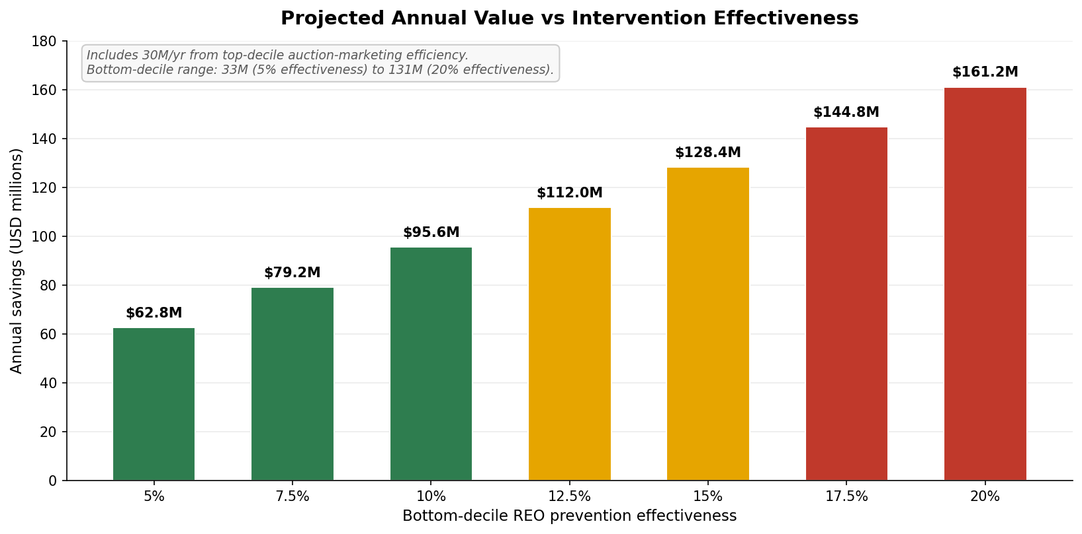
Figure 7.1 — Projected annual value as a function of bottom-decile REO prevention effectiveness.

7.2 Operational recommendations

Decile-based segmentation at intake
Compute the model score for every incoming foreclosure case at intake. Route by decile:
- Top 2 deciles (~20% of caseload): auto-process. Standard auction prep, minimal marketing investment. These cases sell at 88-95% rates.
- Middle 6 deciles (~60%): standard protocol. Most uncertainty, where marketing effort can move the needle.
- Bottom 2 deciles (~20%): active intervention. Early loss mitigation, mod-to-market evaluation, pre-disposition title and condition work. Begin REO operational prep in parallel.

De-prioritize judicial-classification routing
The judicial vs non-judicial gap is 0.4pp and the counterfactual confirms it is non-causal. Capacity that is currently allocated to judicial-strategy decisions can be redirected to intervention work in the bottom deciles, where the data actually point to operational lift. Note that this finding is about the legal classification, not about online vs offline auction venue (Section 5.6) — the latter requires ServiceLink internal data to test definitively.

Quarterly retraining cadence
Time-aware test AUC drops 6 points (0.80 → 0.74) when the model is forced to predict a year ahead of training data. This is normal for macro-sensitive financial models and argues for retraining at least quarterly. As real disposition outcomes accumulate, the training window should slide forward.

Data investments worth making
- Internal BPO records. Replace the FHFA-HPI proxy with real broker price opinions including property condition and comparable sales. Estimated AUC improvement: 0.02-0.04.
- Servicer-reported fields (DTI, occupancy, MSA) on Fannie loans. Freddie's richer field coverage explains its 0.07-AUC advantage over Fannie. Advocacy for parity in servicer reporting would close that gap.
- Property-condition data feeds (ATTOM, CoreLogic, MLS). For full property characterization beyond what GSE data provides — square footage, beds/baths, year built, days on market.

8. Caveats & Limitations

8.1 BPO is a proxy
Discount-to-BPO is the third-strongest feature in the model. Our BPO is computed as original property value × (FHFA state HPI at disposition / FHFA state HPI at origination), clipped to a sanity range. This is a state-level approximation that misses property-level signals (deferred maintenance, occupancy state, recent comparable sales, post-disaster damage). Real BPOs would substantially improve the precision of this feature and likely the overall model.

8.2 ZIP3 aggregation dilutes neighborhood signal
GSE data publishes only the first 3 digits of ZIP. Neighborhood-scale features (Census ACS, Zillow ZHVI, ZORI) are aggregated to the ZIP3 level by mean. A ZIP3 like "902" includes Beverly Hills (90210), East LA (90022), and many other neighborhoods with very different dynamics. Neighborhood features are therefore noisier than they would be with full 5-digit ZIP. ServiceLink integration with property-address-level data (where available) would unlock substantially more local signal.

8.3 Channel inferred, not observed
We infer Judicial vs Non-Judicial from the state's legal classification. We do not have actual auction-venue data (which specific online platform, which courthouse, what marketing intensity). Some "non-judicial" states have judicial-style auctions for specific case types and vice versa. The 0.4pp gap and the negligible counterfactual response suggest channel really doesn't matter, but with actual venue data this could be tested more cleanly.

8.4 Time-aware AUC indicates regime sensitivity
The model loses 6 AUC points (0.80 → 0.74) when forced to predict on out-of-time data (2023-2024) trained on 2016-2022. This is expected for any macro-sensitive credit model — the world changes. The implication is operational: retrain regularly, monitor for distribution shift, and treat predictions on cases from drastically different macro regimes (e.g., recession years) with extra caution.

8.5 Selection bias in the GSE liquidation universe
We model the universe of GSE loans that reached liquidation. Loans that were modified, refinanced, or paid off prior to foreclosure are not in the dataset. This is correct for the operational question ("of cases that reach my desk, what will happen?") but it does mean the model cannot generalize to non-GSE loans without retraining on those populations.

8.6 Failed external sources
Three sources we attempted but could not load reliably from Colab:
- FEMA National Risk Index — IP-blocked from cloud egress. Would have provided county-level natural-hazard scores. Useful for properties in flood/wildfire zones.
- HMDA (Home Mortgage Disclosure Act) loan-application data — IP-blocked. Would have provided origination-side market context that we partly substitute with FHFA HPI.
- Census County Business Patterns industry concentration — API returned empty under our query parameters; not pursued further.
None of these are critical to the final result, but they would have added 2-4 additional features and modestly improved coverage of location-risk dimensions.

9. Next Steps

9.1 Short-term (next 30-90 days)
- Validate cost assumptions internally. Replace the $65K REO holding cost, 30% market share, and intervention effectiveness assumptions with ServiceLink's actual financials before committing to a business case.
- Pilot the decile triage on a slice of caseload. Run the model on 6-8 weeks of incoming cases without changing operations. Measure prediction accuracy on outcomes you observe, not just model AUC. This calibrates expectations before any operational change.
- Identify the BPO data integration owner. Real BPOs are the highest-leverage data improvement. Confirm the source, refresh cadence, and join key with disposition records.

9.2 Medium-term (3-6 months)
- Productionize the model with quarterly retraining. Build the data refresh pipeline so master_extended.parquet rebuilds itself with new disposition events and updated external sources every quarter. The current notebook is a research artifact, not production code; productionizing requires hardened ingestion (retry logic, monitoring, alerting on source failures) and a versioned model registry.
- Stand up a triage workflow tied to the score. Decide what specifically happens for bottom-decile cases — which loss-mitigation paths, which staffing, which timing — and instrument the workflow so its outcomes can be measured against the baseline.
- Replace BPO proxy with real BPO data. Highest-priority data work. Should improve model AUC by 0.02-0.04 and substantially sharpen the discount-to-BPO feature.

9.3 Longer-term (6-12 months)
- Extend to non-GSE portfolios. Train and deploy parallel models for FHA, VA, and private-label loan pools that ServiceLink touches. Different selection effects, different feature availability, but the same architecture should transfer.
- Add full-property characteristic data. ATTOM, CoreLogic, or MLS feeds to capture square footage, beds/baths, year built, condition rating, days on market. These would unlock property-level reasoning beyond what loan-level GSE data can support.
- Build origination-time disposition risk model. A separate model that predicts eventual disposition outcome at origination (years before any default occurs). Useful for risk pricing and portfolio composition decisions.

9.4 Putting the model into production for 2026 forward
A natural follow-up question: how does someone actually use this model in 2026? The answer has two layers — operational scoring (using the model on new cases) and quarterly maintenance (keeping the model accurate as the world changes).

Layer 1 — Scoring new 2026 cases at intake
The trained model is a single file (lgbm_pooled.pkl) plus its associated encoders. Scoring a new foreclosure case takes roughly ten lines of Python: load the model, build a feature row, apply the encoders, call predict, get a probability of sale. A data scientist can run this interactively today. The harder work is the engineering plumbing that turns this into a production capability:
Component | Function | Estimated effort
Intake adapter | Pulls new case data from ServiceLink's foreclosure system into the feature schema. | 1–2 weeks
Feature joiner | Pulls fresh macro (FRED), market (Realtor / Zillow), and ACS context for each case at scoring time. | 1–2 weeks
Scoring service | Wraps the model in a service (REST API or batch job) that ops systems can call. | 1 week
Monitoring | Tracks score distribution over time to detect drift; alerts when feature coverage drops. | 1–2 weeks
UI integration | Surfaces the score and decile to the case manager in their existing tool. | 2–4 weeks

Total upfront engineering: 6–11 weeks to go from "model on disk" to "score visible to operators." None of this is research-grade work — it is standard ML productionization that any competent ML engineering team can deliver.

Layer 2 — Quarterly retraining cadence
Without retraining, AUC will drift from 0.80 toward the time-aware ceiling of 0.74 and lower as the world evolves. Quarterly retraining is the discipline that prevents this. Each cycle takes 3–5 days for a data scientist familiar with the pipeline:
- Pull new GSE disposition data — Fannie and Freddie publish quarterly. Existing Block 1A/1B ingests handle this.
- Refresh external sources — FRED, Zillow, Realtor.com, Census ACS. Same scripts as Block 1.5.
- Rebuild feature matrix — Block 2 + 2.5 + zip3 fix + LTV repair.
- Retrain LightGBM — Block 4. Same hyperparameters, new data.
- Validate — compare new model's AUC on the most recent quarter's holdout against the previous model. If new is lower, investigate before deploying.
- Promote to production — replace lgbm_pooled.pkl with the new version. Tag the old one so rollback is possible.

What ServiceLink needs to make this happen
The capability requires standard ML team composition:
- Data scientist (1 FTE): owns quarterly retrains, validation, and ongoing model improvements.
- ML engineer (0.5–1 FTE): owns the scoring pipeline, monitoring, and deployment.
- Data engineer (0.5 FTE): owns external data refresh jobs (FRED, Zillow, Census, etc.).
- Product / ops owner: decides when scores affect routing, owns the operational workflow, measures business impact.
If those capabilities do not exist in-house today, three realistic options: (1) hire or contract them, (2) engage an analytics consulting firm for productionization plus ongoing maintenance, or (3) use a managed ML platform (Databricks, AWS SageMaker, DataRobot) that handles much of the pipeline plumbing. The choice depends on how strategic ServiceLink considers in-house ML capability versus speed to deployment.

A note on 2026 prediction specifically
The model can score any disposition occurring in 2026 — it does not care about the calendar year, only the feature values. What it cannot do is forecast 2026 outcomes today in aggregate without macro inputs for 2026 (mortgage rates, unemployment, ZHVI). For aggregate 2026 forecasting, ServiceLink would need to feed the model 2026 macro forecasts and accept the compounded uncertainty of forecasting macro variables one year out. The honest framing for the executive: "the model scores cases as they arrive in real time; it does not predict the future independently."

Appendix A: Technical Reproduction
The companion Jupyter notebook contains the full code pipeline. Execution order:
- Block 0 — environment setup, paths, API keys (FRED, Census).
- Block 1A — Fannie Mae per-quarter ingestion (resumable; first run 6-12 hours, subsequent runs instant due to caching).
- Fix 1 — Fannie OLTV correction (re-reads only the OLTV column; ~30 minutes).
- Block 1B — Freddie Mac per-year ingestion (resumable; first run 4-8 hours).
- Block 1C — combine Fannie + Freddie into unified parquet.
- Block 1D — original 10 external sources (cached after first run).
- Fix 2 — FRED distress series correction.
- Blocks 1.5 A-H — extended sources, organized by category.
- Fix 3 — ZHVF static aggregation.
- Harmonization — unify Fannie/Freddie column conventions.
- Block 2 — core feature engineering.
- Block 2.5 — extended feature engineering.
- zip3 fix — source-aware ZIP3 extraction and re-merge.
- LTV repair — handle zero-UPB rows.
- Block 3 — EDA.
- Block 4 — modeling.
- Model comparison cell — verify AUC ceiling.
- Block 5 — SHAP, counterfactual, executive summary.
- Analyses A, B, C, lead-lag, case study.
Total clean-run wall time on a Colab Pro runtime: approximately 12-20 hours for the first run (mostly GSE ingestion); ~5-10 minutes for subsequent runs once parquets are cached.

Appendix B: Failed approaches and why we abandoned them
- Per-channel models. Training separate Judicial and Non-Judicial models reduced AUC to 0.7947 vs the pooled 0.8008. Halving the data hurt more than channel-specific dynamics helped.
- Optuna hyperparameter tuning. 40 trials × 3-fold cross-validation produced no improvement over hand-tuned defaults. The defaults were already near-optimal for this feature set.
- Three-model ensemble. Average of LightGBM + XGBoost + CatBoost yielded 0.8016 vs LightGBM alone at 0.8008. The 0.0008 improvement is operationally noise; the deployment cost (3 models, 3× the maintenance) is real.
- Naive ZIP3 extraction. Initial implementation took ZIP[:3] for both sources, producing nonsense Fannie ZIP3 (Puerto Rico prefixes). Source-aware extraction was required.
- ZHVF as time-series feature. ZHVF publishes only future-dated forecasts; matching on disposition month produces 0% coverage. Treating ZHVF as a static ZIP3-level forward-expectation attribute fixed this.
- FEMA NRI integration. Two endpoint attempts (static CSV and ArcGIS) both blocked from Colab IP. Excluded from final model.

Appendix C: Final feature inventory
57 model features grouped by category (some derived during feature engineering, not raw):
- Loan fundamentals (8): orig_ltv, dti, credit_score, ltv_at_foreclosure, discount_to_bpo, months_in_default, equity_ratio, orig_rate.
- Geographic & housing market (4): hpi_orig, hpi_disp, hpi_msa_disp, market_friction_score.
- Macro at disposition (3): mortgage_rate_30y, unemployment_rate_national, mortgage_rate_delta_90d.
- Buyer psychology (3): UMCSENT, MICH, PAYEMS.
- Supply (4): MSACSR, ACTLISCOUUS, HOUST1F, COMPU1USA.
- Realtor.com metro (4): active_listings_final, median_dom_final, new_listings_final, median_list_price_final.
- Credit & capital (7): BAMLH0A0HYM2, DRTSCLCC, PSAVERT, TDSP, MDSP, CORESTICKM159SFRBATL, HSN1F.
- Distress (3): RRVRUSQ156N, RHVRUSQ156N, DRSFRMACBS.
- ZIP-level home market (4): zhvi, zori, rent_to_price, zhvf_latest_forecast.
- ACS demographics (3): median_hh_income, pct_owner_occupied, poverty_rate.
- Neighborhood proxies (7): investor_density_proxy, mortgage_leverage_ratio, shadow_inventory_proxy, rent_burden, pct_new_construction, education_index, market_tightness_proxy.
- State economy (2): state_wkly_wage, state_total_inflow.
- Categorical (5): state, property_type, occupancy, channel_proxy, income_tier.

