TLEN5370 - Lab 1

Submission by: Ayush Mishra, Zhongze Zhang
Logistics
- Wire the lab according to the diagram below. Be sure that the subnet 2 'hub' is actually a switch with VLAN capabilities.
- Write erase the routers and start from scratch with a default config.
- Connect to your routers with the console and console cables or by configuring the terminal server.
Objectives
- Set up RIP Routing
- Set up OSPF Single Area Routing
- Set up OSPF Multi Area Routing
- Set up OSPF/RIP route redistribution
Network Topology
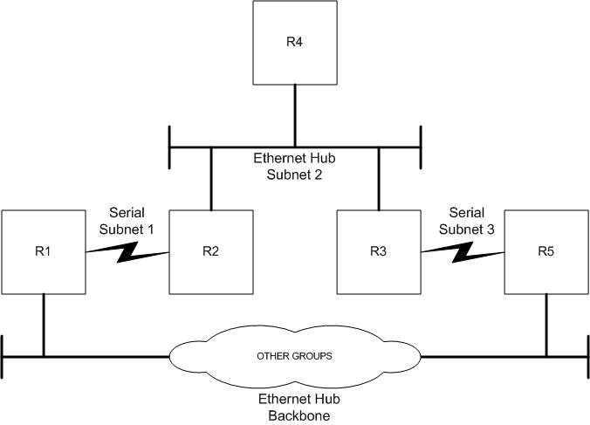
Useful Cisco Commands
- show ip route
- clear ip route *
- reload
- show running-config
Objective 1
Configure OSI Layers 1-3 on the routers. Be sure you have a VLAN capable ethernet switch for subnet 2.

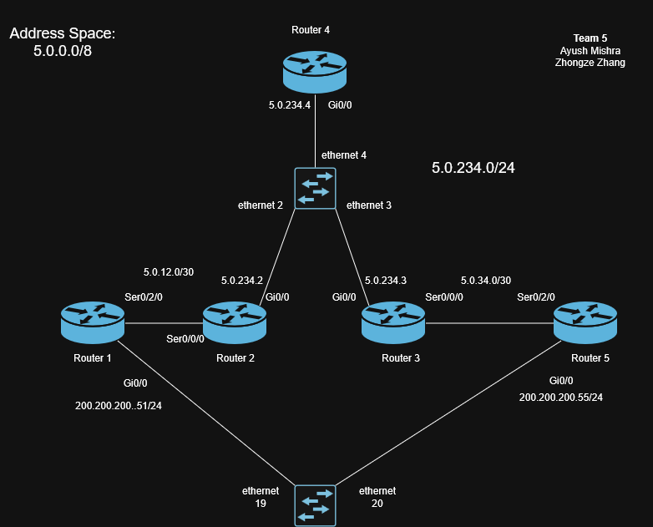
- Each group will use X.0.0.0/8 for their address space where X is the group number.
- Configure IP addressing on you routers. /32s for loopbacks, /30s or /31s for serial segments and /24s for ethernet segments.
- Configure IP addressing of backbone ethernet to be 200.200.200.xr/24, where x is your group number, r is the router number.
- Be sure to name your routers using the scheme xRr, where x is your group number, r is the router number.
- Question 1.1 - How do you tell if all your routers interfaces are 'up' and working. Paste output from one router showing this.
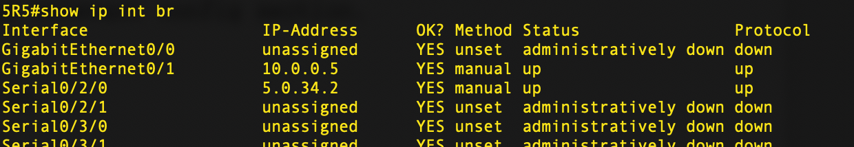
- Question 1.2 - How do you configure the box to never time out the console connection. Paste the relevant config section.
Having “exec-timeout 0 0” ensures that the box never times out
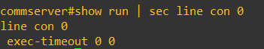

Objective 2
Configure RIP routing in your domain.
- Configure RIPv2 on all 5 routers
- Question 2.1 - show reachability using 'ping' between R1 and R5.
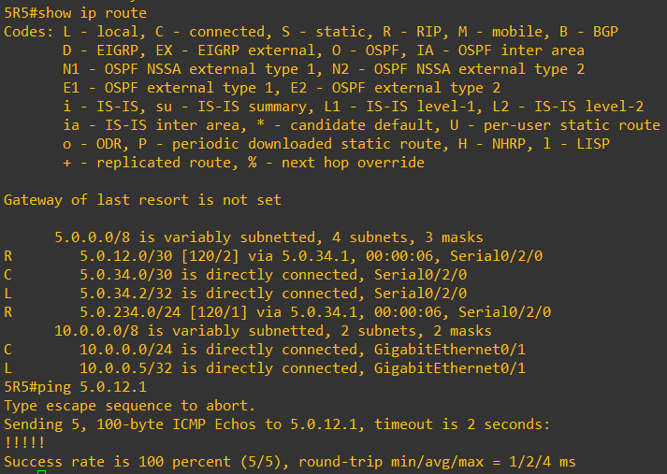

- Question 2.2 - Do not advertise RIP onto the backbone ethernet, show relevant config statements to accomplish this.
We do not advertise the 200.200.200.0/24 network in rip
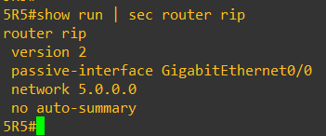
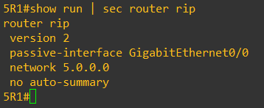

- Question 2.3 - Show successful ping from R5 to R1 (subnet 1 interface) and R1 to R5 (subnet 3 interface.)
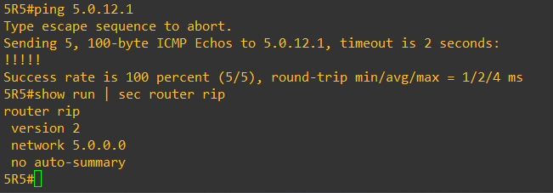

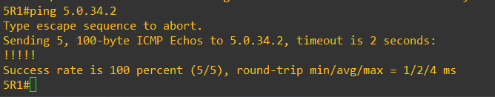
- Run the following command on your backbone routers.
  - term mon
  - debug ip rip
- To turn off debug you would type 'no debug all'
- Question 2.4 - Observe and log the debug messages for 1 minute. Turn in a sample of the log and a description in your words of what the debug messages mean. 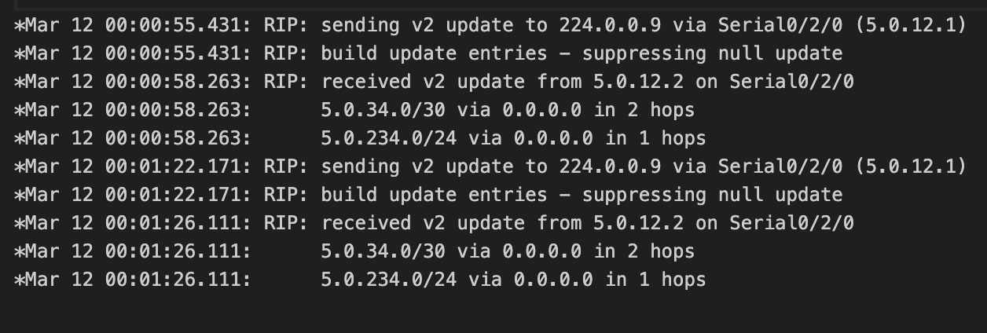
- 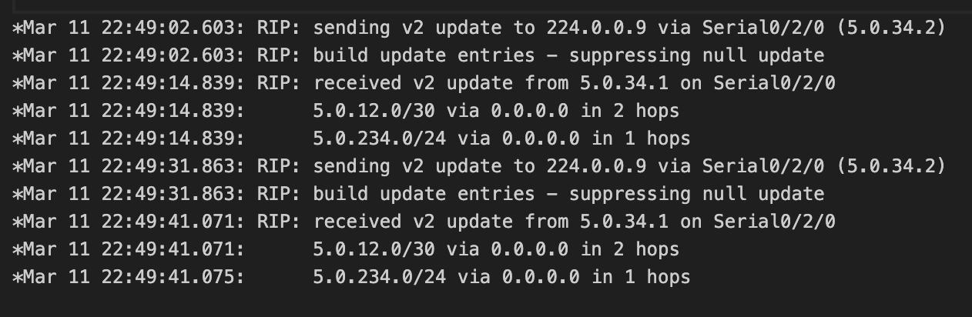
- Question 2.5 - Using the log from 2.4 how do you know RIP is not being advertised to the backbone?
We need the RIP is not been advertise to the backbone because we didn’t receive any RIPv2 updates and we did not send a update from/to 200.200.200.0/24 network which is interface gi0/0 for our backbone routers.
- Enable RIP fully on the backbone network.
- Work with other groups to ensure interpod connectivity.
- Question 2.6 - Can you reach other groups routers via ping? Why, why not?
We can reach other groups, because they have RIPv2 enable and we are advertising RIPv2 on backbone network as well. Please look at the screenshot below.
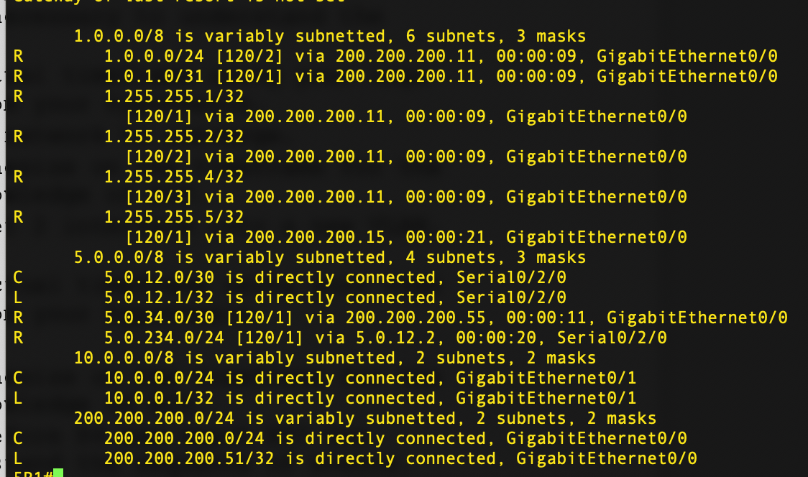

Pinging Group 1
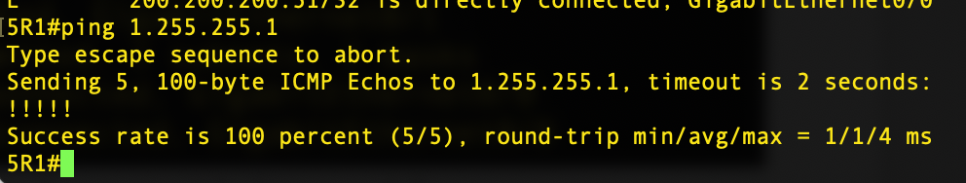
- Work with other groups to fix any interpod connectivity problems.
- Question 2.7 - Write up a short description of how you fixed any interpod connectivity problems.
We did not face any connectivity issues with any groups that had RIP enabled on the backbone.
- Question 2.8 - Write up a short hypothesize on the timeframe for the next instruction using your working knowledge of RIP.
We hypothesize based on our knowledge of RIP that if the link between R3 and R5 fails then it should take less than 20 seconds for R1 to learn about R5 via the backbone network.
- 'Fail' the link between R3 and R5 by unplugging it. How long before R3 can reach R5? Use logging or debug as necessary to understand the sequence of events.
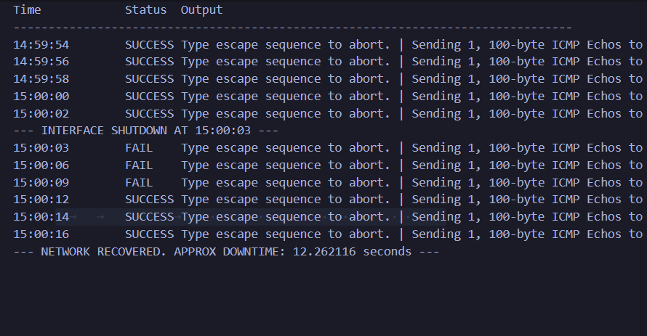

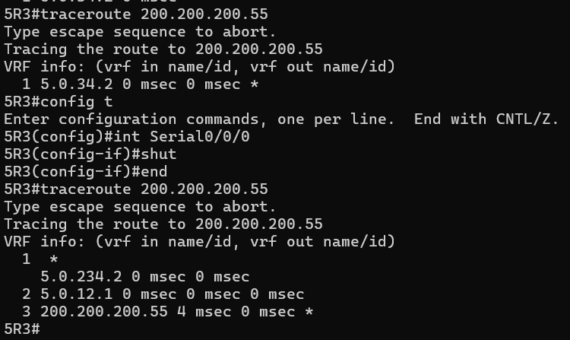

- Question 2.9 - Show and explain the actual timeframe using your logs for support. Explain any difference from your hypothesis.
What we see as you can see in the logs is that the ping fails for about 10 seconds before it is successful again. So our hypothesis was off by 10 seconds which we think in such a small network is still bad.
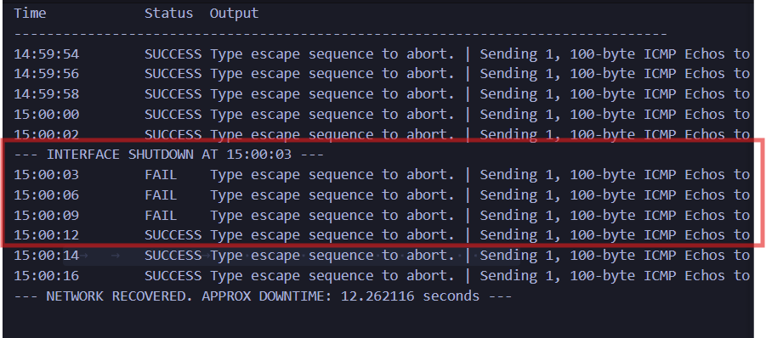

- Plug the link back in and wait for the network to converge.
- Question 2.10 - Write up a short hypothesize on the timeframe for the next instruction using your working knowledge of RIP.
We would think this process would also take about 10 seconds given that we realize that the converge time for this topology is about 10 seconds. In this case R3 will have to Route via R5-R1-R2 to get to R4.

- On the subnet 2 switch, move R3's subnet 2 interface into a new VLAN. How long before R3 can reach R4?
- Question 2.11 - Show and explain the actual timeframe using your logs for support. Explain any difference from your hypothesis.
What we see is that with vlan-mismatch it took way longer for it to converge. In our research we see that the RIP triggered updates just get sent when the interface goes down but for a vlan mismatch the routers wait for the RIP timers to happen before they converge. It took close to 4 minutes for it to happen
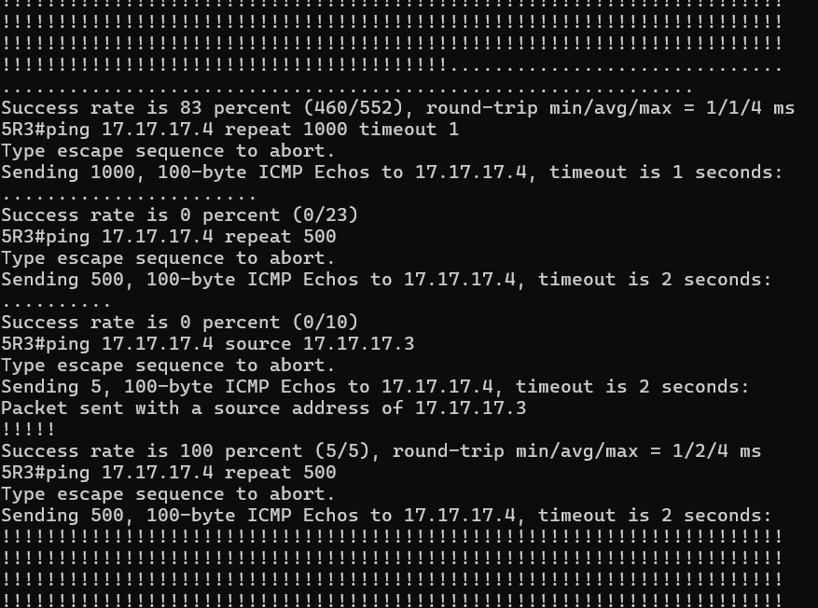

Here is what we see when the routing change does happen
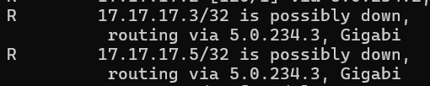
- Fix the VLAN mismatch
- Question 2.12 - Write up a short hypothesize on the timeframe for the next instruction using your working knowledge of RIP.
Now in this case because the Router 3 goes down completely, RIP will send a triggered update so the convergence should happen much faster around a minute.
- 'Fail' R3 by unplugging it. How long before R4 can reach R5? Use logging or debug as necessary to understand the sequence of events.
- Question 2.13 - Show and explain the actual timeframe using your logs for support. Explain any difference from your hypothesis.
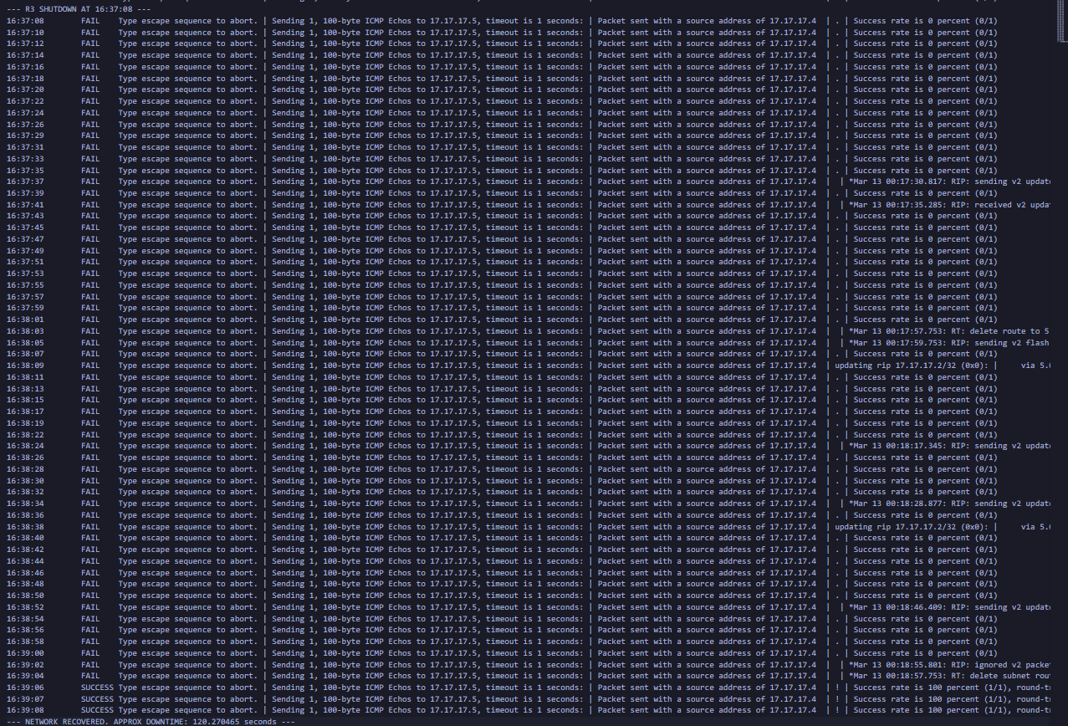

What we see is that the convergence took close to 2 minutes.
- Continue observations, power R3 back on and wait for the network to converge.
- Question 2.14 - Any impact as R3 joins the topology?
When R3 joins the topology back again we see that certain routes are changed back because R3 provides a smaller hop count metric to those destination routes.
- Question 2.15 - Explain the difference if any between the three failure and one recovery scenario.
One difference was that for the VLAN mismatch there was no triggered update sent, it was rather dependent on the timeout for the route to be thrown out. Whereas in other scenarios the interface goes down so it sends out a triggered update making those updates slightly faster.
- Question 2.16 - How did you test the convergence times across these scenarios? Discuss the positives and negatives of this test method.
We did the testing via automation scripts using netmiko, we continued pinging in loops and made the changes as needed for different scenarios, we also logged the fail pings and the success pings and calculate the time difference between them.
OBJECTIVE 3
Configure OSPF routing in your domain.
- Remove RIP from all routers, 'no router rip' on each box will do the trick.
- Configure OSPF on your routers, do NOT enable OSPF on any backbone facing links.
- Question 3.1 - show reachability using 'ping' between R1 and R5
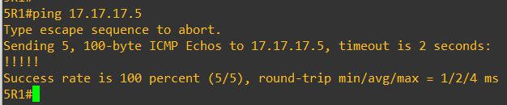
- Question 3.2 - Debug OSPF such that you can view the neighbor establishment between 2 routers. Turn in a sample of the log and a description in your words of what is occuring at each stage of the neighbor establishment.

Question 3.2 - Debug OSPF such that you can view the neighbor establishment between 2 routers. Turn in a sample of the log and a description in your words of what is occuring at each stage of the neighbor establishment.
2026-03-12 16:54:37,035 [INFO] Loading configuration...
2026-03-12 16:54:37,035 [INFO] ✓ Loaded 5 routers from /Users/AndyZ/Desktop/IP-Routing-and-Protocols/lab1/router_config.json

2026-03-12 16:54:37,036 [INFO] Networks to be advertised in OSPF (area 0):
2026-03-12 16:54:37,036 [INFO] - 17.17.17.1/24
2026-03-12 16:54:37,036 [INFO] - 17.17.17.2/24
2026-03-12 16:54:37,036 [INFO] - 17.17.17.3/24
2026-03-12 16:54:37,036 [INFO] - 17.17.17.4/24
2026-03-12 16:54:37,036 [INFO] - 17.17.17.5/24
2026-03-12 16:54:37,036 [INFO] - 5.0.12.0/24
2026-03-12 16:54:37,036 [INFO] - 5.0.234.0/24
2026-03-12 16:54:37,036 [INFO] - 5.0.34.0/24
2026-03-12 16:54:37,036 [INFO]
2026-03-12 16:54:37,036 [INFO] OSPF commands to be applied:
2026-03-12 16:54:37,036 [INFO] > no router rip
2026-03-12 16:54:37,036 [INFO] > router ospf 1
2026-03-12 16:54:37,036 [INFO] > network 17.17.17.1 0.0.0.255 area 0
2026-03-12 16:54:37,036 [INFO] > network 17.17.17.2 0.0.0.255 area 0
2026-03-12 16:54:37,036 [INFO] > network 17.17.17.3 0.0.0.255 area 0
2026-03-12 16:54:37,036 [INFO] > network 17.17.17.4 0.0.0.255 area 0
2026-03-12 16:54:37,036 [INFO] > network 17.17.17.5 0.0.0.255 area 0
2026-03-12 16:54:37,036 [INFO] > network 5.0.12.0 0.0.0.255 area 0
2026-03-12 16:54:37,036 [INFO] > network 5.0.234.0 0.0.0.255 area 0
2026-03-12 16:54:37,036 [INFO] > network 5.0.34.0 0.0.0.255 area 0
2026-03-12 16:54:37,036 [INFO] > exit
2026-03-12 16:54:37,036 [INFO]
2026-03-12 16:54:37,036 [INFO] Target debug router: 5R2

2026-03-12 16:54:37,036 [INFO]
======================================================================
2026-03-12 16:54:37,036 [INFO] STEP 1: Enabling OSPF Debug on R2
2026-03-12 16:54:37,036 [INFO] ======================================================================
2026-03-12 16:54:37,036 [INFO] Connecting to R2 (10.0.0.2)
2026-03-12 16:54:37,046 [INFO] Connected (version 1.99, client Cisco-1.25)
2026-03-12 16:54:37,435 [INFO] Authentication (password) successful!
2026-03-12 16:54:37,659 [INFO] Configuring logging buffer on R2...
2026-03-12 16:54:37,749 [INFO] Enabled logging buffer (32KB)
2026-03-12 16:54:37,749 [INFO] Enabling 'debug ospf adj' on R2...
2026-03-12 16:54:37,845 [INFO] Debug command sent. Ready to capture neighbor establishment.

2026-03-12 16:54:37,845 [INFO]
======================================================================
2026-03-12 16:54:37,845 [INFO] STEP 2: Configuring OSPF on All Routers
2026-03-12 16:54:37,846 [INFO] ======================================================================
2026-03-12 16:54:37,846 [INFO] Configuring 5R1 (10.0.0.1)...
2026-03-12 16:54:37,851 [INFO] Connected (version 1.99, client Cisco-1.25)
2026-03-12 16:54:38,461 [INFO] Authentication (password) successful!
2026-03-12 16:54:38,975 [INFO] ✓ OSPF configured on 5R1
2026-03-12 16:54:38,989 [INFO] Configuring 5R2 (10.0.0.2)...
2026-03-12 16:54:38,993 [INFO] Connected (version 1.99, client Cisco-1.25)
2026-03-12 16:54:39,619 [INFO] Authentication (password) successful!
2026-03-12 16:54:40,127 [INFO] ✓ OSPF configured on 5R2
2026-03-12 16:54:40,139 [INFO] Configuring 5R3 (10.0.0.3)...
2026-03-12 16:54:40,146 [INFO] Connected (version 1.99, client Cisco-1.25)
2026-03-12 16:54:40,569 [INFO] Authentication (password) successful!
2026-03-12 16:54:41,084 [INFO] ✓ OSPF configured on 5R3
2026-03-12 16:54:41,095 [INFO] Configuring 5R4 (10.0.0.4)...
2026-03-12 16:54:41,101 [INFO] Connected (version 1.99, client Cisco-1.25)
2026-03-12 16:54:41,493 [INFO] Authentication (password) successful!
2026-03-12 16:54:42,003 [INFO] ✓ OSPF configured on 5R4
2026-03-12 16:54:42,016 [INFO] Configuring 5R5 (10.0.0.5)...
2026-03-12 16:54:42,026 [INFO] Connected (version 1.99, client Cisco-1.25)
2026-03-12 16:54:42,447 [INFO] Authentication (password) successful!
2026-03-12 16:54:42,975 [INFO] ✓ OSPF configured on 5R5
2026-03-12 16:54:42,988 [INFO]
✓ OSPF configuration complete on all routers

2026-03-12 16:54:42,988 [INFO] ======================================================================
2026-03-12 16:54:42,988 [INFO] STEP 3: Waiting for OSPF Neighbors to Establish
2026-03-12 16:54:42,988 [INFO] ======================================================================
2026-03-12 16:54:42,988 [INFO] Waiting 35 seconds for neighbor adjacencies to establish...
2026-03-12 16:54:42,988 [INFO] (OSPF Hello interval is typically 10 seconds on Ethernet)
2026-03-12 16:54:42,988 [INFO] (Adjacency formation involves multiple state transitions)

2026-03-12 16:54:42,988 [INFO] ... 35 seconds remaining
2026-03-12 16:54:48,009 [INFO] ... 30 seconds remaining
2026-03-12 16:54:53,029 [INFO] ... 25 seconds remaining
2026-03-12 16:54:58,051 [INFO] ... 20 seconds remaining
2026-03-12 16:55:03,071 [INFO] ... 15 seconds remaining
2026-03-12 16:55:08,085 [INFO] ... 10 seconds remaining
2026-03-12 16:55:13,100 [INFO] ... 5 seconds remaining
2026-03-12 16:55:18,113 [INFO]
======================================================================
2026-03-12 16:55:18,114 [INFO] STEP 4: Capturing Debug Output and OSPF Status
2026-03-12 16:55:18,114 [INFO] ======================================================================
2026-03-12 16:55:18,114 [INFO] Disabling debug...
2026-03-12 16:55:18,213 [INFO] ✓ Debug disabled

2026-03-12 16:55:18,213 [INFO] ----------------------------------------------------------------------
2026-03-12 16:55:18,214 [INFO] OSPF ADJACENCY DEBUG OUTPUT (from logging buffer)
2026-03-12 16:55:18,214 [INFO] ----------------------------------------------------------------------
2026-03-12 16:55:18,306 [INFO] Syslog logging: enabled (0 messages dropped, 8 messages rate-limited, 0 flushes, 0 overruns, xml disabled, filtering disabled)

No Active Message Discriminator.

No Inactive Message Discriminator.

Console logging: level debugging, 88 messages logged, xml disabled,
filtering disabled
Monitor logging: level debugging, 0 messages logged, xml disabled,
filtering disabled
Buffer logging: level debugging, 92 messages logged, xml disabled,
filtering disabled
Exception Logging: size (4096 bytes)
Count and timestamp logging messages: disabled
Persistent logging: disabled

No active filter modules.

Trap logging: level informational, 97 message lines logged
Logging Source-Interface: VRF Name:

2026-03-12 16:55:18,306 [INFO] ----------------------------------------------------------------------
2026-03-12 16:55:18,307 [INFO] OSPF NEIGHBOR STATUS ON R2
2026-03-12 16:55:18,307 [INFO] ----------------------------------------------------------------------
2026-03-12 16:55:18,404 [INFO]
Neighbor ID Pri State Dead Time Address Interface
17.17.17.3 1 2WAY/DROTHER 00:00:31 5.0.234.3 GigabitEthernet0/0
17.17.17.4 1 2WAY/DROTHER 00:00:31 5.0.234.4 GigabitEthernet0/0
17.17.17.1 0 FULL/ - 00:00:38 5.0.12.1 Serial0/0/0

2026-03-12 16:55:18,404 [INFO] ----------------------------------------------------------------------
2026-03-12 16:55:18,404 [INFO] OSPF NEIGHBOR DETAILS (verbose)
2026-03-12 16:55:18,404 [INFO] ----------------------------------------------------------------------
2026-03-12 16:55:27,496 [INFO] Translating "verbose"...domain server (255.255.255.255)
^
% Invalid input detected at '^' marker.

2026-03-12 16:55:27,497 [INFO] ----------------------------------------------------------------------
2026-03-12 16:55:27,497 [INFO] OSPF PROCESS INFORMATION ON R2
2026-03-12 16:55:27,497 [INFO] ----------------------------------------------------------------------
2026-03-12 16:55:27,592 [INFO] Routing Process "ospf 1" with ID 17.17.17.2
Start time: 3w2d, Time elapsed: 00:00:47.680
Supports only single TOS(TOS0) routes
Supports opaque LSA
Supports Link-local Signaling (LLS)
Supports area transit capability
Supports NSSA (compatible with RFC 1587)
Event-log enabled, Maximum number of events: 1000, Mode: cyclic
Router is not originating router-LSAs with maximum metric
Initial SPF schedule delay 5000 msecs
Minimum hold time between two consecutive SPFs 10000 msecs
Maximum wait time between two consecutive SPFs 10000 msecs
Incremental-SPF disabled
Minimum LSA interval 5 secs
Minimum LSA arrival 1000 msecs
LSA group pacing timer 240 secs
Interface flood pacing timer 33 msecs
Retransmission pacing timer 66 msecs
Number of external LSA 0. Checksum Sum 0x000000
Number of opaque AS LSA 0. Checksum Sum 0x000000
Number of DCbitless external and opaque AS LSA 0
Number of DoNotAge external and opaque AS LSA 0
Number of areas in this router is 1. 1 normal 0 stub 0 nssa
Number of areas transit capable is 0
External flood list length 0
IETF NSF helper support enabled
Cisco NSF helper support enabled
Reference bandwidth unit is 100 mbps
Area BACKBONE(0)
Number of interfaces in this area is 3 (1 loopback)
Area has no authentication
SPF algorithm last executed 00:00:00.640 ago
SPF algorithm executed 2 times
Area ranges are
Number of LSA 6. Checksum Sum 0x019A83
Number of opaque link LSA 0. Checksum Sum 0x000000
Number of DCbitless LSA 0
Number of indication LSA 0
Number of DoNotAge LSA 0
Flood list length 2

2026-03-12 16:55:27,593 [INFO] ----------------------------------------------------------------------
2026-03-12 16:55:27,593 [INFO] OSPF INTERFACE STATUS ON R2
2026-03-12 16:55:27,593 [INFO] ----------------------------------------------------------------------
2026-03-12 16:55:27,687 [INFO] Interface PID Area IP Address/Mask Cost State Nbrs F/C
Lo0 1 0 17.17.17.2/32 1 LOOP 0/0
Gi0/0 1 0 5.0.234.2/24 1 DROTH 1/2
Se0/0/0 1 0 5.0.12.2/30 64 P2P 1/1

2026-03-12 16:55:27,700 [INFO] Disconnected from R2

2026-03-12 16:55:27,700 [INFO]
======================================================================
2026-03-12 16:55:27,701 [INFO] OSPF NEIGHBOR ESTABLISHMENT EXPLANATION
2026-03-12 16:55:27,702 [INFO] ======================================================================
2026-03-12 16:55:27,702 [INFO]
The OSPF neighbor establishment process goes through multiple states:

1. DOWN
- Initial state when no Hello packets have been received from the neighbor
- OSPF process is running but no communication with neighbor yet

2. INIT
- Router has received at least one Hello packet from the neighbor
- BUT the receiving router's own router ID is NOT in neighbor's Hello packet yet
- One-way communication is happening (asymmetric)

3. 2-WAY
- Both routers have seen each other's Hello packets
- The receiving router sees its own router ID in the neighbor's Hello packet
- Bidirectional communication is established (symmetric)
- THIS IS THE KEY POINT: After this stage, routers decide if they will form an adjacency
- On multi-access networks (Ethernet), only DR and BDR form full adjacencies with all routers

4. EXSTART
- Routers are negotiating DBD (Database Descriptor) exchange parameters
- Master/Slave relationship is established based on router IDs
- Higher router ID becomes the Master (controls DBD sequence numbers)

5. EXCHANGE
- Database Descriptor (DBD) packets are exchanged
- Each router sends a summary of its link state database
- Routers identify which LSAs they need to request

6. LOADING
- Link State Request (LSR) packets are sent
- Link State Update (LSU) packets are received and processed
- Full Link State Database synchronization in progress

7. FULL
- Adjacency is fully established and operational
- Both routers have synchronized link state databases
- Routing can now occur through this adjacency
- Routers are updated when topology changes occur

TIMELINE EXAMPLE:
- Before OSPF config: DOWN (no routes advertising OSPF yet)
- Immediate after config on R2: DOWN (no neighbors configured yet)
- When other routers start OSPF: Hellos arrive → INIT state
- Exchange of Hellos completes: 2-WAY state
- DBD negotiation: EXSTART → EXCHANGE
- Database sync: LOADING
- Complete: FULL (neighbor fully adjacent)

The debug output in the log shows these state transitions as they happen,
revealing the exact sequence and timing of neighbor establishment.

2026-03-12 16:55:27,703 [INFO]
======================================================================
2026-03-12 16:55:27,703 [INFO] DEBUG CAPTURE COMPLETE
2026-03-12 16:55:27,703 [INFO] ======================================================================
2026-03-12 16:55:27,703 [INFO] Results saved to: debug_ospf_neighbor_establishment.log
2026-03-12 16:55:27,703 [INFO] ======================================================================

- Question 3.3 - Provide output and a reason for the current DR/BDR setup of your R2, R3, R4 ethernet link.
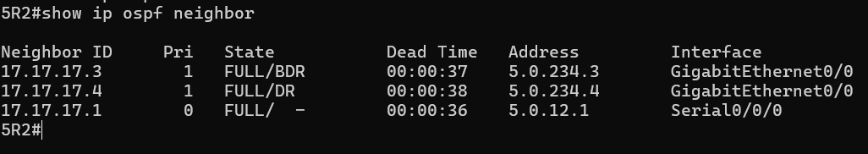
- Question 3.4 - Configure the routers such that R2 is the DR, and R4 is the BDR, and R3 will never compete in an election. Provide show command output showing the new setup/configuration. Did this work after configuration changes or require something additional? Why?
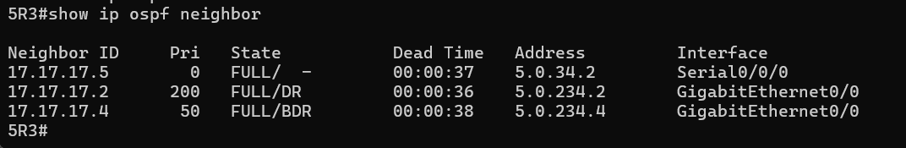

We set the priority for R3 to be 0. What we noticed is that we had to “clear ip ospf process” to redo the election after priority was changed. This is because OSPF is pre-emptive which means they do not do a relection of DR/BDR if an election has already happened.
- Configure OSPF router authentication on the ethernet R2, R3, and R4 routers. Purposely configure one of the routers to have an incorrect password.
- Question 3.5 - Show relevant debug output which details the authentication issue. Fix the issue.
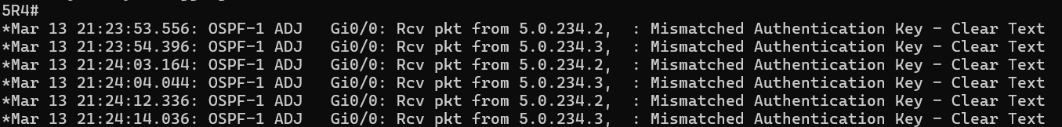
- Question 3.6 - Examine the LSA database on a group router. Paste a sample along with a description of each field header.
The OSPF database header uniquely identifies the origin and source of link-state information through the Link ID and ADV Router. It uses Age and Seq# to jointly determine the freshness and version of topology information, while Checksum verification ensures data integrity during transmission. The Link count directly reflects the total number of physical and logical links advertised by the router within a specific area.
- Configure your group such that R1 and R5 are ABRs with their backbone links in Area 0 and their group facing links in Area x, where x is group number. All other routers in group are part of site area.
- Question 3.7 - Ping the loopback for R1 from R5, be sure to use the loopback of R5 as the ping source. Cut and paste the command showing this.
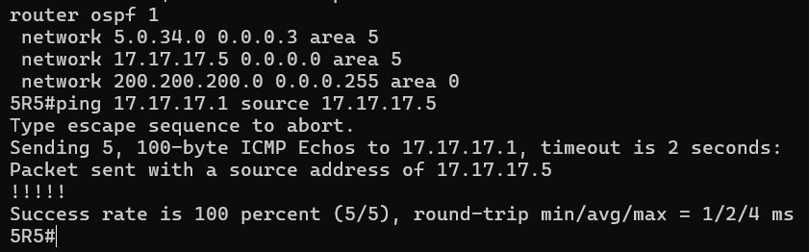

- Question 3.8 - Examine the LSA database and routing table of R1 and R5, how are they the same/different. Why?

The OSPF Link State Databases (LSDB) for both routers are identical because they belong to the same OSPF areas (Area 0 and Area 5).
A core requirement of the OSPF protocol is that all routers within an area must have a synchronized, perfectly matching LSDB. This ensures that every router has the exact same topological "map" of the network before they run the Shortest Path First (SPF) algorithm. If you look at the raw output, the lists of Link IDs, ADV Routers, Checksums, and Sequence numbers match perfectly between the two endpoints.
The only difference in the LSDB output is the string identifying which router generated the output (OSPF Router with ID (17.17.17.1) vs OSPF Router with ID (17.17.17.5)).
Now ayush and andy reviewed the Routing Tables are different because they represent the directions calculated from the map (LSDB), and R1 and R5 are situated at different physical locations in the network.
While they both know about the exact same destination networks they use different paths to get there based on the SPF algorithm's calculation from their own unique perspective:
- Different Next-Hops (Gateways): To each R5's loopback (17.17.17.5), R1 must route traffic out its Serial0/2/0 interface to IP 5.0.12.2. Conversely, to reach R1's loopback (17.17.17.1), R5 must route traffic out its Serial0/2/0 interface to IP 5.0.34.1.
- Directly Connected vs. Learned Routes: Network 5.0.12.0/30 is a directly connected "C" route for R1, but it is a learned OSPF "O" route for R5 (because it sits further away on the topology). The opposite is true for 5.0.34.0/30, which is connected to R5 but must be learned by R1.
- Different Exit Interfaces: Both routers are connected to the transit subnet 200.200.200.0/24 on their Gi0/0 interfaces, but their local IP assignments differ (.51 for R1 vs .55 for R5), which changes the local interface costs to reach external/transit networks via those paths.

- Question 3.9 - Ping successfully between your R5 router and another groups R5 router. Cut and paste the results.
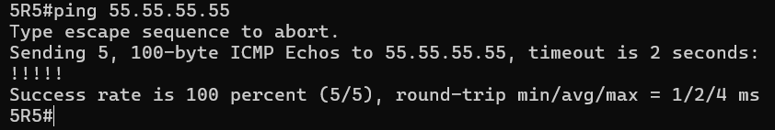
- Question 3.10 - Write up a short hypothesize on the timeframe for the next instruction using your working knowledge of OSPF.
This should be a very fast convergence because OSPF converges really fast so we would say less than 10 seconds before R3 and R5 can ping each other again.
- 'Fail' the link between R3 and R5 by unplugging it. How long before R3 can reach R5. Use logging or debug as necessary to understand the sequence of events and specify how you tested the convergence.
We see that the ping starts working after a time period of 8 seconds. So our hypothesis was pretty close, it was based on the fact that OSPF is link state protocol and doesn’t take much to converge.
We tested the convergence by sending pings from R3 loopback to R5 and then shutting down the interface to replicate a failed link.
- Question 3.11 - Show and explain the actual timeframe using your logs for support. Explain any difference from your hypothesis.
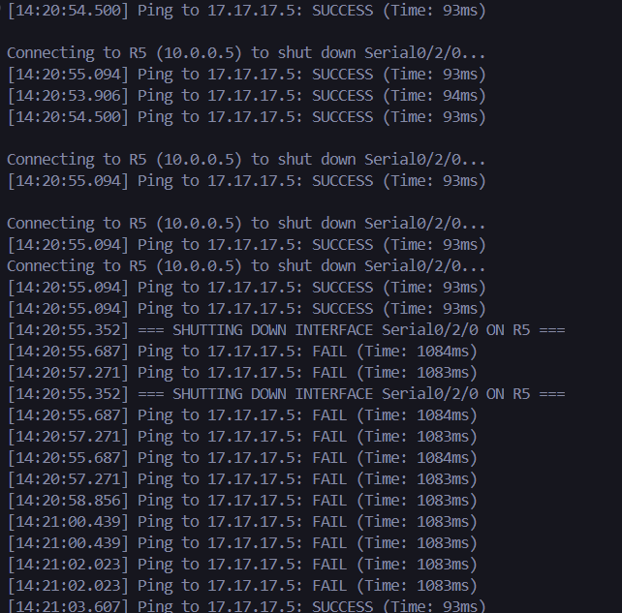
- Plug the link back in and wait for the network to converge.
- Question 3.12 - Write up a short hypothesize on the timeframe for the next instruction using your working knowledge of OSPF.
Our hypothesis is that because it is OSPF it should still be fast. And it should take less than 40 seconds to achieve convergence and ping to start working again.
- On the subnet 2 switch, move R3's subnet 2 interface into a new VLAN. How long before R3 can reach R4.
It took about 46 seconds for the ping to start working again.
- Question 3.13 - Show and explain the actual timeframe using your logs for support. Explain any difference from your hypothesis.
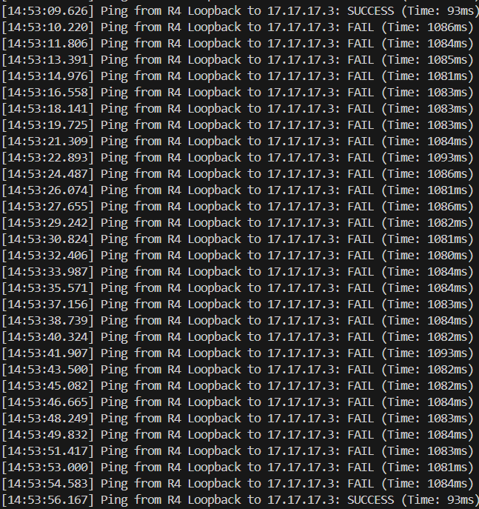

We see that it took about 45 seconds which is still slightly off from our hypothesis.
- Question 3.14 - Write up a short hypothesize on the timeframe for the next instruction using your working knowledge of OSPF.
Our hypothesis is that this should take a similar time frame of about 10 seconds for it to converge.
- 'Fail' R3 by unplugging it. How long before R4 can reach R5? Use logging or debug as necessary to understand the sequence of events.
We see that the interfaces start pinging each other again after 40 seconds.
- Question 3.15 - Show and explain the actual timeframe using your logs for support. Explain any difference from your hypothesis.
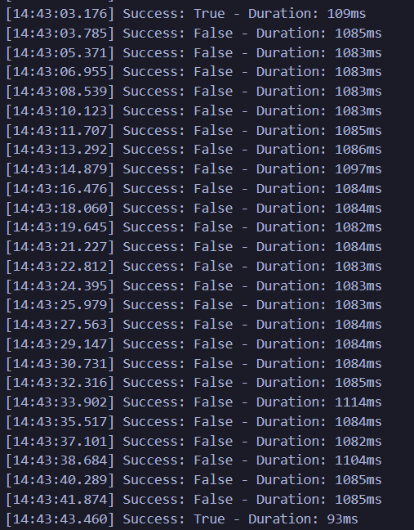
- Continue observations, power R3 back on and wait for the network to converge.
- Question 3.16 - Any impact as R3 joins the topology?
When R3 joins back the topology, there is minor change in the routing table because now that R3 joins the topology there is improvement in certain costs because certain networks have a lower OSPF cost leading to updates in the routing table.
- Question 3.17 - Explain the difference if any between the three failure and one recovery scenario.
The last two scenarios are similar in the time frame as it took about 40 seconds for the recovery to happen, but in the first case it took about 10 seconds to ping to start working. The difference is due to the SPF calculation speed in the different cases.
- Question 3.18 - How did you test the convergence times across these scenarios? Discuss the positives and negatives of this test method.
We automated all three steps, except not being able to fully automate the VLAN mismatch, because we manually started the ping and then mismatched the VLAN through the console connection. But besides that we took time stamps for success pings and then the failed pings too, and then calculated the difference from when the ping goes from “Success” – “Fail” – “Success” again.
- Configure your group area to be a stub.
- Question 3.19 - Examine the LSA database and routing table of R1 and R5, how are they same/different from Question 3.8? Explain any differences.
R1 and R5 are very similar because both routers are acting as ABRs between area 0 and area 5. In the OSPF database, both routers contain Router Link States for area 0 and area 5, Net Link States for both areas, and Summary Net Link States for both areas. This shows that each router has visibility into the backbone and the stub area.
The area 5 LSDB entries are nearly identical on both routers. Each one contains summary information for the same internal networks, including the 0.0.0.0 summary entry that represents a default route being advertised into the stub area. This symmetry is expected because both R1 and R5 sit at the edge of the stub area and perform the same function from opposite sides of the topology.
The routing tables are also mostly the same. Both routers learn the same OSPF inter-area route for 1.0.0.0/8, both have the same intra-area routes for the lab networks, and both contain the same OSPF external routes marked as O E2. This means they are learning the same set of remote destinations from the backbone.
The main differences are local and topology-based. R1 has its own directly connected serial network 5.0.12.0/30 and loopback 17.17.17.1, while R5 has its own directly connected serial network 5.0.34.0/30 and loopback 17.17.17.5. Their next hops are mirrored as well: R1 reaches the area 5 side through 5.0.12.2, while R5 reaches it through 5.0.34.1. The OSPF costs are also mirrored, reflecting that each router is closer to the routers on its own side of the topology.
One important observation is that both R1 and R5 still show Type-5 AS External LSAs and O E2 external routes. This does not contradict the stub-area design. Since R1 and R5 are ABRs and still belong to area 0, they continue to learn external LSAs from the backbone. The stub restriction mainly affects what is flooded into area 5 for the internal routers, not what the ABRs themselves know from area 0.
Another observation is that neither R1 nor R5 has a gateway of last resort installed in its routing table. That is also reasonable. In a stub area, the ABR injects a default route for the internal routers in the stub area. The ABRs themselves do not necessarily need to install that default route if they already have full knowledge of external destinations through area 0.
- Confirm that you still have full connectivity.
OBJECTIVE 4
Configure RIP/OSPF redistribution.
- Change back to a standard area and remove OSPF completely from R4. Remove OSPF from R2 and R3 on the R4 facing link.
- Configure RIP on R4 and on R2 and R3 links facing R4. Be sure to passive interface non RIP interfaces on R2 and R3
- Question 4.1 - Which routers have full intra group connectivity? Which routers have full inter group connectivity? Why?
only 5R2 and 5R3 have full intra-group connectivity because they participate in both OSPF and RIP. 5R1 and 5R5 only know the OSPF domain, while 5R4 only knows the RIP domain, so those routers do not yet have full reachability to all routers in the group. There is not full inter-group connectivity at this point either, because RIP and OSPF have not yet been redistributed, so routes from one routing domain are not being advertised into the other.
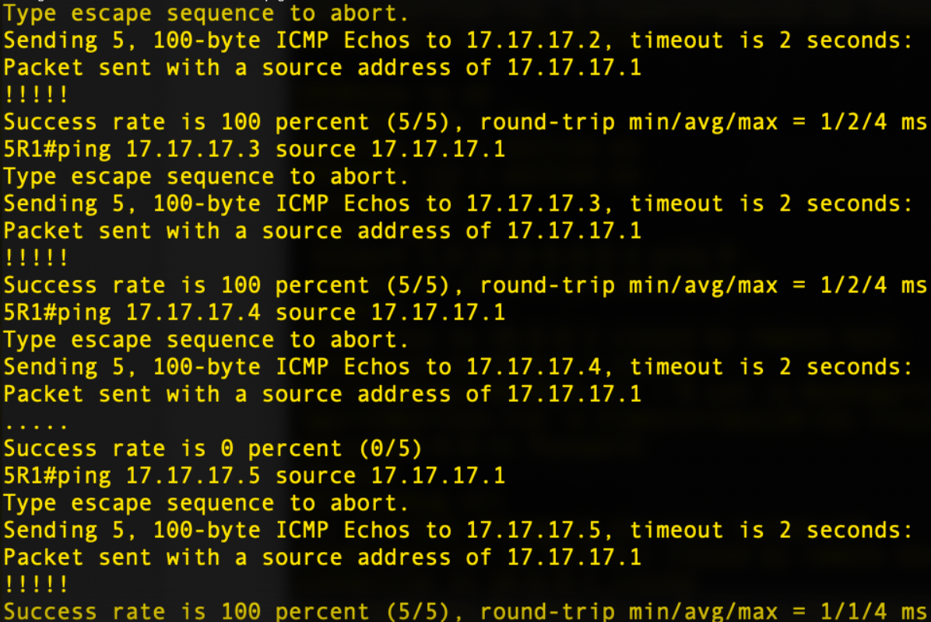
R1 ping fails for Router 4
R2 has full connectivity
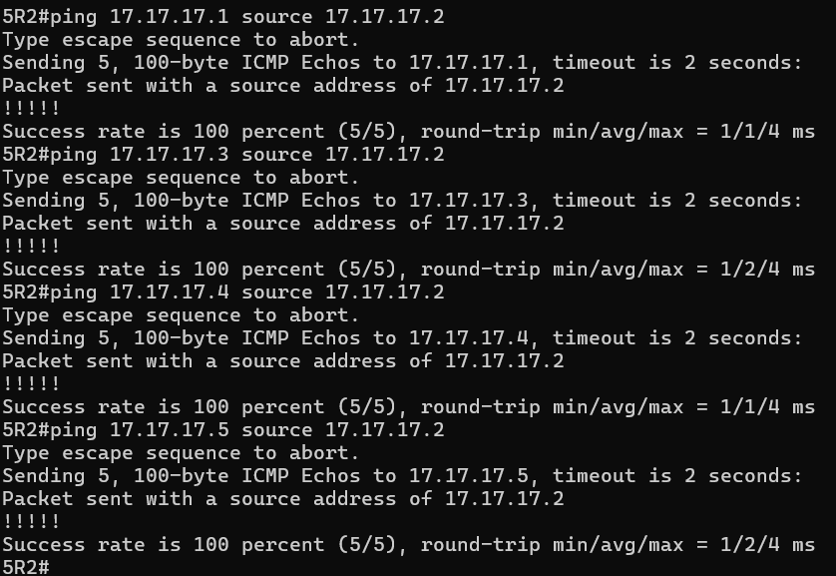

R3 Connectivity test
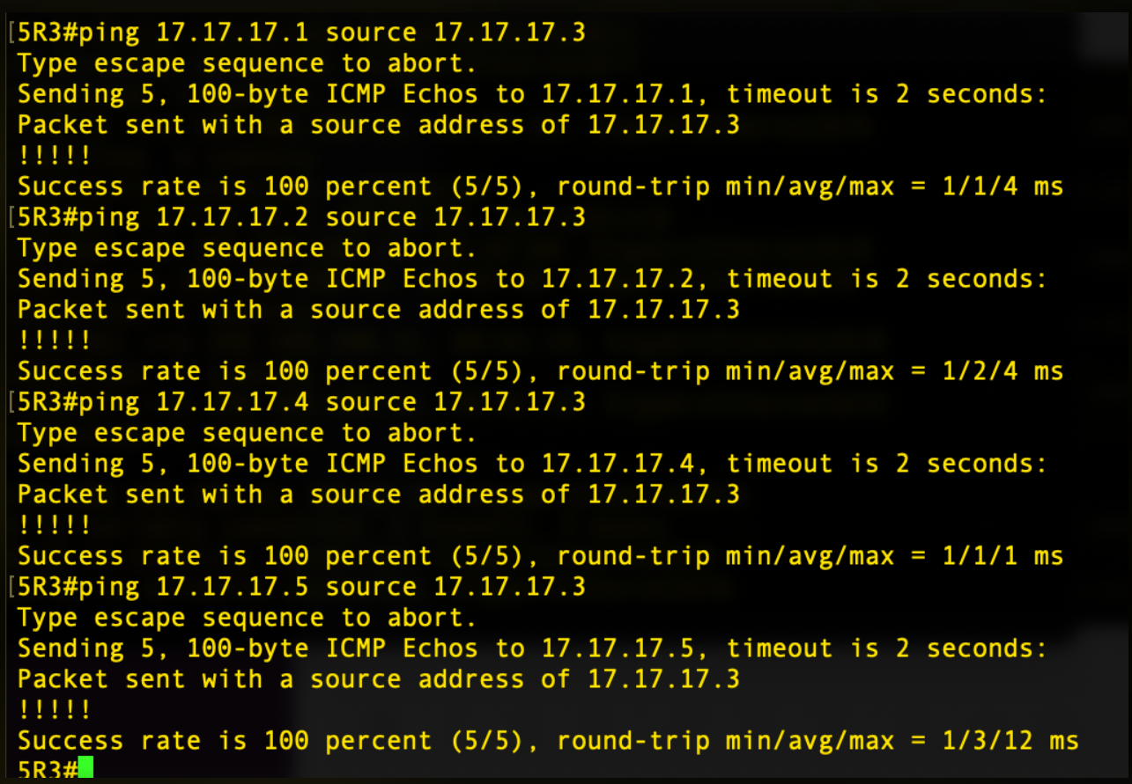

R4 connectivity test
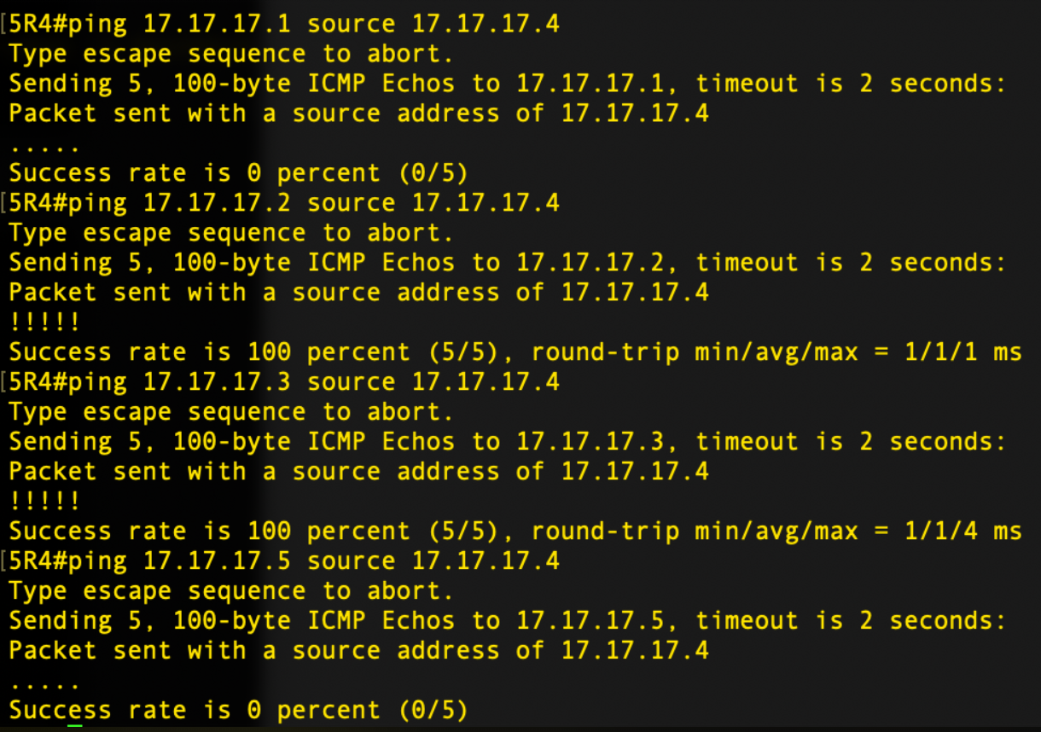
R5 Connectivity test
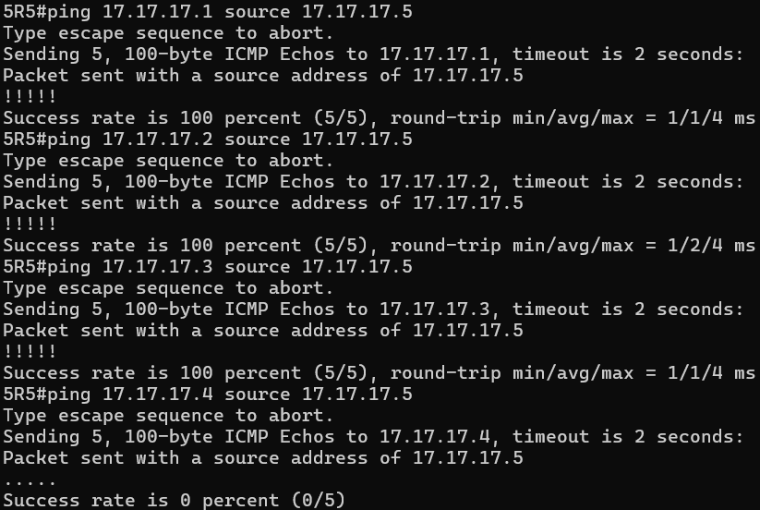
- Configure RIP/OSPF redistribution.
- Question 4.2 - What type of LSA will the RIP networks from a different group show up as on your R1 and R5 routers? Show me output proving your answer.
The RIP networks from a different group show up on 5R1 and 5R5 as Type 5 AS-External LSAs in the OSPF database.
5R2 and 5R3 were configured as ASBRs and are redistributing RIP into OSPF with redistribute rip subnets metric-type 2 metric 20, as shown in the image. Because of that, RIP-learned networks are injected into OSPF as external routes, which appear in the LSDB as Type 5 LSAs.
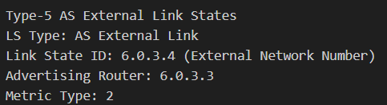

- Question 4.3 - What LSA do the R1 and R5 routers in your group use to route to the RIP networks in a different group. Show me output proving your answer.
R1 and R5 use OSPF External Type 2 routes, shown as O E2, to actually route to RIP networks in other groups.
A Type 5 LSA is the database advertisement. The route installed in the routing table from that LSA is an OSPF external type 2 route.
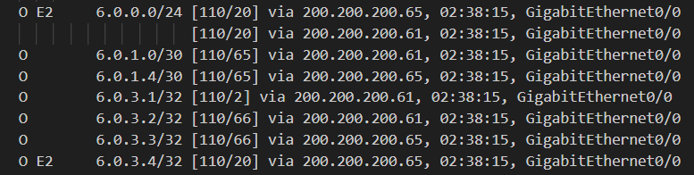

- Question 4.4 - Traceroute between your R4 routers loopback and a different groups R4 router loopback. Show me the output. For each router in the path between R5 routers explain how the router knew where to forward it onto next. I'm interested in understanding the routing updates and LSA types flowing along the path.

- 5R4 is in the RIP domain only, so it learns the destination remote R4 loopback through RIP.
- 5R2 and 5R3 are the redistribution routers. They inject OSPF routes into RIP and RIP routes into OSPF.
- When 5R4 sends traffic toward a different group’s R4 loopback, it forwards the packet to whichever redistribution router, 5R2 or 5R3, RIP selected as the next hop.
- Once the packet reaches 5R2 or 5R3, forwarding is based on OSPF. At that point the remote R4 loopback is known in OSPF as an external destination.
- R1 or R5 then forwards across the backbone using the O E2 route toward the remote group’s ASBR.
- In the remote group, that group’s redistribution router passes the packet from OSPF into RIP, and RIP delivers it to that group’s R4.
- Question 4.5 - Show me successful output of pings from your R4 routers loopback to every other R4 routers loopback in the network.
The pings from our R4 loopback to the other groups’ R4 loopbacks were successful after redistribution was configured. This works because R2 and R3 redistribute OSPF into RIP for our local R4, and they also redistribute RIP into OSPF so the rest of the network can learn our R4 loopback. As a result, reachability is bi-directional between our RIP-only R4 and the other groups’ R4 loopbacks

OBJECTIVE 5
Wrap up
- Question 5.1 - What did you learn from this lab?
From this assignment, we’ve learned that VLAN mismatches prevent Layer 3 routing protocols (RIP and OSPF) from reaching neighbors, causing delayed convergence and route regeneration a critical insight that networking depends on Layer 2 connectivity before Layer 3 routing can function. Beyond this, we also gained valuable understanding of convergence differences between protocols: OSPF converges in seconds using bandwidth-based costs and neighbor state progression through multiple stages, while RIP converges more slowly (up to 3 minutes) using simple hop count metrics and longer timers to prevent routing loops. Most importantly, our experience automating these configurations is a significant advantage; while creating a template library would speed up future work, the automation skills we’ve developed are invaluable and will enable us to scale network management scenarios something many network engineers lack. Moving forward, consider exploring advanced topics like metric calculation, route poisoning/split horizon, and tools like Ansible to further enhance our automation capabilities.
- Question 5.2 - What was the least useful part of this lab?
The manual debugging logs even though helpful probably offered the least value compared to automated test frameworks that would tell the pass/fail status more efficiently.
- Question 5.3 - What was the most useful part of this lab?
The most useful part of this lab was the combination of hands-on failover testing, automation scripting, and real-world protocol comparison we didn't just learn about RIP and OSPF theoretically, but configured them, automated the entire setup process with Python, tested failure scenarios to observe protocol behavior under stress, and debugged real network issues by examining routing tables and LSA databases. We learned about different
OBJECTIVE 6
Juniper it Up
- Did you finish early? Overachievers? Want a good job after graduation? If so replace R1 with a Juniper and rerun objectives 2 and 3.

