IP Routing Lab 3 - GNS Version
Lab 3
Logistics
• Write erase the routers and start from scratch with a default config.
• Use 1.0.0.0/8 for your IP space and AS1 for your autonomous system number.
OBJECTIVE 1
Design and configure a heirarchial backbone topology per the following drawing, notes and requirements
- All routers are running BGP in a resiliant manner.
- Your /8 is in BGP. This should be the *only* static route in your network in this objective.
- We are only building 1 cities for this lab but assume there are 25 more similiar sites on your network.
- Assume any given city could have up to 10 EDGE routers.
- Question 1.1 - What IGP design decisions did you make?
- Question 1.2 - Show relevant IGP config snips from CORE1.SJO1 and EDGE1.SJO1.
- Question 1.3 - What BGP design decisions did you make?
- Question 1.4 - Show relevant BGP config snips from CORE1.SJO1 and EDGE1.SJO1.
- Verify you have reachability to all routers from all routers.
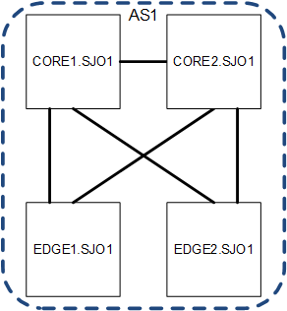
OBJECTIVE 2
Design a routing policy that accounts for network relationships of customer, peer, and transit. Consider that any given EDGE router could have any relationship type.
- Build route policy in and out for each relationship type. Give them a standard name of '{relationship}-in' and '{relationship)-out'
- Incorporate protection mechanisms and or sanity filtering for your network and the connecting networks as appropriate.
- Question 2.1 - How would you set things up to reduce costs? What assumptions might you make about the types of relationships as they relate to costs?
- Question 2.2 - How do you differentiate your received routes by relationship and determine the routes to send to each relationship? Provide a key.
- Question 2.3 - What sort of policy do you need for a statically routed customer?
- Question 2.4 - Show relevant route-policy config snips from an EDGE router for all relationship types.
OBJECTIVE 3
Design and configure customer connections per the following drawing and requirements
- Each customer router is managed by your group. You are resonsible for the configuration and operation.
- While we are only configuring one or two customers per router in the lab plan for several hundred per edge router.
- CUST A is statically routed and announcing the IP space 2.2.2.0/24 Set a loopback on the customer router of 2.2.2.1/32
- Question 3.1 - Show relevant config snips from the CUST A router?
- Question 3.2 - Show relevant config snips from the EDGE router?
- CUST B is running BGP and is using ASN 55 and announcing the IP space 5.5.5.0/23. Set a loopback on the customer router of 5.5.5.1/32
- Question 3.3 - Show relevant config snips from the CUST B router?
- Question 3.4 - Show relevant config snips from the EDGE router?
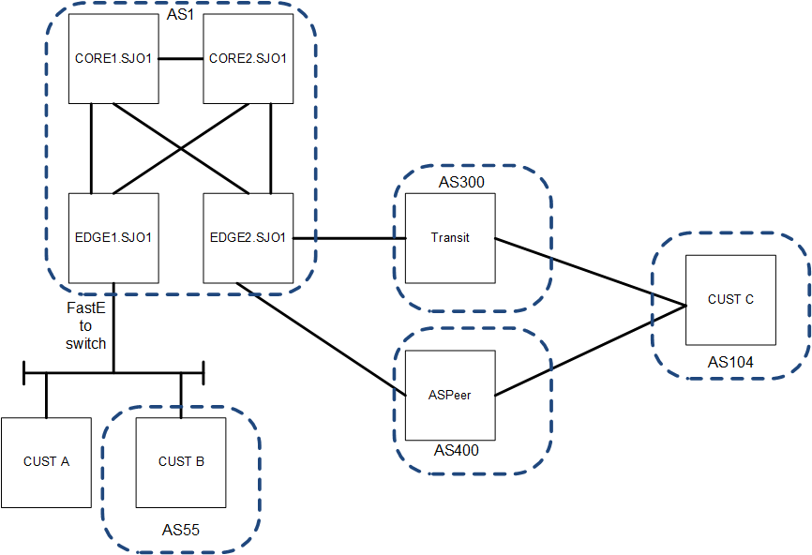
OBJECTIVE 4
Design and configure your peering and transit connections to AS300 and AS400
- Set up a 'transit' connection to AS300 (you are their customer)
- Question 4.1 - Show relevant config snips from the EDGE router?
- Set up a 'peering' connection to AS400 (you are their peer)
- Question 4.2 - Show relevant config snips from the EDGE router?
- CUST C isnt really your customer, but they are customer of AS300 and AS400, running BGP with both and using ASN 104 They are using 128.138.238.0/16. Set a loopback on the customer router of 128.138.238.1/32.
- Question 4.3 - Show relevant config snips from the CUST C router?
- Question 4.4 - Show relevant config snips from the AS300 router?
- Question 4.5 - Show relevant config snips from the AS400 router?
OBJECTIVE 5
Is it working?!?
- Question 5.1 - Show the routes you are advertising to AS55
- Question 5.2 - Show the routes you are receiving from AS55
- Question 5.3 - Show the routes you are advertising to AS300
- Question 5.4 - Show the routes you are receiving from AS300
- Question 5.5 - Show the routes you are advertising to AS400
- Question 5.6 - Show the routes you are receiving from AS400
OBJECTIVE 6
Wrap up
- Question 6.1 - What did you learn from this lab?
- Question 6.2 - What was the least useful part of this lab?
- Question 6.3 - What was the most useful part of this lab?

