CASE STUDY 133
Grocery Kirana Store
Loyalty Points Database
PostgreSQL Mini Project: JSONB, Arrays, Date/Time Functions and Advanced SQL
Student Name | Ayush Parate
Roll No. | 150096726005
Database | PostgreSQL
Case Study | 133 — Grocery Kirana Store Loyalty Points

Abstract
This project models a neighbourhood kirana store loyalty programme using PostgreSQL. Customers, bills, points earned and points redeemed are stored in four related tables. A JSONB column provides flexible customer attributes and a PostgreSQL array stores tags. Date/time functions and advanced SQL produce operational and billing-cycle reports. The points ledger remains auditable because the live balance can always be recalculated as points earned minus points redeemed.

Objectives
- Create four related tables with primary and foreign keys.
- Query JSONB values and filter on JSON attributes.
- Query a PostgreSQL array column.
- Calculate bill age and monthly totals using date/time functions.
- Demonstrate filtering, JOIN, GROUP BY/HAVING and a correlated subquery.
- Explain the trade-off between flexible JSONB storage and conventional relational columns.

ER Diagram
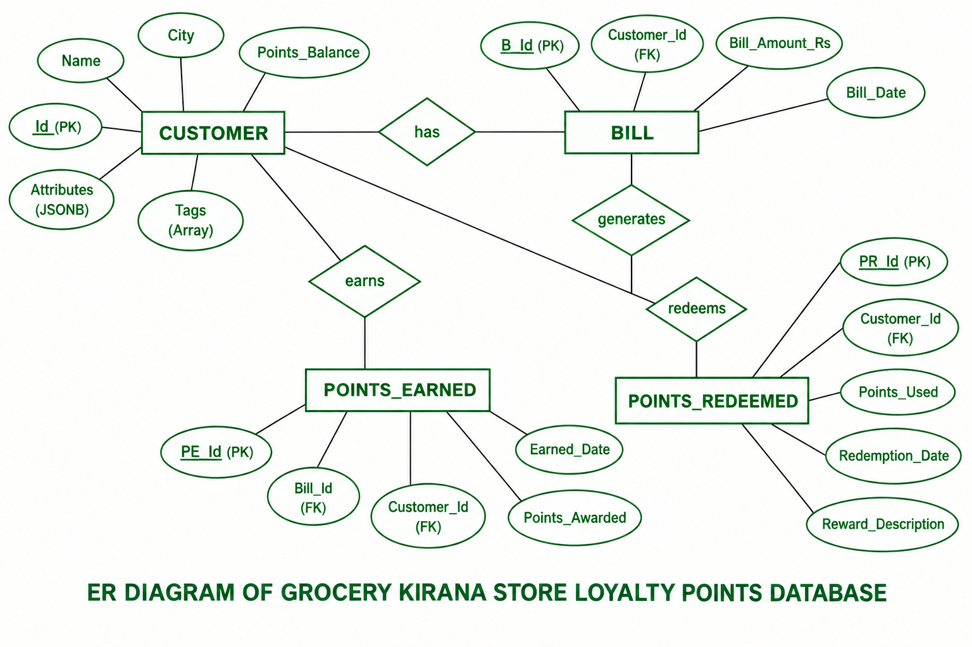
Figure 1: ER diagram of the Grocery Kirana Store Loyalty Points database
One customer can have many bills and many redemption records. Each bill has at most one points_earned record, because the design defines a single accrual row per bill.

Database Schema
Table | Role | Key design
customers | Master customer list | PK id; JSONB attributes; TEXT[] tags; stored convenience balance
bills | Daily billing log | FK customer_id; positive amount; bill date
points_earned | Reward accrual ledger | UNIQUE bill_id; FK customer and bill; positive points
points_redeemed | Reward spending ledger | FK customer; positive points; date and description

Design decisions
- JSONB: optional attributes such as preferred payment, membership tier and home delivery can evolve without adding a column for each one. Stable fields used for joins, constraints or aggregation should remain relational.
- Array: tags are small, multi-valued labels, so TEXT[] is convenient. A normalised tag table would be preferable if tags became complex entities or needed extensive relational analytics.
- Ledger: points_balance is a fast-read convenience value; points_earned and points_redeemed remain the auditable source of truth.

Dataset
The original preview contained only six customers and eight bills. This submission expands it to 35 customers and 88 bills, a realistic classroom-scale dataset so that joins, aggregation, monthly reporting, filtering and subqueries return meaningful results.
Customers | Bills | Billing period
35 | 88 | Jan 2024 – Apr 2024

Query Execution
Each panel shows the student comment, the query and a screenshot of its output captured from the PostgreSQL terminal (psql) on the grocery_kirana database.

Query 1 — JSONB extraction
Uses the ->> operator to turn a flexible JSONB field into ordinary relational output.
--Name - Ayush Parate Roll No - 150096726005
SELECT id, name, attributes ->> 'membership_tier' AS membership_tier
FROM customers ORDER BY id;
Output
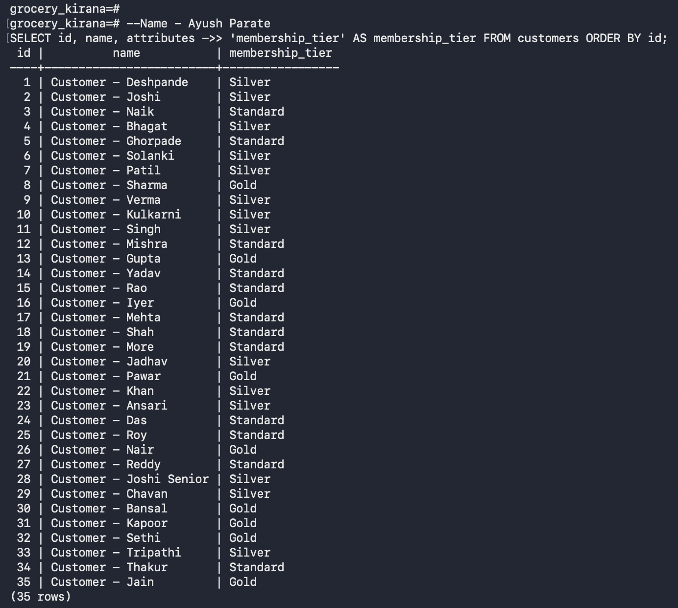

Query 2 — JSONB filtering
Filters rows on a value stored inside the JSONB column.
--Name - Ayush Parate Roll No - 150096726005
SELECT id, name, city, attributes ->> 'preferred_payment' AS preferred_payment
FROM customers
WHERE attributes ->> 'preferred_payment' = 'UPI' ORDER BY id;
Output
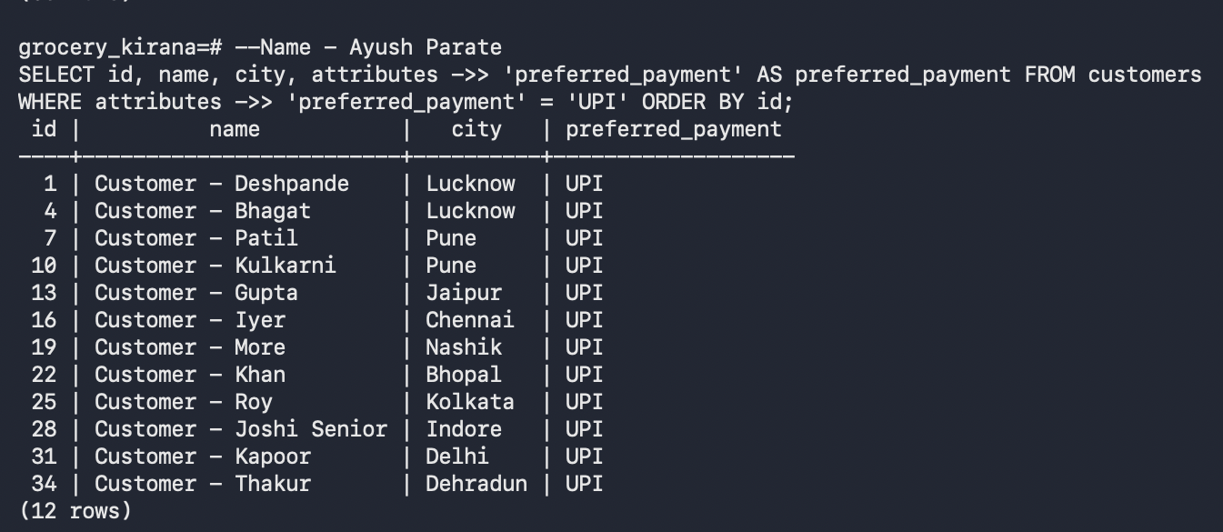

Query 3 — Array tag search
Uses ANY to test membership of a value in a TEXT[] column.
--Name - Ayush Parate Roll No - 150096726005
SELECT id, name, city, tags FROM customers
WHERE 'premium' = ANY(tags) ORDER BY id;
Output
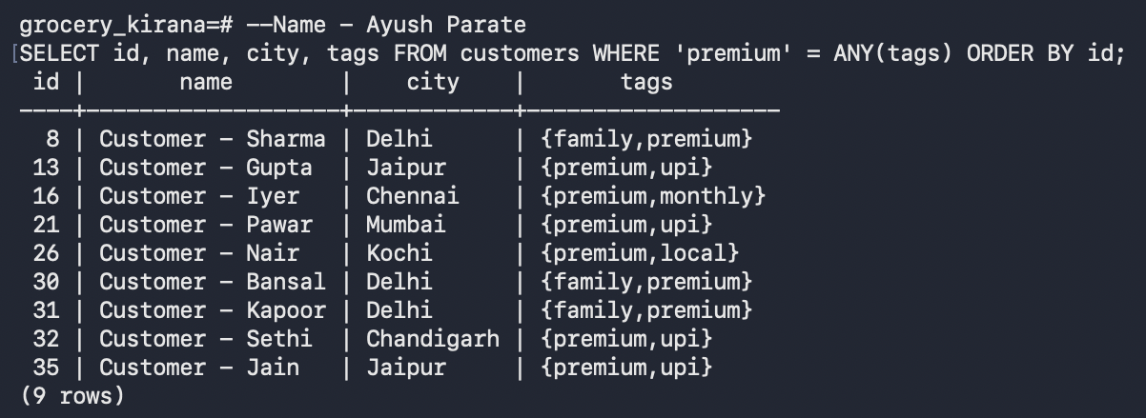

Query 4 — Bill age in days
Subtracts each bill date from the latest bill date to give its age in days.
--Name - Ayush Parate Roll No - 150096726005
SELECT id, customer_id, bill_date,
(SELECT MAX(bill_date) FROM bills) - bill_date AS days_ago
FROM bills ORDER BY bill_date, id;
Output
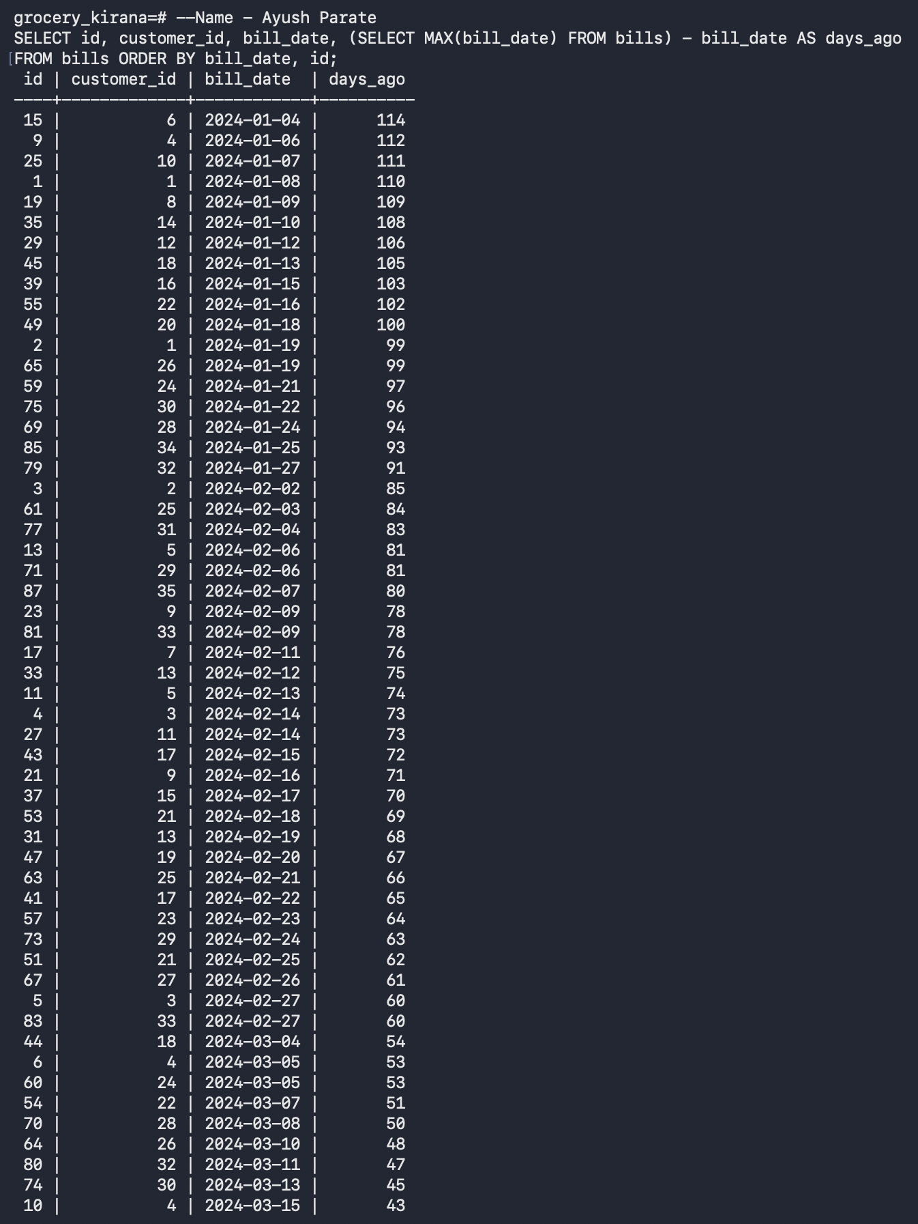

Query 5 — Monthly totals
Groups bills by calendar month using DATE_TRUNC.
--Name - Ayush Parate Roll No - 150096726005
SELECT DATE_TRUNC('month', bill_date)::date AS bill_month, COUNT(*) AS bill_count,
SUM(bill_amount_rs) AS total_bill_amount_rs FROM bills
GROUP BY DATE_TRUNC('month', bill_date) ORDER BY bill_month;
Output
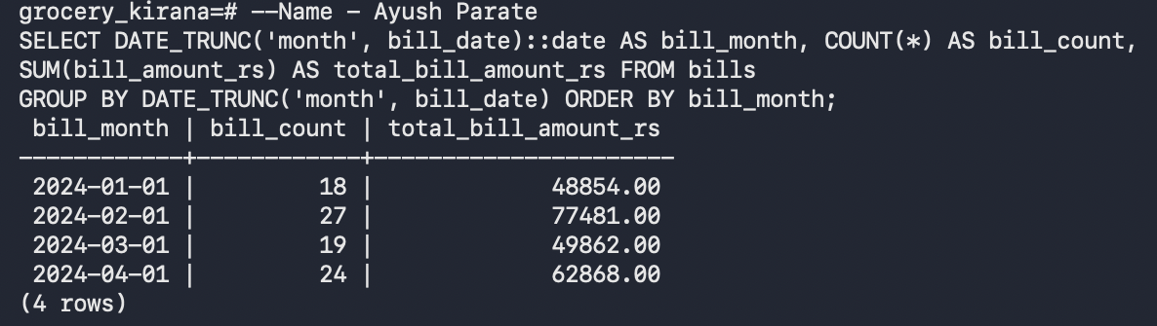

Query 6 — City-wise customers (GROUP BY / HAVING)
Shows the simplicity retained by keeping stable city data in a relational column.
--Name - Ayush Parate Roll No - 150096726005
SELECT city, COUNT(*) AS customers, ROUND(AVG(points_balance),2) AS avg_points
FROM customers
GROUP BY city HAVING COUNT(*) >= 2
ORDER BY customers DESC, city;
Output
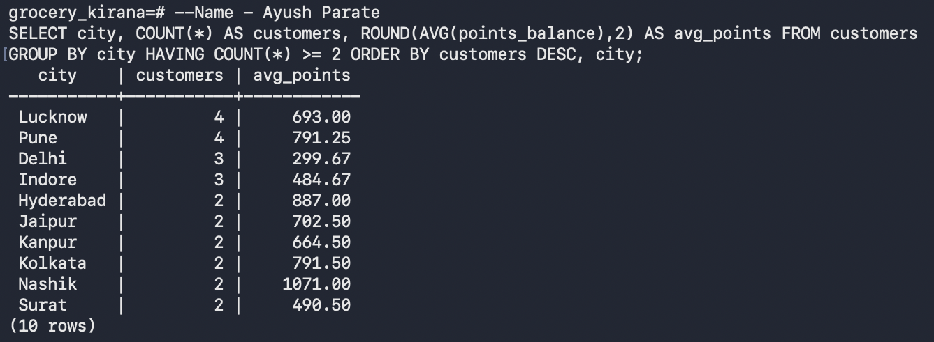

Query 7 — JOIN with filter
Foreign-key join between customers and bills, keeping only bills above ₹4,000.
--Name - Ayush Parate Roll No - 150096726005
SELECT c.id, c.name, b.id AS bill_id, b.bill_amount_rs, b.bill_date
FROM customers c JOIN bills b ON b.customer_id=c.id
WHERE b.bill_amount_rs > 4000 ORDER BY b.bill_amount_rs DESC, b.id;
Output
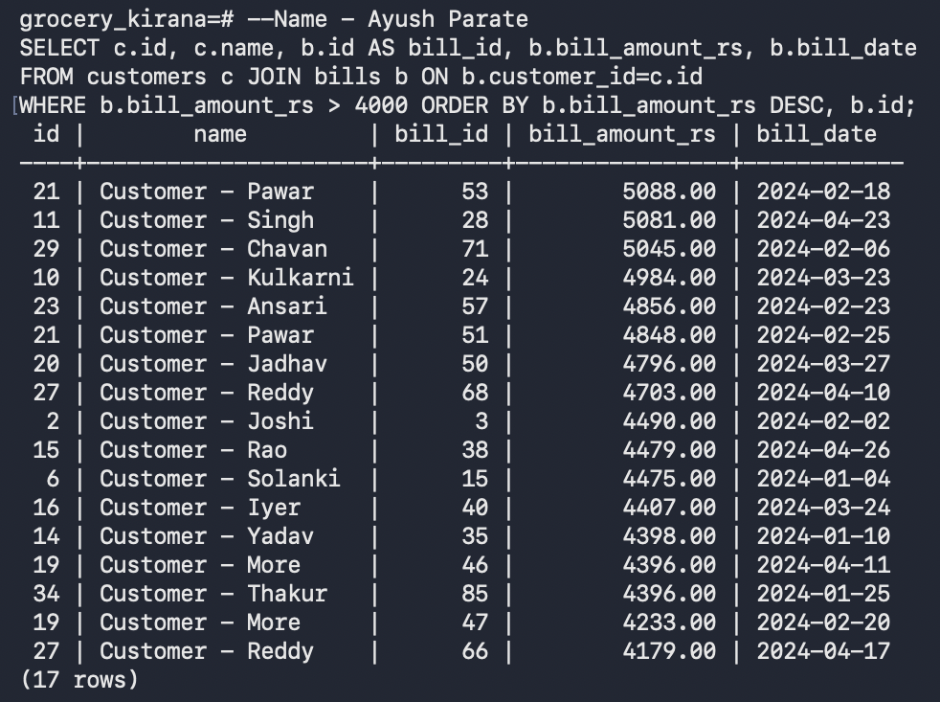

Query 8 — Customer spend (GROUP BY / HAVING)
Aggregates bills per customer and keeps those who spent at least ₹8,000.
--Name - Ayush Parate Roll No - 150096726005
SELECT c.id, c.name, COUNT(b.id) AS bill_count, SUM(b.bill_amount_rs) AS total_spent
FROM customers c JOIN bills b ON b.customer_id=c.id
GROUP BY c.id, c.name HAVING SUM(b.bill_amount_rs)>=8000
ORDER BY total_spent DESC;
Output
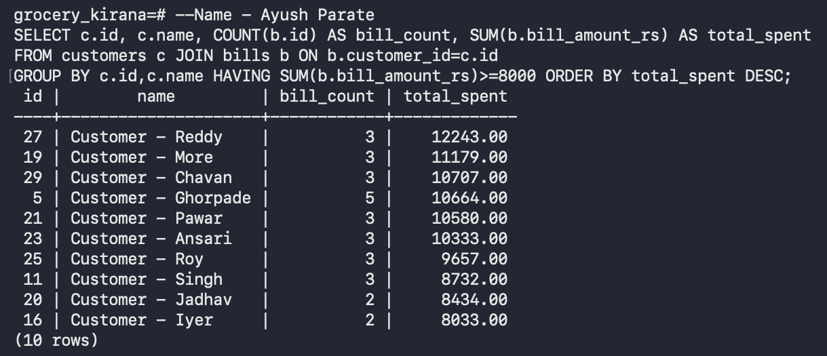

Query 9 — Correlated subquery (same-city comparison)
Lists customers who spent more than the average customer in their own city. The inner query refers to the outer row (c.city), which makes it correlated.
--Name - Ayush Parate Roll No - 150096726005
SELECT c.id, c.name, c.city,
(SELECT COALESCE(SUM(b.bill_amount_rs),0) FROM bills b WHERE b.customer_id=c.id) AS total_spent
FROM customers c
WHERE (SELECT COALESCE(SUM(b.bill_amount_rs),0) FROM bills b WHERE b.customer_id=c.id) >
(SELECT AVG(customer_total) FROM (SELECT c2.id, COALESCE(SUM(b2.bill_amount_rs),0) AS customer_total
FROM customers c2 LEFT JOIN bills b2 ON b2.customer_id=c2.id
WHERE c2.city=c.city GROUP BY c2.id) city_totals)
ORDER BY c.city, total_spent DESC;
Output
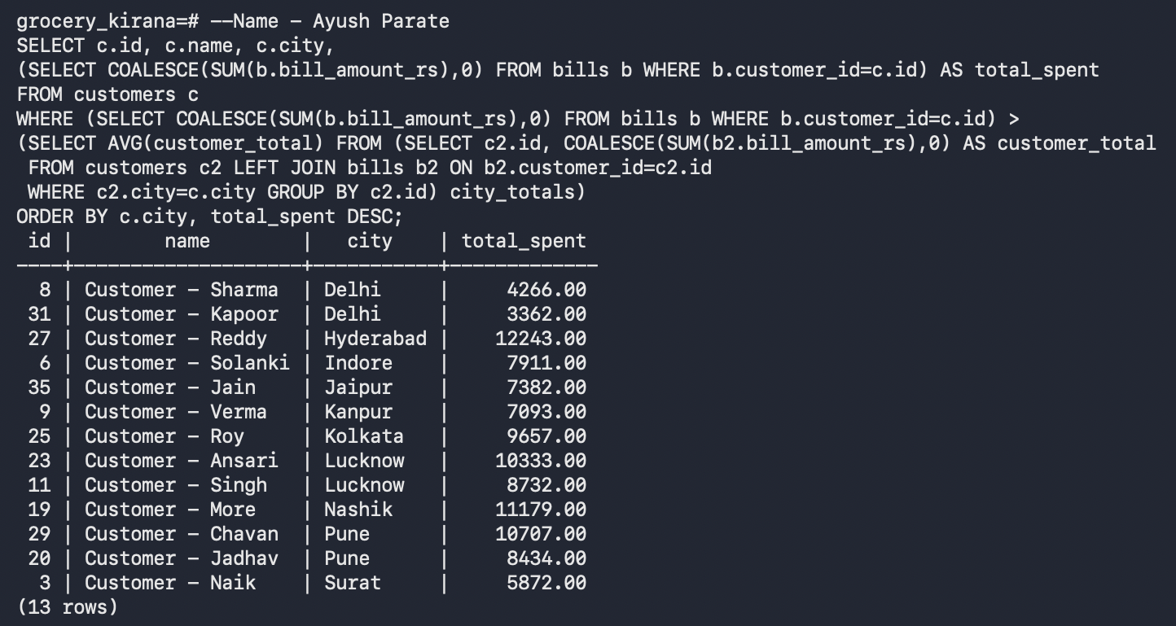

Query 10 — Ledger validation
Independently checks the stored balance against the two loyalty ledgers.
--Name - Ayush Parate Roll No - 150096726005
SELECT c.id, c.name, c.points_balance, COALESCE(e.earned,0) AS earned_points,
COALESCE(r.redeemed,0) AS redeemed_points,
COALESCE(e.earned,0)-COALESCE(r.redeemed,0) AS calculated_balance
FROM customers c
LEFT JOIN (SELECT customer_id,SUM(points_awarded) earned FROM points_earned GROUP BY customer_id) e ON e.customer_id=c.id
LEFT JOIN (SELECT customer_id,SUM(points_used) redeemed FROM points_redeemed GROUP BY customer_id) r ON r.customer_id=c.id
ORDER BY c.id;
Output
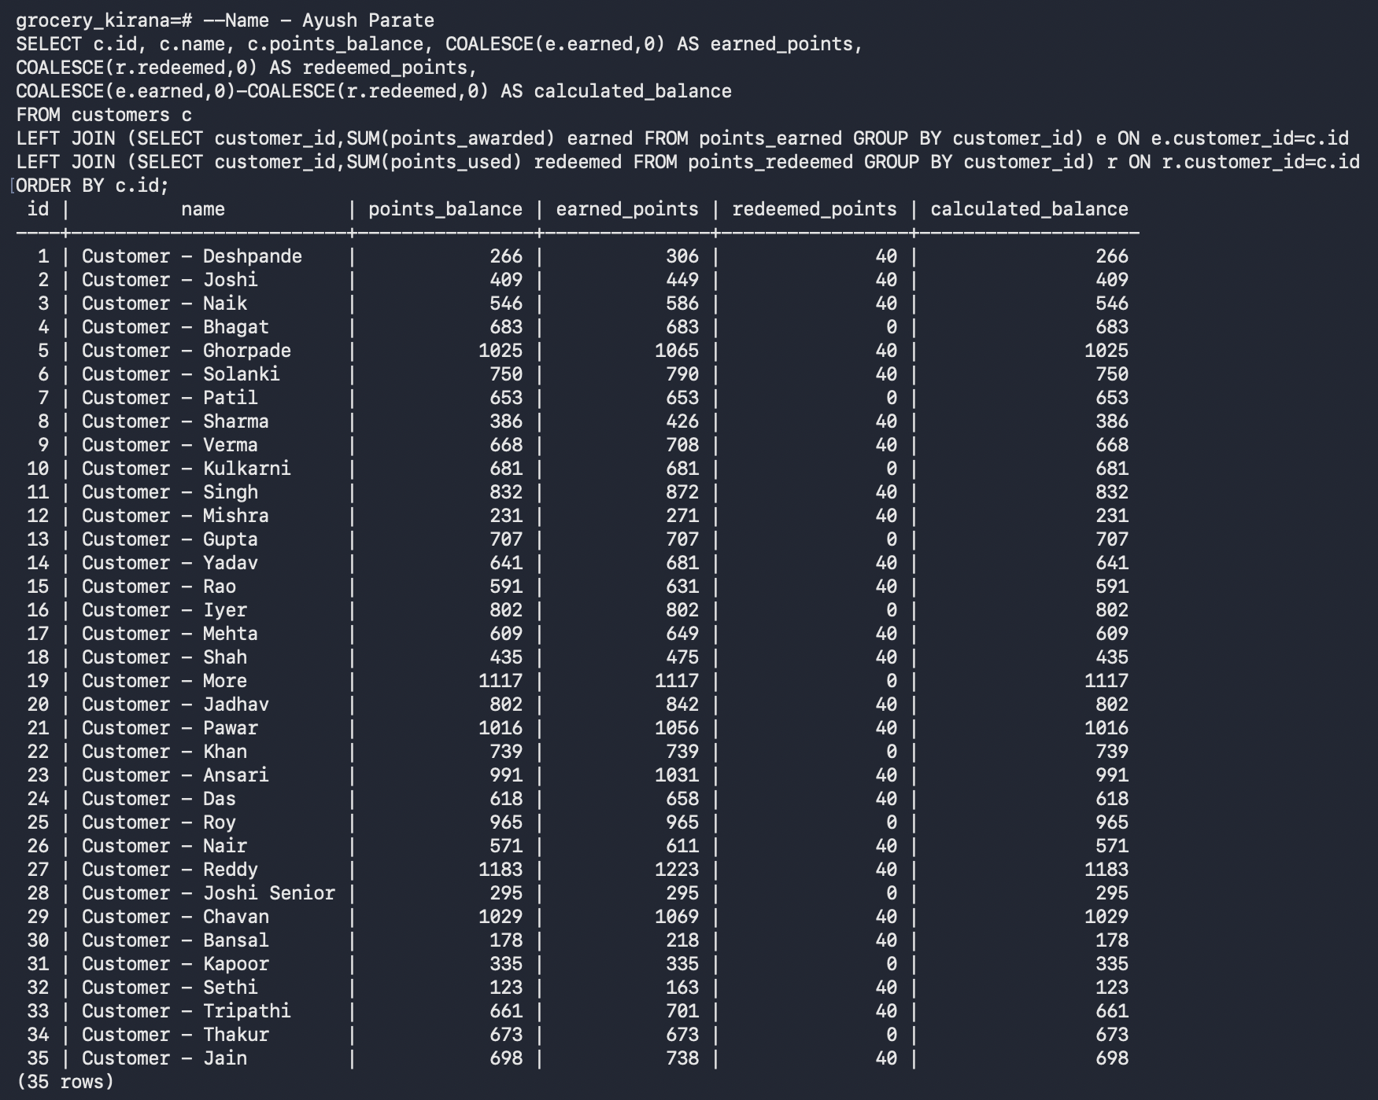

For all 35 customers, the stored points_balance equals earned points minus redeemed points.

Design Defence and Query Rationale

What becomes harder if an attribute moves into JSONB?
If city were stored only inside attributes, a routine report such as GROUP BY city would need JSON extraction, and enforcing a controlled city value or using it in a foreign-key relationship would be less direct. JSONB flexibility suits optional, evolving attributes, but it trades away some relational clarity, constraint convenience and straightforward SQL.

Query rationale
Query | Purpose
Q1 | JSONB text extraction (->>) to turn a flexible field into ordinary output.
Q2 | The same operator used for JSON filtering.
Q3 | ANY for array membership.
Q4 | Date subtraction from the maximum bill date.
Q5 | DATE_TRUNC for month grouping.
Q6 | Simplicity retained by keeping stable city data relational.
Q7 | Foreign-key join with a filter.
Q8 | Customer aggregation with HAVING.
Q9 | Correlated comparison against a same-city average.
Q10 | Validation of the stored balance against the two loyalty ledgers.

Testing
The schema includes primary/foreign key integrity, positive-value checks, a unique bill-to-earned mapping, GIN indexes on the JSONB and tag columns, and a final ledger consistency query. All queries were executed from top to bottom in PostgreSQL (psql), and the terminal output for each query is included in the Query Execution section.

Future Scope
- Add products and bill_items tables for item-level billing.
- Stored procedures for transaction-safe accrual and redemption.
- Audit timestamps and role-based permissions.
- A normalised customer_tags table if tag analytics grows.

Conclusion
The solution uses a hybrid PostgreSQL model: core business facts stay relational and constrained, while JSONB and arrays handle flexible or multi-valued customer metadata. This shows that advanced data types are most useful when they solve a real modelling need rather than replacing well-defined relational attributes.

