# Mukesh Patel School of Technology Management and Engineering Information Technology Department

|  |  |
| --- | --- |
| Student Name: Ayush Patel | Subject: Programming for Analytics |
| Roll No: A232 | Evaluation Tool: Case Study |

**Consider following Business Scenario 1**

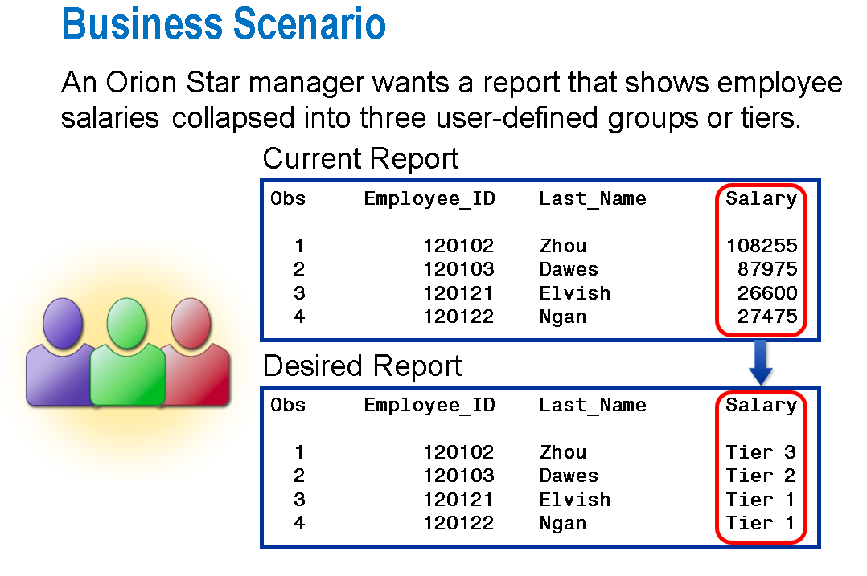Design User Defined Format for Following Range

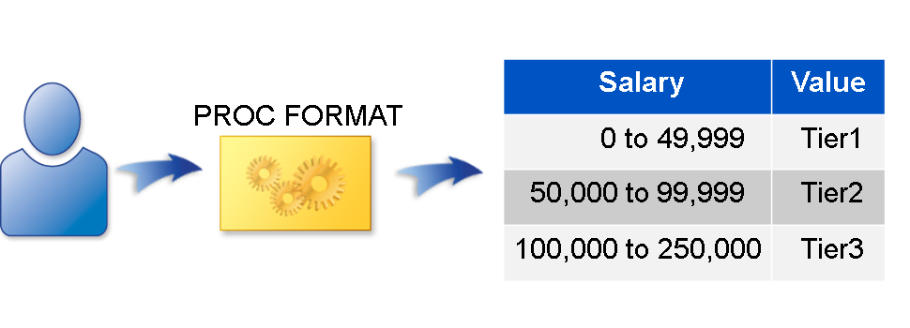

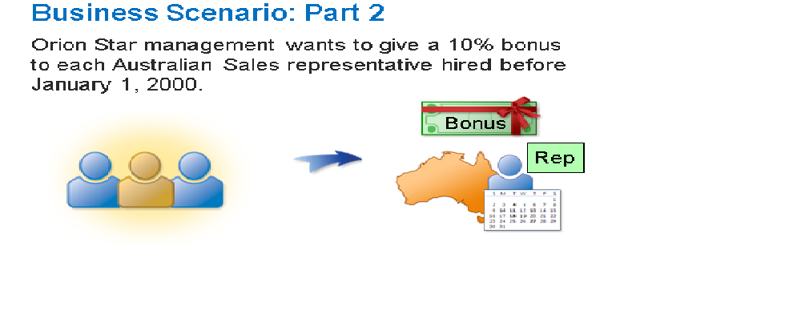

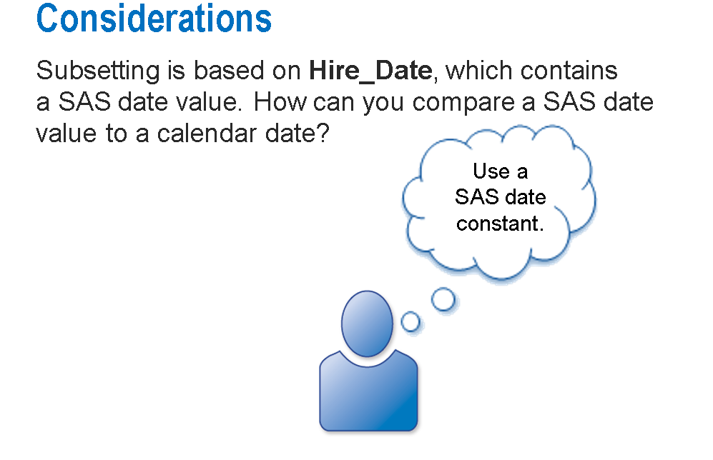

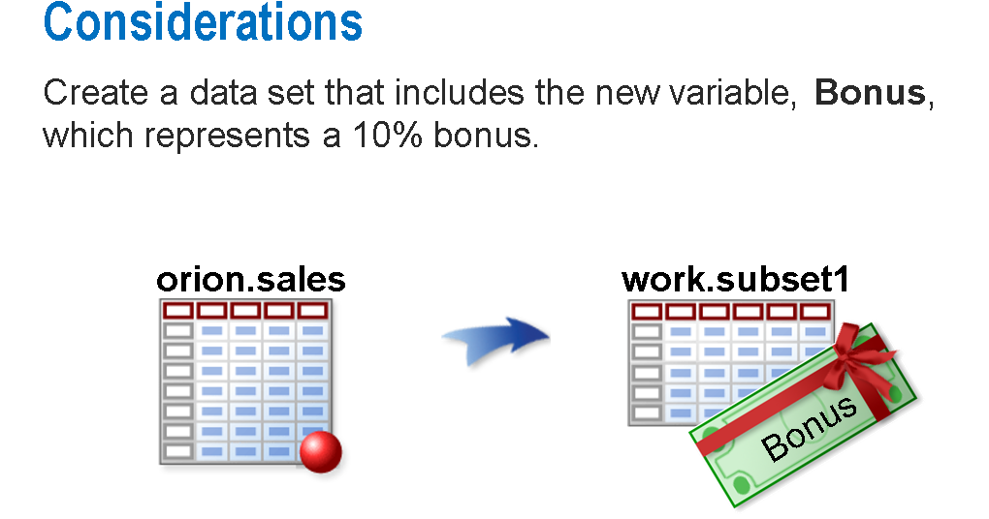

**Ans:**We will compare the Hire_Date with a date constant and if it is greater that mean the employee should be given a bonus of 10%.

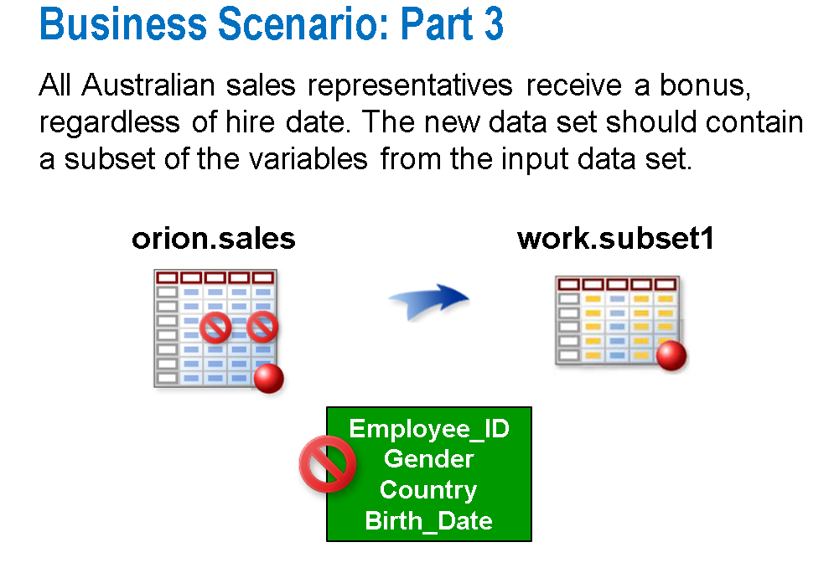

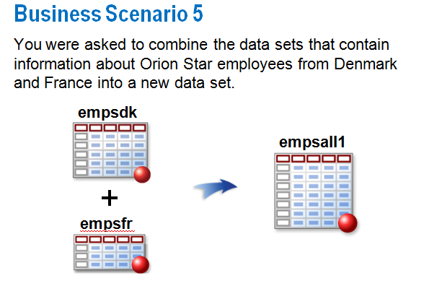

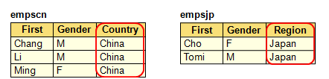

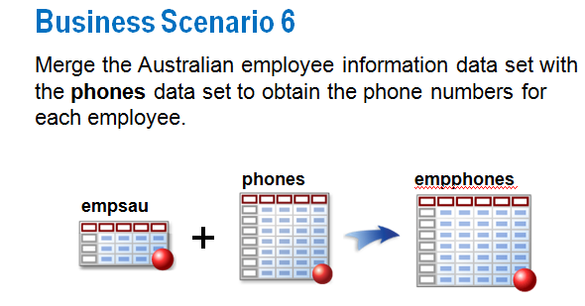

**Output:**

**1)**

data Sales;

infile "/home/u59005730/sasuser.v94/sales.csv" dlm=',';

input EmpId Fname $ Lname $ Gender $ Salary JobTitle $ Country $ BirthDate: date9. HireDate: ddmmyy10.;

run;

proc format;

value newTier 0-27999 = 'Tier 1'

28000-49999 = 'Tier 2'

50000-high = 'Tier 3';

run;

proc print data=sales noobs;

format Salary newTier. ;

format hiredate ddmmyy10. ;

format birthdate ddmmyy10.;

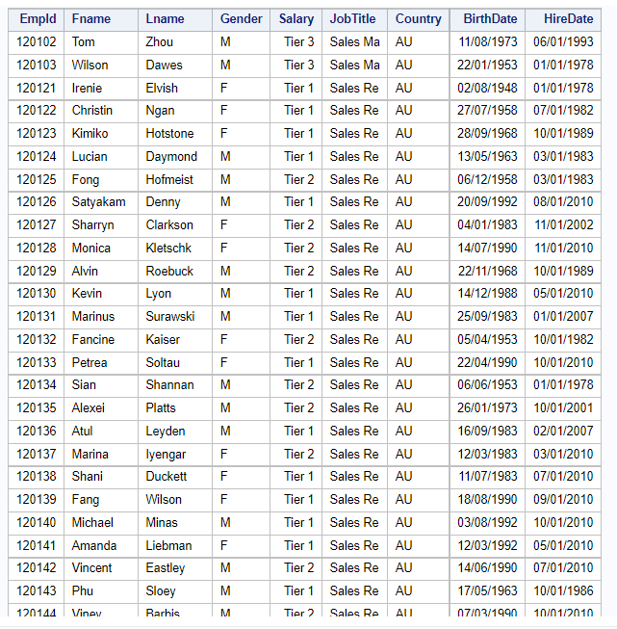

**2)**

data sales_bonus;

set work.sales;

where HireDate < '01JAN2000'd and Country contains 'AU';

Bonus = salary * 0.1;

run;

proc print data=sales_bonus noobs;

format hiredate ddmmyy10. ;

format birthdate ddmmyy10. ;

run;

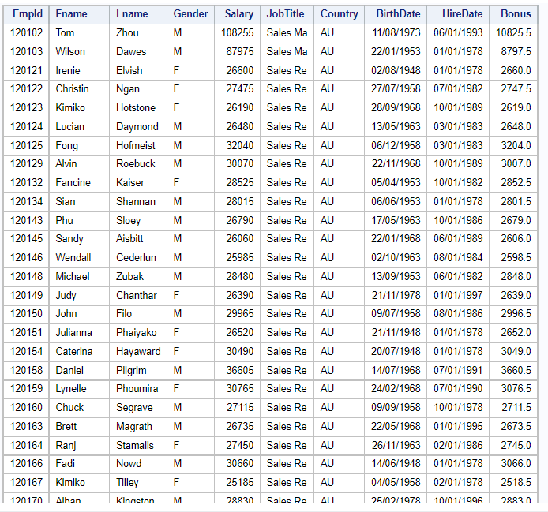

**3)**

title 'Australia';  
data sales_au;  
set sales;  
where Country = 'AU' ;  
drop EmpId Country Birthdate Gender;  
Bonus = salary*0.1;  
run;  
  
proc print data=sales_au;  
format HireDate ddmmyy10. ;  
run;  
  
title;

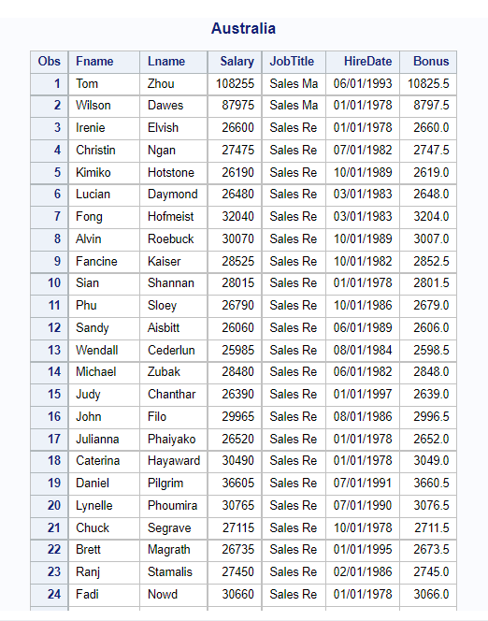

**4)**

data Emp_Den;  
input FName $ LName $ Gender $ Salary Country $ ;  
datalines;  
Jhon Watson M 110000 Denmark  
Sherlock Holmes M 200000 Denmark  
John Luther M 360000 Denmark  
Carol Danvers F 450000 Denmark  
run;  
  
title1 'Denmark Employee' ;  
proc print data=emp_den;  
run;  
  
data Emp_Fra;  
input First Name $ Last Name $ Gender $ Salary Country $ ;  
datalines;  
Francesco Millar M 120000 France  
Larry Rasmussen M 700000 France  
Abigale Vaughn F 900000 France  
Tyreese Burke F 470000 France  
run;  
  
titlel 'France Employee';  
proc print data=emp_fra;  
run;  
  
data Emp_Den_Fra;  
set Emp_Den Emp_Fra;  
run;  
  
titlel 'Denmark and France Employees';  
proc print data=emp_den_fra;  
run;  
  
title;

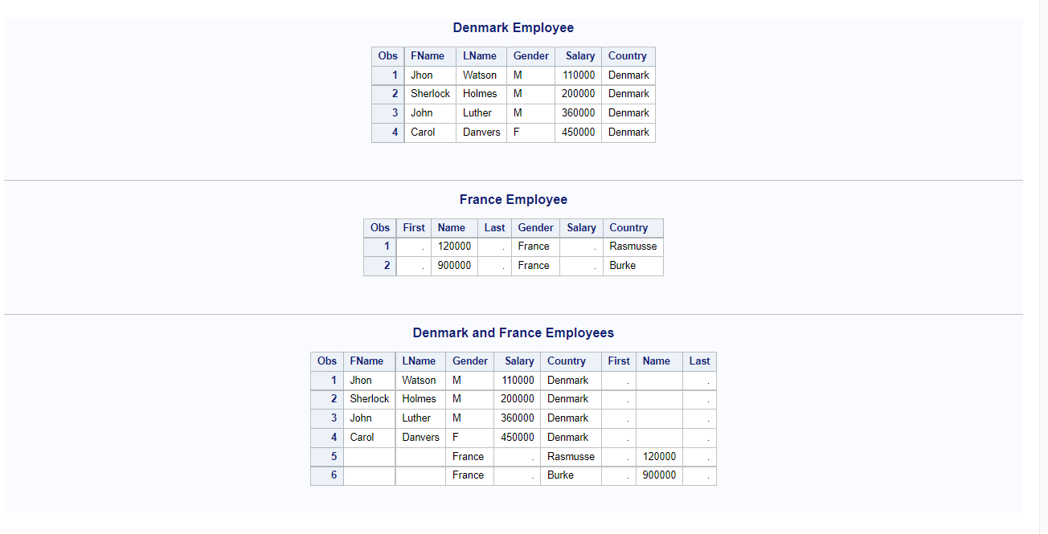

**5)**

data emp_1;  
input First $ Gender $ Emp_Id;  
datalines;  
John M 10011  
Carol F 10045  
Sherlock M 10009  
run;  
  
data emp_phone;  
informat Emp_ID 5. Type $7. Phone $20.;  
input Emp_ID Type $ Phone $;  
datalines;  
10011 Home +21(6)5555-1789  
10011 Work +21(6)5555-1939  
10045 Home +21(6)5555-5618  
10045 Work +21(6)5555-8998  
10009 Home +21(6)5555-6354  
10009 Work +21(6)5555-7309  
run;  
  
proc sort data=emp_1  
out=emp_1_sorted;  
by emp_id;  
run;  
  
proc sort data=emp_phone  
out=emp_phone_sorted;  
by emp_id;  
run;  
  
data emp_id_phone;  
merge emp_1_sorted emp_phone_sorted;  
by emp_id;  
run;  
  
title'Employee';  
proc print data=emp_1;  
run;  
  
title'Employee Phone';  
proc print data=emp_phone;  
run;  
  
title'Employee Info with Phone Number';  
proc print data=emp_id_phone;  
run;

