|  |  |
| --- | --- |
| **Course: B Tech(IT)** | **SEM: VII** |
| **Subject: Programming Analytics** | **Academic Year: 2020-21** |
| **Case Study-2** |  |
| **Name of Student: Ayush Patel** | **Roll No: A232** |

**Business Scenario -1**

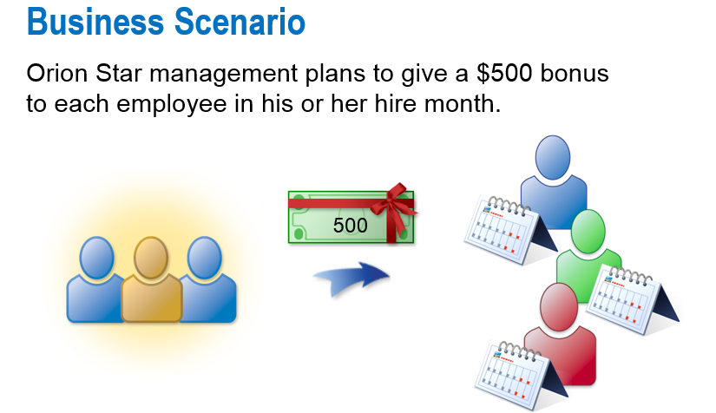

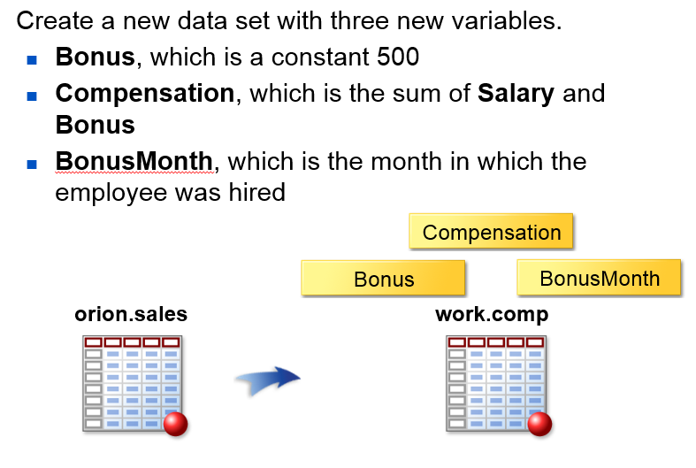

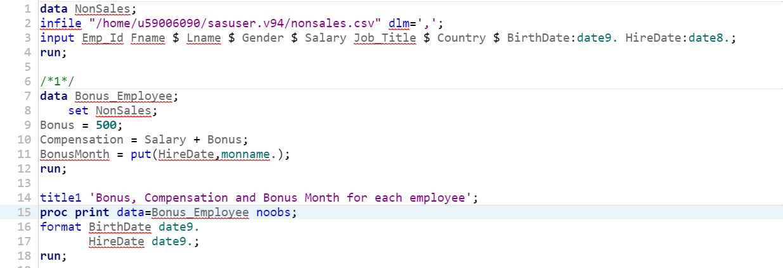

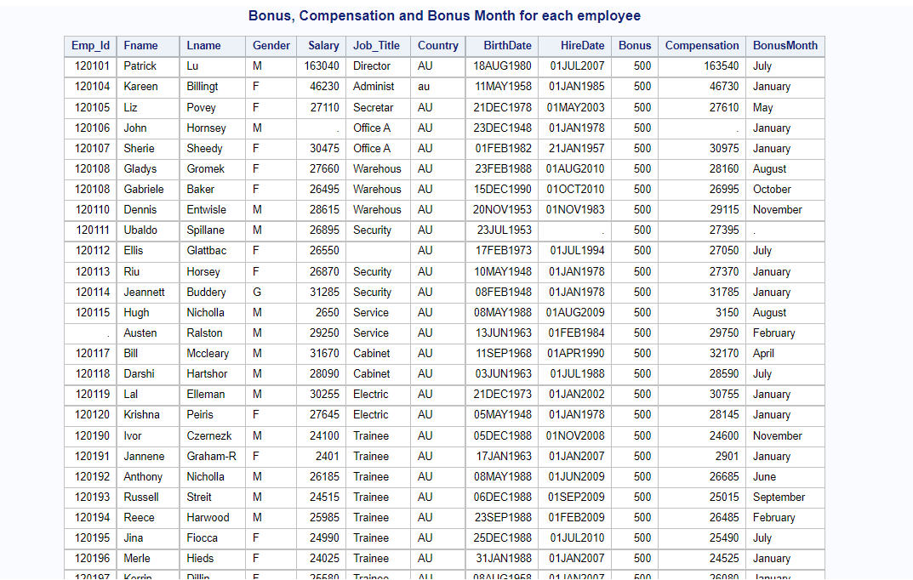

**Business Scenario-2**

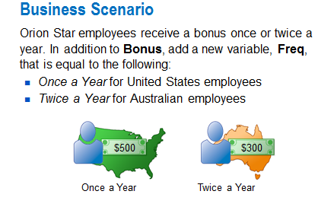

Use Data Set Orion.sales and create new DataSet EmployeeBonusFreq and create Proc print step to display report.

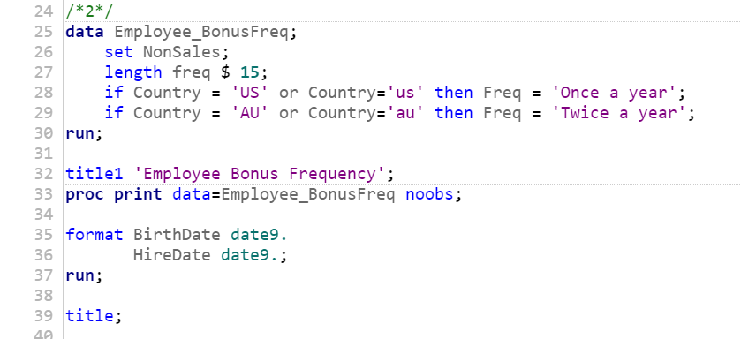

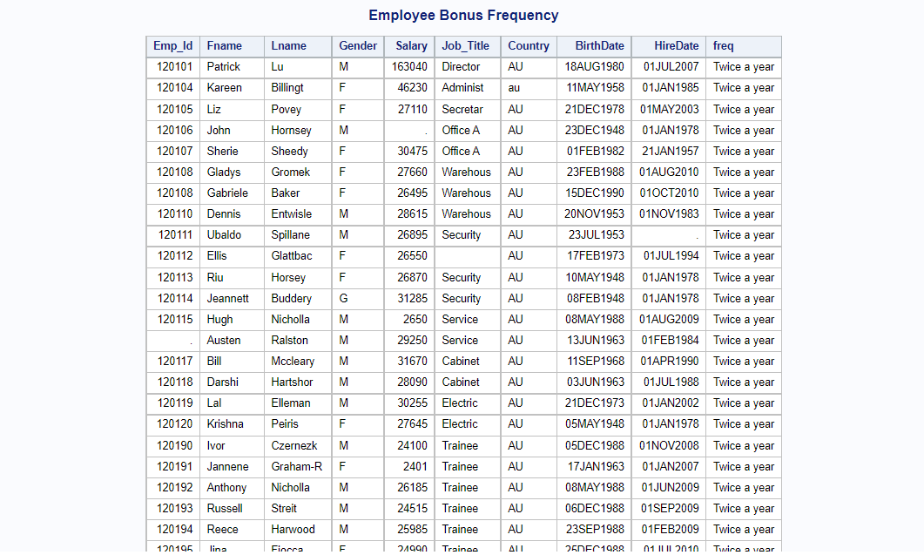

**Business Scenario-3**

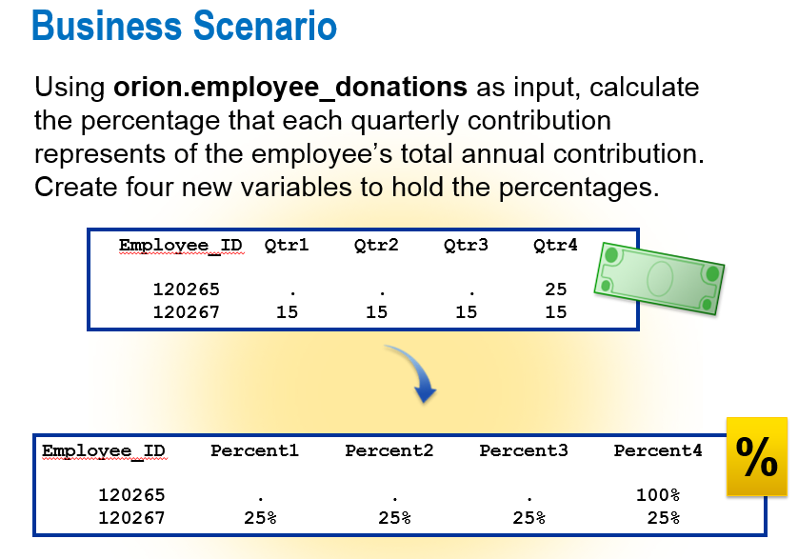

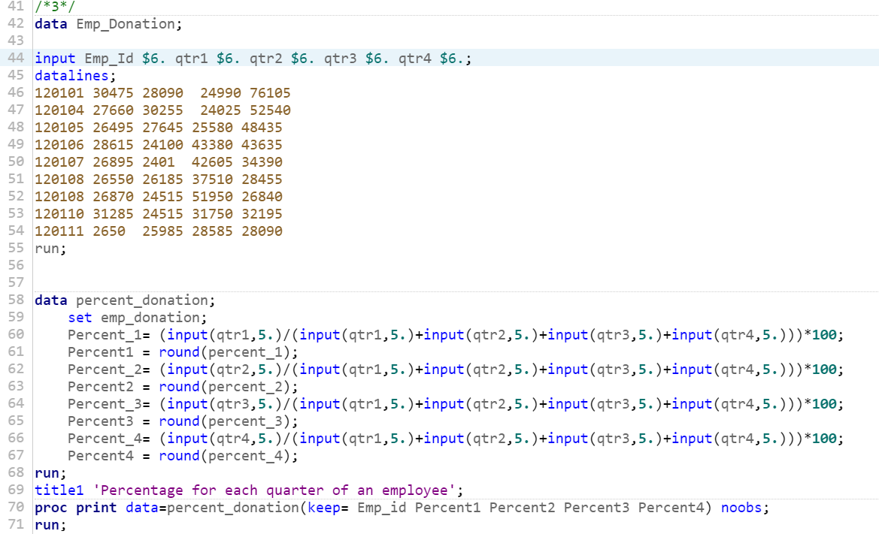

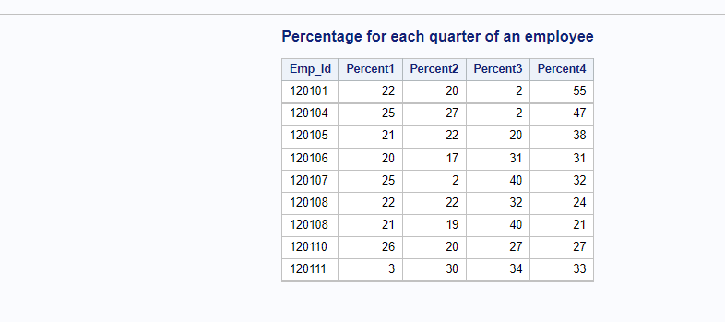

**Business Scenario-4**

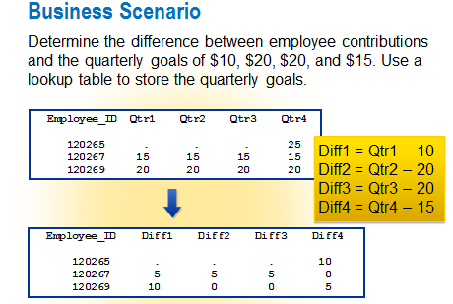

1. Use Orion.Employee_Donation dataset and create Compare Dataset.
2. Write Proc Print Step to display output dataset.

