**Analysis of Financial Statements of Nifty 50**

Ayush PatelDeepesh ShrivastavaMayank Sisodiya

*Department of Computer Science and Department of Computer Science and Department of Computer Science and*

*Engineering Engineering Engineering*

*Medi-caps University Medi-caps University Medi-caps University*

Indore, IndiaIndore, IndiaIndore, India

***1. ABSTRACT:***

The main purpose of this study is to analyse and compare different financial statements or reports i.e., the income statement and the balance sheet of all Nifty 50 stocks from 2013-2022 to infer or conclude about a company’s current financial status. The analysis will help to conclude about important financial indicators such as the liquidity ratios, profitability ratios and the long-term solvency ratios. The tool will help to analyse the financial reports and compare amongst them to reveal the best - on various criteria, that are then be used by managers, shareholders, investors and all other interested parties. To potential investors, the analysis and comparison of the financial statements is very important because, predictability is a major factor in the profitability of stock market trading and investment. If the market's trajectory is correctly forecasted, investors may receive superior guidance and earn a profit.

The main purpose of this research is to provide a comprehensive analysis of the financial performance of Nifty 50 stocks over a period of ten years. By comparing and contrasting the income statement and balance sheet of these companies, the study aims to identify trends, patterns, and differences that can shed light on the financial strengths and weaknesses of each company. The study also examines other financial ratios such as liquidity ratios, debt-to-equity ratios, and return on assets to provide a more comprehensive analysis.

The data for this research is obtained from secondary sources such as the annual reports and financial statements of the companies listed on Nifty 50, as well as other publicly available financial databases. The data is then explored, cleaned, manipulated, analysed, and plotted using statistical methods and other relevant techniques to draw inferences about the financial status of these companies.

The study contributes to the existing literature by providing a comprehensive analysis of the financial status of the Nifty 50 companies, and highlights the importance of financial statement analysis for making informed investment decisions. Future research could explore the impact of macroeconomic factors on the financial performance of Nifty 50 companies, or compare their performance with that of companies outside the index.

**2. INTRODUCTION:**

The Indian stock market has been one of the fastest-growing in the world over the last decade. The Nifty 50 is the main index that represent the performance of the Indian stock market. The Nifty 50 comprises the top 50 companies listed on the National Stock Exchange (NSE). These indices are widely used as benchmarks for measuring the overall performance of the Indian stock market. The price movement of 50 equities chosen based on market cap and liquidity is reflected in the Nifty index [1]. Every six months, Nifty is reviewed, and NSE provides the necessary notice before replacing the stocks that make up the index [2].

Financial Statement provides an overview of a business fiscal condition in both short and long term. In financial statement, all the relevant financial information of a business enterprise is presented in a structured manner and in the form of easy to understand. The process of financial statement analysis involves making informed judgments and assessments to determine the current and past financial positions of an enterprise, as well as its operating results, in order to infer potential future outcomes and possibilities. The purpose of the financial analysis is to provide information to financial managers and analysts to make thorough decisions about their business, strengths and weaknesses. In order to maximise their return on investment, stock market investors are interested in purchasing securities at a discount and selling them at a premium [1].

The objective of this research paper is to analyse and compare the financial statements of companies listed on the Nifty 50 from 2013-2022. The study focuses on two key financial reports – the income statement and the balance sheet – to draw inferences about the current financial status of these companies, by calculating working capital, current ratio, return-on-asset ratio, return-on-equity ratio, and debt-to-equity ratio. The research will provide a comprehensive analysis of the financial performance of Nifty 50 stocks over a period of ten years. The study is significant because it provides valuable insights into the financial health of companies listed on the Indian stock market. The findings can help investors, analysts, and other stakeholders to make informed decisions about investing in these companies. Furthermore, the study can be useful for companies to identify areas for improvement in their financial management and planning.

**3. LITERATURE REVIEW:**

***3.1. A study by Hasan et al. (2018)*** analysed the financial performance of Nifty 50 companies from 2008 to 2017 [3]. The study used financial ratios, such as return on assets (ROA), return on equity (ROE), and debt-to-equity (D/E) ratios, to assess the financial health of these companies. The study found that the average ROA and ROE of Nifty 50 companies were 5.14% and 15.56%, respectively, which indicates a healthy financial performance. However, the D/E ratio was found to be higher than the industry average, indicating that these companies have a higher level of debt.

***3.2. Juhi Ahuja (2012)*** gives an overview of the Indian Capital Market's structure. It was observed that the outlook for the Indian capital market had changed about ten years ago or thereabouts. The Indian capital market has become equivalent to the global capital markets thanks to the adoption of several reforms and upgrades. Currently, the market has a developed administrative structure, a market foundation with advanced features, and developing business sector capitalization, showcasing liquidity, and asset activation[4].

***3.3. A study by Damodaran and Sreenivasan (2018*)** [5]suggests that financial statement analysis can be used to predict future stock returns. They analysed the financial performance of Indian companies listed on the NSE from 2008 to 2017. The study found that financial ratios, such as price-to-earnings (P/E) ratio, price-to-book (P/B) ratio, and dividend yield, were significant predictors of future stock returns.

***3.4.******Pang et al.*** [6] proposed the LSTM-NN network with automatic encoder and the deep LSTM with embedded layer (ELSTM) to forecast the stock because traditional NN algorithms might inadvertently predict the stock market. The precision accomplished with LSTM –NN with embedded layer is better. The maximum accuracy accomplished is 57.2%.

Numerous studies have examined the financial performance of companies listed on stock markets around the world. A study by Chung and Kim (2001) analysed the financial statements of companies listed on the Korean stock market [7]. Various studies found that financial ratios like liquidity and profitability ratios were significant predictors of stock returns.

**4. DESCRIPTION:**

***4.1. Meaning of Financial Statement Analysis***

The process of examining and understanding financial statements is commonly referred to as financial statement analysis, which can also be described as the analysis and interpretation of financial statements. The two financial statements, particularly the income statement and position (balance) sheet, are established in a meaningful way. It identifies the company's financial strengths and shortcomings [8]. Thus, the systematic numerical computation of the relationship between one fact and another to assess the business's liquidity, profitability, and solvency is known as financial statements analysis [8]. The financial statements of a corporation provide crucial financial data on every aspect of the operations of a business. They can therefore be assessed based on their past, present, and performance [9].

The main financial statements are the means used by the accounting for the purpose of collecting, processing and presenting economic information. The purpose of financial statements is to provide information on the position and financial changes as a very important basis for making managerial decisions [10]. Financial statements are intended to provide information that may be utilised by a variety of users to make financial decisions about the health, performance, and changes of an institution's financial condition [11].

The statement of financial position, commonly referred to as the balance sheet, presents the assets, liabilities, and equity of a company as of a particular moment in time. The balance sheet provides insights into a company’s financial position and can be used to assess its ability to meet its financial obligations in the future.

The following goals are achieved through financial analysis: Identifying the trend of accomplishments, gauging the business's potential for growth, and measuring profitability position in comparison to other businesses, evaluate the overall financial situation examine the firm's solvency [12]. Financial statements provide a summary of a company's financial performance and position, reflecting the impact of management's decisions over a certain period of time. [13].

***4.2. Parties Interested in Analysis of Financial Statement***

Companies use financial statements to communicate the outcomes of their business operations to a range of stakeholders such as managers, investors, lenders, and regulatory bodies through official reports. These parties then make various decisions based on the reported facts, such as whether to invest in or lend money to the company. [14]

The financial accounts of the company are relevant to everyone interested in the state of the firm. The analysis of financial accounts is relevant to the following parties: [8].

• **Management:** In order to identify the company's strengths and weaknesses and create successful business plans, the management wants to know the profitability, liquidity, efficiency, and soundness of the firm [8].

• **Shareholders:** The earning potential of the company and its projected expansion pique the curiosity of shareholders. Although shareholders are not actively involved in the day-to-day operations of the company, they are interested in learning about the true profitability through the financial statements [8].

• **Debenture-holders:** Debenture-holders are interested to know whether the financial position of the business is sound or not. They are also interested to know whether the company is able to pay the interest as well as to redeem the debentures on maturity date.

• **Credit Institutions:** Banks and credit institutions are interested in learning whether a company is solvent. They also inquire as to the security of the loaned funds [8].

• **Creditors:** The business's creditors are concerned with both its immediate and long-term financial stability [8]. Anyone who has borrowed money to a business is concerned about how well it will be able to repay the loan, therefore they will pay close attention to different cash flow measurements [15].

• **Taxation Authorities:** Tax authorities are interested to know the profitability of the business, so that income tax can be collected. Similarly, sales tax authorities are interested in the sales of the business.

• **Workers:** The employees of a company are concerned about the profitability of the business, as it can serve as a basis for labour unions to negotiate higher wages in cases where profits are deemed sufficient. Additionally, workers may receive bonuses based on productivity and profitability, further emphasizing their vested interest in the financial analysis of the business.

• **Government:** For the purposes of taxation, regulation, and nationalization, many governmental organisations investigate profitability and turnover ratios. Financial statements aid in the creation of national accounts by the government [8].

• **Economist and Researchers:** These parties are interested in the financial activities of the business, so that they may study the financial health of the business enterprise, study the rate of financial growth and compare it with other business enterprises and finally, suggest effective measures to increase the growth rate.

• **Society or Public:** In the course of developing, a company becomes a part of society. It must satisfy its responsibilities to the community. The public and society are informed about the means by which a firm has carried out its social responsibility through the analysis of financial accounts [8].

• **Competitors:** Competitors are interested in knowing the strategies of an enterprise by financial statement analysis, so that they can also formulate the appropriate policies.

• **Investors:** Financial statements are examined by both present and potential investors to determine a company's capacity to continue paying dividends, create cash flow, or expand at its historical rate [15].

***4.3. Types of Financial Analysis***

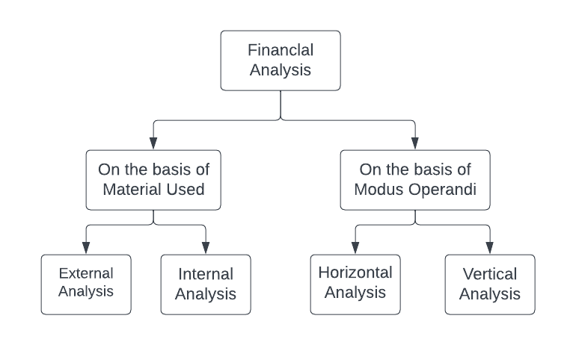

Fig 1: A Family tree of types of Financial Analysis

***4.3.1. On the basis of Material Used***

**External Analysis -** External analysis is research conducted by third parties (investors, credit agencies, government organisations) who are unable to access the company's internal records [8]. External analysis involves the use of financial statements and other financial information that is publicly available. This includes analysing a company’s financial statements, such as the income statement, balance sheet, and cash flow statement, to evaluate its financial performance and health.

**Internal Analysis –** People who have access to the company's books of accounts and other information conduct this type of study. The company's management and staff conduct this analysis [8]. Internal analysis involves the use of financial information that is not publicly available, such as management accounts and internal reports. Internal analysis can include analysing a company’s financial ratios, budget variances, and other financial metrics to assess its financial health and performance. It is important for a company to conduct regular internal analysis to ensure that it is meeting its financial goals and objectives.

***4.3.2. On the basis of Modus Operandi***

**Horizontal Analysis –** Comparing financial data over time to find trends and changes is known as horizontal analysis, often referred to as trend analysis. In this kind of study, financial data from the same company is compared over a period of two or more years, typically as percentage changes. The direction and size of changes in a company's financial performance over time are determined via horizontal analysis.

**Vertical Analysis –** Comparing financial data as a percentage of a single base figure is a component of vertical analysis, sometimes referred to as common-size analysis. This kind of analysis aids in determining the relative significance of various elements on financial statements of a corporation. Vertical analysis is helpful for tracking changes in a company's financial structure over time or comparing the financial performance of several businesses.

***4.4. Financial Statements to Analyse***

***4.4.1 Income Statement*** – A company's revenues, expenses, and net income during a given time period, such as a quarter or a year, are displayed on an income statement, also known as a profit and loss statement. Investors, creditors, and other stakeholders use the income statement, a crucial part of a company's financial reporting, to assess the performance and profitability of the business. Operating and non-operating are the two primary divisions of the income statement. Revenues and costs associated with the company's main business operations, such as sales and cost of products sold, are included in the operating section. Revenues and costs that are not directly tied to the company's main business operations are included in the non-operating segment. Examples include interest income and expense.

*Income* – is a measure of the assets produced by business operations [16].

*Expenditure* – indicate the quantity of resources used in business operations, as well as the flows and commitments made throughout production [10].

***4.4.2 Balance Sheet*** – The balance sheet is a report of a company's assets, liabilities, and equity at a specific moment in time, typically at the end of a quarter or a fiscal year. The balance sheet provides a snapshot of a company’s financial position and is used by investors, creditors, and other stakeholders to evaluate a company’s financial health and liquidity. As a result, the balance sheet's total assets must match its total liabilities and capital [10]. The assets section includes all of the resources owned or controlled by the company, such as cash, accounts receivable, and property. The liabilities & equity section includes all of the company’s obligations and sources of financing, such as loans, accounts payable, and shareholder equity.

This equation is used to express this equilibrium. [17]:

Assets = Liabilities + Capital [16]

***4.5. Financial Ratio’s to Derive from Analysis***

The key measures of financial analysis include the following ratios [13]:

***4.5.1 Liquidity Ratios*** – Liquidity is a phrase used to describe a company's capacity to pay down short-term obligations when they become due. Liquidity is the capacity to transform economic operations into cash or to generate income in other ways [18]. We will be calculating two liquidity ratios –

**a). Working Capital** – Working capital is always among the first factors that creditors take into account. This is due to the fact that the creditor always looks for and reads safety in the financial accounts [16]. Since liquidity "protects" him from an unfavourable circumstance of running out of money, he is interested in it [19]. Working Capital is calculated as the difference between short-term assets and short-term liabilities. A positive working capital, greater than 0 is considered as a good working capital.

*Working Capital = (short term assets – short term liabilities)*

**b). Current Ratio** – A direct proportion between short-term assets and short-term liabilities is shown by the current ratio. Through this, a company's capacity to pay short-term obligations at their maturity date (expiration date of payments) is assessed [18]. Current Ratio greater than 1 is considered as a positive or good current ratio.

*Current ratio = (Short term assets / short term liabilities)*

***4.5.2 Profitability Ratios-*** A direct proportion between short-term assets and short-term liabilities is shown by the current ratio. Through this, a company's capacity to pay short-term obligations at their maturity date (expiration date of payments) is assessed [10]. We will be calculating two profitability ratios -

**a). Return on Assets (ROA)** – The relationship between net profit and total assets is shown to be direct. The return on total assets is a ratio that assesses how well total assets are used to produce net profit [18]. ROA totally depends on the sector; the company is serving. So, there’s no threshold point of ROA

*Return on Assets (ROA) = (Net Profit / Total Assets) * 100*

**b). Return on Equity (ROE)** – It measures the profit made from investments of regular shareholders in the company’s assets. The rate of return on share capital, then, is the rate of return from normal shares that the company's owners have invested [10]. ROE greater than 12 is considered a good ROE ratio.

*Return on Equity = (Net Profit / Total Shareholders’ Equity) * 100*

***4.5.3 Long-term Solvency Ratio-*** Solvency reports gauge the company's capacity to settle long-term debt by the due date [16]. We will be calculating -

**a). Debt on Equity Ratio** – It is the ratio of long-term debt to total invested capital (capitalization) or the total equity / share capital. D/E ratio lesser than 2 is considered as a good ratio.

*Debt ratio to Equity = Total Debt / Share Capital*

**5. METHOD:**

***5.1. Type of Financial Analysis***

a. On the basis of Material Used – External Analysis

b. On the basis of Modus Operandi – Horizontal Analysis

***5.2. Data Collection***

The first step in the research process involved the collection of financial data for all companies in the Nifty 50 stock index. For that, web scraping tools and techniques were used to perform data collection. Python’s Beautiful Soup and Requests library were used to scrape the income statement and balance sheet data of all the companies from secondary sources. An algorithm was developed using these libraries to scrape and collect data from any stock. It can be scheduled to run once a year (March-April), to collect the latest available annual financial data. Then, the data collected is then stored in MongoDB as documents in a collection.

***5.3. Data Pre-processing***

Once the data was collected, it underwent pre-processing to ensure its accuracy and consistency. The data was cleaned to remove any inconsistency, missing values, or outliers. The financial statements were also standardized to ensure that they could be compared across companies.

***5.4. Calculation of Financial Ratios***

After data pre-processing, the next step involved calculating various financial ratios that could provide insights into a company’s financial health and performance.

* Liquidity Ratios – Working Capital and Current Ratio
* Profitability Ratios – Return on Assets (ROA) and Return on Equity (ROE)
* Long-term solvency Ratio – Debt to Equity Ratio

***5.5. Data Analysis***

Once the ratios were calculated, they were analysed and compared to evaluate a company’s financial status. The calculated ratios were compared with each other to identify which company performed best in terms of each ratio. This allowed for a comprehensive analysis of a company’s financial status, taking into account multiple aspects of its financial performance.

***5.6. Data Visualization***

The calculated ratios and their comparison were visualized using various data visualization techniques such as bar graphs, and line charts. And the data is also displayed in the form of a table, for easy and better comparison. These visualizations were used to represent the data in an easy-to-understand format and help in making data-driven decisions.

***5.7. Statistical Analysis***

In addition to calculating the financial ratios, statistical analysis techniques such as mean, median, and standard deviation were also used to analyse the data and to get better insights. These techniques were used to identify trends, patterns, and anomalies in the data and draw meaningful conclusions.

**6. RESULT:**

The analysis of the financial statements of the Nifty 50 companies from 2013-2022 reveals some interesting findings. The average ROA for the Nifty 50 companies is 8.36%, which is higher than the average ROA reported in the study by Hasan et al. (2018) for the period 2008-2017. This suggests that the Nifty 50 companies have performed better in terms of generating profits from their assets during the period under study. Similarly, the average ROE for the Nifty 50 companies is 19.63%, which is also higher than the average ROE reported by Hasan et al. (2018). This indicates that the Nifty 50 companies have been more successful in generating profits for their shareholders during the period under study**. Moreover, the maximum ROE of 75.03% achieved by HUL is an impressive feat and showcases the potential for high returns in some Nifty 50 companies**.

The final outcomes for overall Nifty-50 analysis performed is as follows-

|  |  |
| --- | --- |
| **Analyzed Ratio** | **Outcomes** |
| Working Capital – positive & negative count | Positive: 40 & Negative: 10 |
| Current Ratio - good & bad count | Good: 42 & Bad: 08 |
| Return-on-Assets (ROA) – average roa | 8.36% |
| Return-on-Equity (ROE) – average roe | 19.63% |
| Debt-to-Equity (D\E) - positive & negative count | Positive: 46 & Negative: 04 |

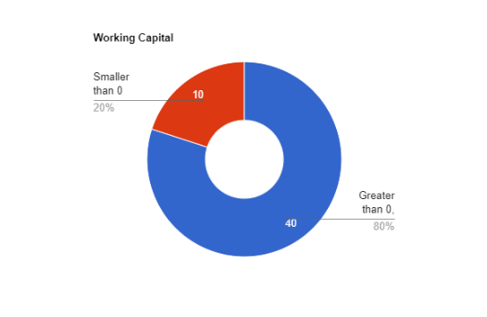

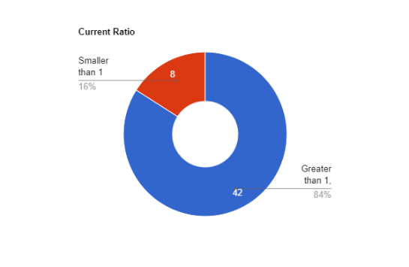

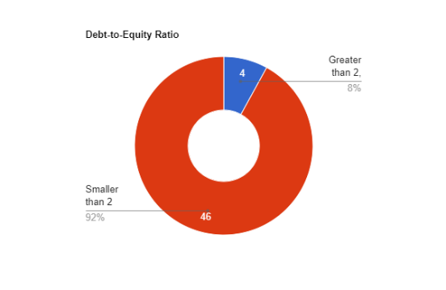

Fig 2: Pie chart of working capital, current ratio, and debt-to-equity ratio

Overall, the results of the analysis suggest that the Nifty 50 companies have performed well financially during the period under study. The higher ROA and ROE indicate that the companies have been successful in generating profits for their shareholders, while the good liquidity and long-term solvency ratios suggest that the companies are financially stable and able to meet their obligations. The findings of this study can be useful for investors and stakeholders in making informed decisions related to investment and risk management.

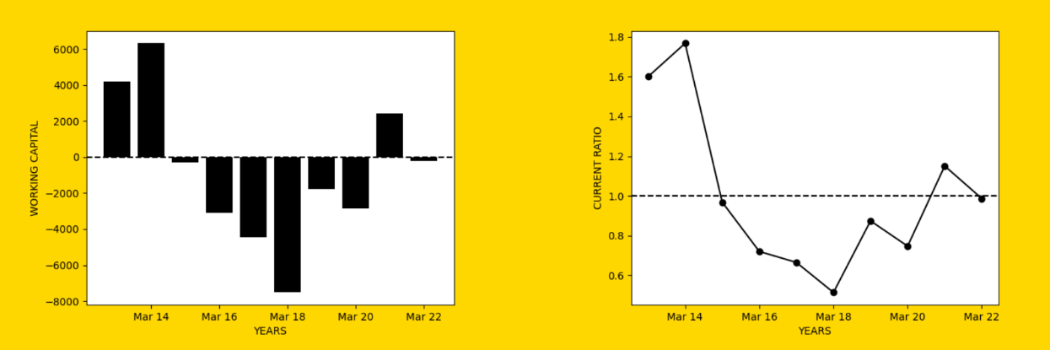The individual stock analysis was also conducted using various data analysis and visualization techniques such as graphs, and charts including the working capital graph, current ratio graph, ROA graph, ROE graph, and debt-to-equity graph. These charts aided in a more precise and efficient analysis of individual stocks. An analyzed final chart of respective ratios for Maruti Suzuki Ltd. From 2013-2023 is attached below:

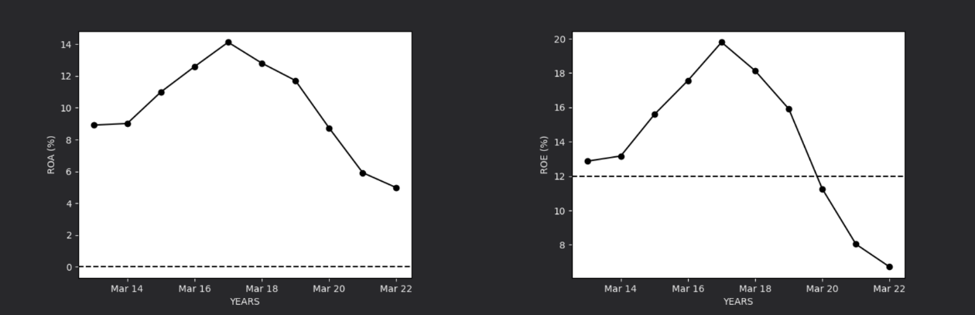

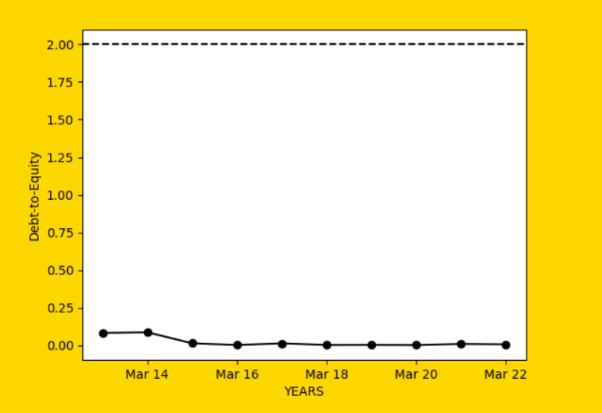

Fig 3: Chart of Maruti Suzuki’s performance during 2013-2022

The final analysed data i.e., the mean of working capital, current ratio, return-on-asset, return-on-equity, and debt-to-equity for individual company of Nifty 50 over the period of 2013-2022 is displayed in the table below: -

|  |  |  |  |  |  |
| --- | --- | --- | --- | --- | --- |
| **Stock Name** | **Working Capital(cr.)** | **Current Ratio** | **ROA (%)** | **ROE (%)** | **D/E (%)** |
| Adani Enterprises | -3644.25 | 0.91 | 1.41 | 5.460 | 1.65 |
| Adani Ports | 3042.33 | 1.78 | 8.5 | 20.78 | 1.18 |
| Apollo Hospital | 892.83 | 1.69 | 3.69 | 8.35 | 0.72 |
| Asian Paints | 3202.28 | 1.68 | 15.53 | 26.97 | 0.06 |
| Axis Bank | 72636.79 | 3.36 | 0.8 | 8.78 | 1.84 |
| BPCL | -6568.88 | 0.89 | 6.01 | 21.08 | 1.18 |
| Bajaj Auto | 4012.96 | 1.94 | 18.22 | 24.07 | 0.00 |
| Bajaj Finance | 62186.61 | 2.41 | 2.97 | 16.98 | 4.25 |
| Bajaj FinServ | 60685.61 | 1.55 | 2.71 | 21.77 | 2.95 |
| Bharti Airtel | -46283.57 | 0.42 | 0.01 | -1.34 | 1.63 |
| Britannia | 602.03 | 1.32 | 20.13 | 42.4 | 0.3 |
| Cipla | 5927.78 | 2.56 | 8.15 | 11.86 | 0.2 |
| Coal India | 38463.92 | 2.06 | 10.9 | 41.27 | 0.08 |
| Divis Lab | 3446.96 | 5.25 | 18.6 | 22.02 | 0.01 |
| Dr Reddy’s Lab | 4789.90 | 1.68 | 8.75 | 15.49 | 0.31 |
| Eicher Motors | 1658.39 | 1.7 | 20.77 | 31.89 | 0.01 |
| Grasim | 11722.58 | 1.37 | 4.3 | 11.56 | 0.74 |
| HCL Tech | 16013.01 | 2.25 | 17.04 | 25.12 | 0.05 |
| HDFC | 160293.88 | 1.41 | 1.85 | 12.72 | 3.25 |
| HDFC Bank | 6377.89 | 2.07 | 3.09 | 30.91 | 1.05 |
| HDFC Life | 17908.32 | 10.06 | 0.99 | 23.72 | 0.01 |
| HUL | 2349.39 | 1.26 | 26.71 | 75.03 | 0.01 |
| Hero MotoCorp | 3496.60 | 1.75 | 18.88 | 28.51 | 0.02 |
| Hindalco | 17084.38 | 1.47 | 2.28 | 6.61 | 1.26 |
| ICICI Bank | 35680.55 | 1.5 | 1.31 | 13.38 | 1.96 |
| ITC | 18511.51 | 2.95 | 19.61 | 25.63 | 0.00 |
| IndusInd Bank | 34530.97 | 4.22 | 1.58 | 14.46 | 1.43 |
| Infosys | 34255.80 | 3.23 | 18.59 | 24.46 | 0.00 |
| JSW Steel | -6354.96 | 0.77 | 3.96 | 12.97 | 1.34 |
| Kotak Mahindra | 24306.60 | 2.4 | 3.52 | 24.37 | 1.26 |
| Larsen & Turbo | 31540.74 | 1.3 | 3.31 | 14.34 | 1.84 |
| M&M | 11236.98 | 1.26 | 2.81 | 10.66 | 1.32 |
| Maruti Suzuki | -729.03 | 1 | 9.98 | 13.9 | 0.02 |
| NTPC | -1785.95 | 1.04 | 4.4 | 11.69 | 1.23 |
| Nestle | 1340.47 | 1.76 | 20.4 | 62.5 | 0.06 |
| ONGC | -21083.63 | 0.85 | 5.76 | 11.89 | 0.37 |
| PowerGrid Corp | -12750.51 | 0.57 | 4.03 | 15.81 | 2.21 |
| Reliance | -28848.40 | 0.96 | 4.52 | 10.55 | 0.59 |
| SBI | 155770.05 | 1.49 | 0.41 | 7.38 | 1.66 |
| SBI Life Insurance | 45866.72 | 15.91 | 0.93 | 17.56 | 0.00 |
| Sun Pharma | 13955.13 | 2.21 | 8.74 | 14.00 | 0.17 |
| Tata Consumer Product | 2665.63 | 2.33 | 4.08 | 6.32 | 0.15 |
| TCS | 51660.79 | 3.49 | 26.65 | 36.52 | 0.00 |
| Tata Motors | -6864.56 | 0.95 | 0.65 | -0.99 | 1.44 |
| Tata Steel | 58.97 | 1.01 | 2.22 | 5.35 | 1.59 |
| Tech Mahindra | 9277.33 | 2.17 | 12.47 | 20.47 | 0.08 |
| Titan Company | 3466.93 | 1.69 | 10.81 | 23.20 | 0.25 |
| UPL | 7074.89 | 1.65 | 6.08 | 21.29 | 1.19 |
| Ultratech Cement | 217.57 | 1.07 | 6.33 | 12.25 | 0.46 |
| Wipro | 27162.21 | 2.26 | 12.64 | 19.64 | 0.19 |

**7. DISCUSSIONS:**

The analysis of financial statements of Nifty 50 companies from 2013 to 2022 provide insights into the financial health of these companies. The liquidity, profitability, and long-term solvency ratios were used to assess the financial performance of these companies. The results showed that the average ROA and ROE were 8.36% and 19.63%, respectively, which indicates a healthy financial performance. The max ROE was 75.03% by HUL, which suggests that this company has a higher return on equity as compared to other companies.

The analysis also showed that 42 stocks out of 50 have above average or a good current ratio, indicating that these companies have the ability to meet their short-term obligations. Additionally, 40 stocks have above average or a good positive working capital, which indicates that these companies have sufficient funds to run their day-to-day operations. Moreover, 40 companies have a debt-to-equity ratio of less than 2, which is considered to be a healthy ratio in the industry. This suggests that these companies have a lower level of debt and are less risky to invest in.

One limitation of this study is that it only considers the financial statements of the companies and does not take into account other factors such as market trends, economic conditions, and company-specific events that can impact the financial performance of the companies. Therefore, the conclusions drawn from this study should be taken with caution.

***Future Scopes:***

Future research can consider incorporating other factors such as market trends, economic conditions, and company-specific events to provide a more comprehensive analysis of the financial performance of companies. Additionally, the analysis can be extended to cover companies from other stock indices to provide a comparative analysis of the financial health of companies from different sectors. The analysis can also be extended to cover a longer time period to assess the financial performance of companies over a longer period of time.

**8. REFERENCES:**

|  |  |
| --- | --- |
| [1] | K. L. Ambashtha and M. K. Singh, “Comparative Technical Analysis and Prediction of Nifty-50,” *Social Sciences Journal,* vol. 9, 2020. |
| [2] | C. Prasanna, “Investment Analysis and Portfolio Management,” *McGraw Hill Education(India)Pvt. Ltd,* 2015. |
| [3] | H. e. al., “Analysis of financial performance of Nifty 50 companies,” 2018. |
| [4] | J. Ahuja, ““Indian Capital Market: An Overview with Its Growth,” *VSRD International,* vol. 2, no. 7, pp. 386-399, 2012. |
| [5] | Damodaran and Sreenivasan, “Financial Statement Analysis to predict future stock price,” 2018. |
| [6] | X. Pang, Y. Zhou and P. Wang, “LSTM and LSTM-NN to forecast stock,” *Supercomput,* 2018. |
| [7] | H. Y. Chung and J.-B. Kim, “A Structured Financial Statement Analysis and the Direct Prediction of Stock Prices in Korea,” *Asia-Pacific Financial Markets,* 2001. |
| [8] | D. I. Allad, “A Conceptual Research on Financial Statement Analysis,” *IJRSML,* vol. 5, no. 2, 2017. |
| [9] | M. Seilmaier, “Balance Sheet Vertical Analysis Current Assets”. |
| [10] | R. R. Asllanaj, “Financial Accounting,” *University of Pristina, Pristina,* pp. 50-68, 2008. |
| [11] | R. Lewis and D. Pendrill, in *Advanced Financial Accounting, seventh edition*, 2004, pp. 4-5. |
| [12] | M. S. Kapoor, “An Analysis of Financial StatementsMeasurement of Performance and Profitability,” *JEITR,* vol. 6, no. 7, p. 70, 2019. |
| [13] | E. A. Helfert, “financial analysis tools and techniques,” in *financial analysis tools and techniques*, McGraw-Hill, United States, Team-Fly, 2001. |
| [14] | H. Charles, H. Walter and W. Thomas, Financial Accounting, 9th Edition, 2012. |
| [15] | “Financial statement analysis,” *osou,* 2018. |
| [16] | P. S. Hasanaj and B. Kuqi, “Analysis of Financial Statements,” *Humanities and Social Science Research,* 2019. |
| [17] | H. Xhafa, Analysis of Financial Statements, third edition, Pegi, Tirana, 2005. |
| [18] | H. Mayo, “UET Press,” *Principles of Finance,* pp. 251-276, 2012. |
| [19] | I. Shuli and R. Perri, “Analysis of Financial Statements,” *albPAPER,* 2010. |
| [20] | A. Joshi and D. Joshi, “ A study on liquidity analysis of select Indian companies,” *Global Journal of Finance and Management,* 2015. |
| [21] | R. Dubey and R. Singh, “A study on profitability analysis of selected Indian FMCG companies,” *Asia Pacific Journal of Research in Business Management,* vol. 8, no. 1, pp. 15-22, 2017. |