GPU Benchmarking

Dataset : Ayush-Sharan-1/ placeCoinOnGrid_v01
cameras : 2 * (640 * 480)
fps : 30
episodes : 15
episode_s : 25 secs
frames : 5616

Google Collab Tesla T4
time for 1k steps: 9.5 mins

RTX 3090
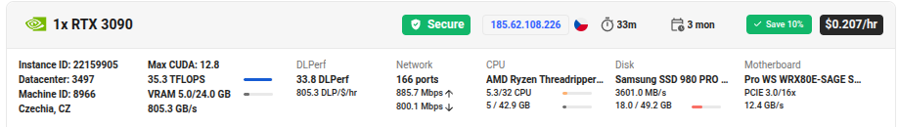
time for 1k steps: 2 mins
GPU Usage: Need to check

RTX 5090
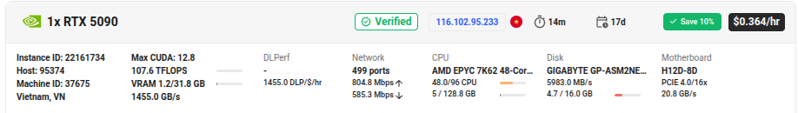
num_workers = 4
batch size = 8
time for 1k steps: 1 mins 30 secs
GPU Usage: 60%

num_workers = 8
batch size = 8
time for 1k steps: 1 mins 20 secs
GPU Usage: 69% (small datapoint not reliable)

num_workers = 8
batch size = 32
time for 1k steps: 3 mins 26 secs (each step has 4 times the samples, so sample efficiency is higher)
GPU Usage: 88% (small datapoint not reliable)

