**Resume**

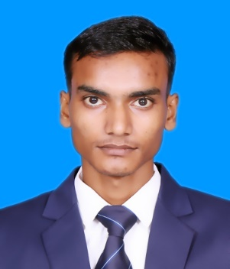**AYUSH SHARMA**  Kanpur, Uttar Pradesh-209305

Mob: +919454186929

Email: [ayushsharma945418@gmail.com](mailto:ayushsharma945418@gmail.com)

**CAREER OBJECTIVE**

To take up a challenging career and growth with honesty, loyalty, good relationship and best performance and translate my experience, knowledge and abilities into value.

**ACADEMIC QUALIFICATION**

|  |  |  |  |
| --- | --- | --- | --- |
| 10th | U.P. Board | Science | 80.17% |
| 12th | U.P. Board | PCM | 76.00% |
| BCA | PSIT Kanpur |  | Pursuing |

**COMPUTER KNOWLEDGE**

C language, C++, Basic Python, HTML5, CSS, JavaScript and Mathematics.

Certifications by Infosys springboard.

**STRENGTH FACTORS**

Good communication skills, problem solving ability strong ability to work with passion.

**PERSONAL DETAILS**

Father Name : Mr. Rajesh Sharma

Date of Birth : 10/10/2004

Gender : Male

Religion : Hindu

Nationality : Indian

**DECLARATION**

I do here by declare that the statements made in this document are true and solid to the best of my knowledge and belief.

**Ayush Sharma**