1 SHOW TABLES
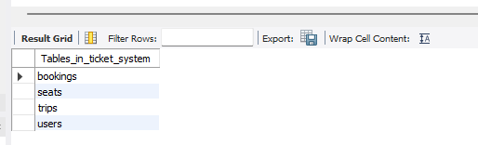

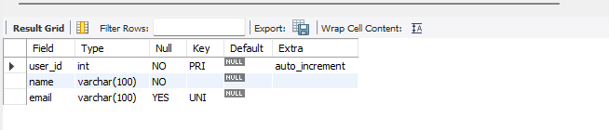

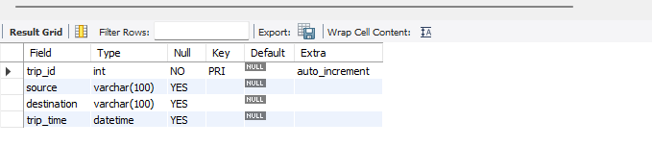

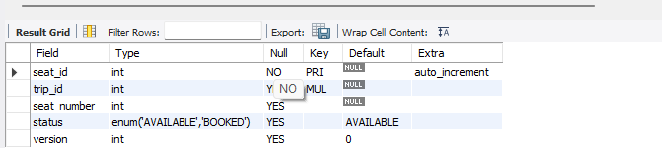

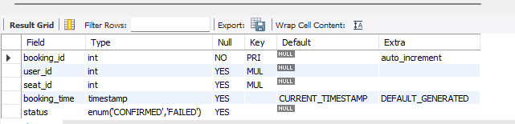
booking

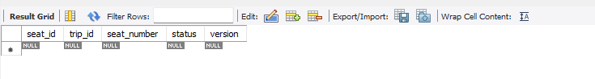

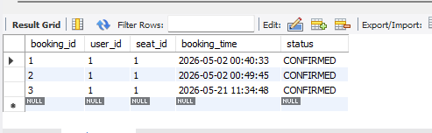

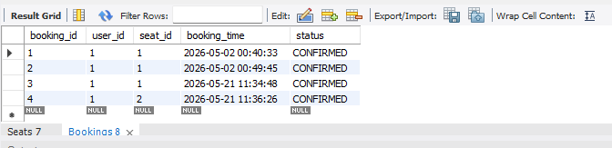

Deadlock Simulation

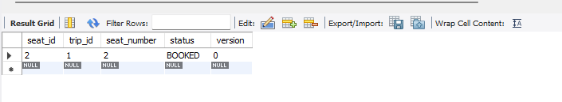
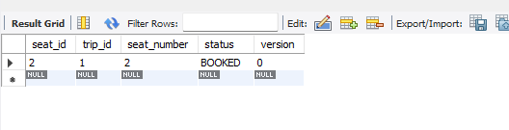
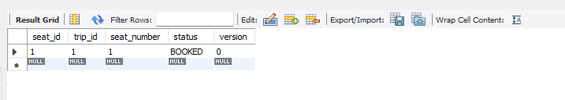
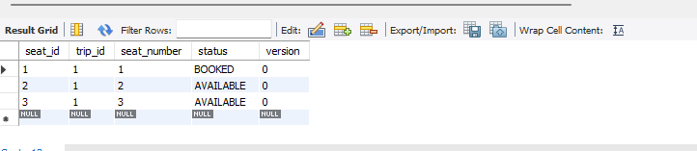

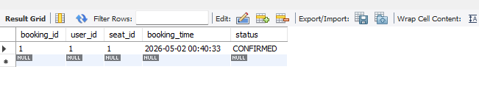

Optimistic Locking

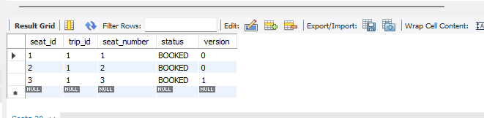

Failure & Rollback Handling
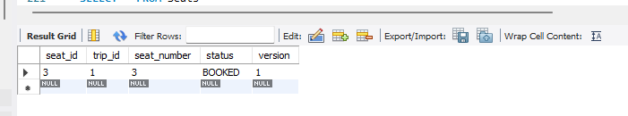
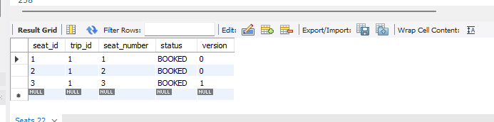

Isolation Level Analysis
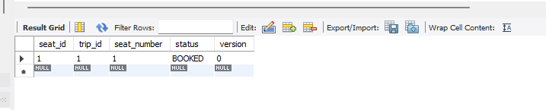

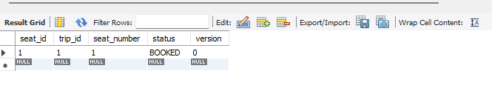

Bonus Challenge

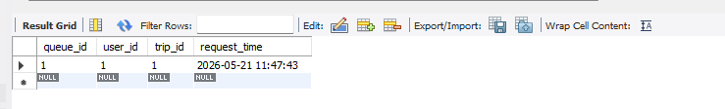
Final output
