LAB 10: SOFTWARE METRICS & COMPLEXITY ANALYSIS
Online Grocery Store System

1. Aim
To identify relevant software metrics for the Online Grocery Store System and analyse the complexity, size, maintainability, and testing needs of its major workflows.

2. Introduction
Software metrics are quantitative measures used to assess aspects of a software system, such as size, complexity, quality, and maintainability. Complexity analysis helps identify logic that may be difficult to understand, test, or modify. Since this project is currently represented through design and UML models, the values below are design-level estimates or illustrative calculations, not measurements from completed source code.

3. Software Metrics Relevant to the Project
Metric | What it measures | Application in Online Grocery Store
Lines of Code (LOC) | Number of source-code lines. | Can estimate implementation size after coding.
Cyclomatic Complexity (CC) | Number of linearly independent paths through control flow. | Useful for checkout, stock validation, payment, and login decisions.
Coupling | Dependency between modules. | Check whether cart, order, payment, and delivery modules rely on each other's internals.
Cohesion | How closely tasks within a module are related. | Cart management should focus on cart operations; payment should focus on transactions.
Response Time | Time taken to respond to a request. | Measure product search, checkout, and order tracking performance.
Defect Density | Number of defects relative to software size. | Can be calculated during testing when defect and size data are available.
Test Coverage | Percentage of code or requirements exercised by tests. | Check login, stock checks, payment success/failure, and delivery status updates.

4. Complexity Analysis
Cyclomatic Complexity (CC) estimates the number of independent execution paths in a control-flow graph. A common formula is:
CC = E − N + 2P
Where E is the number of control-flow edges, N is the number of nodes, and P is the number of connected components (normally 1 for a single function). For structured code, CC is also commonly calculated as the number of decision points plus 1.

5. Example: Checkout and Payment Workflow
Consider a simplified checkout function with two decision points: (1) whether stock is available and (2) whether payment succeeds. If each decision has two possible outcomes, the estimated cyclomatic complexity is:
CC = 2 decision points + 1 = 3
This is an illustrative example for the simplified flow below. Additional branches, exception handling, retries, or validation rules in the actual implementation may increase the value.
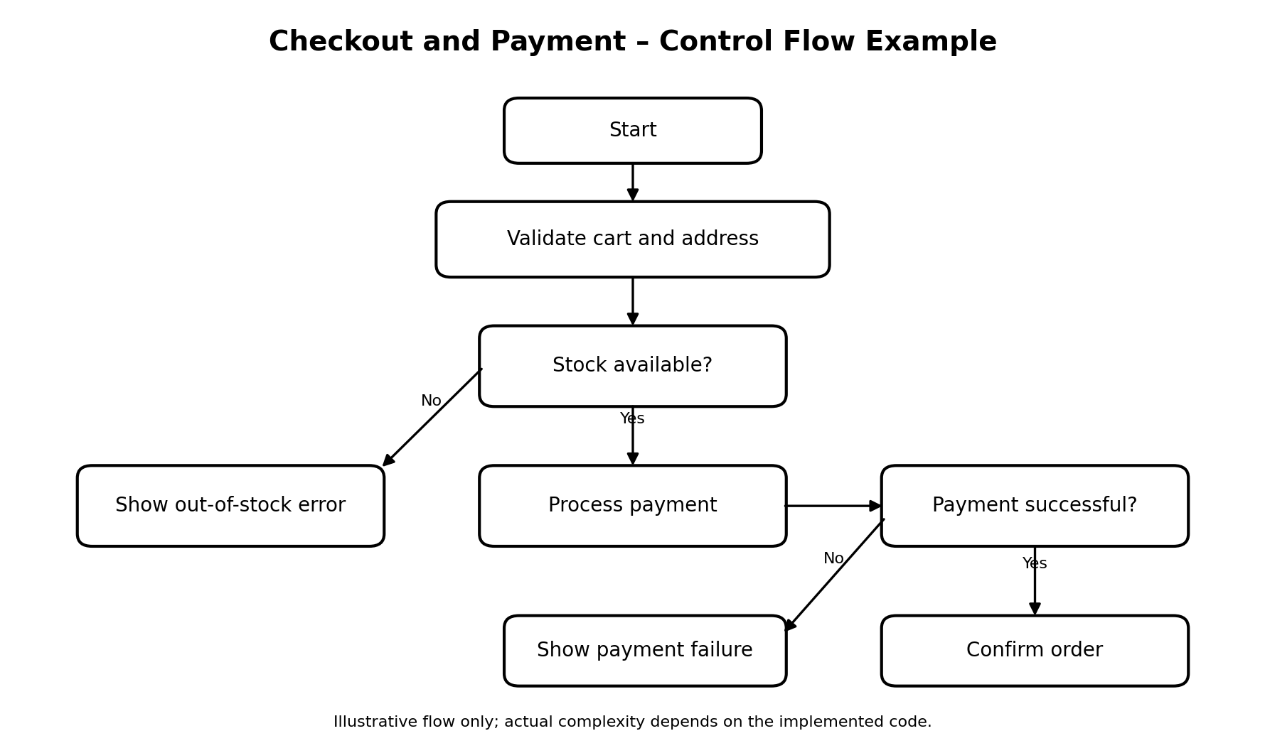
Figure 1. Illustrative checkout and payment control flow.

6. Module-Level Complexity Review
Module / Workflow | Likely decision points | Relative complexity | Reason / testing focus
User & Access Management | Existing email? Valid credentials? | Low–Medium | Test duplicate registration, invalid credentials, successful login.
Product Catalogue & Inventory | Product found? Stock available? | Low–Medium | Test empty search results, unavailable products, insufficient quantity.
Cart Management | Item already present? Quantity valid? | Medium | Test adding new/existing items, quantity updates, removing items.
Order & Checkout | Cart valid? Address valid? Order allowed? | Medium–High | Test empty cart, invalid address, stock changes at checkout.
Payment Processing | Payment success/failure? Timeout? | Medium–High | Test success, decline, timeout, duplicate callback, and retry handling.
Delivery Management | Order assigned? Valid status transition? | Medium | Test invalid status changes and marking delivery complete.

7. Maintainability and Testing Recommendations
- Keep each module focused on one responsibility to maintain high cohesion.
- Use controller/service/repository interfaces to reduce direct dependencies between modules.
- Write unit tests for stock validation, cart totals, order creation, and payment-result handling.
- Test both successful and unsuccessful paths for every decision point.
- Record response times for product search, checkout, and order tracking once a working build is available.
- Calculate actual LOC, cyclomatic complexity, test coverage, and defect density from the implementation rather than estimating them from diagrams.

8. Conclusion
Software metrics provide a structured way to evaluate the Online Grocery Store System. Cyclomatic complexity highlights the number of independent paths that need testing, while coupling, cohesion, response time, defect density, and test coverage help assess design quality and operational behavior. The checkout example has an illustrative CC of 3 based on two decision points. Actual metric values should be measured from the completed source code and test results.

