LAB 9: SOFTWARE ARCHITECTURE DESIGN & DESIGN PATTERNS
Online Grocery Store System

1. Aim
To design the high-level architecture of the Online Grocery Store System and identify design patterns that can improve modularity, maintainability, and extensibility.

2. Introduction
Software architecture describes the main components of a system and how they communicate. Design patterns are reusable solutions to common design problems. Based on the project's UML models, a layered architecture is proposed to separate user interaction, application coordination, business rules, data access, and external services.

3. Proposed Software Architecture
The system uses a layered architecture. Requests move from the interface to controllers and services, then to business components and data-access operations. The Payment Gateway is treated as an external service.
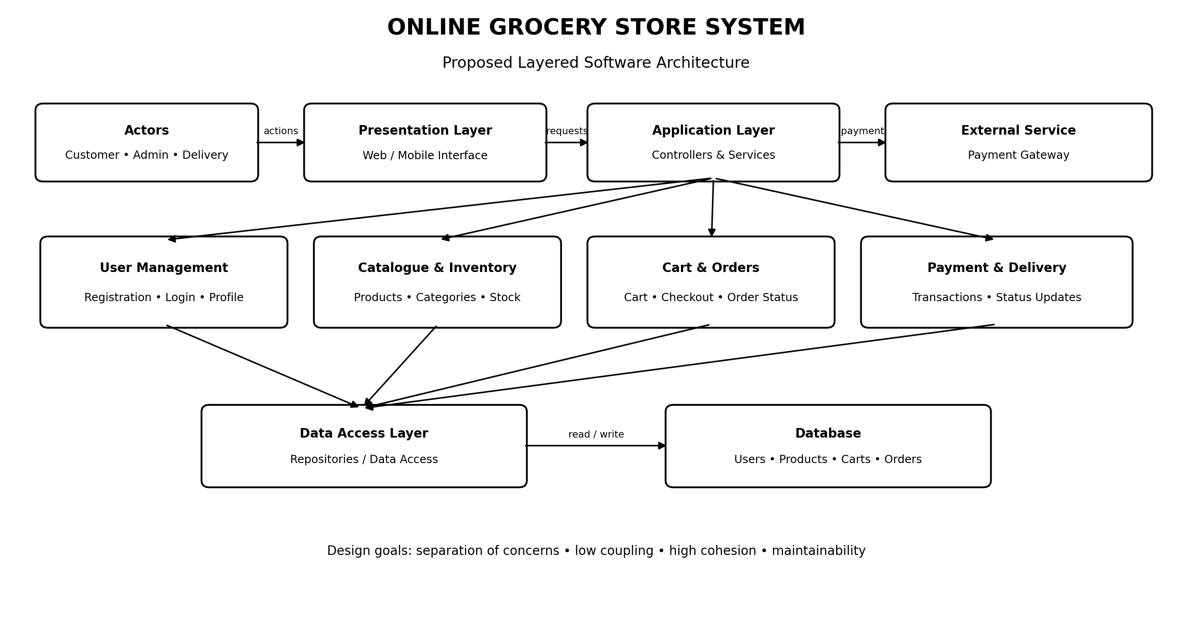
Figure 1. Proposed logical architecture of the Online Grocery Store System.

4. Main Layers
Layer | Responsibility | Examples
Presentation | Accepts input and displays results. | Login, product listing, cart, checkout, tracking.
Application | Coordinates requests and calls services. | Auth, Product, and Order Controllers.
Business / Domain | Applies rules and manages core objects. | User, Product, Cart, Order, Payment, Inventory.
Data Access | Reads and saves records through defined operations. | UserRepository, ProductRepository, OrderRepository.
Database | Stores persistent information. | Users, products, carts, orders, payments, reviews.
External Integration | Connects to third-party services. | Payment Gateway; optional notifications.

5. Data Flow
1. A customer, admin, or delivery partner performs an action in the interface.
2. The relevant controller validates the request and calls a service.
3. Business logic checks rules such as stock availability, order totals, and delivery status.
4. Data-access components read or update stored records.
5. For online payments, the payment component contacts the Payment Gateway and handles its response.
6. The result or error message is returned to the interface.

6. Design Patterns
The patterns below are proposed design options. They should be described as implemented only if they are added to the project code.
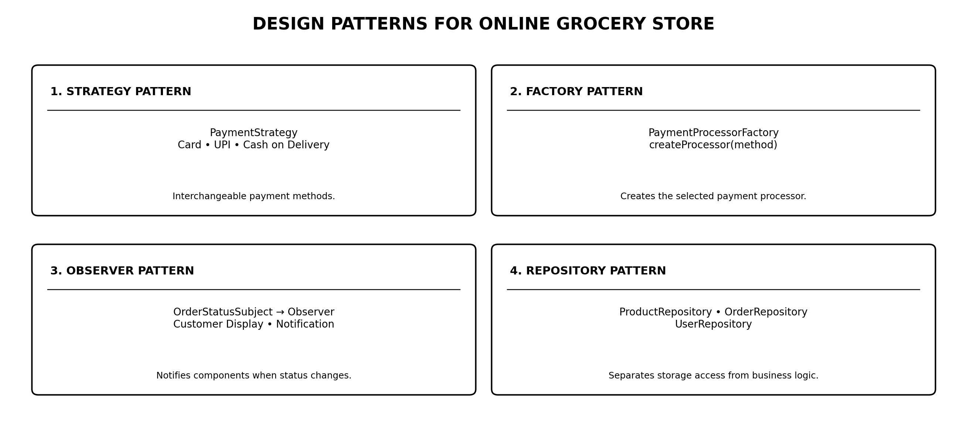
Figure 2. Suggested design patterns and their roles.

6.1 Strategy Pattern
Supports different payment methods through a common PaymentStrategy interface, such as Card, UPI, or Cash on Delivery. Checkout can use the selected strategy without containing every payment algorithm.

6.2 Factory Pattern
A PaymentProcessorFactory can create the correct payment processor based on the selected method. This keeps object-creation logic separate from checkout.

6.3 Observer Pattern
When an order status changes, interested components such as the customer status display or notification service can be notified without placing all notification logic inside the delivery module.

6.4 Repository Pattern
Repositories such as ProductRepository and OrderRepository separate data-access operations from business rules, making services easier to test and storage code easier to change.

7. Design Quality Considerations
- Low coupling: modules communicate through clear interfaces and exchange only the data required.
- High cohesion: each module focuses on one responsibility, such as cart management or payment processing.
- Security: passwords should be securely hashed and administrative operations should require authorization.
- Reliability: update order status only after validating payment or delivery results.
- Extensibility: new payment methods and notification options should require minimal changes to unrelated modules.

8. Conclusion
A layered architecture separates the main responsibilities of the Online Grocery Store System. Strategy and Factory can organize payment methods, Observer can support order-status notifications, and Repository can isolate database operations. These design choices align with the project's UML models and provide a maintainable starting point for implementation.

