SOFTWARE DESIGN ANALYSIS REPORT
Online Grocery Store System

Project Title | Online Grocery Store System
Team Members | Ayush Gupta, Jahnvi Gupta, Lakshya Jaiswal, Ayush Gupta
Roll Numbers | 2400290120079,2400290120123,2400290120143 2400290120078____________________________________________
Practical / Subject | Software Design Analysis / Software Engineering

Prepared from the current system understanding and UML models: Use Case, Class, Sequence, and Activity Diagrams.

A. Project Details
Project title: Online Grocery Store System
Team / roll numbers: Ayush Gupta (Roll No. 2400290120079), Jahnvi Gupta (Roll No.2400290120123), Lakshya Jaiswal (Roll No. 2400290120143) Ayush Gupta (Roll No. 2400290120078).
Project objective: To design an online grocery platform where customers can browse products, manage a cart, place orders, make payments, and track deliveries. The system also supports administrative product and order management, inventory control, and delivery-status updates.
Technology stack: The current work is a design-level model. The diagrams assume a Web/Mobile Application, controller/service layer, databases, and an external Payment Gateway. The exact programming language, framework, and database technology are to be finalized during implementation.

B. Module Identification and Modularization
The system is divided into focused modules so that each module has a clear responsibility, can be designed and tested separately, and communicates with other modules through defined inputs and outputs.
Module ID | Module name | Main responsibility | Inputs / outputs | Depends on
M1 | User & Access Management | Registration, login, authentication, profile management. | Input: account details/credentials; Output: account result, session/profile. | User Database
M2 | Product Catalogue & Inventory | Browse/search products, show details, check and update stock. | Input: search/product/quantity; Output: product list, details, stock result. | M1 (where login required), Product Database
M3 | Cart Management | Add/remove items, update quantities, calculate cart total. | Input: product ID, quantity; Output: updated cart and subtotal. | M2, Cart storage
M4 | Order Management | Checkout, validate order, create order, manage order status. | Input: cart, address, payment choice; Output: order ID/status/summary. | M3, Address data, Order Database
M5 | Payment Processing | Send payment request and handle success/failure response. | Input: order ID, amount, method; Output: payment result/transaction ID. | M4, Payment Gateway
M6 | Delivery Management | Assign/view deliveries and update delivery status. | Input: assigned order/status; Output: saved status and customer update. | M4, Order Database
M7 | Admin & Catalogue Management | Manage products, categories, users, offers, and reports. | Input: admin action/data; Output: updated records and reports. | M1, Product/Order/User data
M8 | Reviews & Offers | Record reviews and apply valid offers/discounts. | Input: rating/comment or offer code; Output: saved review/discount result. | M1, M2, M4, Review/Offer data

Total number of modules: 8
Module hierarchy / decomposition diagram:
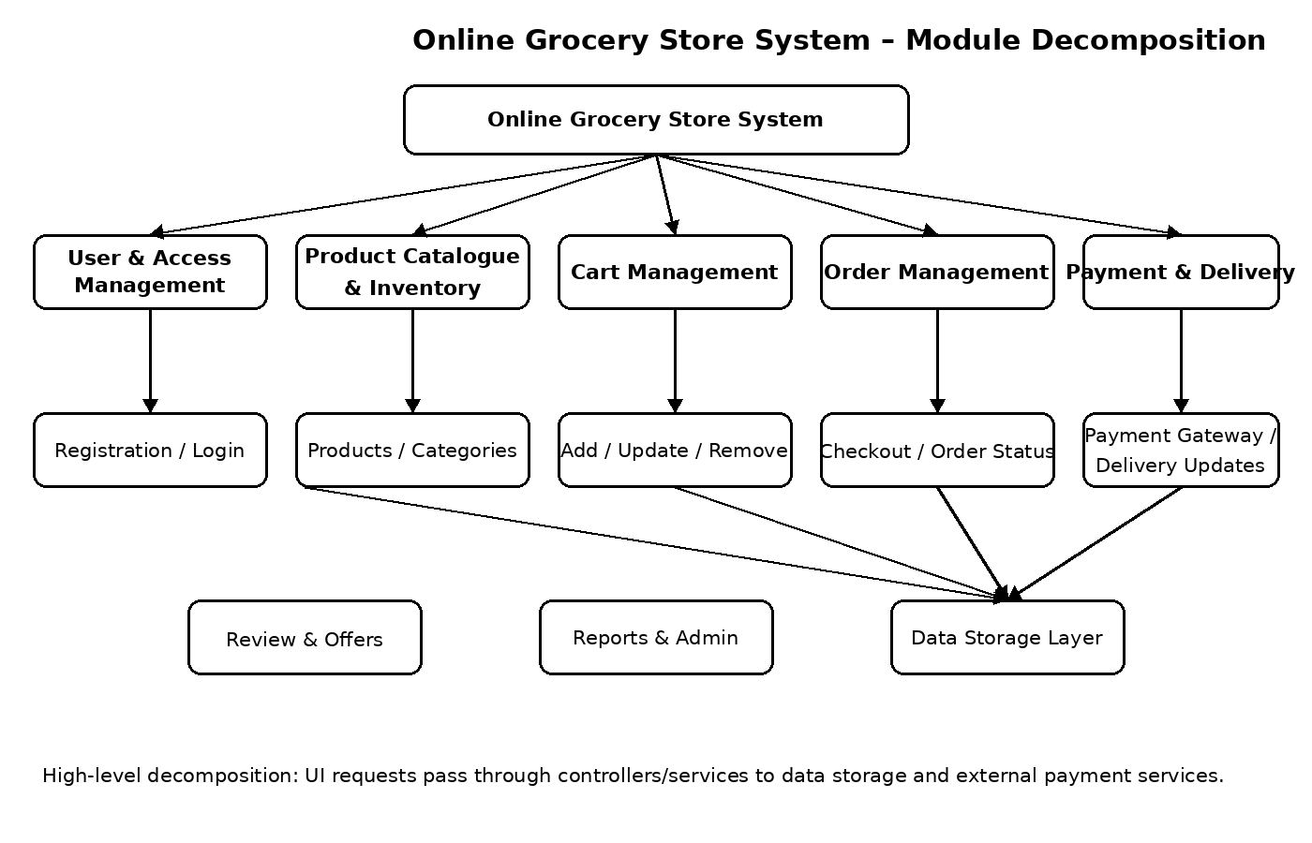
Figure 1: High-level module decomposition of the Online Grocery Store System.

C. Design Strategy
Selected strategy: ☒ Top-Down ☐ Bottom-Up ☒ Hybrid
Justification: The system is first divided into major functional areas such as users, products, cart, orders, payments, and delivery. Each area is then refined into smaller responsibilities. A hybrid approach is appropriate because the overall architecture is planned top-down, while reusable components such as authentication, data access, and payment integration can be developed and integrated independently.
Evidence: The system-level requirements are represented by the Use Case Diagram. These are decomposed into modules in Figure 1. The class diagram identifies the data entities and relationships, while sequence and activity diagrams describe the interactions and workflows within the modules.
Build-up sketch: Requirements → Major modules → Classes/controllers/services → Database and external-service integration → End-to-end workflows.

D. Design Approach
Selected approach: ☐ Function-Oriented ☒ Object-Oriented ☒ Mixed
Justification: Object-oriented design is suitable because the system contains identifiable entities such as User, Customer, Admin, Product, Cart, Order, Payment, Address, Review, Inventory, and DeliveryPartner. Each class groups related data and operations. The design also uses functional modules such as checkout, product search, and payment processing to organize the workflows, so a mixed view of objects and modules is useful.
Main classes/objects: User (with Customer, Admin, and DeliveryPartner roles), Product, Category, Inventory, Cart, CartItem, Order, OrderItem, Payment, Address, Review, and Offer.
Evidence: The Class Diagram shows attributes, methods, inheritance, associations, composition, and multiplicities. Sequence Diagrams show how the application, controllers, databases, and external services exchange messages.

E. Coupling Analysis
Coupling describes the degree of dependency between modules. The design aims for low coupling by passing only necessary data and keeping database and external-service details behind controllers or service interfaces.
Module pair | Interaction / shared data | Coupling type / level | How to reduce dependency
M2 Product Catalogue ↔ M3 Cart | Product ID, price, requested quantity, stock result. | Data coupling; low to moderate. | Pass only product ID, quantity, and validated price; avoid exposing product database tables directly.
M3 Cart ↔ M4 Order Management | Cart items, quantities, subtotal, customer/address reference. | Data coupling; moderate. | Send a checkout request/DTO and validate cart contents in the order service rather than sharing internal cart objects.
M4 Order Management ↔ M5 Payment | Order ID, amount, payment method, payment result. | Data coupling through service interface; moderate. | Use a payment service interface and a normalized success/failure response; keep gateway-specific logic inside M5.
M4 Order Management ↔ M6 Delivery | Order ID, delivery assignment, delivery status. | Data coupling; low to moderate. | Exchange order ID and status values through defined operations; do not let delivery code modify unrelated order fields.
M1 User Management ↔ M7 Admin | User identity, role, authentication result. | Data coupling; low to moderate. | Use role-based authorization services and pass user/role identifiers instead of sharing authentication internals.

F. Cohesion Analysis
Cohesion measures how closely the tasks inside a module relate to one another. The design aims for high functional cohesion, where each module has one clear purpose.
Module | Main responsibility | Cohesion type / level | Improvement, if needed
M1 User & Access Management | Registration, login, authentication, profile updates. | Functional cohesion; high. | Keep authorization rules separate from profile display logic if the module grows.
M2 Product Catalogue & Inventory | Product search/details and stock availability. | Functional cohesion; high if stock operations stay closely related. | Separate inventory updates from catalogue display if stock rules become complex.
M3 Cart Management | Add/remove items, quantity updates, subtotal calculation. | Functional cohesion; high. | Keep payment and order persistence out of the cart module.
M4 Order Management | Checkout validation, order creation, order status. | Functional cohesion; high. | Delegate payment processing and delivery-specific logic to their own modules.
M5 Payment Processing | Payment request, gateway response, transaction result. | Functional cohesion; high. | Isolate each payment provider behind the same interface.
M6 Delivery Management | Assigned deliveries and delivery-status changes. | Functional cohesion; high. | Keep customer notification as a separate service if notification features expand.

G. Module Interaction and Design Quality
The sequence diagram below shows the main interactions for checkout and payment. The customer submits checkout details through the application. The Order Controller validates and stores the order, requests payment from the Payment Gateway, and updates the order according to the payment result. This illustrates clear module responsibilities and limited information exchange.
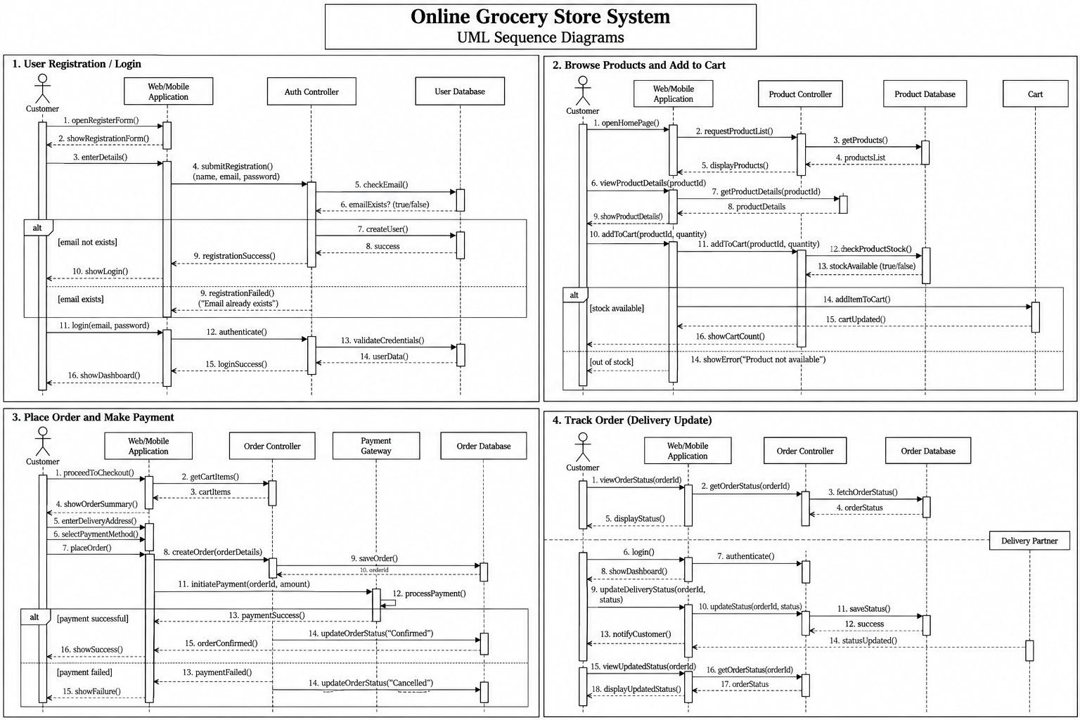
Figure 2: Sequence diagrams for the main Online Grocery Store workflows.
Design quality observations:
- Separation of concerns: user access, product browsing, cart, order, payment, and delivery responsibilities are separated.
- Low coupling: modules exchange identifiers, requests, and results rather than depending on each other's internal implementation.
- High cohesion: each module focuses on a related set of tasks.
- Maintainability: changes to payment-provider logic can be contained within the Payment Processing module.
- Validation and error handling: registration, stock checks, order validation, and payment outcomes have alternative flows.

Overall Conclusion
The Software Design Analysis Report decomposes the Online Grocery Store System into eight modules and evaluates the chosen design strategy, object-oriented approach, coupling, cohesion, and module interactions. The existing UML Use Case, Class, Sequence, and Activity Diagrams provide complementary views of system functionality, static structure, message flow, and workflow. Together, these models provide a practical blueprint for implementation and testing. The technology stack and roll numbers should be completed once confirmed.

