
KIIT UNIVERSITY
School of Computer Engineering
B.Tech — SAP Business Cloud Data Analyst
SAP ERP BLUEPRINT DOCUMENT

SAP ERP Project Report
SAP ERP Blueprint: Design and Setup of a Fictitious Company
Using FI | MM | SD Modules

Fictitious Company: VedaStar Retail Solutions Pvt. Ltd.

Submitted By
Field | Details
Student Name | Ayush Raj
Roll Number | 23051337
Program | B.Tech (SAP Business Cloud Data Analyst)
University | KIIT University, Bhubaneswar
Academic Year | 2025-2026
Submission Date | April 2025

SAP ERP | FI | MM | SD | ABAP

1. Executive Summary
This report presents a complete SAP ERP blueprint for a fictitious Indian company called VedaStar Retail Solutions Pvt. Ltd. The company sells consumer electronics and home appliances across multiple cities in India. As the business grew, it faced many problems in managing its day-to-day operations — like tracking stock manually, raising bills on paper, and keeping accounting records in spreadsheets.
To solve these problems, the company decided to implement SAP ERP. SAP (Systems, Applications, and Products in Data Processing) is a software used by companies all over the world to manage their business processes digitally — all in one system.
In this project, three main SAP modules are used:
- FI (Financial Accounting) — To manage all money-related transactions, payments, and financial reports.
- MM (Materials Management) — To handle purchasing, stock management, and supplier dealings.
- SD (Sales and Distribution) — To manage customer orders, product deliveries, and billing.

The report explains the company profile, enterprise structure, master data setup, two important business process flows (Procure-to-Pay and Order-to-Cash), and how the three SAP modules work together. All information is kept simple so it is easy to understand and explain in a viva.

2. Problem Statement
Before implementing SAP, VedaStar Retail Solutions Pvt. Ltd. was managing its business operations manually or using separate spreadsheet tools. This created several serious problems:

Key Problems Faced by the Company
- No single system: Different departments (accounts, warehouse, sales) worked in isolation. Data was stored in separate Excel files and was not shared automatically.
- Stock confusion: The warehouse team did not know the exact quantity of goods available. Items were sometimes over-ordered or out of stock due to poor visibility.
- Delayed payments: Invoice processing took too long because there was no proper system to match purchase orders, goods receipts, and vendor bills.
- Customer service issues: Sales team did not know stock availability in real time, leading to wrong delivery promises to customers.
- Human errors in accounts: Manual data entry caused calculation mistakes in financial statements, tax filings, and vendor payments.
- No real-time reports: Management could not see up-to-date business performance because reports were prepared manually at the end of each month.

In simple words — the company was running like a machine with broken gears. Every department was working hard, but they were not connected. This cost the company time, money, and customer trust.
SAP ERP solves all of these problems by bringing every department into one connected digital system.

3. Solution — What SAP ERP Provides
SAP ERP acts as a central platform where all business activities are recorded and shared in real time. When one department updates data, other departments can see it immediately. Here is how each module helps:

SAP Module | Problem It Solves | Key Benefit
FI — Financial Accounting | Manual accounting and payment errors | Automatic accounting entries, real-time balance sheet
MM — Materials Management | Stock confusion and slow purchasing | Automated purchase orders, live inventory tracking
SD — Sales & Distribution | Wrong delivery promises, billing delays | Real-time stock check, faster billing and delivery

Additional benefits of SAP ERP for VedaStar:
- All data is stored in one central database — no duplicate files
- Reports are generated instantly at any time
- GST and tax calculations are done automatically
- Audit trail is available for every transaction
- Reduces paperwork and manual effort

4. Company Profile — VedaStar Retail Solutions Pvt. Ltd.
VedaStar Retail Solutions Pvt. Ltd. is a completely fictitious company created for this SAP project. It is designed to represent a realistic mid-sized Indian retail business so that all SAP concepts can be applied in a meaningful way.

Field | Details
Company Name | VedaStar Retail Solutions Pvt. Ltd.
Founded | 2015
Industry | Consumer Electronics & Home Appliances Retail
Headquarters | Bhubaneswar, Odisha, India
Business Type | Private Limited Company
Annual Turnover | Approx. INR 85 Crore
Number of Employees | 420+
Branches | Bhubaneswar, Kolkata, Patna, Ranchi
GST Number | 21AADCV1234A1Z5 (Fictitious)
PAN Number | AADCV1234A (Fictitious)
SAP System Used | SAP ECC 6.0 (Simulation)

What the Company Sells
- Televisions (LED, OLED — brands like Samsung, Sony, LG)
- Washing Machines (IFB, Bosch, Whirlpool)
- Laptops and Computers (Dell, HP, Lenovo)
- Air Conditioners (Daikin, Voltas, Blue Star)
- Kitchen Appliances (Mixer grinders, microwave ovens)

Company Vision
To become the most trusted electronics retail brand in Eastern India by delivering quality products and exceptional customer service.
Company Mission
To use technology effectively to streamline operations, reduce costs, and ensure every customer gets the right product at the right time — supported by a fully integrated SAP ERP system.

5. Business Overview
VedaStar operates through four branches — one head office and three regional branches. The company buys goods from national distributors and manufacturers, stores them in regional warehouses, and sells them through showrooms and an online portal.

Organisational Hierarchy
VedaStar Retail Solutions Pvt. Ltd. (Head Office – Bhubaneswar)
|
+---------+---------+---------+
| | | |
Kolkata Patna Ranchi Online
Branch Branch Branch Store

Key Business Departments
Department | Function | SAP Module Used
Finance & Accounts | Payments, receipts, ledger, balance sheet | FI
Purchase / Procurement | Buying goods from vendors, stock replenishment | MM
Warehouse / Stores | Receiving goods, stock management | MM
Sales | Customer orders, pricing, delivery planning | SD
Billing | Raising invoices to customers | SD + FI
Management / MIS | Reports, dashboards, decision-making | FI + MM + SD

Types of Transactions
- Purchase transactions: Company buys goods from vendors like Reliance Digital Distributors, Flipkart Wholesale, and Ruchi Electronics (all fictitious).
- Sales transactions: Company sells goods to customers through showrooms and through the VedaStar online portal.
- Intercompany transfers: Goods are sometimes transferred between branches based on demand.

6. SAP Enterprise Structure
In SAP, before we start any transaction, we need to set up a structure that reflects the company's legal and operational organisation. This is called the Enterprise Structure. Think of it as the skeleton of the company inside SAP.

6.1 FI Enterprise Structure (Financial Accounting)
The FI module handles all money-related activities. Its structure consists of the following units:

FI Unit | What It Means | VedaStar Value
Client | The top-most level in SAP. Represents the entire SAP system. | 100
Company Code | Legal entity that maintains its own complete set of accounts. | VS01 — VedaStar Retail Solutions
Chart of Accounts | List of all ledger accounts used for accounting entries. | VS_COA (VedaStar Chart of Accounts)
Fiscal Year Variant | Defines the financial year (April to March in India). | V3 — April to March
Posting Period Variant | Controls which accounting periods are open for posting. | VS01

6.2 MM Enterprise Structure (Materials Management)
The MM module handles purchasing and inventory. Its structure is:

MM Unit | What It Means | VedaStar Value
Plant | A location where goods are produced or stored. In retail, it is a warehouse/branch. | VS10 — Bhubaneswar Hub  VS20 — Kolkata Branch  VS30 — Patna Branch
Storage Location | A specific storage area within a plant. | SL01 — Main Warehouse  SL02 — Display Floor
Purchasing Organisation | The team responsible for all purchasing activities. | VSPO — VedaStar Central Procurement
Purchasing Group | A specific buyer or group of buyers within the purchasing org. | PG1 — Electronics Buyer  PG2 — Appliances Buyer

6.3 SD Enterprise Structure (Sales & Distribution)
The SD module handles sales. Its structure is:

SD Unit | What It Means | VedaStar Value
Sales Organisation | The unit responsible for selling goods and services. | VS30 — VedaStar Sales India
Distribution Channel | How goods reach the customer (showroom, online, etc.). | 10 — Retail Showroom  20 — Online Store
Division | Product category being sold. | 01 — Electronics  02 — Appliances
Sales Area | Combination of Sales Org + Distribution Channel + Division. | VS30 + 10 + 01
Sales Office | City-level sales office. | BBR — Bhubaneswar, KOL — Kolkata

Enterprise Structure Diagram

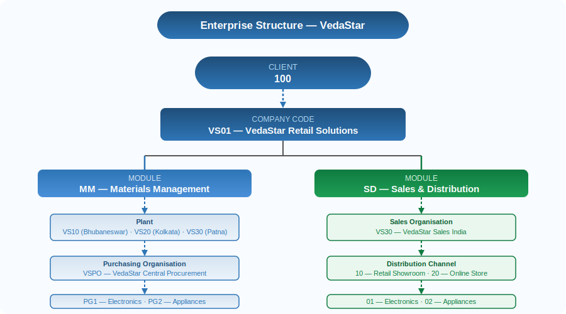

7. Master Data
Master data is the foundation of SAP. It is the basic information about customers, vendors, and materials that is created once and reused in every transaction. Think of master data as the 'contacts list' and 'product catalogue' of the company in SAP.

7.1 Material Master
Material master stores all details about a product — what it is, how much it costs, how it is stored, and how it is sold. Each material has a unique Material Number.

Material No. | Description | Material Type | Unit | Base Price (INR) | Plant
VS-MAT-001 | Samsung 55" LED TV | FERT | EA | 45,000 | VS10
VS-MAT-002 | Bosch 8kg Washing Machine | FERT | EA | 32,000 | VS10
VS-MAT-003 | Dell Inspiron 15 Laptop | FERT | EA | 58,000 | VS10
VS-MAT-004 | Daikin 1.5T Split AC | FERT | EA | 38,000 | VS20
VS-MAT-005 | Philips Mixer Grinder 750W | FERT | EA | 4,500 | VS30

T-Code to create Material Master: MM01 | T-Code to display: MM03
T-Code: MM01 → Select Material Type: FERT → Select Industry Sector: M (Retail)
→ Fill: Description, UOM, Price, Storage Data → Save

7.2 Vendor Master
A vendor is any company or person from whom VedaStar buys goods. The vendor master stores details like name, address, bank account, and payment terms.

Vendor No. | Vendor Name | City | Payment Terms | Account Group
V-1001 | Reliance Digital Distributors | Mumbai | 30 days net | LIEF (Vendor)
V-1002 | Flipkart Wholesale Pvt. Ltd. | Bangalore | 45 days net | LIEF (Vendor)
V-1003 | Ruchi Electronics Supply Co. | Delhi | 15 days net | LIEF (Vendor)
V-1004 | BrightTech Appliances Ltd. | Hyderabad | 30 days net | LIEF (Vendor)

T-Code to create Vendor Master: XK01 | T-Code to display: XK03

7.3 Customer Master
A customer is any person or organisation that buys products from VedaStar. The customer master stores name, address, credit limit, and payment terms.

Customer No. | Customer Name | City | Credit Limit (INR) | Payment Terms
C-2001 | Sharma Electronics Emporium | Patna | 5,00,000 | Immediate
C-2002 | Digital World Retail | Ranchi | 8,00,000 | 15 days
C-2003 | Gupta Home Store | Kolkata | 3,00,000 | Immediate
C-2004 | Aryan Modern Appliances | Bhubaneswar | 10,00,000 | 30 days

T-Code to create Customer Master: XD01 | T-Code to display: XD03

7.4 G/L Account Master (FI)
G/L stands for General Ledger. These are accounts used to record every financial transaction. Examples of G/L accounts in VedaStar:
G/L Account No. | Account Name | Account Type
100001 | Cash Account | Asset
100010 | Bank Account — HDFC Current | Asset
200001 | Accounts Payable (Vendors) | Liability
200010 | Accounts Receivable (Customers) | Asset
300001 | Sales Revenue Account | Revenue
400001 | Purchases / Inventory Account | Expense
T-Code to create G/L Account: FS00

8. Customisation Steps (SPRO)
In SAP, customisation means configuring the system to match how your company works. All customisation is done through a special transaction called SPRO (SAP Project Reference Object — basically the settings/configuration menu).
This means we tell SAP: 'This is our company, this is how we want things to work.' We do not change SAP's code — we just set our preferences.

8.1 FI Customisation
Step No. | What We Configure | T-Code / Path
FI-01 | Create Company Code VS01 | OX02
FI-02 | Define Chart of Accounts: VS_COA | OB13
FI-03 | Assign Chart of Accounts to Company Code | OB62
FI-04 | Define Fiscal Year Variant (April–March) | OB29
FI-05 | Assign Fiscal Year to Company Code | OB37
FI-06 | Define Posting Period Variant | OBBO
FI-07 | Create G/L Accounts | FS00
FI-08 | Define Payment Terms | OBB8
FI-09 | Configure Tax Procedure (GST) | OBYZ

8.2 MM Customisation
Step No. | What We Configure | T-Code / Path
MM-01 | Define Plant VS10, VS20, VS30 | OX10
MM-02 | Define Storage Locations | OX09
MM-03 | Create Purchasing Organisation VSPO | OX08
MM-04 | Assign Purch. Org to Company Code and Plant | OX01 / OX17
MM-05 | Define Number Ranges for Purchase Orders | OMH6
MM-06 | Set Valuation Area (at Plant level) | OMWM
MM-07 | Configure Movement Types for GR/GI | OMJJ

8.3 SD Customisation
Step No. | What We Configure | T-Code / Path
SD-01 | Define Sales Organisation VS30 | OVX5
SD-02 | Define Distribution Channels (10, 20) | OVXI
SD-03 | Define Divisions (01, 02) | OVX3
SD-04 | Set Up Sales Area (Org + Channel + Division) | OVXG
SD-05 | Assign Sales Org to Company Code | OVX3
SD-06 | Define Pricing Procedure | V/08
SD-07 | Configure Output (Invoice print format) | NACE
SD-08 | Define Shipping Points | OVXD

9. Business Process Flows
A process flow is the step-by-step journey that a business activity follows — from the starting point to the final completion. In SAP, every process flow leaves a digital trail of documents that are linked to each other.

9.1 Procure-to-Pay (P2P) Process
P2P is the process of buying goods from a vendor and paying for them. VedaStar follows this process whenever it needs to stock up products for its showrooms.

P2P Flow Diagram
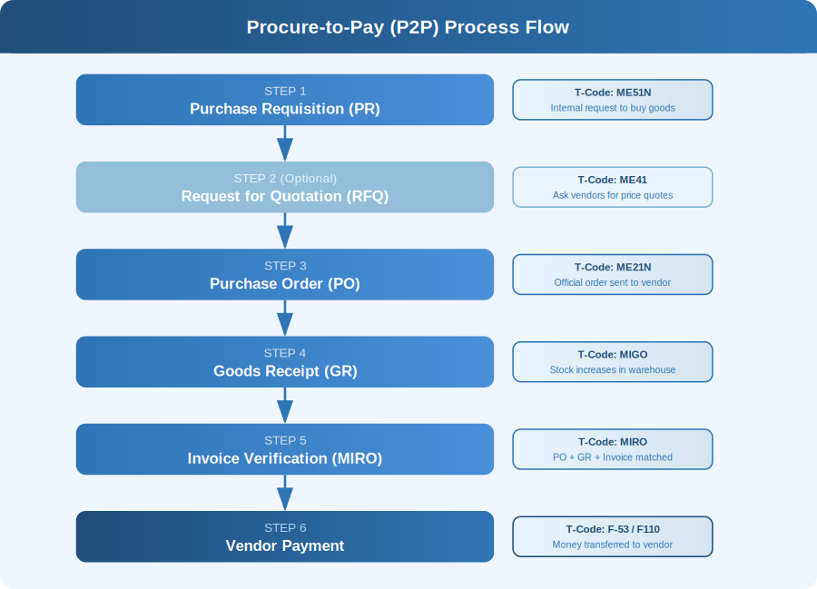
Step-by-Step Explanation
- Purchase Requisition (PR): The warehouse team at VedaStar Bhubaneswar notices that Samsung 55" LED TVs are running low. They raise a Purchase Requisition in SAP to request the purchase department to order more. T-Code: ME51N
- Purchase Order (PO): The purchase department approves the PR and creates a Purchase Order for 50 units of Samsung LED TV from Vendor V-1001 (Reliance Digital Distributors) at INR 45,000 per unit. Total PO Value = INR 22,50,000. T-Code: ME21N
- Goods Receipt (GR): When the goods arrive at the warehouse, the stores team does a Goods Receipt in SAP (T-Code: MIGO). SAP automatically increases the stock count for VS-MAT-001 at Plant VS10. A Material Document and Accounting Document are created automatically.
- Invoice Verification (MIRO): The vendor sends a bill. The accounts team uses MIRO to enter the invoice in SAP. SAP checks whether the invoice quantity and price match the PO and GR — this is called 3-way matching. If everything matches, the invoice is posted. A liability is created in FI.
- Vendor Payment (F-53): On the due date, the accounts team runs the payment (T-Code: F-53 or F110 for automatic payment). SAP transfers the amount from the VedaStar bank account and clears the vendor liability. The accounting entry is: Debit Vendor Account, Credit Bank Account.

Accounting Entries in FI (P2P)
Step | Debit | Credit
Goods Receipt (GR) | Inventory / Stock Account | GR/IR Clearing Account
Invoice Verification (MIRO) | GR/IR Clearing Account | Vendor Account (Payable)
Vendor Payment (F-53) | Vendor Account (Payable) | Bank Account

Example: ME21N — Create Purchase Order
Vendor : V-1001 (Reliance Digital Distributors)
Purch. Org. : VSPO
Purch. Group : PG1
Plant : VS10
Material : VS-MAT-001 (Samsung 55" LED TV)
Quantity : 50 EA
Net Price : INR 45,000
Delivery Date : 15.05.2025

9.2 Order-to-Cash (O2C) Process
O2C is the process of receiving an order from a customer, delivering the product, and collecting payment. This is VedaStar's main revenue-generating process.

O2C Flow Diagram
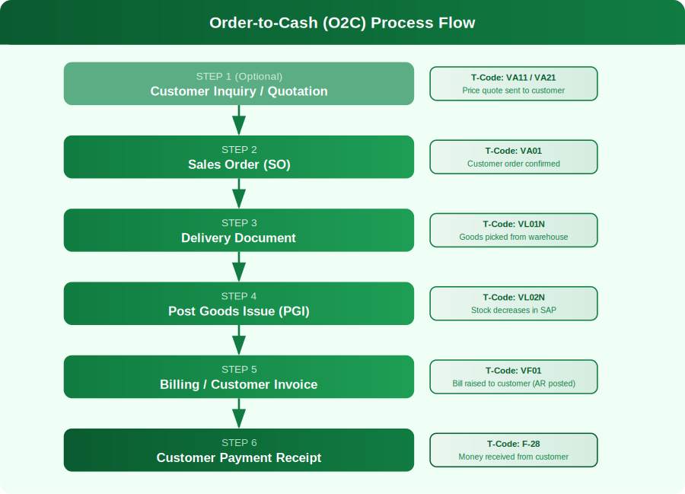

Step-by-Step Explanation
- Customer Inquiry / Quotation: Customer C-2001 (Sharma Electronics Emporium, Patna) contacts VedaStar asking for a price quote on 10 units of Dell Laptops. The sales team creates a Quotation in SAP (T-Code: VA21) showing price, delivery terms, and validity.
- Sales Order (SO): The customer agrees to the quote and places the order. The sales team converts the quotation into a Sales Order (T-Code: VA01). SAP checks stock availability and credit limit of the customer automatically. Sales Order No.: SO-2025-0041, Qty: 10 units of VS-MAT-003 @ INR 58,000 each. Total: INR 5,80,000.
- Delivery Document: The warehouse receives a notification from SAP. They pick 10 Dell Laptops from Storage Location SL01 at Plant VS10 and create a Delivery Document (T-Code: VL01N). The delivery date is set as 3 days from the order date.
- Post Goods Issue (PGI): After the goods are physically dispatched, the team does Post Goods Issue in SAP (T-Code: VL02N). This reduces the stock count by 10 in SAP. An accounting entry is created: Debit Cost of Goods Sold, Credit Inventory Account.
- Billing / Invoice (VF01): Once PGI is done, the billing team creates a customer invoice (T-Code: VF01). SAP generates the invoice automatically based on the sales order and delivery data. Invoice Amount: INR 5,80,000 + 18% GST = INR 6,84,400. The accounting entry is: Debit Customer Account, Credit Sales Revenue Account.
- Customer Payment (F-28): The customer pays within the credit period. The accounts team posts the incoming payment (T-Code: F-28). SAP clears the customer receivable. Entry: Debit Bank Account, Credit Customer Account.

Accounting Entries in FI (O2C)
Step | Debit | Credit
Post Goods Issue (PGI) | Cost of Goods Sold (COGS) | Inventory / Stock Account
Billing / Invoice | Customer Account (Receivable) | Sales Revenue Account
Customer Payment (F-28) | Bank Account | Customer Account (Receivable)

Example: VA01 — Create Sales Order
Order Type : OR (Standard Order)
Sales Org. : VS30
Dist. Channel : 10 (Retail Showroom)
Division : 01 (Electronics)
Customer : C-2001 (Sharma Electronics Emporium)
Material : VS-MAT-003 (Dell Inspiron 15 Laptop)
Quantity : 10 EA
Price : INR 58,000 per unit
Req. Del. Date: 20.05.2025

10. Module Integration — How FI, MM, and SD Work Together
One of the biggest strengths of SAP ERP is that all modules are connected. When something happens in MM or SD, SAP automatically updates the FI (accounting) module. The user does not need to manually enter accounting entries — SAP does it automatically. This avoids errors and saves a huge amount of time.

Integration Flow Diagram
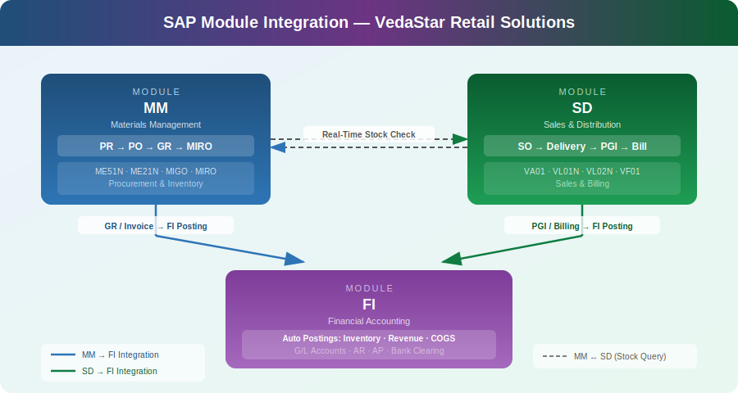

10.1 MM-FI Integration
- When a Goods Receipt (GR) is posted in MM → SAP automatically posts an accounting document in FI (Debit Inventory, Credit GR/IR Clearing).
- When an invoice is posted in MIRO → SAP clears the GR/IR account and creates a vendor payable in FI.
- When payment is made (F-53) → The vendor payable is cleared from the FI accounts.

10.2 SD-FI Integration
- When PGI (Post Goods Issue) is done in SD → SAP automatically reduces inventory in MM and posts COGS in FI.
- When a billing document (VF01) is created in SD → SAP automatically creates a customer receivable in FI.
- When customer payment (F-28) is received → The receivable is cleared in FI.

10.3 MM-SD Integration
- Stock availability check during Sales Order (VA01) in SD reads real-time stock data from MM.
- Material details (price, unit of measure) in SD are linked to the Material Master maintained in MM.

In simple terms: MM handles buying, SD handles selling, and FI handles the money. All three talk to each other automatically inside SAP — this is called Real-Time Integration.

11. Important SAP Reports Used in VedaStar
SAP provides many built-in reports that help management make decisions. These reports can be generated at any time and show live data. No need to wait for month-end!

11.1 FI Reports
Report Name | T-Code | What It Shows
Balance Sheet | F.01 | Assets, liabilities, and equity of the company
Profit & Loss Statement | F.01 | Revenue, expenses, and net profit/loss
Customer Ledger Report | FBL5N | All transactions for a specific customer
Vendor Ledger Report | FBL1N | All transactions for a specific vendor
General Ledger Report | FBL3N | All entries in a particular G/L account
Accounts Payable Ageing | S_ALR_87012085 | How much is owed to vendors and for how long

11.2 MM Reports
Report Name | T-Code | What It Shows
Stock Overview | MMBE | Current stock at each plant and storage location
Purchase Order List | ME2M / ME2N | All open and completed purchase orders
Vendor Evaluation Report | ME6H | Rating of vendors based on delivery and quality
Material Movement Report | MB51 | All goods receipts and goods issues for a material
Slow-Moving Stock Report | MB52 | Items that have not moved in a long time

11.3 SD Reports
Report Name | T-Code | What It Shows
Sales Order List | VA05 | All sales orders — open and completed
Delivery List | VL06 | Pending and completed delivery documents
Billing Document List | VF05 | All invoices raised to customers
Customer Sales Analysis | MCTA | How much each customer has bought
Sales Info System Report | MC+2 | Product-wise sales performance report

12. Unique Points of This Project
This SAP ERP blueprint for VedaStar Retail Solutions Pvt. Ltd. has several unique features that make it stand out from a basic student project:

- Indian Business Context: The project is designed around the real-world challenges of an Indian retail company — including GST handling, INR currency, and India-specific payment terms like 30/45-day credit cycles.
- End-to-End Coverage: Both the P2P and O2C processes are covered fully — from the first document to the final payment — with proper accounting entries at each stage.
- 3-Way Matching in P2P: The invoice verification step uses 3-way matching (PO + GR + Invoice), which is the industry-standard best practice for preventing fraud and overpayment.
- Real-Time Integration Design: The project demonstrates how MM, SD, and FI modules share data automatically — no manual accounting is needed after each transaction.
- Multi-Branch Structure: VedaStar operates across 4 cities with different plants and storage locations, making the enterprise structure realistic and complex enough for learning.
- GST Integration: The pricing procedure is designed to include CGST and SGST/IGST automatically based on whether the transaction is intra-state or inter-state — a real requirement for Indian companies.
- Customised Pricing Procedure: The SD module has a customised pricing procedure (VS_PRICE) that handles base price, trade discounts, and GST calculation in sequence.

13. Future Improvements
This project covers the core SAP modules. In the future, the following improvements could be added to make VedaStar's SAP system even more powerful:

Improvement | SAP Module/Feature | Benefit
Add SAP HR (HCM) Module | SAP HCM | Manage employee payroll, leave, and attendance in SAP
Implement SAP CRM | SAP CRM / C4C | Track customer complaints, loyalty programs, and after-sales service
Migrate to SAP S/4HANA | S/4HANA | Faster real-time analytics using in-memory HANA database
Add SAP Analytics Cloud | SAC Dashboards | Live graphical dashboards for top management decision making
Integrate E-Commerce Portal | SAP Commerce Cloud | Connect VedaStar's online store directly with SAP backend
Implement Barcode/RFID Scanning | Extended WM | Faster and more accurate goods receipt using warehouse scanning
Add EDI with Vendors | SAP EDI / IDocs | Automatic purchase orders sent to vendor systems electronically

14. Conclusion
This project successfully demonstrates how SAP ERP can transform a growing retail company from a disorganised, manual operation into a streamlined, data-driven business. VedaStar Retail Solutions Pvt. Ltd. — though fictitious — represents the real-world challenges faced by thousands of small and medium Indian businesses today.

By implementing the three core modules — FI, MM, and SD — VedaStar can now:
- Know exactly how much stock is available at every branch at any moment
- Raise purchase orders and sales invoices digitally — no more paper
- Automatically post accounting entries without manual effort
- Receive instant reports on sales, profitability, vendor performance, and cash flow
- Comply with GST regulations easily through SAP's built-in tax engine

SAP ERP is not just software — it is a way of organising a business correctly. Every student learning SAP is essentially learning how real companies across the world manage their daily operations. The concepts of Purchase Requisitions, Goods Receipts, Sales Orders, and Financial Postings are not just SAP features — they are universal business practices.

This project gives a clear, step-by-step understanding of how these processes work, how they are configured in SAP, and how they connect with each other. It is a strong foundation for any student aiming to build a career in SAP consulting, business analysis, or ERP project management.

"SAP connects every part of a business — just like the human nervous system connects every part of the body."

15. Appendix — Complete T-Code Reference
A T-Code (Transaction Code) is a shortcut in SAP that takes you directly to a specific function or screen. Instead of navigating through menus, you simply type the T-Code in the command bar and press Enter.

FI — Financial Accounting T-Codes
T-Code | Function | When Used
FS00 | Create / Edit G/L Account | Setting up ledger accounts
FB50 | Post G/L Document (Journal Entry) | Manual accounting entries
FBL3N | G/L Account Line Items Report | View all entries in an account
FBL1N | Vendor Line Items Report | View vendor payment history
FBL5N | Customer Line Items Report | View customer payment history
F-53 | Post Outgoing Payment (Vendor) | Paying a vendor manually
F-28 | Post Incoming Payment (Customer) | Receiving customer payment
F110 | Automatic Payment Run | Batch payment to multiple vendors
F.01 | Financial Statements | Balance Sheet and P&L
OB13 | Define Chart of Accounts | Configuration — done once
OBB8 | Define Payment Terms | Set 30/45-day payment terms

MM — Materials Management T-Codes
T-Code | Function | When Used
MM01 | Create Material Master | New product added to system
MM02 | Change Material Master | Update product details
MM03 | Display Material Master | View product information
XK01 | Create Vendor Master | New vendor added
XK02 | Change Vendor Master | Update vendor details
ME51N | Create Purchase Requisition | Request to purchase goods
ME21N | Create Purchase Order | Official PO to vendor
ME22N | Change Purchase Order | Modify an existing PO
ME23N | Display Purchase Order | View PO details
MIGO | Goods Movement (GR/GI) | Receive or issue goods
MIRO | Invoice Verification | Enter vendor bill in SAP
MMBE | Stock Overview | Check current stock levels
MB51 | Material Document List | View all GR/GI history

SD — Sales & Distribution T-Codes
T-Code | Function | When Used
XD01 | Create Customer Master | New customer added
XD02 | Change Customer Master | Update customer details
VA11 | Create Inquiry | Customer asks for information
VA21 | Create Quotation | Send price quote to customer
VA01 | Create Sales Order | Customer confirms purchase
VA02 | Change Sales Order | Modify an existing order
VA05 | Sales Order List | View all sales orders
VL01N | Create Outbound Delivery | Prepare goods for shipping
VL02N | Change Delivery / Post PGI | Confirm goods dispatched
VF01 | Create Billing Document | Raise invoice to customer
VF02 | Change Billing Document | Modify an invoice
VF05 | Billing Document List | View all invoices
MCTA | Customer Analysis | Sales report by customer

General / Cross-Module T-Codes
T-Code | Function
SPRO | Configuration/Customisation menu — all SAP settings
SE38 | ABAP Editor — write and run ABAP programs
SM30 | View/Table Maintenance — view configuration tables
SU01 | User Administration — create/manage SAP users
AL11 | SAP File Directory
ST05 | SQL Trace — for performance analysis

End of Report
Ayush Raj | Roll No: 23051337 | KIIT University

