RAG-based Legal Assistant
System Documentation

1. System Overview
Legal Crime Analyzer is a Retrieval-Augmented Generation (RAG) system that accepts a free-text description of a crime scenario, identifies the applicable crime types, and retrieves relevant legal provisions from a corpus of Indian legal acts. The system grounds all responses in retrieved legal text, preventing hallucinated sections.

Unlike naive chunking approaches, this system extracts and indexes legal documents at the section level, significantly improving retrieval precision for legal queries.

2. Problem Statement Mapping
Input | Free-text description of a crime scenario in natural language
Crime Identification | Identified crime categories extracted from the scenario
Legal Retrieval | Relevant legal sections retrieved from vector store
Output | Structured JSON with crime types, applicable laws, descriptions, and justifications

3. System Architecture
The pipeline has 5 steps:

- The query is reformulated into legal language
- Then crime types and keywords are extracted
- Then relevant legal sections are retrieved using FAISS
- They are re-ranked to keep the most relevant ones
- Finally, a structured legal answer is generated grounded in those sections

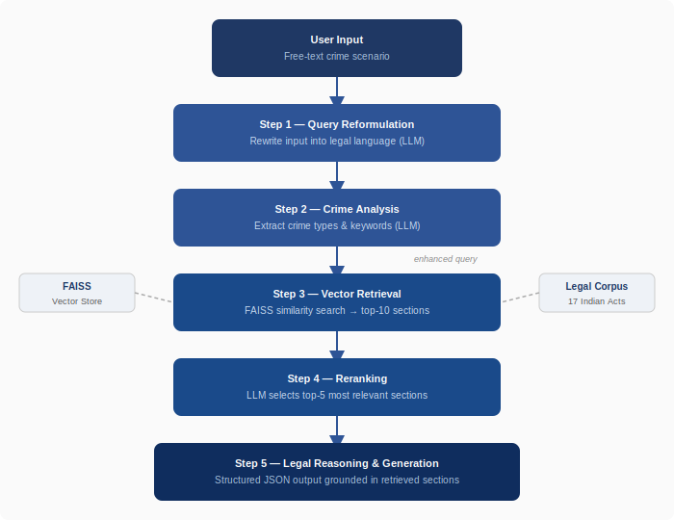

4. Design Decisions

Retrieval-Augmented Generation (RAG)
Instead of relying solely on LLM parametric knowledge, the system retrieves legal sections at query time and grounds every response in actual retrieved law text. This is the primary mechanism for reducing hallucinations.

Section-Level Chunking
Legal PDFs are not split by character count or page. Instead, the unstructured_legal_chunker.py uses an LLM to extract individual sections with their identifiers, titles, and full text. Each section is stored as a discrete vector. This is the most significant design decision as it ensures retrieval returns a complete legal provision rather than a fragment of one.

Multi-Stage Query Enhancement
I use two LLM steps before retrieval:
- one to convert the query into legal language
- one to extract crime types and keywords

This improves retrieval because user queries are usually informal.

LLM-Based Reranking
After vector retrieval returns 10 candidates, an LLM reranking step selects the 5 most relevant. This is a lightweight alternative to a dedicated cross-encoder reranker and reduces the volume of context passed to the generation step.

Grounded Output Enforcement
I restrict the model to only use retrieved sections through prompt design, which helps prevent hallucination.

Checkpoint-Based PDF Processing
PDF ingestion saves extracted sections to a temporary JSON file after each chunk. If processing is interrupted, it resumes from the last completed chunk. This is important for large acts that may take several minutes to process.

5. Assumptions
- Legal PDFs are text-selectable. The chunker uses the fast strategy from the unstructured library. Scanned PDFs require OCR preprocessing which is not currently included.
- Each PDF filename is used as the act identifier in metadata (e.g., Indian_Penal_Code.pdf becomes the act field value in all retrieved sections from that file).
- All LLM calls use OpenAI gpt-4.1-mini with temperature 0 for deterministic outputs. All embeddings use text-embedding-3-small.
- The FAISS index fits in memory. For very large corpora, an approximate nearest neighbour service would be needed.
- Each query is independent. The system has no conversation memory across turns.

6. Limitations
- Scanned or image-based PDFs will produce empty or garbled text from the fast extraction strategy, leading to missing sections in the index.
- LLM-based reranking adds one additional API call per query, contributing to latency. A cross-encoder model would be faster and more accurate.
- The flat FAISS index does not support hybrid (keyword + semantic) search. Queries referencing an exact section number (e.g., Section 302) may not retrieve it if the embedding similarity is low.
- The generation step has no post-hoc validation of cited sections against the index. The no-hallucination constraint is prompt-based only.
- Procedural queries such as bail eligibility, jurisdiction, or trial procedure are not well handled as the retrieval and prompting are tuned for substantive criminal provisions.
- Outputs may vary slightly across runs due to probabilistic LLM behavior, though temperature is set to 0 to minimize variance.

7. Future Improvements
- Add BM25 sparse retrieval alongside dense embeddings (hybrid search) to improve recall for exact section number queries.
- Replace LLM reranking with a dedicated cross-encoder model (e.g., ms-marco-MiniLM) for lower latency and better precision.
- Add OCR support using Tesseract or AWS Textract for scanned legal documents.
- Maintain conversation history to support follow-up queries within the same session.
- Add a post-generation validation step that checks cited section IDs against the FAISS metadata before returning output.
- Expand output to include prescribed punishment ranges alongside each applicable section.

8. Sample Output
Input scenario: A person broke into a house at night and stole valuables.

{
"crime_type": ["House-breaking by night", "Theft"],
"applicable_laws": [
{
"act": "India_Penal_Code",
"section": "457",
"description": "Lurking house-trespass or house-breaking by night
in order to commit an offence punishable with imprisonment.",
"justification": "The accused broke into a house during nighttime,
satisfying the elements of house-breaking by night."
},
{
"act": "India_Penal_Code",
"section": "378",
"description": "Whoever intending to take dishonestly any moveable
property out of possession without consent commits theft.",
"justification": "The accused took valuables without the owner's consent."
}
]
}

9. Technology Stack
Component | Technology
LLM | OpenAI GPT-4.1-mini (temperature 0)
Embeddings | OpenAI text-embedding-3-small
Vector Store | FAISS (via LangChain)
PDF Parsing | Unstructured (fast strategy)
Orchestration | LangChain
Frontend | Streamlit
Language | Python 3.9+

10. Demo
The system can be run locally using:
streamlit run app.py

A recorded demonstration showcasing end-to-end functionality is provided here:
https://drive.google.com/file/d/1POaD-oRRNbWd1Iws6gSaWoQWYwMGWyzr/view?usp=sharing

