RAILWAY WHEEL INTELLIGENCE
From a Predictive Model to a Decision-Support Platform

Strategic Framing Note
Gold Layer Design · Fleet & Route Analytics · Decision Support

July 2026

Executive Summary
The Gold layer is not the end product of this pipeline — it is a digital representation of wheel life. Framed correctly, it can answer dozens of the engineering questions that shed staff, fleet managers, and infrastructure planners ask every day, well beyond a single Remaining Useful Life (RUL) prediction.
This note reframes the project from a single-model build into a Railway Wheel Intelligence Platform: a stack of decision-support modules built on a Gold layer that is organized around real engineering questions rather than raw tables.
The core reframe
Instead of asking “Which ML model should we train?”
Start asking “What decisions does an engineer make every day that this data can improve?”

1. The Mindset Shift
Three raw measurements, reframed as decisions:
Instead of asking | Start asking
Diameter = 1112 mm | If I don't turn this wheel today, what is the probability of unscheduled maintenance in the next 20 days?
Flange wear = 3.2 mm | This wheel is wearing 2.8× faster than comparable wheels under similar conditions.
Wear ↑ (unexplained) | 42% route curvature, 27% braking frequency, 18% axle loading, 9% reprofiling depth, 4% weather.

2. Six Questions a Shed Engineer Actually Asks
Each question pulls the analysis one level higher — from a single wheel, to a locomotive, to a route, to a maintenance practice.
1 | Should this wheel be turned today?  Raw signal: Diameter, flange thickness readings  Engineering insight: 20-day unscheduled-maintenance risk score

2 | Which wheel is deteriorating abnormally?  Raw signal: Wear measurement in isolation  Engineering insight: Peer-normalised anomaly: wear rate vs. similar locomotives/conditions

3 | Why is this wheel wearing faster?  Raw signal: A single “wear ↑” flag  Engineering insight: Multi-source attribution across route, braking, load, and reprofiling history

4 | Which locomotives are damaging wheels?  Raw signal: Wheel → RUL, per asset  Engineering insight: Locomotive → Wheel Health, exposing suspension/braking effects by class

5 | Which routes destroy wheels?  Raw signal: No route-level rollup  Engineering insight: Wear-per-km heatmap by section, e.g. Delhi–Kanpur at 1.9× network average

6 | Which maintenance practices actually work?  Raw signal: Shed-level records kept separately  Engineering insight: Shed A vs. Shed B wheel-life comparison (420 vs. 530 days) tied to practice differences

Illustrative attribution: why a wheel is wearing faster
Even where these are statistical contributions rather than proven causes, they focus investigation on the right subsystem first.
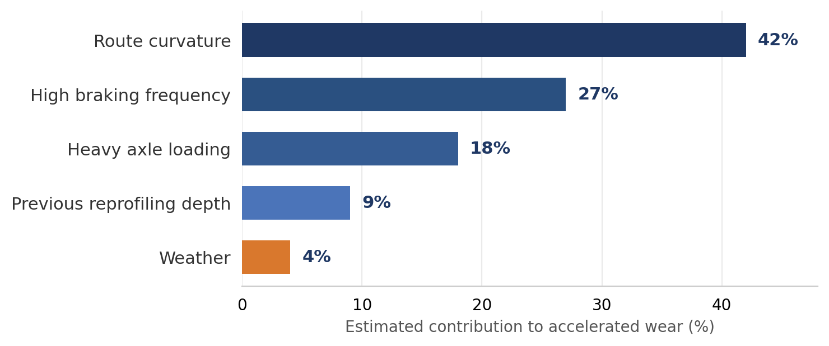
Figure 1 — Estimated contribution to accelerated wheel wear, by source

3. The Railway Wheel Intelligence Platform
The deliverable widens from a single prediction into eight linked modules, each consuming the same Gold layer:
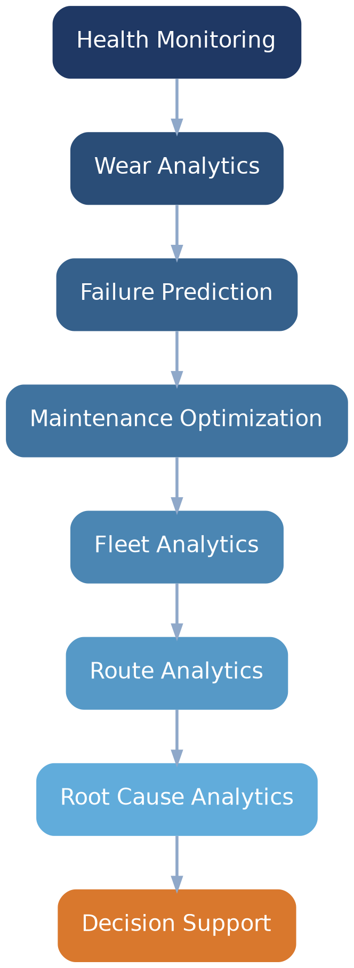
Figure 2 — Platform modules, from raw health monitoring to deployed decision support

4. Redesigning the Gold Layer Around Questions
Rather than a set of generic fact tables, the Gold layer is organized as four question-oriented pillars — together they form the complete “medical history” of a wheel.
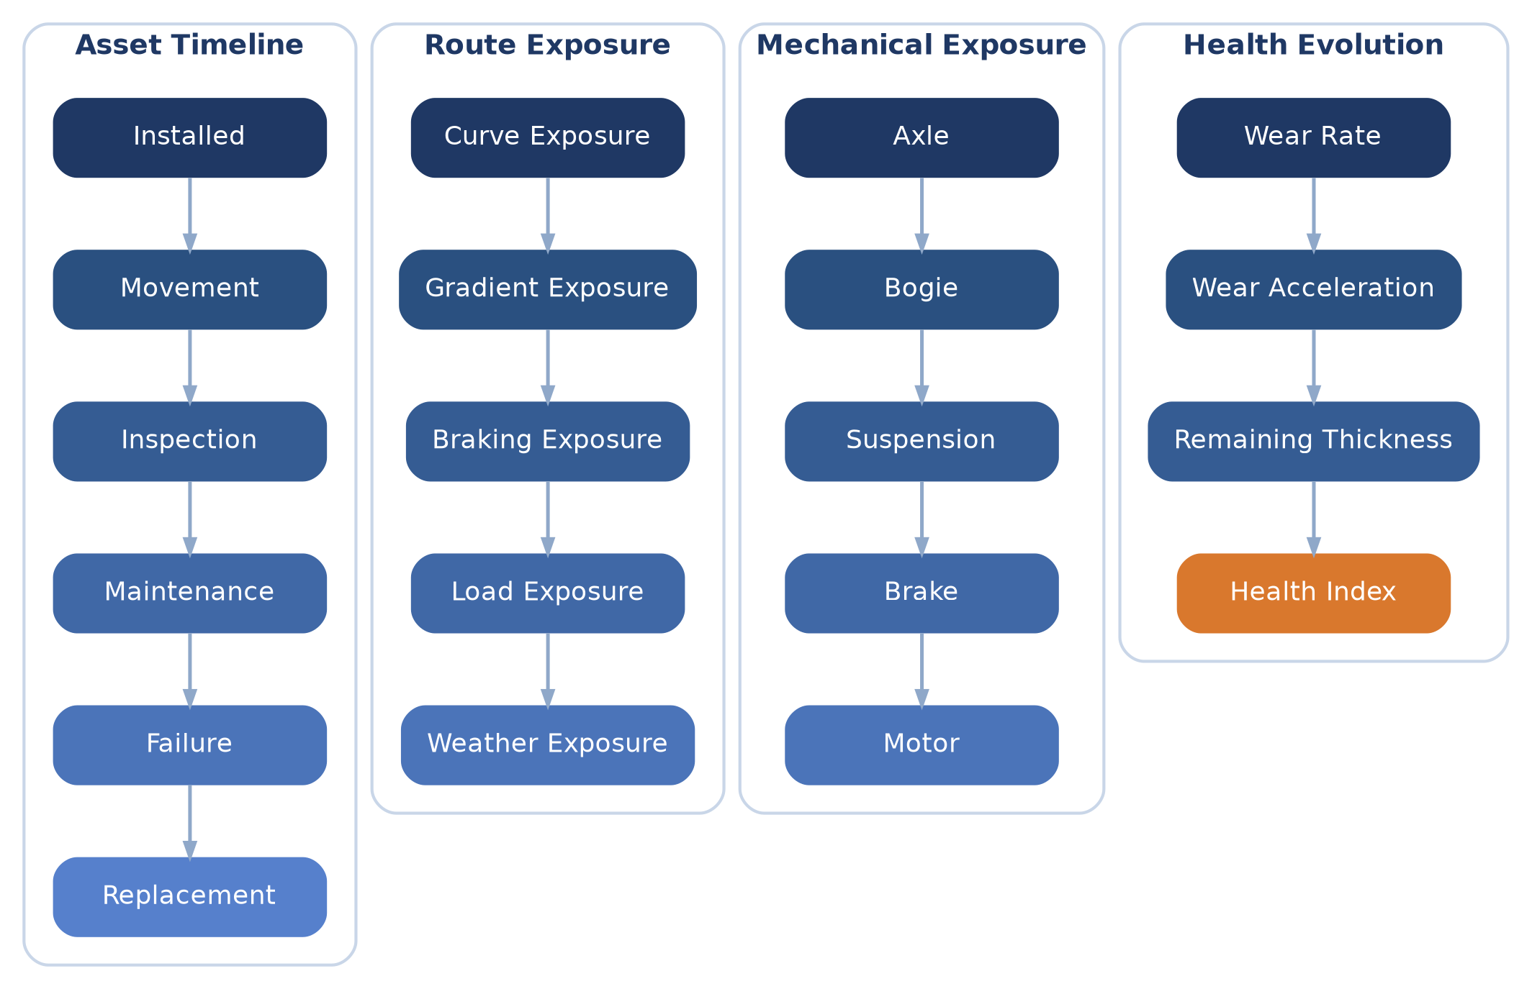
Figure 3 — Gold layer pillars: asset history, route/mechanical exposure, and health evolution

5. From Measurements to a Daily Decision

Wheel Risk Score
A single, explainable score an engineer can act on each morning, without interpreting dozens of raw measurements:
Wheel Risk Score — 81 · HIGH
• High flange wear rate
• High braking intensity
• Two emergency brake events
• Curve exposure +38%
• Maintenance overdue

Digital Twin
Extended further, every wheel carries a continuously updated profile — current state, 30-day forecast, next reprofiling date, confidence, and the leading degradation drivers behind the recommendation. This is closer to how modern predictive-maintenance systems operate in practice.

6. Revised Roadmap
The change is subtle but decisive: the Gold layer should be designed to answer engineering questions first, and to feed a model second.
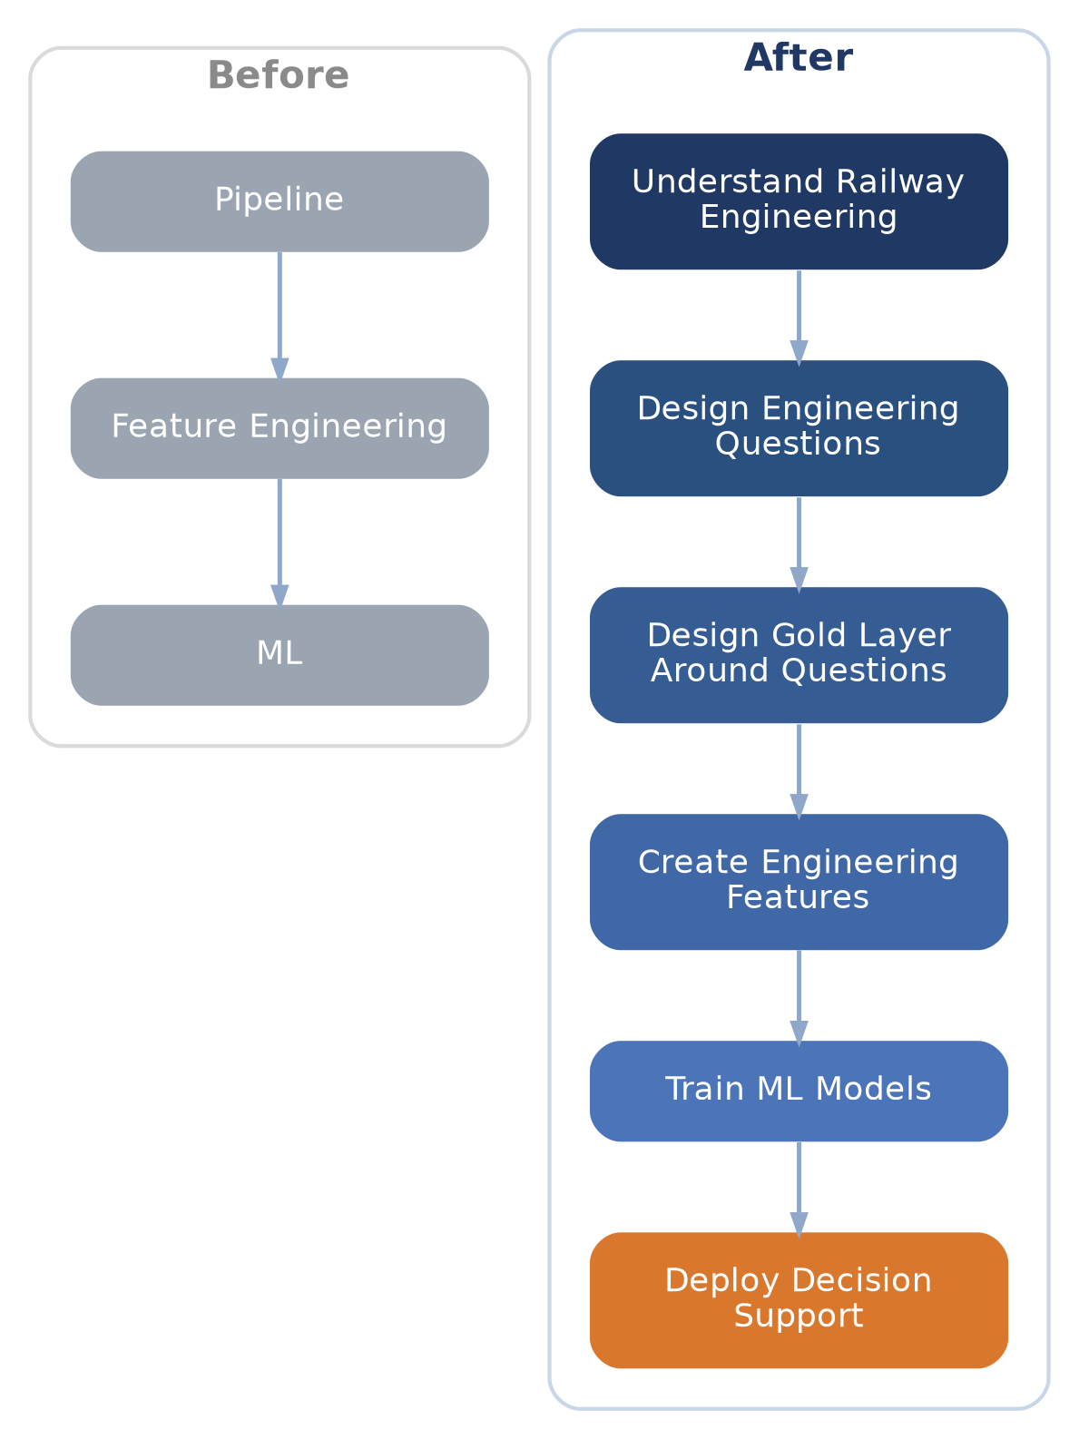
Figure 4 — From a generic ML pipeline to a question-driven, decision-support roadmap

7. The Challenge Ahead
Next step
Once the Bronze and Silver layers are complete, brainstorm 30–50 high-value engineering questions that CRIS, locomotive sheds, fleet managers, and maintenance planners would genuinely ask.
The Gold schema and required features are derived from those questions — not the other way around.

This approach keeps the project from becoming a purely academic exercise. Every ML model becomes one component of a broader decision-support system, and every prediction stays tied to a concrete maintenance action or operational insight.

