Experiment No. 1
Title of the Program: Demonstrate JavaScript basics: var, let, const with scope & mutability.
Objective: To study and demonstrate the use of JavaScript variable declarations (var, let, and const) and understand their differences through practical examples.
Program:
<!doctype html>
<html>
<body>
<script>
var a = 100;
if (true) {
var a = 150;
}
console.log("var:", a);

let b = 300;
if (true) {
let b = 450;
console.log("letinside:", b);
}
console.log("letoutside:", b);

const c = 500;
console.log("const:", c);
</script>
</body>
</html>

Output Screenshot:
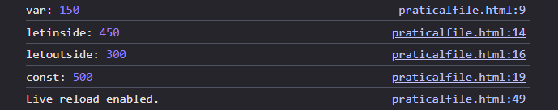

Experiment No. 2
Title of the Program: Demonstrate primitive data types and typeof.
Objective: To demonstrate different primitive data types in JavaScript and use the typeof operator to identify their data types.
Program:
<!doctype html>
<html>
<body>
<h2>Primitive Data Types and typeof Example</h2>
<p id="demo"></p>

<script>
let num = 19;
let name = "Whisk";
let isStudent = true;
let t;
let empty = null;
let big = 9876543210123n;
let sym = Symbol("id");

document.getElementById("demo").innerHTML =
"Number: " +
typeof num +
"<br>" +
"String: " +
typeof name +
"<br>" +
"Boolean: " +
typeof isStudent +
"<br>" +
"Undefined: " +
typeof t +
"<br>" +
"Null: " +
typeof empty +
"<br>" +
"BigInt: " +
typeof big +
"<br>" +
"Symbol: " +
typeof sym;
</script>
</body>
</html>

Output Screenshot:
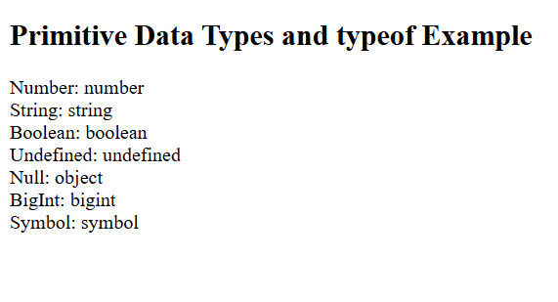

Experiment No. 3
Title of the Program: Implement operators (comparison, logical, ternary) and expressions.
Objective: To implement and demonstrate comparison operators, logical operators, and the ternary operator in JavaScript, and understand how expressions evaluate to produce boolean or conditional results.
Program:
<!doctype html>
<html>
<body>
<script>
let a = 15;
let b = 28;

console.log("Equal:", a == b);
console.log("Not Equal:", a != b);
console.log("Strict Equal:", a === b);
console.log("Greater:", a > b);
console.log("Less or Equal:", a <= b);

let x = true;
let y = false;

console.log("AND:", x && y);
console.log("OR:", x || y);
console.log("NOT:", !x);

let age = 18;
let result = age >= 18 ? "Eligible to vote" : "Not eligible to vote";
console.log("Ternary:", result);
</script>
</body>
</html>

Output Screenshot:

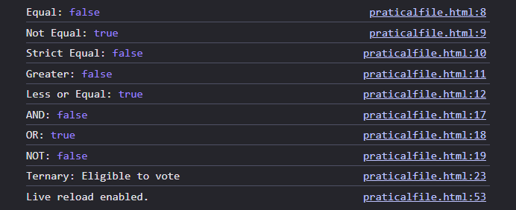

Experiment No. 4
Title of the Program: Implement control flow using if/else and switch.
Objective: To implement control flow statements in JavaScript using if/else and switch, and understand how program execution changes based on conditions.
Program:
<!doctype html>
<html>
<body>
<script>
let number = 26;

if (!(number % 2 == 0)) {
console.log("Odd number");
} else {
console.log("Even number");
}

let day = 3;
switch(day) {
case 1:
console.log("Monday");
break;
case 2:
console.log("Tuesday");
break;
case 3:
console.log("Wednesday");
break;
case 4:
console.log("Thursday");
break;
case 5:
console.log("Friday");
break;
case 6:
console.log("Saturday");
break;
case 7:
console.log("Sunday");
break;
default:
console.log("Invalid date");
}
</script>
</body>
</html>

Output Screenshot:
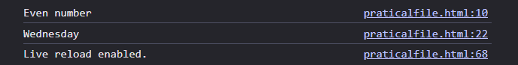

Experiment No. 5
Title of the Program: Demonstrate all loop types (for, while, do/while, for...in, for...of).
Objective: To demonstrate different looping statements in JavaScript including for, while, do…while, for…in, and for…of for repeated execution of statements.
Program:
<!doctype html>
<html>
<body>
<script>
for (let i = 1; i <= 5; i++) {
console.log("for:", i);
}

let j = 1;
while (j <= 5) {
console.log("while:", j);
j++;
}
let k = 1;
do {
console.log("do while:", k);
k++;
} while (k <= 5);
let obj = { name: "Wick", age: 20, course: "BTech" };
for (let key in obj) {
console.log("for in:", key, obj[key]);
}
let arr = [10, 20, 30, 40, 50];
for (let value of arr) {
console.log("for of:", value);
}
</script>
</body>
</html>
Output Screenshot:

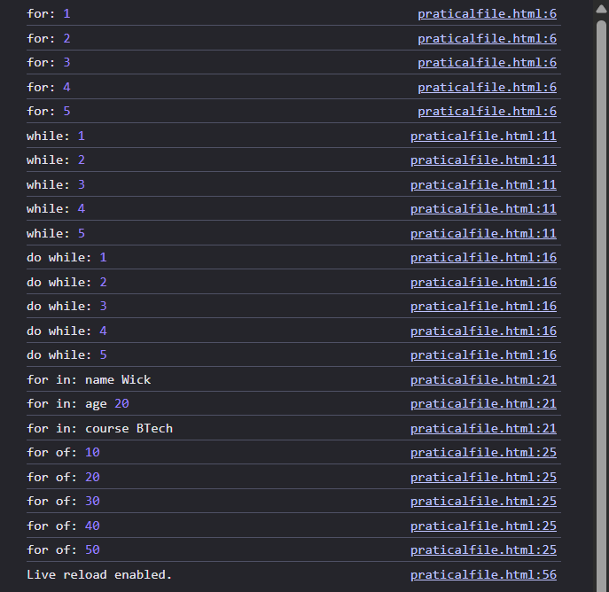

Experiment No. 6
Title of the Program: Create and use objects (reference type), property access, dynamic properties.
Objective: To create and use JavaScript objects (reference type), demonstrate property access methods, and implement dynamic properties.
Program:
<!doctype html>
<html>
<body>
<script>
let student = {
name: "English",
age: 18,
course: "BTech",
};

console.log(student.name);
console.log(student["age"]);

student.city = "Rajpura";
console.log(student);

let dynamicKey = "marks";
student[dynamicKey] = 95;

console.log(student);

for (let key in student) {
console.log(key, student[key]);
}
</script>
</body>
</html>

Output Screenshot:
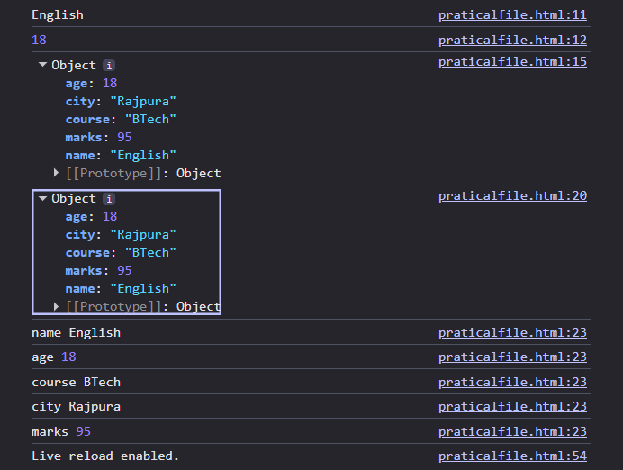

Experiment No. 7
Title of the Program: Demonstrate function declaration vs function expression and hoisting.
Objective: To demonstrate the difference between function declaration and function expression in JavaScript, and understand how hoisting affects their execution.
Program:
<!doctype html>
<html>
<body>
<script>
greet();

function greet() {
console.log("Function Declaration Executed");
}

try {
sayNamaste();
} catch (error) {
console.log("Function Expression not hoisted");
}

let sayNamaste = function () {
console.log("Function Expression Executed");
};

sayNamaste();
</script>
</body>
</html>

Output Screenshot:

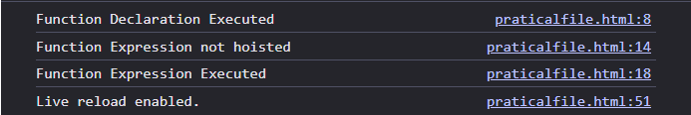

Experiment No. 8
Title of the Program: Implement arrow functions and demonstrate lexical this.
Objective: To implement arrow functions in JavaScript and demonstrate how lexical this works compared to a regular function.
Program:
<!doctype html>
<html>
<body>
<script>
let add = (a, b) => a + b;
console.log("Sum:", add(5, 3));

let person = {
name: "Steve",
regularFunction: function () {
console.log("Regular this:", this.name);
},
arrowFunction: () => {
console.log("Arrow this:", this.name);
},
lexicalDemo: function () {
setTimeout(() => {
console.log("Lexical this inside arrow:", this.name);
}, 1000);
},
};

person.regularFunction();
person.arrowFunction();
person.lexicalDemo();
</script>
</body>
</html>

Output Screenshot:
