**International Affairs**

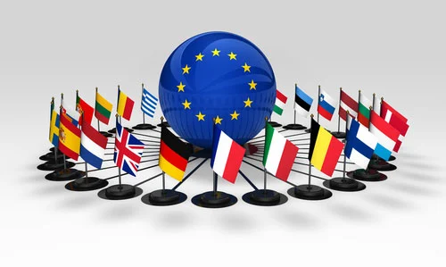In this 21st century, things have became more open to the world, no country is bounded by the region, trading has became borderless, the world is open for travelers and enthusiasts. In such rapid raising world, some countries are making their influential position at the global level. This could be either by making strong economy or by increasing defense and space technologies, It looks like that world is on the edge of competition. Every other nation wants be better than the other.

Today, **India** is in highlights as a developing nation, during the *Harappan Civilization* India was considered as a global trade center, now India is on the urge of regaining that position, Not only the developing and underdeveloped nations but also so called superpowers are insisting over the friendship with India.

India’s dominance was seen when many powerful nations were insisting India to cast its vote during the **Russia-Ukraine** war, **Russia** is insisting or forcing **Ukraine** to step back as a **NATO** member, the question is Why Russia don’t want Ukraine to be a part of **NATO** ? Answer to this question is very simple, Russian President **Vladimir Putin** has always disowned this organization, Russia always considered **NATO** as a threat to its security, since Ukraine is at the border of Russia, if Ukraine joins **NATO** then its **NATO** itself on the border of Russia which is considerably more threat to Russia’s **security**, That’s why Russia started war against Ukraine. In this severe time, nations who promised to help Ukraine also step back. This results in the fall of import-export business of many nations with Ukraine, which result in the fall of shares of many multinational Companies.

Investments in the **Stock** **market** has been increased across the world, people are becoming more smarter and expert in investing the money, we have recently seen the various **UP’s** and **DOWN’s** in the US stock market, due to heavy investors market is becoming unpredictable day by day, many investors are losing and so the others are making profit, many working professional are seeing stock market as a source of part time income. *Stock market is an ocean which can fulfil the needs of every single person*, If a person has a simple and basic knowledge about the working of Stocks in the market, then he/she can easily earn profit by investing. This is like a weapon which can be used for the **development** of the nation for increasing its economy, but it can also **harm** the economy of the nation if market falls down badly, it can create severe economical crises among the people.

Apart from the economics, Health is one of the major issue in front of the world, few years back, whole world has faced a huge health disaster, **COVID-19**, such outbreaks can be proved hazardous to the mankind, these public health risks are often unpredictable, such health crises are monitored by **World Health Organization**. Nowadays, pollution is becoming more severe problem, among that air pollution is more serious. Last year, **WHO** releases new repository of resources for air quality management, this repository defines a well defined standards and guidelines for air quality management, this was enforced when **99%** people worldwide are exposed to harmful levels of fine particulate matter. **WHO** is piloting a program to train health professionals as advocates for clean air policies.

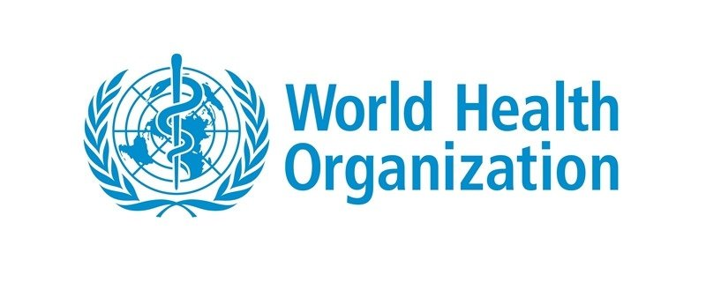Air Pollution directly increase the temperature, this leads to the climate change. Since **1992** when the **UN** has considered climate change as a serious issue, negotiations are made among the countries to slow down global temperature rise, several agreement like *Kyoto Protocol* and *Paris Agreement* were undertaken but still failed to stop the temperature rise. Now continuous increase in temperature have been resulted in the depletion of **Ozone** layer.

In **conclusion**, the world leaders must lookout towards these problems as one, these are the crises which can affect the future generation in a bad way, World must maintain and save its legacy for the future generation, these problems must be resolved for making world a better place for living, disputes among the nations must be handled through diplomatic ways to prevent war like situation, this will left world nations with fewer enemies.