**What is a Project in Project Management?**

12.06.2024

A project is defined as a sequence of tasks that must be completed to attain a certain outcome. According to the Project Management Institute ([PMI](https://www.pmi.org/)), the term Project refers to ” to any temporary endeavor with a definite beginning and end”. Depending on its complexity, it can be managed by a single person or hundreds.

Characteristics of a project

A project is a set of interdependent tasks that have a common goal. Projects have the following characteristics:

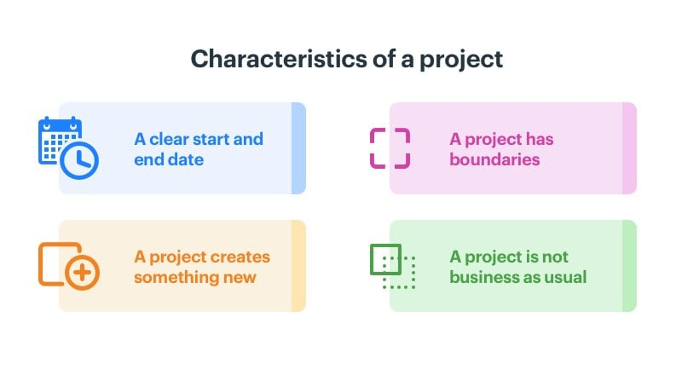

1. **A clear start and end date** – There are projects that last several years but a project cannot go on forever. It needs to have a clear beginning, a definite end, and an overview of what happens in between.
2. **A project creates something new** – Every project is unique, producing something that did not previously exist. A project is a one-time, once-off activity, never to be repeated exactly the same way again.
3. **A project has boundaries** – A project operates within certain constraints of time, money, quality, and functionality. We’ll see more about this in later sections.
4. **A project is not business as usual** – Projects are often confused with processes. A Process is a series of routine, predefined steps to perform a particular function, say, expense reimbursement approvals. It’s not a one-off activity. It determines how a specific function is performed every single time.

The diverse nature of projects

Projects come in a wide range of shapes and sizes.

*A project can:*

* **Be big:** Like the construction of the Hoover Dam, take years to complete, and have a humongous budget.
* **Be small:** Like your weekend project of installing a pathway in your lawn
* **Involve many people:** Like planning a wedding
* **Just yourself:** rearranging the photos in your wedding album

Types of projects

Projects can be diverse in the ways in which they are implemented. *Here are some examples of projects:*

* **Traditional projects:** These are run sequentially in phases. These phases are typically initiation, planning, execution, monitoring, and closure. Most high-cost infrastructure projects make use of traditional project management.
* **Agile projects:** These are used mainly in software development. They are people-focused and adaptive. They also typically have short turnaround times.
* **Remote projects:** [Remote project management](https://kissflow.com/project/remote-project-management/) is usually used by distributed teams that seldom meet in person. Handling freelance contributors is an example of a remote project.
* **Agency projects:** Agency projects are outsourced to an agency that is likely to have projects with multiple clients. [Marketing and design projects](https://kissflow.com/project/marketing-project-management/) are commonly outsourced to agencies.

**Projects and operations** are both parts of the product life cycle. Projects are temporary efforts to create unique products or services, that involve phases like design, coding, and testing. Operations are the ongoing activities that produce and deliver these products repeatedly. While projects focus on creating something new, operations ensure consistent production and efficiency. Understanding both is essential for managing and sustaining business activities.

**What is Project?**

Any software is developed in various phases. These are called [software development life cycle](https://www.geeksforgeeks.org/software-development-life-cycle-sdlc/) phases. They start from Requirement gathering and include designing, programming (coding), integration, [testing](https://www.geeksforgeeks.org/software-testing-basics/)and maintenance. All these procedures carried out in a specified time frame, for creation of a product are collectively called a Project. A project is an endeavor that is temporary in nature, that is undertaken to produce a unique product.

**What are Operations?**

After product is made it is then brought out to market. The processes of creating product again and again using same techniques that were used earlier, for purpose of distributing to users and (making profit in most cases) are a part of Operations. Operations are ongoing execution of activities which occur after product is made to produce same result or a repetitive service. Production, manufacturing, and accounting are examples of operations.

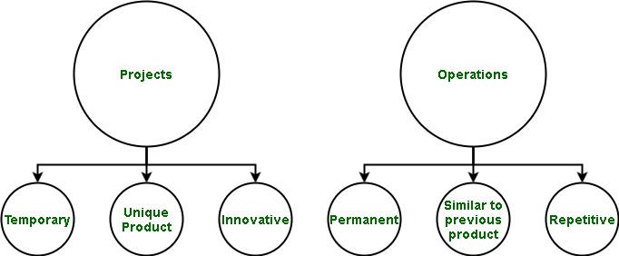

**Differences between Projects and Operations**

| **Category** | **Projects** | **Operations** |
| --- | --- | --- |
| **Definition** | A project is an endeavor that is temporary in nature, that is undertaken to produce a unique product. | Operations are ongoing execution of activities which occur after product is made to produce same result or a repetitive service. |
| **Duration** | It is temporary as it does not exist after product is made. This is because phase before a product is made includes a project. | It is permanent as it only exists after product is made and can go on forever. The same product is manufactured as long as it has a demand or as long as it generates profit. |
| **Budget** | The budget is Defined for Projects. The stake holders and management, who wish to get a product made, specify a budget for it. | The budget is not defined for Operations as the earning needs to be done to keep operations alive. This is because if there is a great response for or enough revenue and profit from product, more such products can be made. |
| **Newness** | It is new (new product). A project is undertaken to create a new kind of product. | It is has nothing new. This is because it is just process of making product in more numbers so as to be distributed among users. |
| **Product** | Unique product is created. The project is undertaken for creation of a unique product. | Same product is produced to keep system running. More numbers of the existing product are made for end-users. |
| **Risk** | It has more risk as it is done for first time. There is a risk of failure attached because specified thing has never been made before. | It has less risk as such products have already been made before and it is only process of creating them in greater numbers. |
| **Focus** | Performance is primary focus of projects. The project must be of optimal performance and meeting requirements specified by clients. | Efficiency is primary focus. The entire operation must be carried out in an efficient manner so as to reduce manufacturing time and optimizing processes for better revenue. |
| **Type of Management** | Management of project is called[Project Management](https://www.geeksforgeeks.org/what-is-project-management/) | Management of operation is called [Business Process Management.](https://www.geeksforgeeks.org/business-process-management-bpm/) |
| **Reasons for Undertaking** | It can be undertaken due to an opportunity or business need, Social need, Technological enhancement, Customer private need, Market demand, Legal requirements etc. | It is done to run business and sustain system. |
| **Basis** | Projects are based on achieving objectives that are specified in requirement specification phase. | Operations are based on metrics according to which entire product is measured. |
| **Organization** | The organization that deals with projects is called a Projectized organization. | The organization that deals with operations is called a Functional organization. |
| **Existence** | Projects exist before product is made. This is because once project is completed and is out in market, it is called a product. | Operations exist only after product is made. This is so, as only after one product is made, can more such products be developed. |
| **Nature** | It is Innovative in nature. The project is undertaken for creation of a new product. | It is Repetitive in nature. The process of making product once is again repeated for several other products manufacture. |

**Why is Project Management Important?**

[Project management](https://www.geeksforgeeks.org/software-engineering-software-project-management-spm/) is crucial for several reasons and its importance extends across various industries and types of projects. Here are key reasons why project management is essential:

Why is Project Management Important

**1. Foundation for Success**

Successful project is based on appropriate and effective management of projects. Consider a building in which the foundation is poorly built, this poses a threat to the entire structure. Likewise, project management ensures that projects are accomplished within a certain scope, time frame, and cost. For instance, a software development project may have milestones and deadlines in place that keep the team from straying off-course by delivering the product right on time, as well as within budget.

**2. Risk Mitigation and Planning**

Project management requires detailed planning and preliminary hazard analysis to determine potential issues. Imagine a marketing campaign, where the team is preparing for possible problems like market trends or new rivals. Risk mitigation strategies allow the project manager to create contingency plans so, that projects will not deviate even under unanticipated challenges.

**3. Resource Optimization**

Proper resources must be allocated for project success. Consider any production venture that focuses entirely on reducing the raw materials, machinery as well as human resources to increase productivity. Allocation of resources is effective through project management that reduces waste and maximizes output thereby leading to cost effectiveness.

**4. Stakeholder Communication**

Communication is the cement that makes a project stick together. For a construction project, interested parties can be architects, contractors, and clients. As communication brokers, project managers contribute towards making sure that all stakeholders are well aware of the requirements and goals to be actively involved throughout implementing a given project. Clear communication prevents misunderstandings and maintains domestic harmony.

**5. Adaptability and Flexibility**