# 

# 

# 

**ASSIGNMENT**

**Student Number:**

**Module name:**

**Table of Contents**

Introduction 3

Methods 4

Results 5

Discussion 7

Conclusion 8

References 10

# Introduction

The task of this coursework focused on the development of a Lab report based on the collected data by the “Douglas Bag Practical”. The main purpose of this lab report was to highlight the changes in the metabolic system of the participants in 3 different work rates. Along with the changes in work rate, “breathing frequency” (BrF), “respiratory exchange ratio” (RER), “consumption of oxygen” (VO2), “ventilation response” (VE), “rated perceived exertion” (RPE) and “heart rate” (HR) modified in a significant manner.

***Review of literature***

The application of the experimental approach was helpful to identify the changes in aerobic endurance with the increment of work rate. As opined by Mylsidayu (2019, p-29), the enhancement of the aerobic endurance of the body was helpful to improve the “heart-lung capacity”. This was also important to secure the optimal performance of the blood vessel, lungs, and heart systems in both rest and working situations. On the other hand, the review of the research by Görner & Reineke (2020, p-20) highlighted the adaptive changes in the body due to endurance and training. It was helpful to identify the fitness level of the human being in a significant manner. Moreover, this study evaluated the importance of physical fitness in the improvement of physical and mental fitness. Furthermore, Mohajan & Mohajan (2023) mentioned the role of VO2 in the enhancement of cardiorespiratory fitness. It also evaluated the standard measure of cardiorespiratory fitness based on VO2.

***Aim and objectives***

**Aim**

The main aim of this work was to perform a statistical analysis of the key factors associated with ***cardiovascular fitness*** and ***aerobic endurance*** to ensure better physical health.

***Objectives***

* To explore the mean and standard deviation of the key attributes to measure cardiovascular fitness.
* To highlight the aerobic endurance of the participants based on the value of RER based on the information collected by Douglas Bag practicals.

***Experimental hypothesis***

The increment of the RER value has a positive impact on the development of aerobic endurance in the human body.

# Methods

***Sample selection***

In the practice of experimental analysis, the collection of relatable information played a major role. In this task, the information related to the consumption of O2, CO2, BrF, HR, and the rating of perceived excretion (RPE) was collected for the required analysis. The data was collected for this experiment during the time of the group's practical by Douglas Bag. The information consisted of details for both males and females with their respective heights and weights. Moreover, the attributes were collected in 3 different stages of work rate in the combination of rest, 60, 90, 120, and 180 watts.

***Tools selection and experiment procedure***

The purpose of this work was to perform the statistical analysis of the collected information by the application of MS Excel. The application of this tool was important in this task to perform the statistical analysis and evaluate the desired outcome in a successful manner (Bramer et al. 2020, p-3). The value of VO2, VCO2, RER, and VESTPD was evaluated from the attributes in different working conditions. Moreover, the mean and standard deviation (SD) was measured for each of the attributes in various working stages. This was helpful to identify the current situation of the cardiovascular fitness of individual participants.

***Data analysis***

The assessment of tables and graphs was helpful in this task to achieve the desired results. The providence of proper units and axes was important in this context to evaluate the findings in a better way. Furthermore, the table was formed by the value of mean and SD and it was presented in the form of mean ± SD. On the other hand, the presentation of the graph helped to identify the statistical findings for both the males and females in a respective manner.

# Results

***Table***

The description of this table highlighted the statistical analysis of this lab report by the application of MS Excel.

|  |  |  |  |
| --- | --- | --- | --- |
|  | **Rest** | **Exercise 1** | **Exercise 2** |
| **VE** | **13.12 ± 2.08** | **37.32 ± 3.45** | **58.20 ± 7.10** |
| **VO2** | **0.40 ± 0.06** | **1.53 ± 0.18** | **2.24 ± 0.29** |
| **VCO2** | **0.42 ± 0.07** | **1.5 ± 0.20** | **2.42 ± 0.27** |
| **RER** | **1.03 ± 0.03** | **0.97 ± 0.04** | **1.10 ± 0.04** |

**Table 1: Measure of variance**

(Source: Self-created)

The description of this table was highlighted the different attributes such as VE, VO2, VCO2, and RER in 3 different stages of work rate. As per the description of this table, the value of attributes was increased along with the increment of exercise intensity. The definition of the range of RER helped to highlight the endurance level of the participants in working conditions.

***Figure***

The analysis of the graphs was important to measure the changes in different attributes along with the changes in work rate.

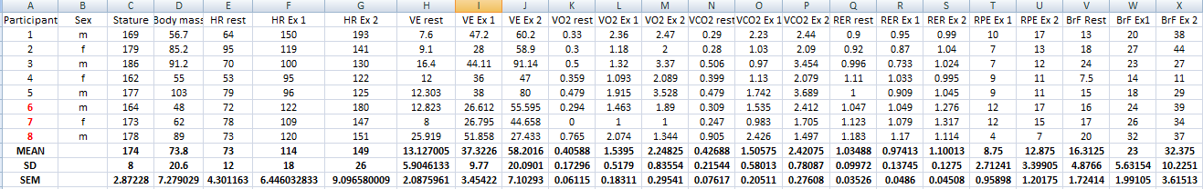

**Figure 1: Measure of cardiovascular fitness**

(Source: Self-created)

A statistical analysis of cardiovascular fitness was accomplished by measuring the mean, standard deviation, and standard error of the mean. Each attribute had been measured for rest, exercise 1, and exercise 2 by the participants in the three groups. The standard error of the mean was calculated by using the formula ***STDEV/SQRT(COUNT)***.

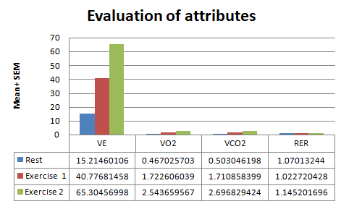

**Figure 2: Evaluation of VE, VO2, VCO2, and RER for 3 work conditions**

(Source: Generated in Excel)

The description of the above figure measured the value of different attributes in rest, exercise 1, and exercise 2 conditions. As per the description of this figure, the VE measured for Exercise 2 was measured as 65.30 and the value of VO2 for the same condition was evaluated as 2.54. Moreover, the value of RER was measured for a similar exercise as 1.14.

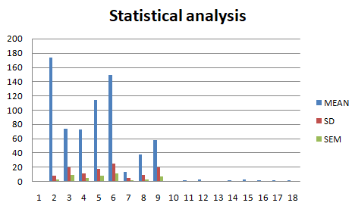

**Figure 3: Statistical analysis**

(Source: Developed in Excel)

The presentation of this graph highlighted the value of the mean, SD, and “standard error of the mean” (SEM) of different attributes in different exercise conditions. It was effective to develop the overview of all the key attributes in a successful manner. The SEM of body mass was larger than the stature of the participant in each group.

# Discussion

***Discussion***

The description of the findings of this report mentioned the value of key parameters associated with the evaluation of metabolic rate. As per the description of these results, the range of parameters increased along with the increment of the intensity of the workout. Furthermore, the value of RER was significantly increased with the increment of the work rate level. On the other hand, the research work developed by Leal‐Martín et al. (2023) mentioned the increment of RER suggested the excessive amount of energy consumption during the work.

In a similar way, the findings of this report evaluated the increment of the RER range along with the increment of the rate of working. The value of VE was also increased with the enhancement of working stress for the individuals. Furthermore, Lemus et al. (2022, p-12) evaluated the increment of physical stress influenced BMI and reduced fitness level in a significant manner. The findings of this work also highlighted the increment of physical activity was responsible for the increment of RER and it was influenced by the intensity of work in a significant manner. The evaluation of the findings measured the value of statistical information such as mean, SD, and SEM for the evaluation of aerobic endurance in different conditions of work-rate.

***Methodological limitations***

In this practical work, MS Excel was considered a primary tool for data analysis. In the implementation of complex formulas, and manual entry of information, the chance of inconsistencies in results was comparatively higher in Excel. In the implementation of complex and large datasets, the functionality of Excel was slowed down along with the difficulties in sharing (Mustafa & Hatemi-J, 2022, p-3). On the other hand, the evaluation of advanced data analysis was difficult with this methodological approach. Due to this reason, machine learning and data mining were not possible by the consideration of this approach.

***Implication of findings and future work***

The successful work of this report provided suggestions to maintain the highest level of endurance level and uplift physical fitness in a significant manner. In addition, the findings provided insights into VO2 and VCO2 in order to maintain physical fitness on a higher level. The implication of the findings was also important to highlight the strategies to maintain ***cardiovascular fitness*** through the proper maintenance of RER and BrF. However, consideration of more attributes along with the evaluation of advanced statistics will improve the evaluation in the upcoming works.

# Conclusion

The description of the above lab report concluded the changes in attributes due to different working rates. The evaluation of the mean and SD values was important in this context to highlight the modification in values according to the variations in stature and body mass of the individuals. The selection of attributes value in 3 different exercises was effective to evaluate the results in a more descriptive manner. Therefore, the evaluation of this lab report provided insight into the process to maintain both physical and mental fitness in a successful manner.

# References

Bramer, L. M., White, A. M., Stratton, K. G., Thompson, A. M., Claborne, D., Hofmockel, K., & McCue, L. A. (2020). ftmsRanalysis: An R package for exploratory data analysis and interactive visualization of FT-MS data. PLoS Computational Biology, 16(3) <https://doi.org/10.1371/journal.pcbi.1007654>

Görner, K., & Reineke, A. (2020). The influence of endurance and strength training on body composition and physical fitness in female students. Journal of Physical Education and Sport, 20, 2013-2020. DOI:10.7752/jpes.2020.s3272

Leal‐Martín, J., Mañas, A., Alfaro‐Acha, A., García‐García, F. J., & Ara, I. (2023). Optimization of VO2 and VCO2 outputs for the calculation of resting metabolic rate using a portable indirect calorimeter. Scandinavian Journal of Medicine & Science in Sports. DOI: 10.1111/sms.14425

Lemus, S. A., Volz, M., Tiozzo, E., Perry, A., Best, T. M., & Travascio, F. (2022). The effect of clinically elevated body mass index on physiological stress during manual lifting activities. Plos one, 17(12), e0278858. <https://doi.org/10.1371/journal.pone.0278858>

Mohajan, D., & Mohajan, H. (2023). Long-Term Regular Exercise Increases V̇O2max for Cardiorespiratory Fitness. <https://mpra.ub.uni-muenchen.de/116962/1/MPRA_paper_116962.pdf>

Mustafa, A., & Hatemi-J, A. (2022). A VBA module simulation for finding optimal lag order in time series models and its use on teaching financial data computation. Applied Computing and Informatics, 18(3), 208-220. <https://doi.org/10.1016/j.aci.2019.04.003>

Mylsidayu, A. (2019, February). The Influence of Cardio Workout to Aerobic Endurance. In 2nd International Conference on Sports Sciences and Health 2018 (2nd ICSSH 2018) (pp. 29-32). Atlantis Press. <https://www.atlantis-press.com/article/55914020.pdf>