**Week 1 (Algorithms and Data Structure)**

**Exercise 2: E-commerce Platform Search Function:**

import java.util.*;

// Step 1: Product class

class Product {

    int productId;

    String productName;

    String category;

    public Product(int productId, String productName, String category) {

        this.productId = productId;

        this.productName = productName;

        this.category = category;

    }

    @Override

    public String toString() {

        return productId + ": " + productName + " (" + category + ")";

    }

}

// Step 2: Linear Search

class LinearSearch {

    public static Product search(Product[] products, String name) {

        for (Product p : products) {

            if (p.productName.equalsIgnoreCase(name)) {

                return p;

            }

        }

        return null;

    }

}

// Step 3: Binary Search

class BinarySearch {

    public static Product search(Product[] products, String name) {

        Arrays.sort(products, Comparator.comparing(p -> p.productName.toLowerCase()));

        int low = 0, high = products.length - 1;

        while (low <= high) {

            int mid = (low + high) / 2;

            int compare = products[mid].productName.compareToIgnoreCase(name);

            if (compare == 0) return products[mid];

            else if (compare < 0) low = mid + 1;

            else high = mid - 1;

        }

        return null;

    }

}

// Step 4: Main class to run everything

public class SearchDemo {

    public static void main(String[] args) {

        Product[] products = {

            new Product(1, "iPhone", "Electronics"),

            new Product(2, "T-shirt", "Clothing"),

            new Product(3, "Shoes", "Footwear"),

            new Product(4, "Laptop", "Electronics"),

            new Product(5, "Book", "Stationery")

        };

        Scanner sc = new Scanner(System.in);

        System.out.print("Enter product name to search: ");

        String target = sc.nextLine();

        // Linear Search

        System.out.println("\n-- Linear Search --");

        Product result1 = LinearSearch.search(products, target);

        System.out.println(result1 != null ? "Found: " + result1 : "Product not found.");

        // Binary Search

        System.out.println("\n-- Binary Search --");

        Product result2 = BinarySearch.search(products, target);

        System.out.println(result2 != null ? "Found: " + result2 : "Product not found.");

    }

}

**Output:**

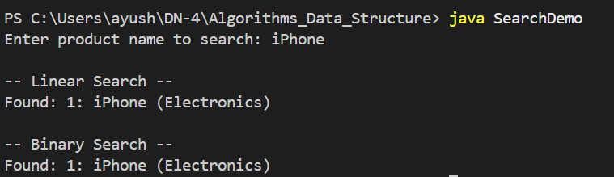

**Exercise 7: Financial Forecasting:**

import java.util.Scanner;

public class FinancialForecast {

    // Recursive method to calculate future value

    public static double futureValueRecursive(double initialValue, double growthRate, int years) {

        if (years == 0) {

            return initialValue;

        }

        return futureValueRecursive(initialValue, growthRate, years - 1) * (1 + growthRate);

    }

    // Iterative method to calculate future value

    public static double futureValueIterative(double initialValue, double growthRate, int years) {

        double result = initialValue;

        for (int i = 0; i < years; i++) {

            result *= (1 + growthRate);

        }

        return result;

    }

    public static void main(String[] args) {

        Scanner scanner = new Scanner(System.in);

        // Input

        System.out.print("Enter the initial investment amount: ₹");

        double initialValue = scanner.nextDouble();

        System.out.print("Enter the annual growth rate (as percentage, e.g. 10 for 10%): ");

        double ratePercent = scanner.nextDouble();

        double growthRate = ratePercent / 100.0;

        System.out.print("Enter the number of years to forecast: ");

        int years = scanner.nextInt();

        // Recursive calculation

        double resultRecursive = futureValueRecursive(initialValue, growthRate, years);

        // Iterative calculation

        double resultIterative = futureValueIterative(initialValue, growthRate, years);

        // Output

        System.out.printf("\nFuture value after %d years (Recursive): ₹%.2f\n", years, resultRecursive);

        System.out.printf("Future value after %d years (Iterative): ₹%.2f\n", years, resultIterative);

    }

}

**Output:**

